(If you have any questions, please contact:

Weibo @黎浮_ @FnEnustik Baidu Tieba @离梦°塔依 @耶薇亦葵

For English: touken-ranbu.fandom.com @Tangelor142)

1.Installion Tutorial

**It is recommended you use the latest Chrome web browser version.**

**You must use Developer Mode to load the plugin.**

First, open the extensions window in Chrome (either by typing ‘chrome://extensions’ in the address bar or by finding it under ‘More Tools’ in the additional options button in the top right)

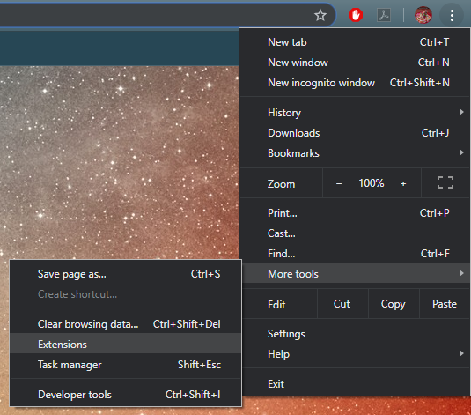

Once opened, turn on ‘Developer Mode’.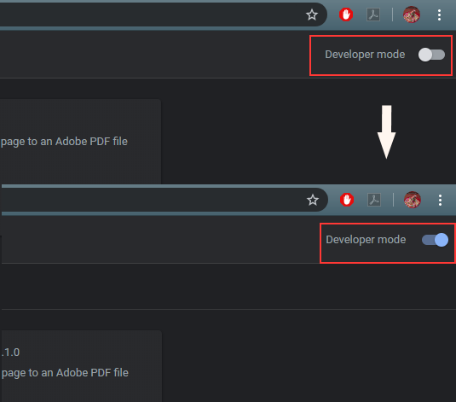

Second, choose to ‘Load unpacked extension…’ and select the directory where the extracted extension is located.

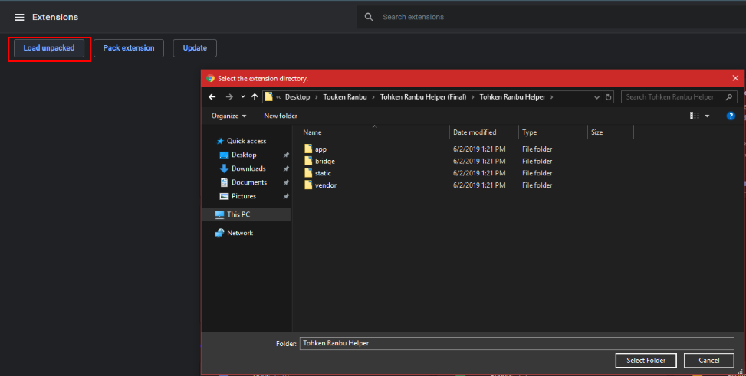

2.How to Use Tutorial

1. Open the game web page.

 2. Press **F12** or **right-click** in a blank space and select **Inspect element**.

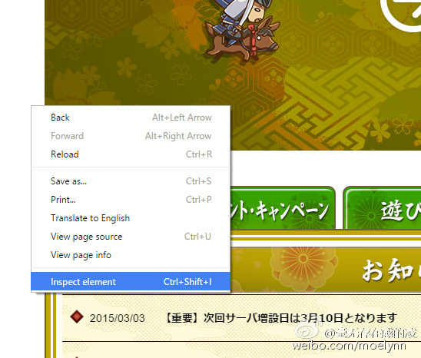

3. In the Developer tools window that pops up, find the Helper tab.

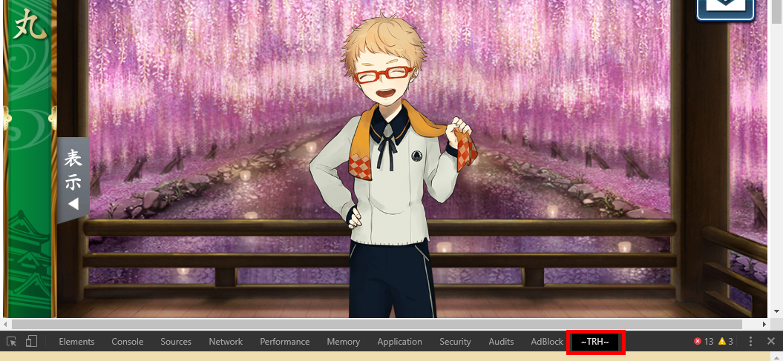

4. After this step you should be able ton enter the game: however, if the extension displays nothing or is stuck on a screen similar to the one below, refresh the game interface (web page).

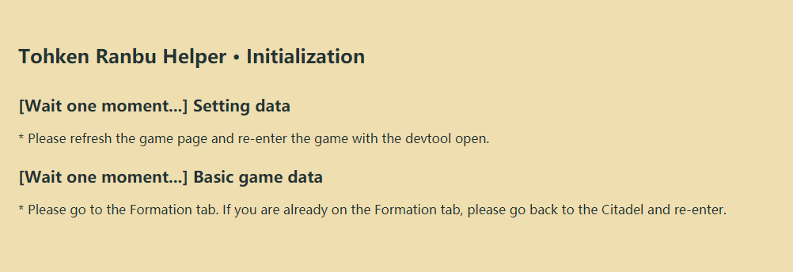

3. Version Introduction （seeing game details）

First, Player information and resource quantities will be displayed.



- There may be times when the resources do not update automatically. The first five resources (the 4 smithing resources and request tokens) may auto-update, but the rest might not. To update help tokens, visit the Formation (結成) or Shop (万屋) menus in game. To update Koban, visit the Front Lines (出陣) or Background (景趣) menus in game. (Inventory might not be auto-updated after using an item.)

- Received mission rewards and opened koban boxes auto-update.

- 其余问题请及时反馈。

Second, Contents of the Dropdown Labels

Under each corresponding tab, you can click on the sub-tab to go directly to its location on the page.

1. Team

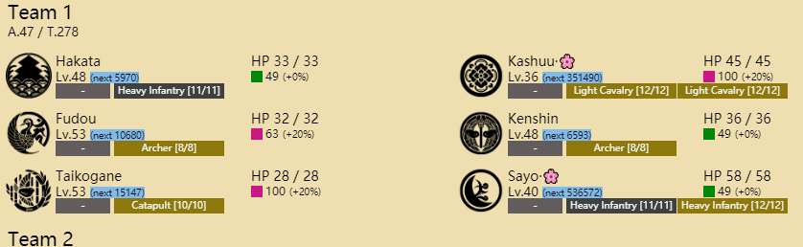

- Displays 1-4 equips in order. The Team’s ‘A’ indicates average level, while ‘T’ is total level.

-If a team is away on expedition, the return time will be displayed next to team name.

-Swords icons, which are the swords’ crests, can be changed.

-队员图标为刀纹，可魔改，此版本已将极化与普刀读取分开。

-To customize the crest images, please go to the ‘static/sword’ folder. They will be in .png format and named after their swords.

-If the sword is injured, the corresponding damage will be displayed next to name (in the correct damage color indication).

-Troop rarity (Gold, Silver, Bronze) will be displayed in the background using the corresponding color. If the troop is destroyed in battle, it will turn red.

-If the sword goes for repairs, that will be noted in blue next to sword HP.

2. Enemy Info

1.Battle Menu

Shows active regular battles (from Front Lines or events).

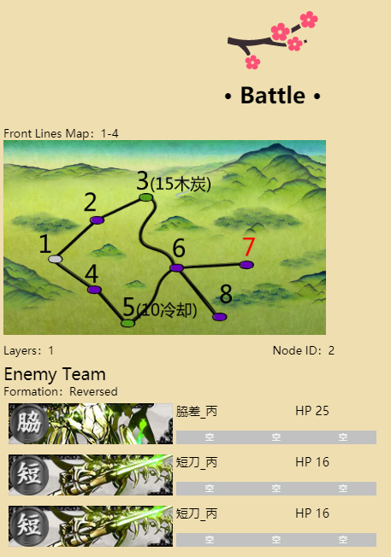

-When in battle, the corresponding battle map and map IDs will be displayed. The numbers on the map represent node IDs, the red number is the Boss node. The parentheses are the resource nodes find. If the Map ID is negative, that indicates an event map.

*（特殊标记法：*

*1.兔子活动：由于地图形状相同但实际内容不同，采用特殊标记。*

*此活动请一定注意地图下方的层数。*

*括号内红色数字代表此点是哪一层的boss，白色为每一层对应的资源标记。*

*2.打鬼活动：黄色数字标记的点为随机点。）*

-Enemy team will be displayed as soon as you enter a node, after selecting your formation, enemy troops will be displayed. Extremely fast enemy swords (swords with mobility over 100) will have their names high-lighted in red.

2.Practice Menu (PVP)

Shows opponent swords’ troops and horse equips. Click on the PVP opponents “申し込む”[Offer] to display the info.

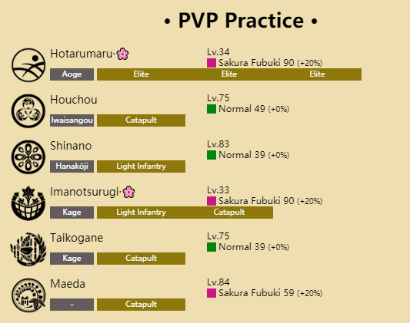

It should be forewarned that this info will not refresh or reappear. It will only show the opponent who was last opened for the “first time” only. If you open another offer, you will not be able to see previous ones.

For example:

Click on Opponent 1 offer (Opponent 1 is displayed)

Click on Opponent 2 offer (Opponent 2 is displayed)

Then Click on Opponent 1 again (Opponent 2 will remain)

To be able to view opponent 1 again, please leave the PVP menu, refresh the tool (right-click, and press Reload frame), and then re-renter the PVP menu.

In addition, due to the game mechanics, the opponent's details shown and the actual combat team may not be the same. The extension will only display the teams in the details, and will not be able to update to the teams in battle in real time. Please be cautious in fighting.

3.Citadel

All miscellaneous items are displayed here: Troops, Horses, Forge, Repair, IA, Kiwame Training, Sword Library, and Inventory.

1. Troops & Horses

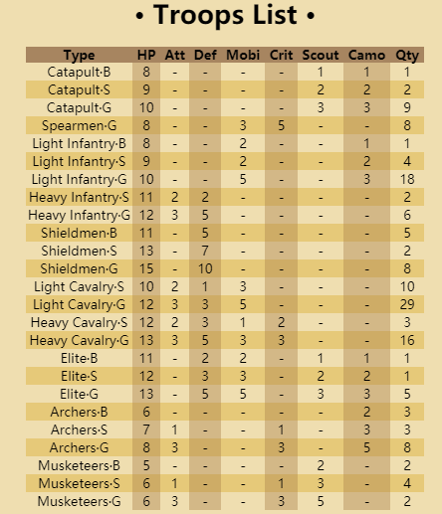 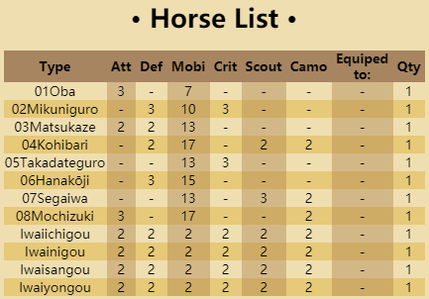

2.Smithing & Repair

Shows current smithing and repair end times.

If nothing is there, no info is displayed. You need to re-enter to get the info to properly display.

3.Sword Library

This is your sword list (list of owned swords) as well as gallery library.

Collection of Base and Kiwame sword illustrations. Normally the image gallery is blank and only populates when you visit the Sword Library menu. If there is no entry for a sword, that means you have all images.

Sword List. List of all swords you own in order of acquisition date.

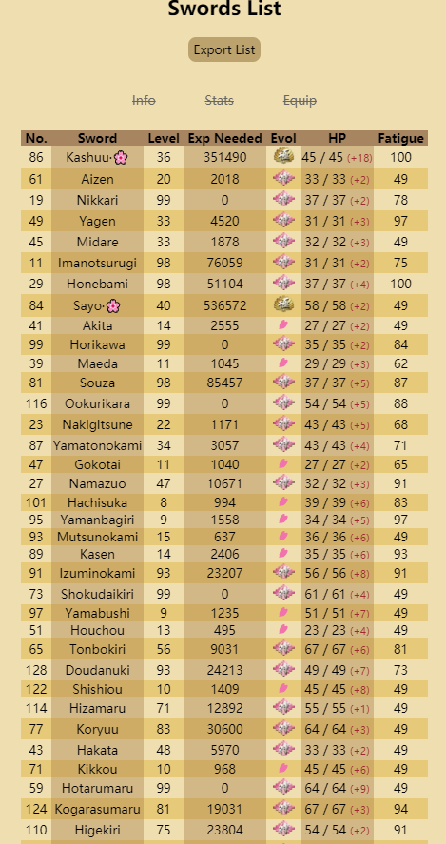

It has three options that may be clicked to open additional info on the swords: information, stats, and equips.

Swords are updated in real time (as in destroyed or newly obtained swords will be subtracted/added accordingly and immediately)

4.Internal Affairs & Kiwame Training

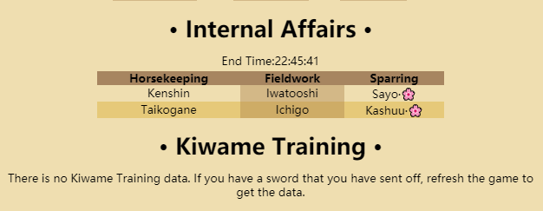

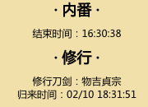

Shows the end times of IA and Kiwame training.

IA: Shows which swords are doing each type of duty

Kiwame: If there is no sword on a journey, Figure 1 is shown, but if there is a sword journeying and you still have Figure 1, you need to refresh the game window. It will then display Figure 2.

**5.Inventory**

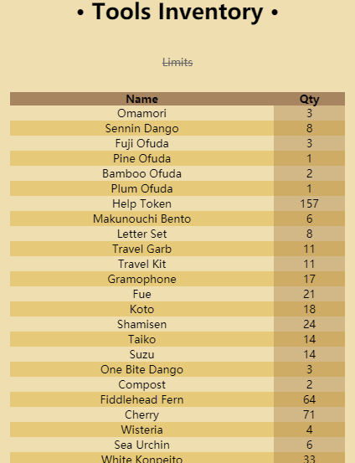

If you have none of a particular item, it is removed from the list.

Koban box opening, expedition returns, and rewards collecting will be reflected in inventory automatically.

You can click the ‘Limits’ option above to see what the maximum you can carry of that particular item.

4.Logs

You can clear or export logs.

After clearing, you need to refresh in order to be rid of the displayed info.

1.Smithing Log

2.Battle Log

3.PVP Log

4.IA Log

5.Settings

Secretary Setting: Enter a sword’s ID number and that sword’s crest will be used on Expedition and IA notifications.

Notification Settings：various push notification settings