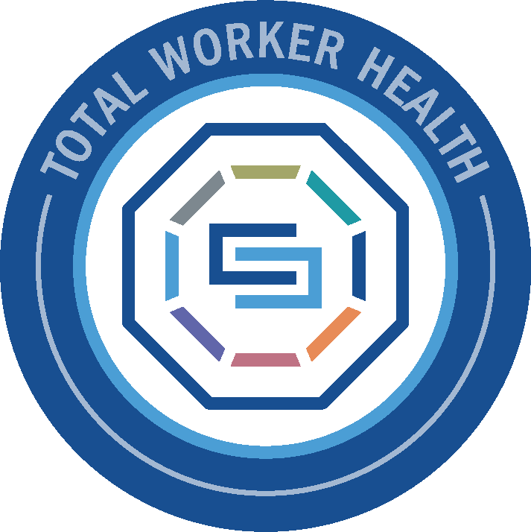
TOOLBOX TALK

DISTRACTED DRIVING AWARENESS (APRIL)

Distracted Driving Awareness Month takes place each April and highlights a risk many of us face every day—on the road before and after work. Whether commuting to a data center, traveling between sites, or running errands, even a brief distraction can have serious consequences. In fast-paced environments like ours, staying focused doesn’t stop at the job site—it extends to how we get there and back. Taking a few simple steps can prevent incidents that impact not just you, but your team and others on the road.
What Creates Risk?
Distracted driving is anything that takes your attention away from the road. The most common risks include:
- Mobile phone use: Texting, checking emails, or using apps while driving
- In-vehicle distractions: Adjusting navigation, music, or climate controls
- Mental distractions: Thinking about work tasks, fatigue, or stress
- Eating or drinking while driving
- Fatigue-related inattention, especially during early or late shifts
Even a few seconds of distraction at highway speeds can mean traveling the length of a football field without looking at the road.
Practical Ways to Stay Focused
- Set up before you go: Enter directions, adjust controls, and secure items before driving
- Put the phone away: Use “Do Not Disturb” or hands-free only when absolutely necessary
- Stay alert: If you’re tired after a long shift, take a break before driving
- Avoid multitasking: Driving deserves your full attention—save meals, messages, and adjustments for later
- Plan your commute: Give yourself enough time so you don’t feel rushed or tempted to cut corners
- Watch for others: Defensive driving is key—assume others may be distracted
Driving is one of the most routine yet highest-risk activities we do each day. Staying focused behind the wheel helps ensure you arrive safely—every time.


Thank you for reading this week’s Toolbox Talk!

