**DP Ex1: yoavSraya 207496464 YonatanBrooker 313592420**

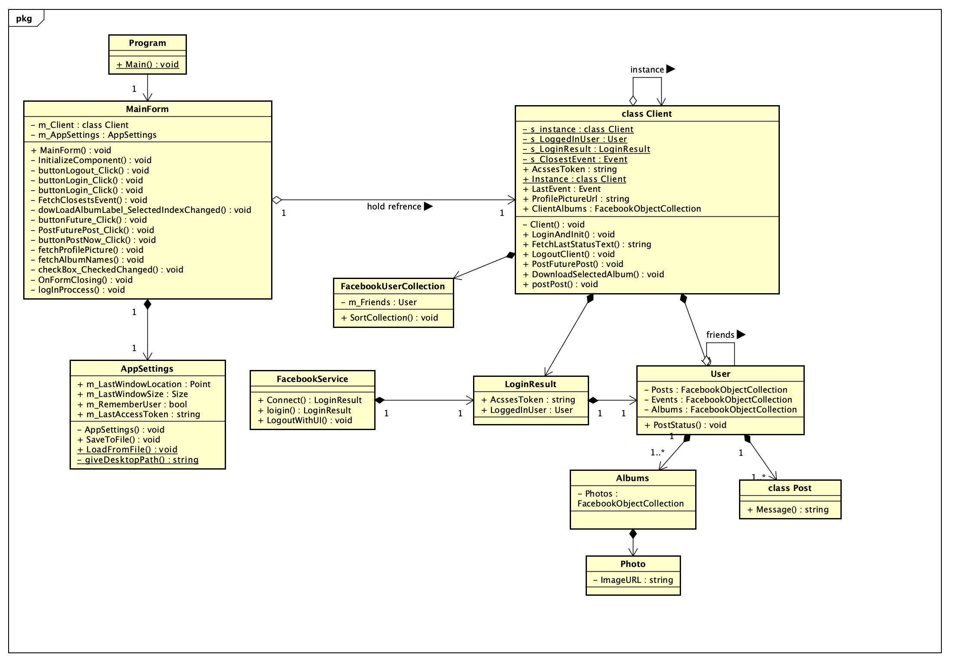**Class Diagram:**

**UseCase Diagram:**

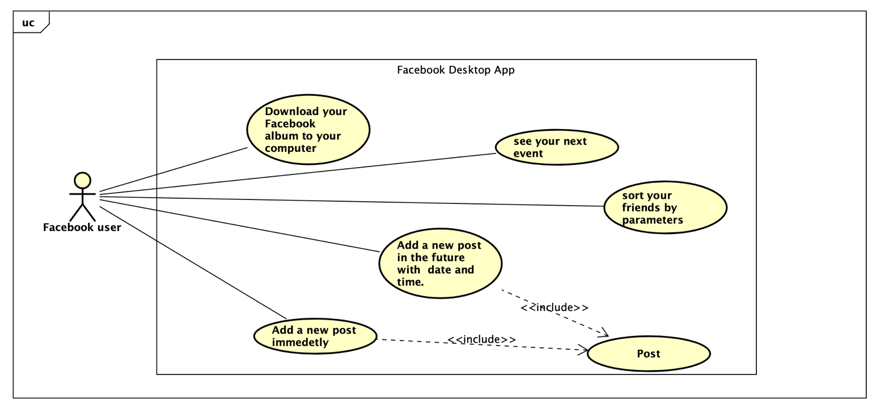

**First feature: Download FacebookAlbum To the computer:**

Let the user select Album form his Facebook album. Select path where the album will be saved (the app create folder with the album name).

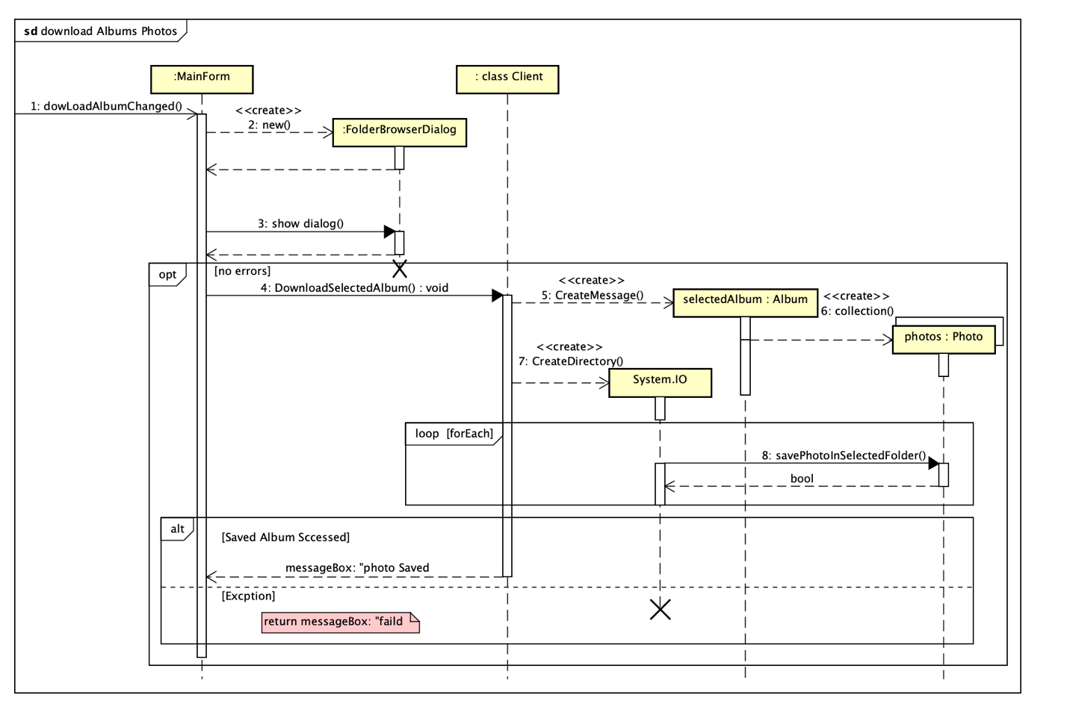

**Second feature: Sort your Friend By parameter:**

After login, the user see all is Facebook friend that connect with the app. The user can sort the friends by one of the parameters (gender, name, birthday)

