MVP

-Landing page will be as displayed below. Unregistered (unauthorized) providers will not be able to navigate to provider page, patient list page or appointment page. Unregistered (unauthorized) provider/user will be redirected to landing (signup/login) page if trying access provider, patient or appointment page. 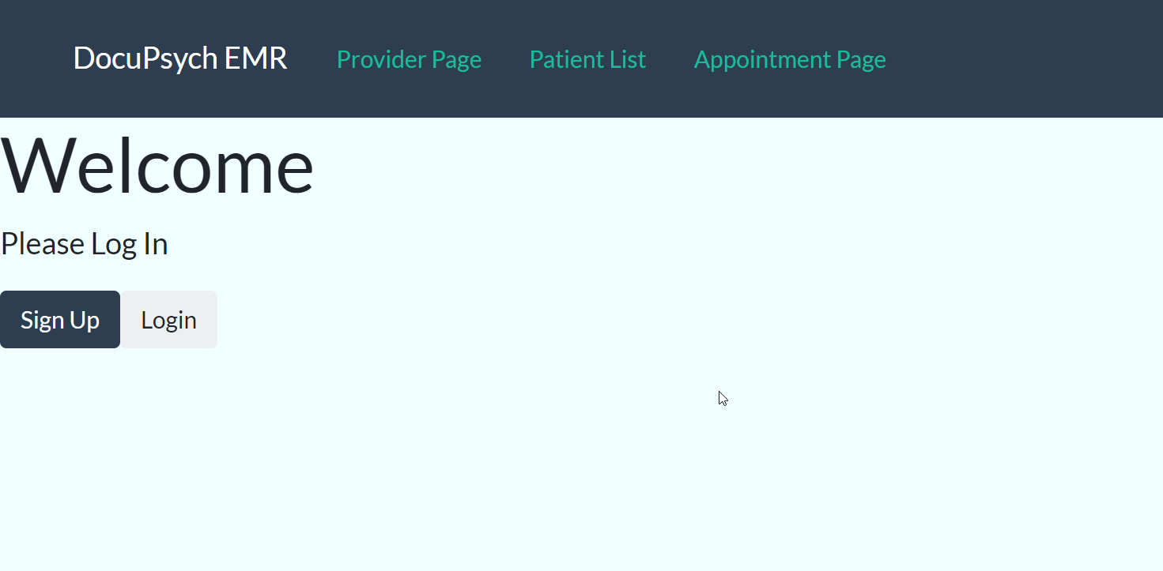

* Authorized provider can enter new patient information and update current patient list.
* Authorized provider will click on patient from current patient list and be navigated to appointment page to document appointment or note. When clicked on, appointment page will include selected patient’s information. Said information may include previous notes/appointments.
* Upon completion of note or documentation, appointment information will save to database.