Website Assignment

Proof of uploaded html files. Both html open over http.

1. Assignmentc8website.html
2. Assignmentc8form.html

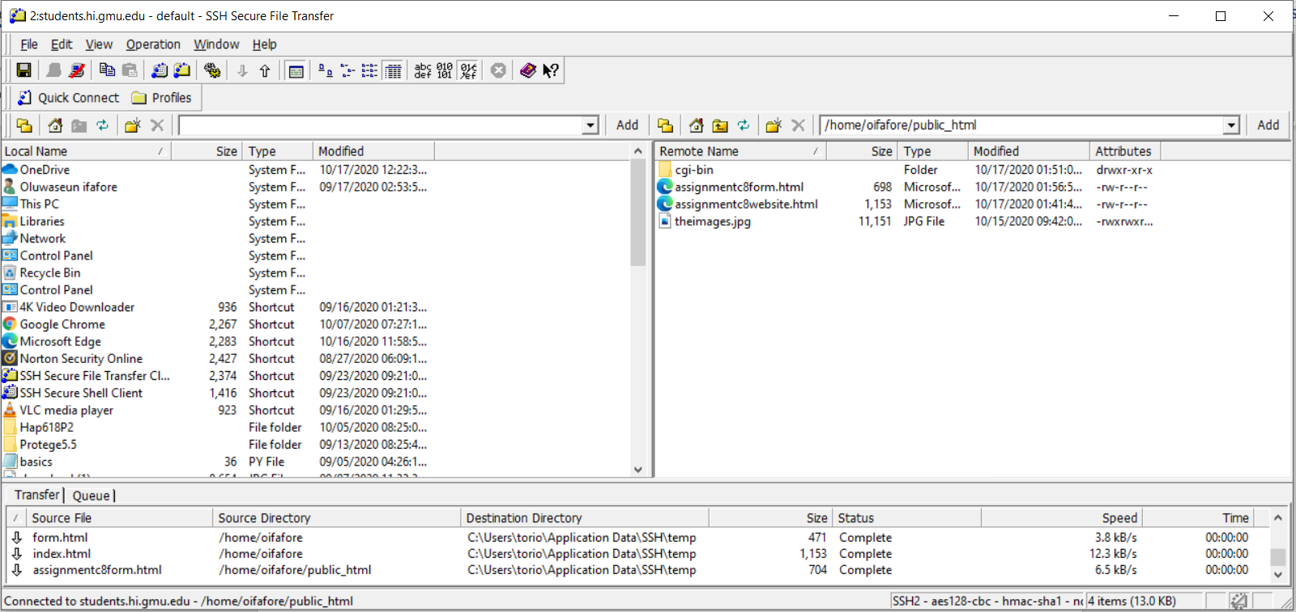

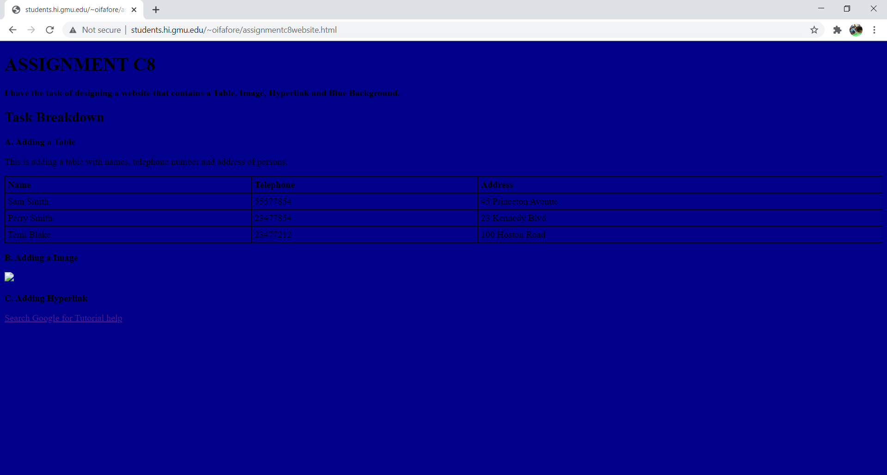

HTML open fine when on my computer but

