1. Problem introduction

It’s about looking for good pet coffee shops to visit on a daily basis, as going to pet coffee shops such as cat coffee has become a popular and daily activity, especially for animal lovers like me. However, in real life, I found it’s time-consuming and energy- draining as there is no platform dedicated to providing this kind of information, which is interspersed among multiple platforms now, but each platform does not have a systematic introduction and clear classification.

1. Persona type
2. A regular at pet coffee shops
3. Someone who occasionally follows friends to pet coffee shops.
4. Student who want to organize a group building activity with fellows there but without experience.
5. A current journey map

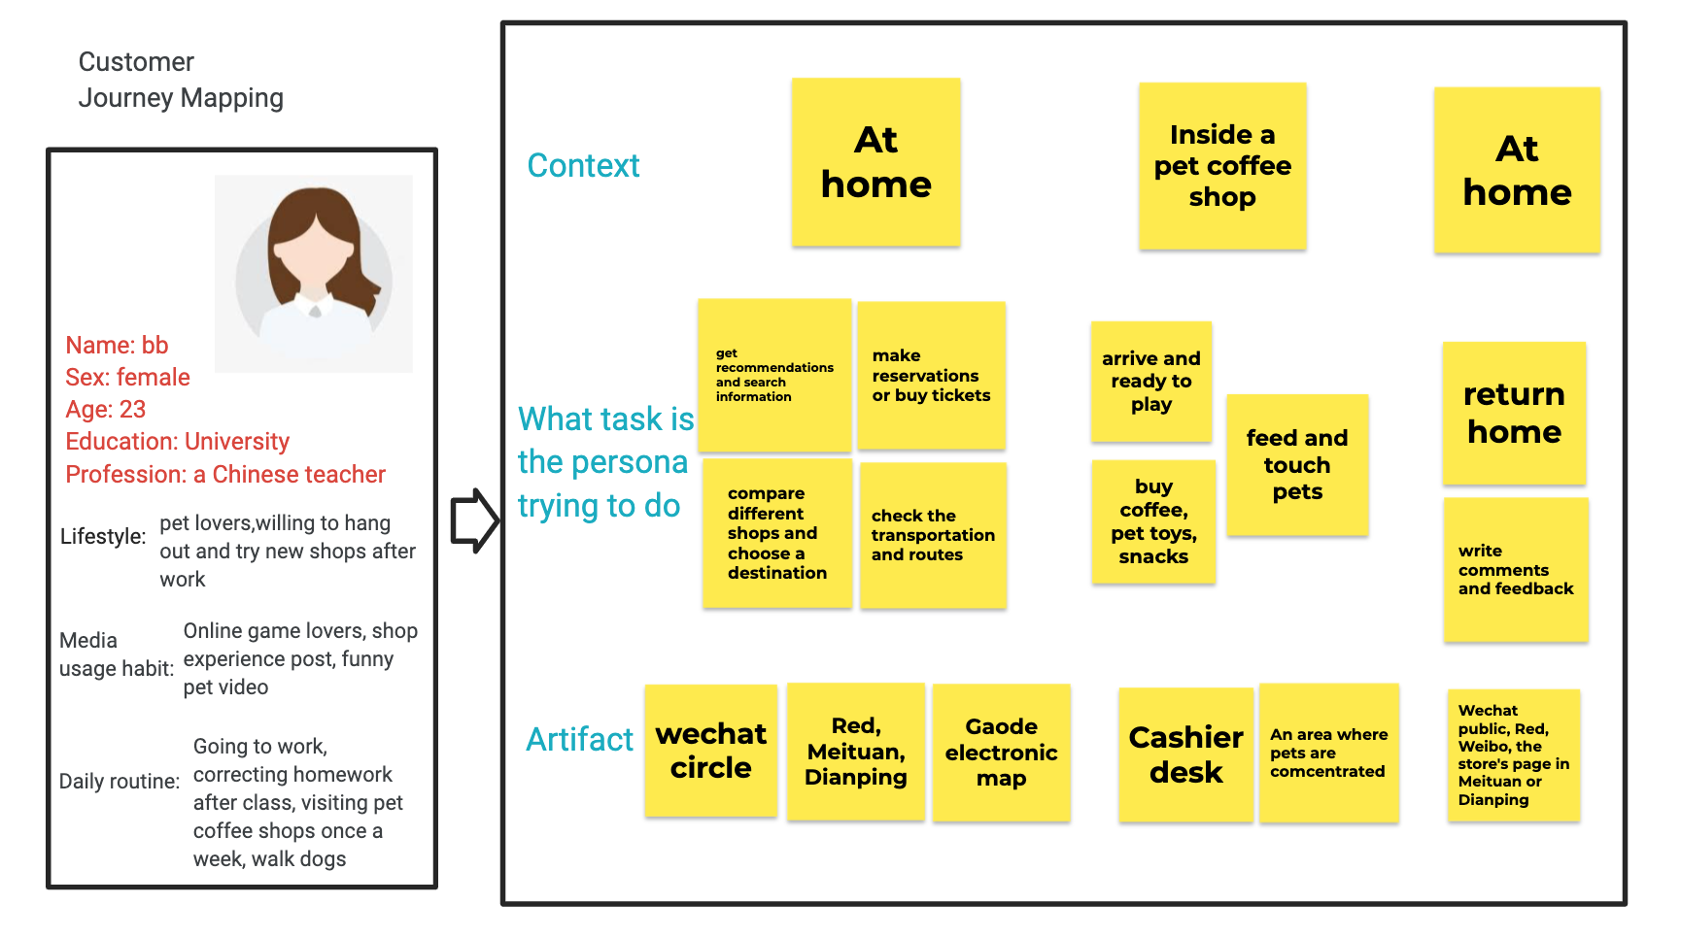

<https://jamboard.google.com/d/19FopdVepDw4ibbePjQcTZqeEi8Csulle8ce1-IIM3HM/viewer?f=0>

The reason:I choose this person for two mean reasons. On the one hand, since she is a pet lover and a frequent visitor to pet coffee shops, she is typical as a representative of the main source of customers, and her problems are also typical. On the other hand, because of her experience in querying relevant information on different platforms, she provided more effective information based on her high participation in the past during the interview, and she could raise more questions and suggestions, which is of more reference value.

1. Problem statement

How might we make a busy teacher as well as a pet lover (who) address the problem of finding some good and new pet coffee shops efficiently where playing with animals she likes (what) to achieve the goal of making good use of her time to get enough rest and release pressure from it instead of wasting time in the process of searching through different platforms (why)?

1. Story map

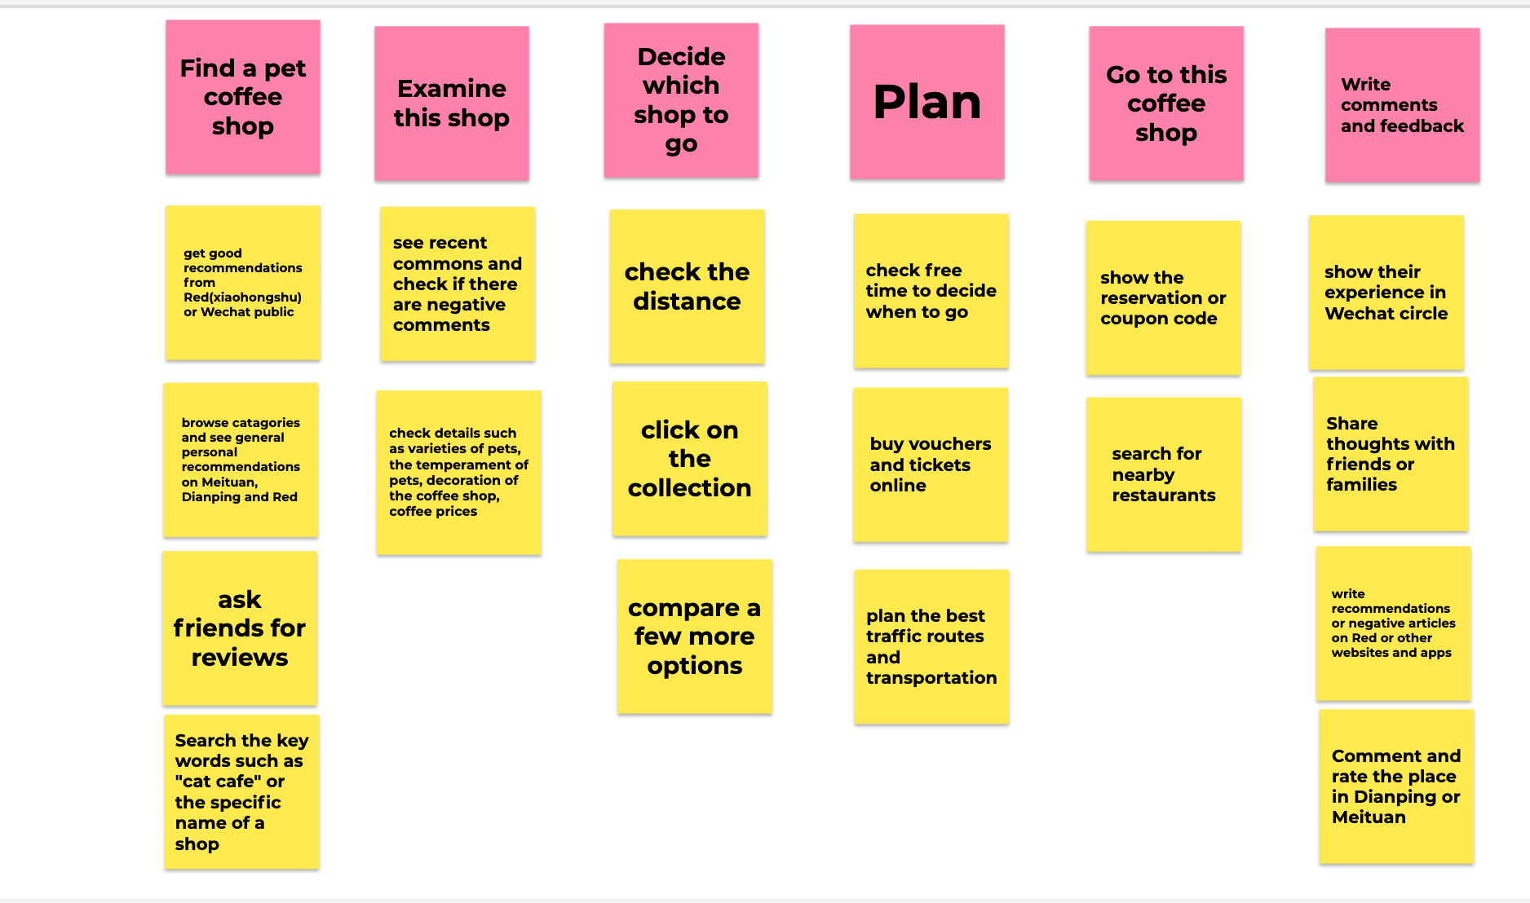

1. Card sort



The open card sort



The card sort labeled by one participant

<https://jamboard.google.com/d/18zZ2HA_aaMIM_mvn9iuAl8yCH1_LiobCfWTfNWn5fvw/viewer?f=0>

1. Position map

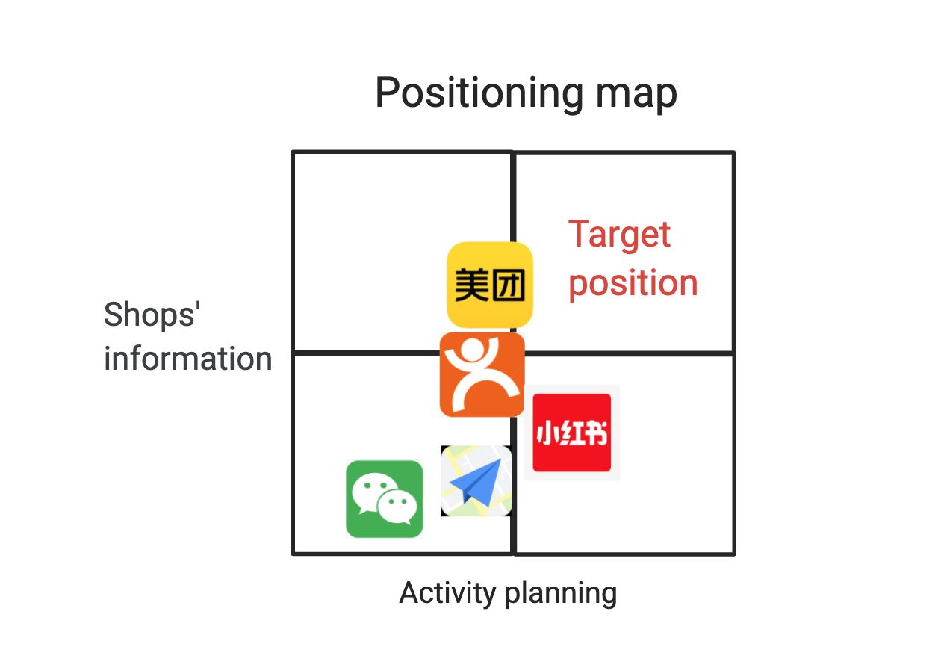

<https://jamboard.google.com/d/19FopdVepDw4ibbePjQcTZqeEi8Csulle8ce1-IIM3HM/viewer?f=2>