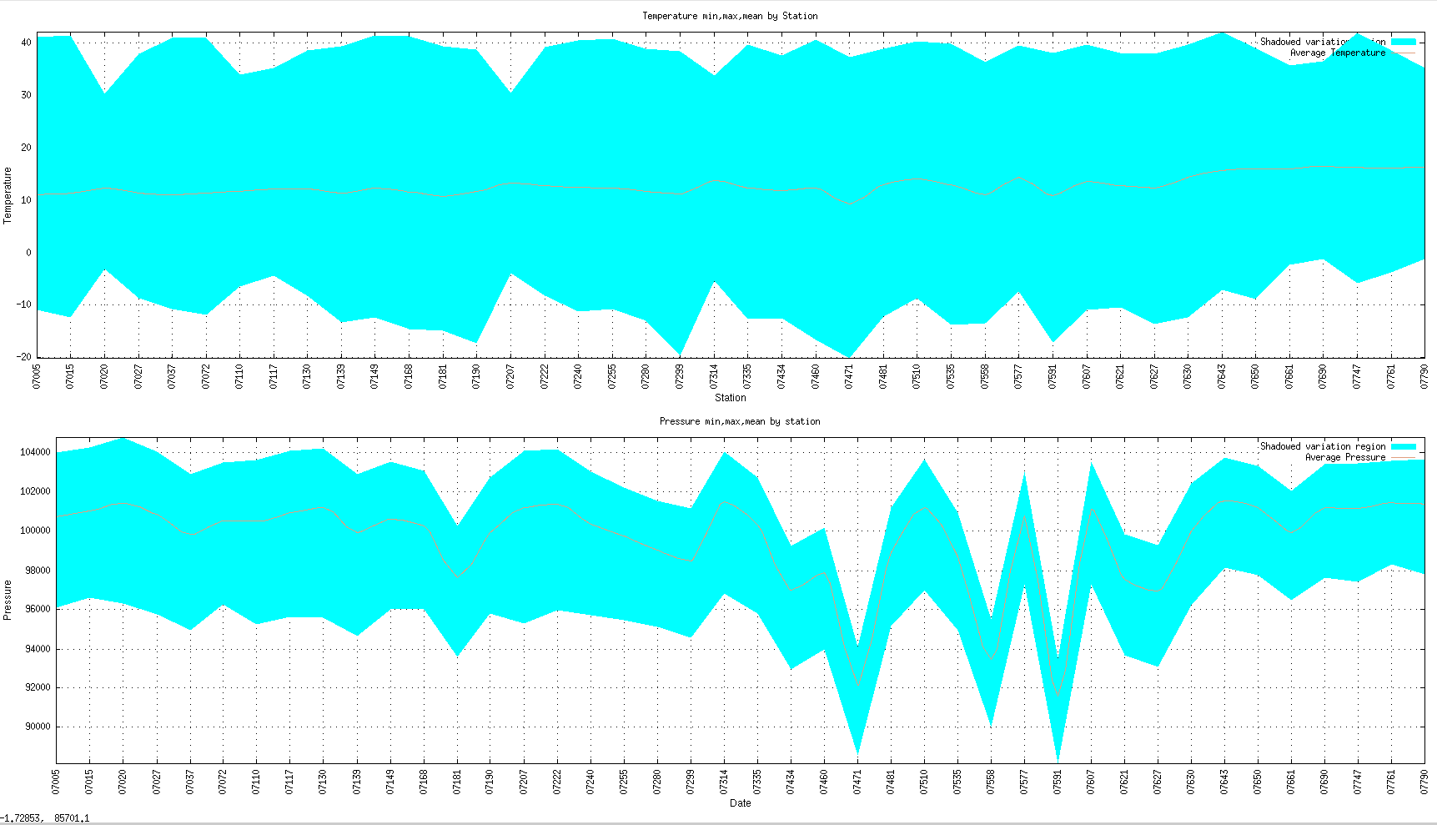

***Average temperature and pressure and variation for France between 2010 and 2020***

$ **bash meteo.sh** -t1 -p1 -f meteoall.csv -F -d 2010-01-01 2020-12-31 --multiplot

Files are in **“./sample-2010-2020-F-t1-p1”**

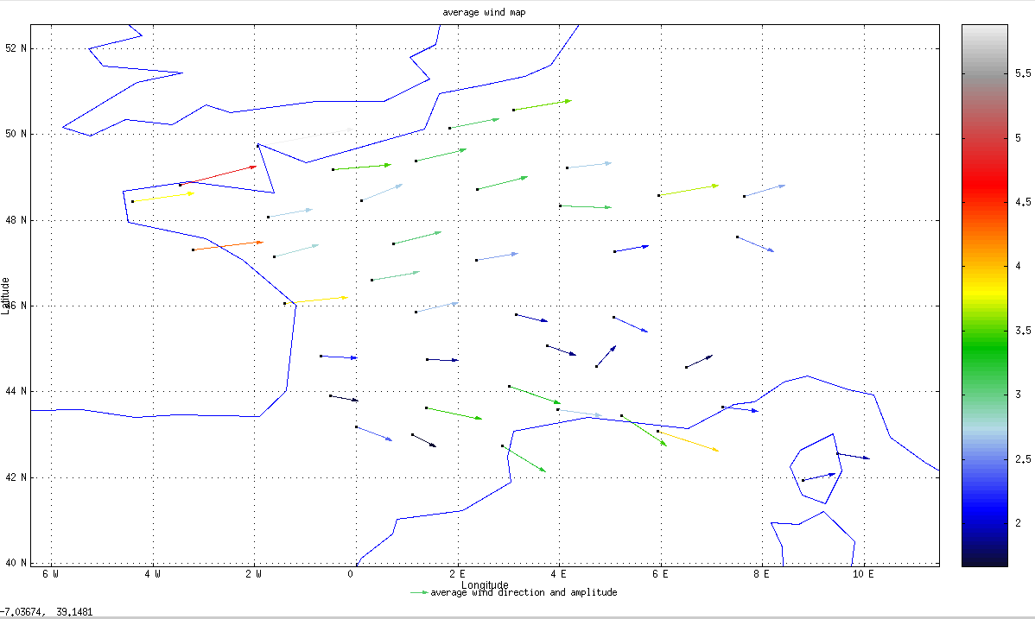

***Average wind intensity and direction in March 2020 in France***

$ **bash meteo.sh** -w -f meteoall.csv -F -d 2020-03-01 2020-04-01

Files are in **“./sample-2010-03-F-w”**

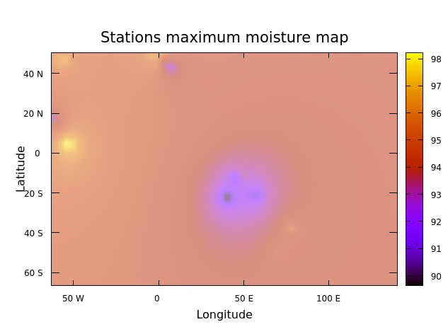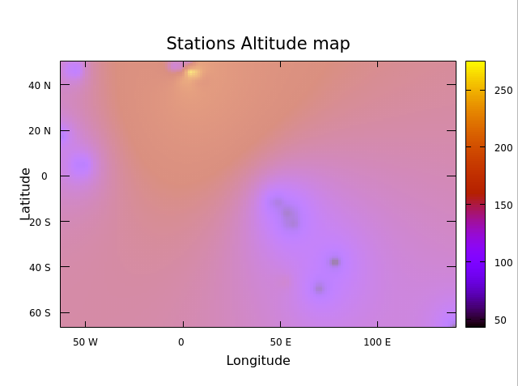

***Left : Maximum humidity first week of July 2020 all stations (sorted by TAB method)***

***Right : Altitude of all stations***

$ **bash meteo.sh** –w -h -f meteoall.csv --tab -d 2020-07-01 2020-07-08

Files are in **“./sample-2020-07-01-w-h”**

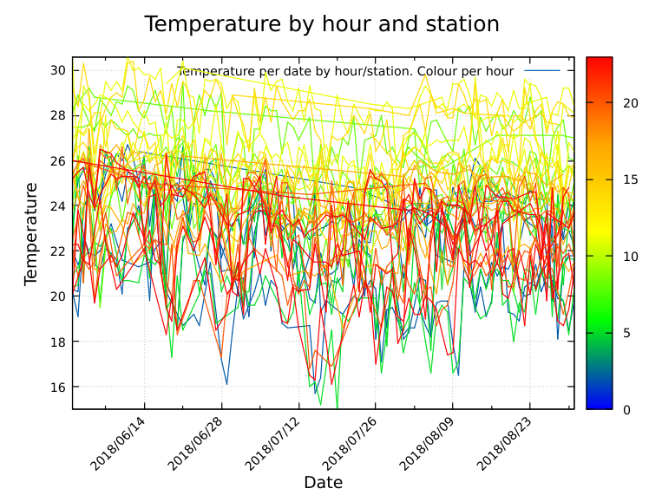

***Temperature variation in summer 2018 in Indian Ocean (color indicates the hour). Sorted by ABR***

$ **bash meteo.sh** -t3 -f meteoall.csv --abr -d 2018-06-01 2018-08-31 -O

Files are in **“./sample-2010-03-F-w”**

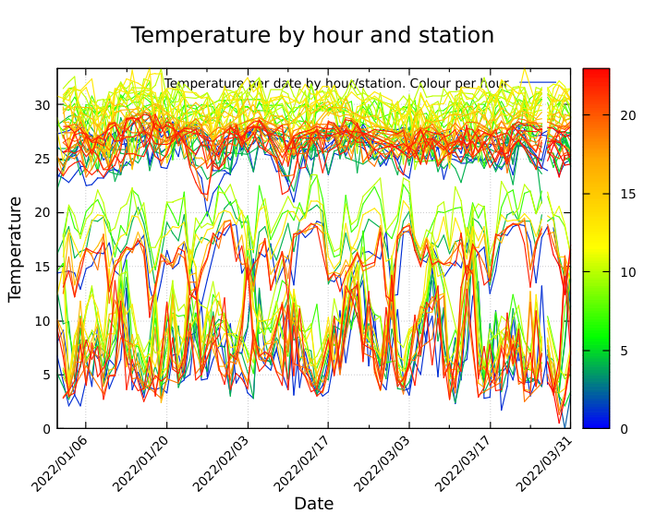

***Temperature variation Q1-17 in the frame of longitude [30 : 100] and latitude [-60 : 0]***

$ **bash meteo.sh** -t3 -f meteoall.csv -d 2022-01-01 2022-03-31 -g 30 100 -a -60 0

Files are in **“./sample-2017-Q1-g-a-t3”**

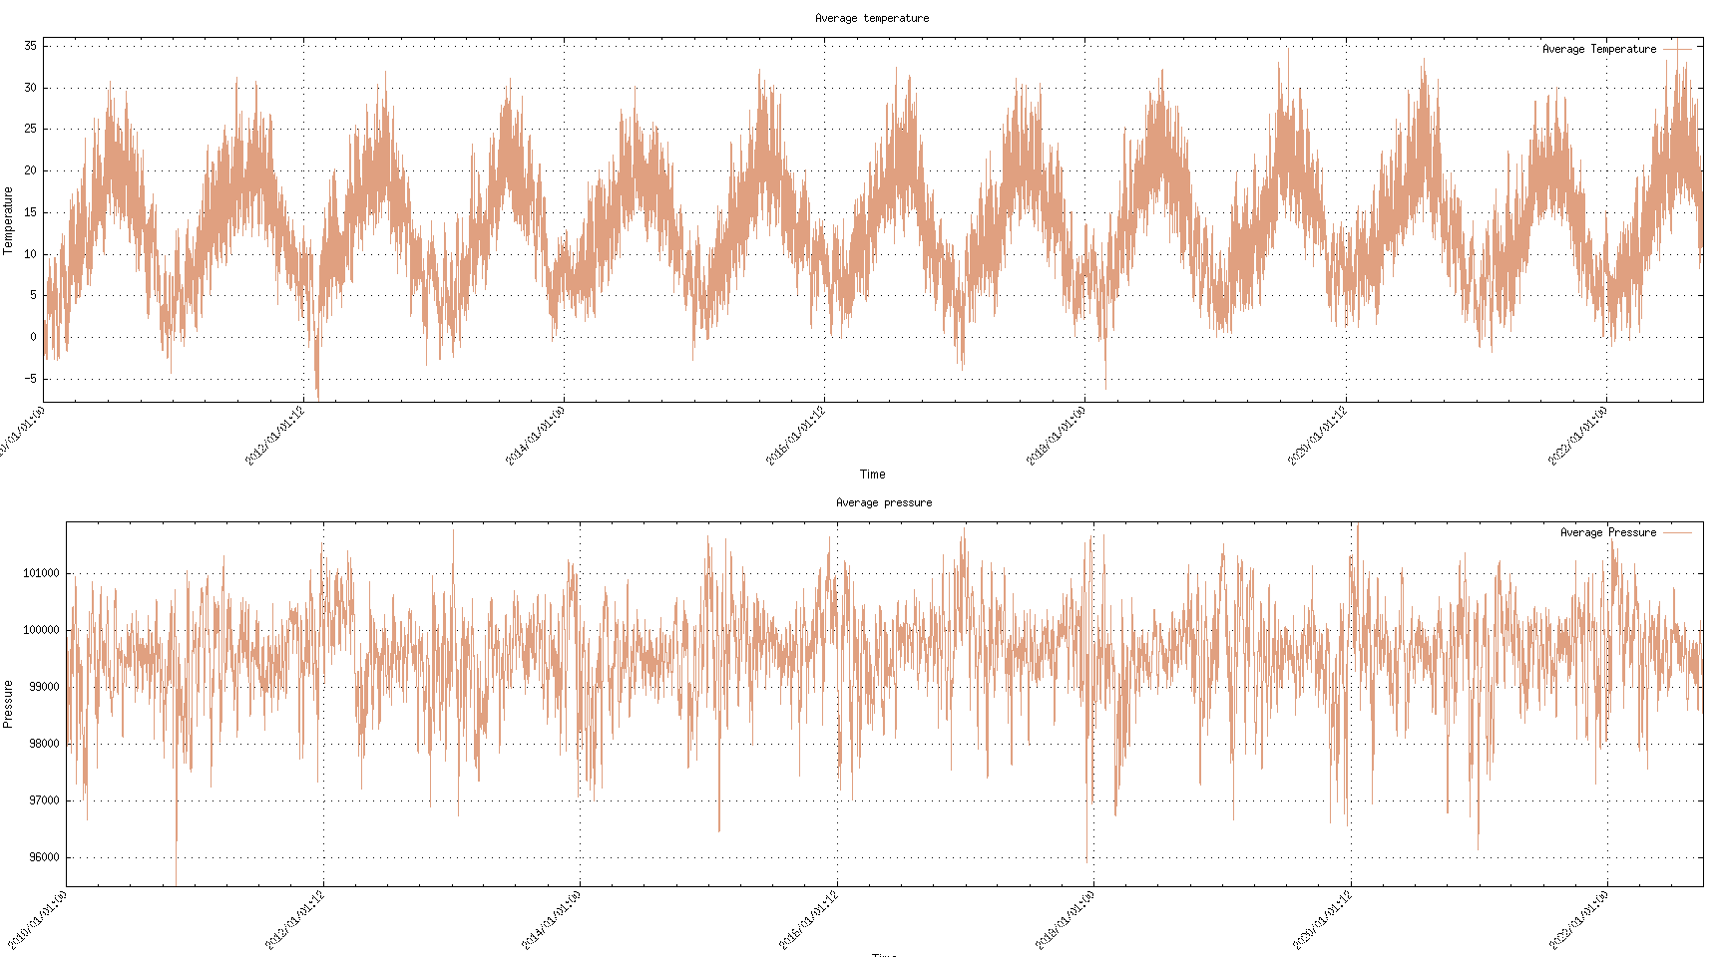

***Temperature & Pressure variation over 12 years in France***

*We can clearly notice the increasing trend year after year (Climate change ?!)*

$ **bash meteo.sh** -t2 -p2 -f meteoall.csv -d -F --multiplot

Files are in **“./sample-F-t1-p1”**

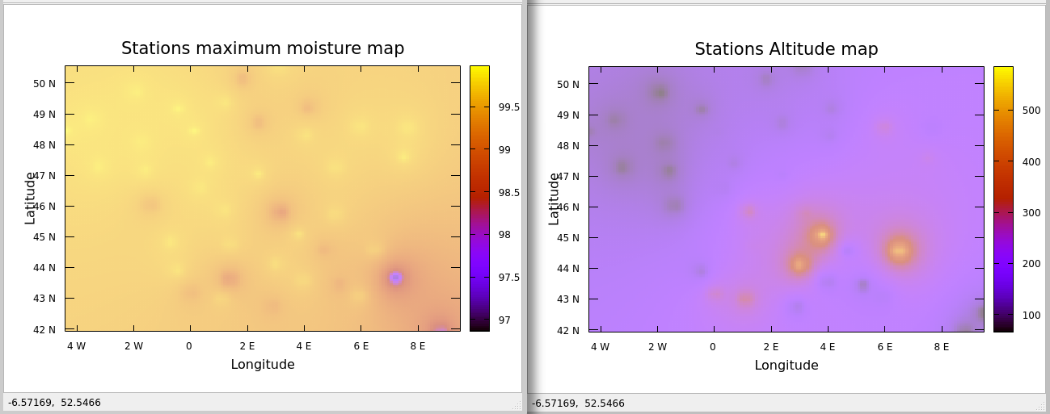

***Max humidity in France in 2018 (Right: Reminder of the stations altitude)***

$ **bash meteo.sh** -m -h -f meteoall.csv -F -d 2018-01-01 2018-12-31

Files are in **“./sample-2018-F-m-h”**

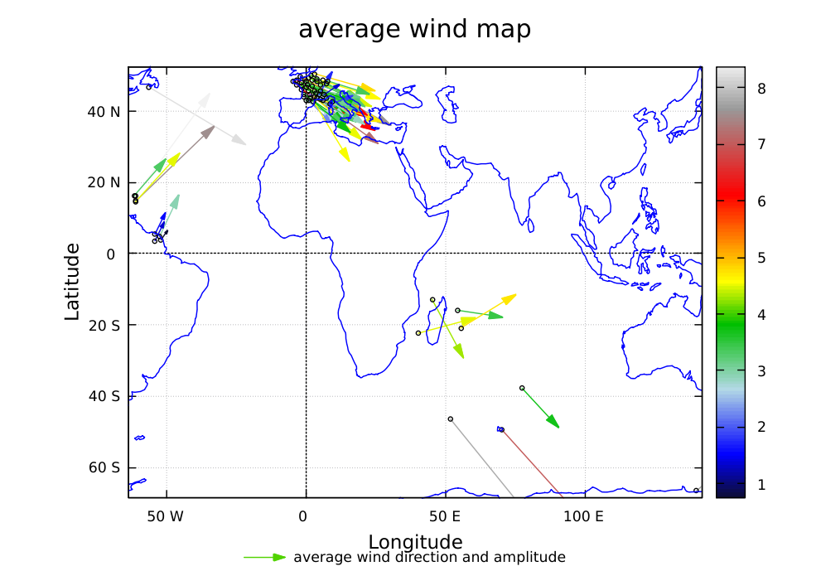

***Average wind intensity and direction in January 2018 in all french stations***

$ **bash meteo.sh** -w -f meteoall.csv -d 2018-01-01 2018-01-31

Files are in **“./sample-2018-01--w”**

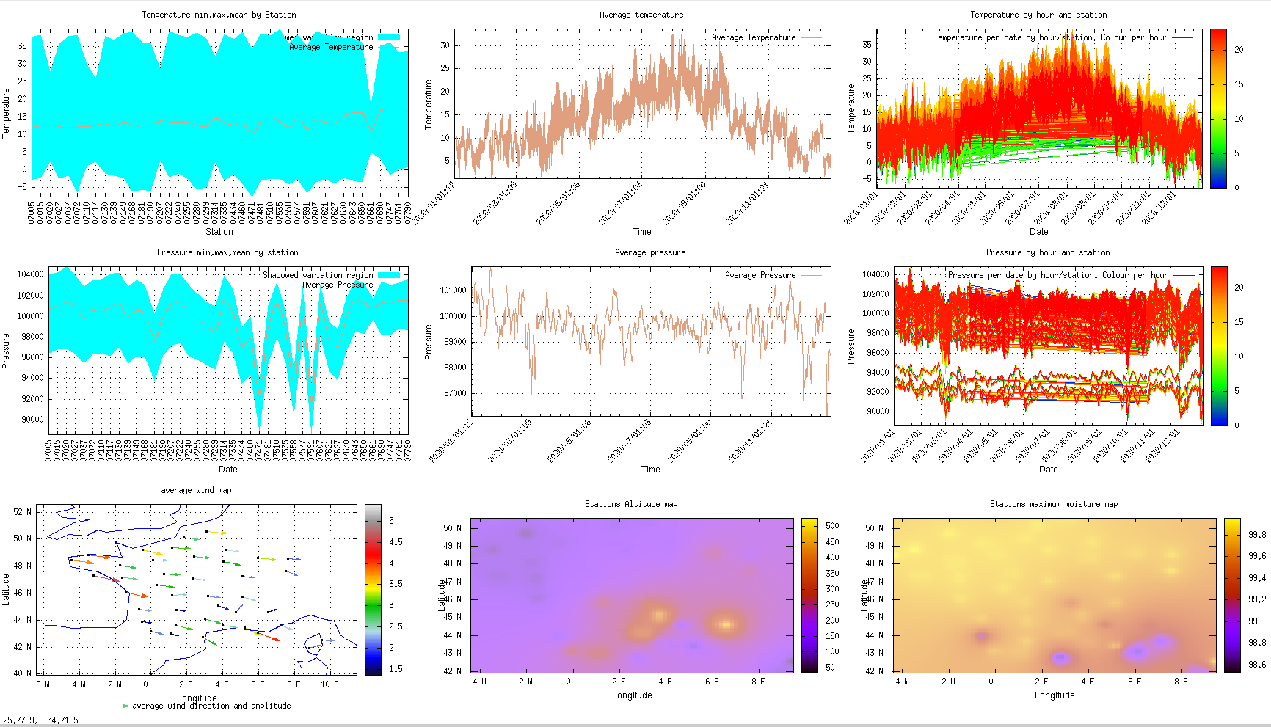

***Dashboard for France for 2020***

$ **bash meteo.sh** -t1 -t2 -t3 -p1 -p2 -p3 -w -h -m -f meteoall.csv -F -d 2020-01-01 2020-12-31 --multiplot

Files are in **“./sample-2020-F-dashboard”**