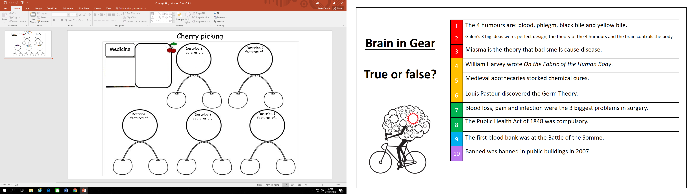

Feature 2 …………………………………………………………………………………………………………….

…………………………………………………………………………………………………………………………………

…………………………………………………………………………………………………………………………………

.....................................................................................................................................

Feature 1………………………………………………………………………………………………………………

…………………………………………………………………………………………………………………………………

…………………………………………………………………………………………………………………………………

.....................................................................................................................................

Feature 2 ……………………………………………………………………………………………………………..

…………………………………………………………………………………………………………………………………

…………………………………………………………………………………………………………………………………

.....................................................................................................................................

Feature 1……………………………………………………………………………………………………………….

…………………………………………………………………………………………………………………………………

…………………………………………………………………………………………………………………………………

.....................................................................................................................................

Diagnosis in the 20th century.

Hospitals in the 19th century.