Curriculum Vitae
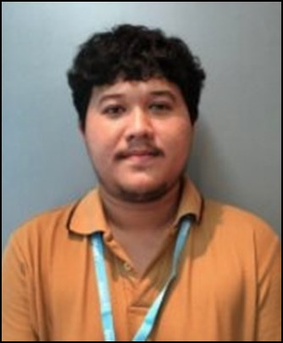
First name: Natthakorn Last name: Nakhaseno
Nickname: Tron Birthday: 6 Nov 1992 Nationality: Thai
E-mail: tron.natthakorn@engineer.com Mobile: (+66)XX-XXX-XXXX
Online CV: https://torlondev.js.org/cv
GitHub: TronNatthakorn DockerHub: TronNatthakorn
Address: Wireless Rd. Pathumwan Bangkok 10330.
_____________________________________________________________
History Work
- Mar 2019 - Jun 2021: Luma Health Insurance. (2 years 4 months)
Roles: Full Stack Developer & Android Developer & IT Support.
Works: Linux / Docker / PHP / Laravel / NodeJS / Java / MySQL / MongoDB
- Mar 2017 - Jul 2018: Scale360. (1 year 4 months)
Roles: Mobile & Web Developer.
Works: React / React-Native / Redux / JQuery
- Feb 2016 - May 2016: Infiniti Global Investor. (4 months)
Roles: Laravel Developer & Head IT Support.
Works: Laravel / JQuery
- May 2014 - Feb 2015: True Corporation. (9 months)
Roles: Trainee Programmer.
Works: PHP / MySQL
_____________________________________________________________
Dream Work: Work with understanding together for at least 3-5 years++ and more like be family.
Hobby: Play with dog. / Make merit.
Salary Expected: Up to company. (Latest more than 30K THB.)

