AI Usage DISCLOSURE FORM

1. Team Details
Team Name: ______LobsterClaw_________
Project / Product Name: ______LobsterClaw______________
Organization / Institution (if any): ___RVCE_________________
Submission Date: _______________8/5/2026________

2. AI Usage Declaration
Did your team use any Artificial Intelligence (AI) in developing this project? Yes / No
______________Yes_________________

3. Purpose of AI Usage ( Brief Details)
Idea generation / brainstorming _______Slide content, pitch narrative___________
Code generation or assistance Android app, Kotlin, backend
UI / UX design Screen layouts, component structure
Content creation README, SKILL files, documentation
Data analysis ___Not Used
Testing / debugging __Error diagnosis, fix suggestions
Other _____OpenClaw skill prompts

4. Feature Origin Classification ( Please add/delete based on the number of the feature)
Feature 1
- Name: Recipe generation feed
- Origin: Both
- Description: Claude (claude.ai) used to design prompt structure and OpenRouter API integration. Output was the HomeViewModel logic and recipe JSON schema. Manually integrated into Kotlin codebase.
Feature 2
- Name: Grocery price comparison
- Origin: Both
- Description: Claude used to write OpenClaw SKILL-grocery.md and OpenClawClient.kt. Prompts designed to search Blinkit, Zepto, Instamart via SearXNG. Output reviewed and wired manually into app.
Feature 3
- Name: Onboarding taste profile
- Origin: Both
- Description: Claude assisted with flow design and ViewModel logic. UI screens written with AI suggestions, manually adjusted for layout and state handling.
Feature 4
- Name: Pitch deck content
- Origin: AI-Generated
- Description: Claude (claude.ai) used to generate all slide content including problem statement, differentiation, and use cases based on project context provided by team.
Feature 5
- Name: Project documentation
- Origin: AI-Generated
- Description: Claude generated README, SETUP.md, and skill documentation. Team provided project context and reviewed output for accuracy.

5. Ethical & Compliance Confirmation
AI usage complies with guidelines and policies. Yes
No proprietary or copyrighted data misused. I Agree

6. Declaration & Sign-Off
Name of Team Representative: Ajay Girish
Role: Team Member/Representative
Signature: 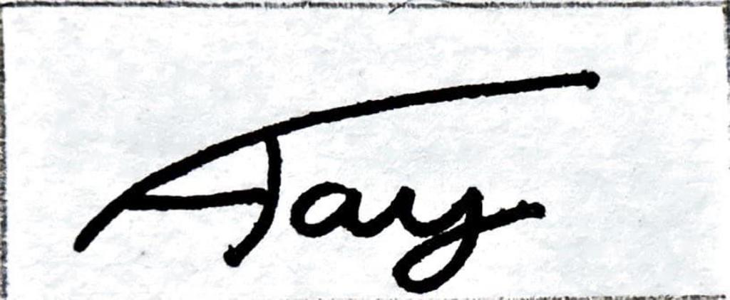

Date: 08/05/2026

