23.11.2025

T.C.
AKDENIZ UNIVERSITY



EDUCATION DEPARTMENT REPORT

GÖKÇE KARACA
20250805032

2025

ANTALYA

What Is an Embedded System?

An embedded system devices are small computer systems designed to perform a specific task or set of tasks. It typically consists of a combination of hardware and software components that work together to provide a particular function or service.

Embedded systems are ubiquitous, found in consumer electronics like smartphones and smartwatches, industrial control systems, medical devices, and automotive systems. These systems are integral to the operation of many modern technologies, providing the necessary control and processing capabilities. [1]

What Are the Top Embedded Programming Languages?
Embedded programming languages are critical to modern software development. As the name suggests, developers use them in embedded systems, so the languages need to have low-level access to the hardware for the devices in question. Also, since embedded systems are generally real time, the programming languages need to be able to support this characteristic.

There are several well-known programming languages used for embedded systems.

- C
C is the go-to embedded programming language, due to its ease of use and fast compiling speeds. It’s benefits being:
- Low memory usage
- Compiled language
- Low-level access, making it a first choice for most embedded programmers
- Port embedded
- Best speed and performance
- Can easily create compilers
- Has a large ecosystem of libraries and frameworks
- Serves as the foundation for many other languages.

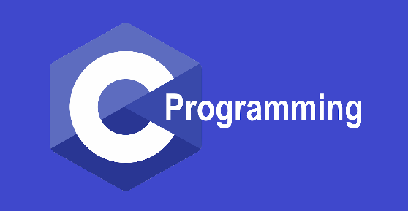
Figure 1.1: C logo

- C++
C++ is the extension of C, with even more power and speed. It appeals more to experienced developers due to its resources and features. It has benefits such as:
- Accesses low-level system resources
- Has a streamlined memory stack
- Programming paradigm is object oriented
- Inline functions replace macro definitions
- Safer and more secure than C
- Efficient and versatile due to native constructor and destructor features
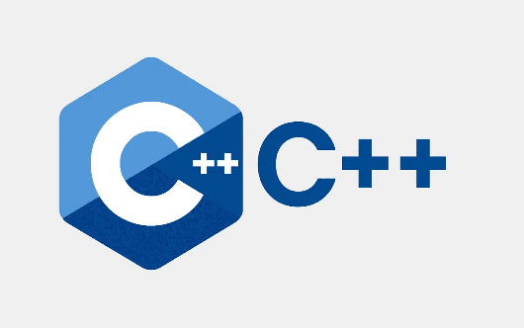
Figure 1.2: C++ logo

- Python
Python is popular due to its easy-to-read code. It is a good language to use for both general and specific projects. It’s benefits are:
- An interpreted language
- Open source and available for free
- Can quickly write embedded system programs
- Popular in work with data analytics, ML, and AI
- Easily reads, writes, and executes code
- Supports short development periods with simple prototyping
- Best used for networking systems
- Can build real-time data-processing systems

Figure 1.3: Python logo

- Java
Java was built and expanded off C++. It supports virtualization. It’s benefits being:
- Considered the general-purpose language of internet applications
- Easy to use to write, transport, and download embedded system applications
- Provides developers with tools and powerful libraries
- Enables isolating part of the application from the rest of the code
- Functional even with older hardware. [2]

Figure 1.4: Java logo

What is Linux?
Linux is an open source operating system (OS) based on Unix. It runs on computers, servers, mobile phones and a wide range of other devices.

Since its invention in 1991, it has become 1 of the most widely used operating systems in the world, providing a free alternative to other operating systems that are proprietary, such as Microsoft Windows and macOS.

Linux was developed by Linus Torvalds to be a Unix-like alternative to Unix, 1 of the first operating systems ever built. It relies heavily on the Linux kernel for its functionality. In an OS, the kernel is a computer program that allows users to control the system's hardware and software. In addition to the kernel, the Linux OS uses various components, such as system libraries and space utilities, but they all rely on the kernel to communicate and receive commands from users. [3]
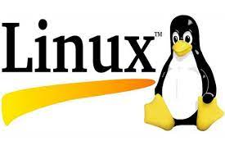
Figure 2.1: Linux logo

Why use Linux?
Linux is an OS that is so flexible that it could do anything, so versatile that it could be made into anything, so transparent that you know everything it does and so secure that the concept of an antivirus itself is irrelevant.

Each Linux machine is different. Your system belongs to you, not some multi-billion dollar corporation. When you start using Linux, you start to understand your system. You know what all files execute on startup, what processes are run when, and if something goes wrong you know what causes it, this power of truly knowing your system is so much underrated.

The amount of customization opportunities in Linux is unparalleled. You could easily make two of the same systems unintelligible within minutes. The levels at which you have the power to change anything is astounding. And above all, it is completely free. [4]

What is Ubuntu?
Ubuntu is a free and open-source operating system that is accessible on a variety of devices. Whether it is a smartphone or server, Ubuntu is compatible with them. The source code is freely available for users to modify and access. Ubuntu has a vast community that assists the web developers 24/7.

Ubuntu Linux is basically a Linux distro like CentOS, Debian, and Fedora. It has a user-friendly nature, and its different versions have popular usages in desktop, server and core.

Ubuntu is a Linux distribution, a complete operating system built on top of the Linux kernel. It includes a user interface, desktop environment, pre-installed applications, and package management tools, providing a user-friendly experience for interacting with the underlying Linux kernel.

Ubuntu’s Advantages
Whether it is Python, C++, Ruby, Java, or more, Ubuntu has pre-configured web development tools compatible with these programming languages.

Ubuntu was never outdated, and it will never be in the future. Regular updates from Canonical ensure developers access new features, libraries, and tools for their development projects. It streamlines the workflow smoothly and efficiently, letting you focus and write awesome codes.

Ubuntu is a popular Linux distro due to several factors, such as a friendly, free, and open-source system, security, and scalability features. Because of these robust qualities, many web developers are using the Ubuntu operating system on their servers. [5]

Figure 3.1: Ubuntu logo

What is Arch Linux?
Arch Linux is an open-source and free Linux distribution that offers exceptional customizability and control over your system. One of the major reasons for its growing popularity in the technical community is its lightweight and minimalistic nature.

This x86-64-centric Linux distribution adheres to the “Keep It Simple, Stupid” (KISS) principle. As the name indicates, Arch supports making the OS a new starting point that leaves each decision to the user. You will not find any major distribution-centric modifications in Arch, making the seamless transition from different Linux distributions possible.

As a newcomer, getting started with Arch Linux is quite challenging. Arch Linux makes no presumptions and provides no predetermined choices during installation. It is an outstanding feature for a professional Linux user, as it opens up new opportunities for customization.

Inherently, Arch Linux is immensely technical, making it a perfect Linux distribution for users who can thoroughly use it. Professionals and experienced users get the most out of Arch Linux, provided its Do It Yourself (DIY) nature.

A professional user can personalize Arch Linux as per their requirements and reap the benefits from the active Arch Linux community. Pacman and AUR are the distinguishing features that you’ll find only in Arch Linux and other Arch-based Linux distributions. [6]

What are Microcontrollers?
Essentially, a microcontroller is a small computer on a single chip, containing a processor core (or cores), operational memory (RAM) and electrically erasable programmable read-only memory for program memory. Optimized to function as standalone units, microcontroller integrations improve real-time signal processing and make these compact units ideal for controlling specific tasks or duties within embedded systems.

Lightweight, small and requiring comparatively low power, microcontrollers are ideal for battery-operated electronic devices like smartphones, smartwatches and other wearables. They are also a favorite among hobbyists. Consumer-grade programmable microcontrollers, such as those made by Arduino or the Raspberry Pi, can be easily configured in programming languages like C, C++ and Python, commonly used across Windows, Linux and MacOS operating systems. While accessible to even beginner developers, microcontrollers are also frequently applied in a wide range of professional and industrial use cases, including industrial automation, transportation safety systems and prototyping. [7]

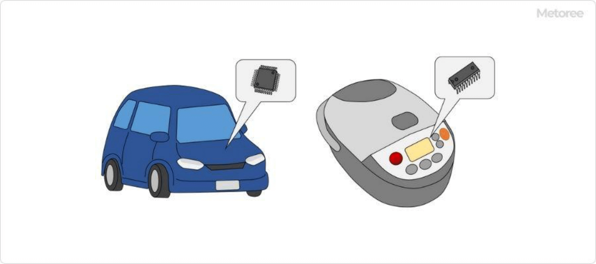
Figure 4.1: Microcontroller uses

Microcontrollers are used in familiar products such as automobiles and home appliances, including rice cookers. Here are some examples of other home appliances in which microcontrollers are used.
- Refrigerators
- Washing machines
- Microwave ovens
- Cordless vacuum cleaners and robot vacuum cleaners
- Hair dryers
- Thermometers
- Lighting devices
- TV remote controls
In addition to home appliances, microcontrollers are also used in microcomputer meters that measure household electricity and gas usage, and in game consoles like the Switch. Microcomputers are installed in a wide variety of electrical appliances around us. [8]

Types of Microcontrollers
There are many different types of microcontrollers available in the market, with varied architectures, performance levels, and feature sets. Some common microcontroller architectures are:
- 8-bit microcontrollers: These microcontrollers have 8-bit CPUs and are typically used in low-end applications that do not require a lot of processing power. They are often less expensive than other types of microcontrollers and are commonly used in consumer products, such as appliances, toys, and other devices.

- 16-bit microcontrollers: These microcontrollers have 16-bit CPUs and are more powerful than 8-bit microcontrollers. They are commonly used in industrial and automotive applications, as well as in consumer products that require more processing power.

- 32-bit microcontrollers: These microcontrollers have 32-bit CPUs and are among the most powerful types of microcontrollers. They are often used in high-end applications that require a lot of processing power, such as in medical equipment, military systems, and other demanding applications. [9]
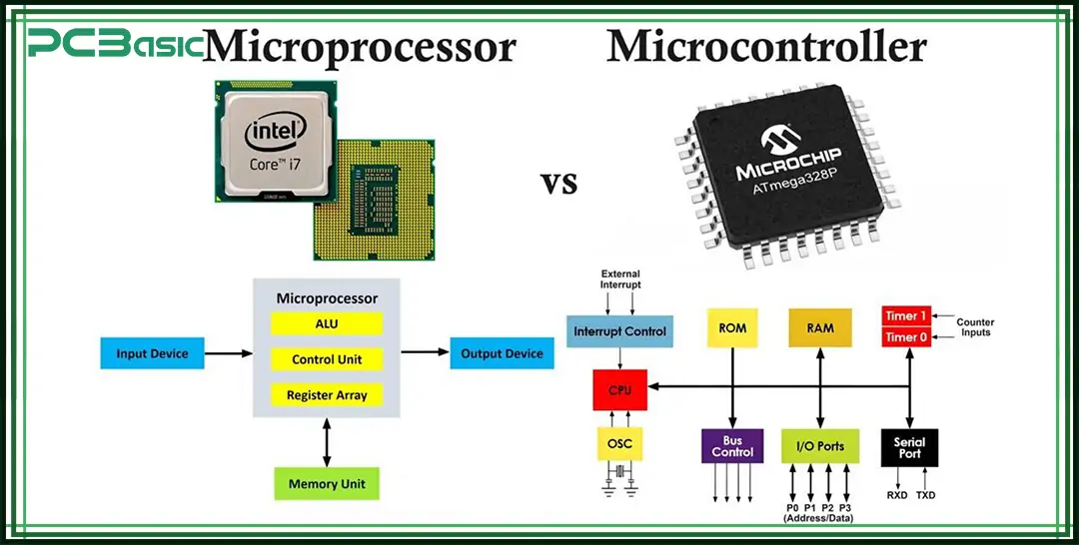
Figure 4.2: Microprocessor vs. Microcontroller

What are Microprocessors?
The microprocessor is the heart of any normal computer, whether it is a desktop machine, a server or a laptop. There are many types of microprocessors, but they all do approximately the same thing in approximately the same way.

A microprocessor — also known as a CPU or central processing unit — is a complete computation engine that is fabricated on a single chip. The first microprocessor was the Intel 4004, introduced in 1971. The 4004 was not very powerful — all it could do was add and subtract, and it could only do that 4 bits at a time. But it was amazing that everything was on one chip. Prior to the 4004, engineers built computers either from collections of chips or from discrete components ( transistors wired one at a time). The 4004 powered one of the first portable electronic calculators. [10]
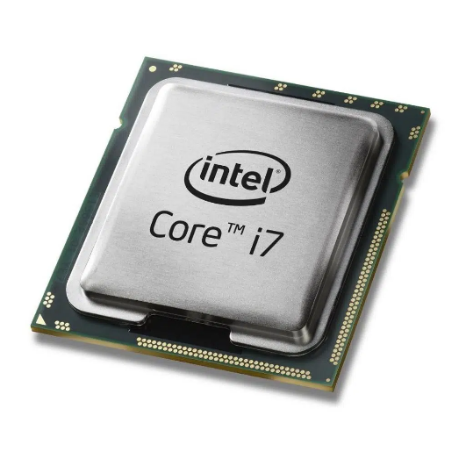
Figure 4.3: Intel CPU Core İ7 2.Gen 1155P Tray Hdvga

What Is The Difference Between Microcontrollers and Microproccessors

Microprocessor | Microcontroller
Since memory and I/O are connected externally, the circuit becomes large. | Since memory and I/O are present together, the internal circuit is small in size.
It cannot be used in compact systems. | It can be used in compact systems.
Complex and expensive due to a large number of instructions to process. | Simple and inexpensive due to less number of instructions to process.
It is not suitable for devices that run on stored power since total power consumption is high due to external components. | It can be used on devices that use stored power since total power consumption is low due to less external components.
RAM, ROM, I/O units, and other peripherals are not embedded on a single chip. | RAM, ROM, CPU and other peripherals are embedded on a single chip.
Do not have power saving mode. | Have a power-saving mode.
Used in personal computers. | Used in embedded systems.
Less number of registers. | More number of registers.
Uses an external bus. | Uses an internal controlling bus.
Based on the Von Neumann model. | Based on the Harvard architecture.
It is a central processing unit on a single silicon-based integrated chip. | It is a byproduct of the development of microprocessors with a CPU along with other peripherals.
Can run at a very high speed. | Can run up to 200MHz or more.

[11].
Advantages Of Arduinos
One of the main reasons for Arduino being so accessible and affordable across the globe is because all of the Arduino hardware is open source. Being open-source has a plethora of advantages- anyone can access the design and build of the device and make improvements; anyone can use the same hardware design to create their product lineup. Since Arduino is open source, it has its own devoted community that strives to help the core company develop and improve its hardware products. Another significant advantage of being open source, especially in the case of hardware, is that local companies can create replicas of the products, making it more accessible and affordable to the local consumers as it avoids hefty customs and shipping charges. All of these advantages contribute to Arduino being so widespread, affordable and ever improving.
It is necessary to know that Arduino doesn't necessarily offer just one piece of hardware, it provides a range of boards, each of which caters to a different level of expertise and have different use-cases altogether. Arduino Uno is one of the most basic and popular boards that Arduino offers. This is because it features an ATMega328 microcontroller that is both cheap and powerful enough for most basic beginner-level projects.

Understanding Arduinos
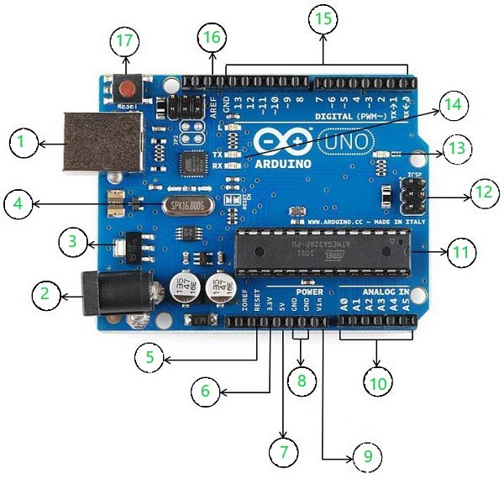
Figure 5.1: Hardware of an Arduino
- USB: Can be used for both power and communication with the IDE.

- Barrel Jack: Used for power supply

- Voltage Regulator: Regulates and stabilizes the input and output voltages

- Crystal Oscillator: Keeps track of time and regulates processor frequency

- Reset Pin: Can be used to reset the Arduino Uno

- 3.3V pin: Can be used as a 3.3V output

- 5V pin: Can be used as a 5V output

- GND pin: Can be used to ground the circuit

- Vin pin: Can be used to supply power to the board

- Analog pins(A0-A5): Can be used to read analog signals to the board

- Microcontroller(ATMega328): The processing and logical unit of the board

- ICSP pin: A programming header on the board also called SPI

- Power indicator LED: Indicates the power status of the board

- RX and TX LEDs: Receive (RX) and transmit (TX) LEDs, blink when sending or receiving serial data respectively

- Digital I/O pins: 14 pins capable of reading and outputting digital signals; 6 of these pins are also capable of PWM

- AREF pins: Can be used to set an external reference voltage as the upper limit for the analog pins

- Reset button: Can be used to reset the board. [12]

What Can We Do with Arduinos?
The Arduino boards can work as a stand-alone project and can be interfaced with other Arduino boards or Raspberry Pi boards.
- Weighing Machines
- Traffic Light Count Down Timer
- Parking Lot Counter
- Embedded systems
- Home Automation
- Industrial Automation
- Medical Instrument
- Emergency Light for Railways. [13]

Microcontroller Manufacturers
- Microchip Technology
Microchip Technology Incorporated is an American publicly traded semiconductor corporation that manufactures microcontroller, mixed-signal, analog, and Flash-IP integrated circuits.

Its corporate headquarters is located in Chandler, Arizona. Its wafer fabs are located in Gresham, Oregon, and Colorado Springs, Colorado. The company's assembly/test facilities are in Chachoengsao, Thailand, and Calamba and Cabuyao, Philippines.

Microchip Technology offers support and resources to educators, researchers and students in an effort to increase awareness and knowledge of embedded applications. [14]

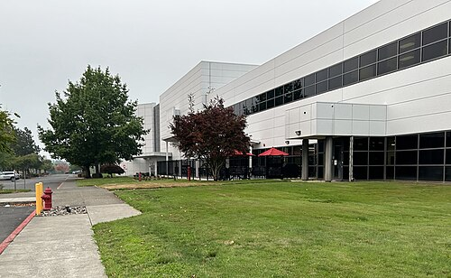
Figure 6.1: Microchip Technology Incorporated

- Intel
Intel Corporation is an American multinational technology company headquartered in Santa Clara, California. It designs, manufactures, and sells computer components such as central processing units (CPUs) and related products for business and consumer markets. Intel was the world's third-largest semiconductor chip manufacturer by revenue in 2024[3] and has been included in the Fortune 500 list of the largest United States corporations by revenue since 2007. It was one of the first companies listed on Nasdaq. Since 2025, Intel is partially owned by the United States government.

Intel supplies microprocessors for most manufacturers of computer systems, and is one of the developers of the x86 series of instruction sets found in most personal computers (PCs). It also manufactures chipsets, network interface controllers, flash memory, graphics processing units (GPUs), field-programmable gate arrays (FPGAs), and other devices related to communications and computing. Intel has a strong presence in the high-performance general-purpose and gaming PC market with its Intel Core line of CPUs, whose high-end models are among the fastest consumer CPUs, as well as its Intel Arc series of GPUs. [15]


Figure 6.2: Intel Corporation

What are MCU Peripherals?
Microcontrollers (MCUs) are the brains behind modern electronics, controlling everything from your smart thermostat to complex industrial machinery. What makes them so powerful isn’t just their central processor—it's their peripherals built right into them that enable them to interact with the outside world. Without peripherals, a microcontroller is just a digital brain that can't sense or control anything in the real world.

Peripherals are specialized hardware components inside the microcontroller that support interaction with external systems, sensors, and devices. Think of them as "built-in hardware tools" that you configure and control using software.
They handle:

- Input/Output (e.g., reading a button press, turning on an LED)
- Communication (e.g., sending data to a GPS module or another microcontroller)
- Timing (e.g., blinking LEDs at regular intervals, controlling motor speed)
- Signal Conversion (e.g., reading analogue voltages from a temperature sensor)
- Control Logic (e.g., responding to external events). [16]
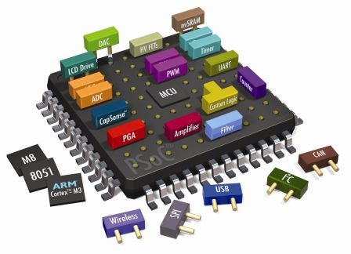
Figure 7.1: MCU Peripherals

Types of Sensors

- LM35 Temperature Sensor
The LM35 is a low-power, low-cost, high-precision temperature sensor designed and manufactured by Texas instruments. This IC provides a voltage output that is linearly proportional to the change in temperature.

It has a typical accuracy of ±0.5°C at room temperature and ±1°C over a full −55°C to +155°C temperature range. It has an operating voltage of 4V to 30V and consumes 60-uA current while it's in working state, this also makes it perfect for battery-powered applications. [17]
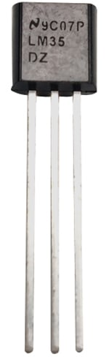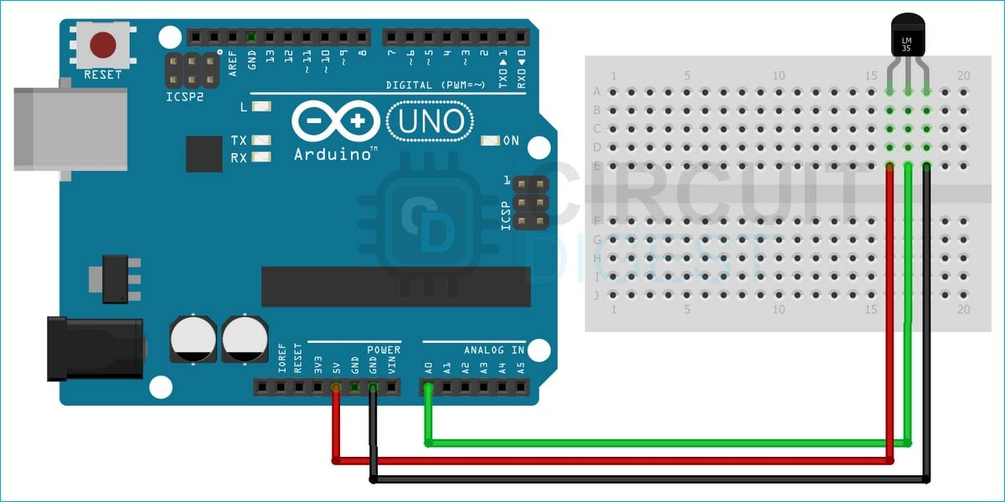
Figure 8.1: Arduino LM35 Temperature Sensor Circuit Diagram

- GL5537 LDR Sensor Photoresistor
The GL5537-1 - 5mm LDR Sensor Photoresistor Photo Cell 20-30K from Senba Sensing Technology is a photo-conductive cell (a passive component) that decreases resistance with respect to receiving luminosity (light) on the component's sensitive surface. A light-dependent resistor or Photoresistor or Photocell is made of semiconductor material and has a (variable) resistance that changes with the light intensity that falls upon it. According to this characteristic, the LDR sensor can be produced with different figures and illuminated areas. LDR sensor is widely used in many industries, such as toys, lamps, cameras, etc. [18]
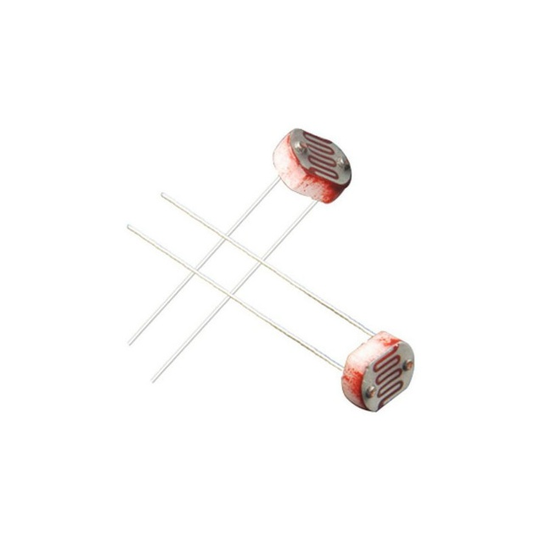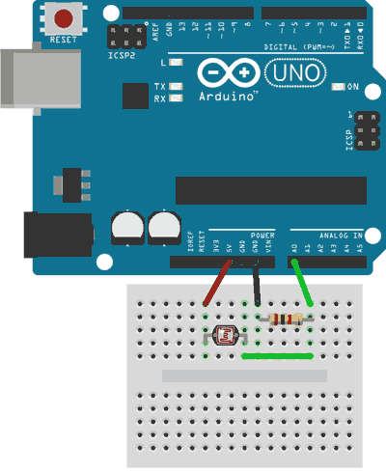
Figure 8.2: Arduino GL5537 LDR Sensor Circuit Diagram
- HC-SR04 Ultrasonic Sensor
The HC-SR04 is an affordable and easy to use distance measuring sensor which has a range from 2cm to 400cm (about an inch to 13 feet).

The sensor is composed of two ultrasonic transducers. One is transmitter which outputs ultrasonic sound pulses and the other is receiver which listens for reflected waves. It’s basically a SONAR which is used in submarines for detecting underwater objects. [19]
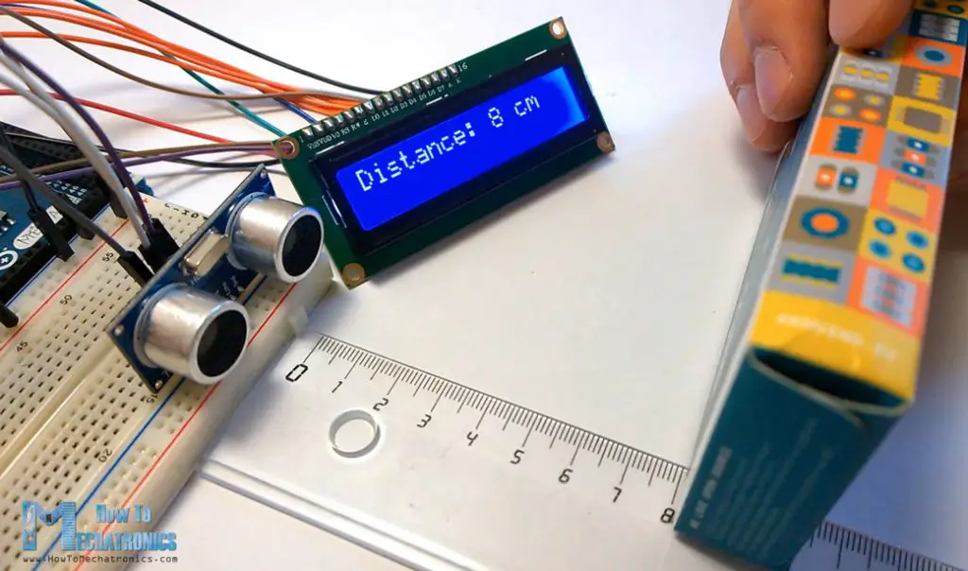
Figure 8.3: Displaying Distance with HC-SR04 Sensor
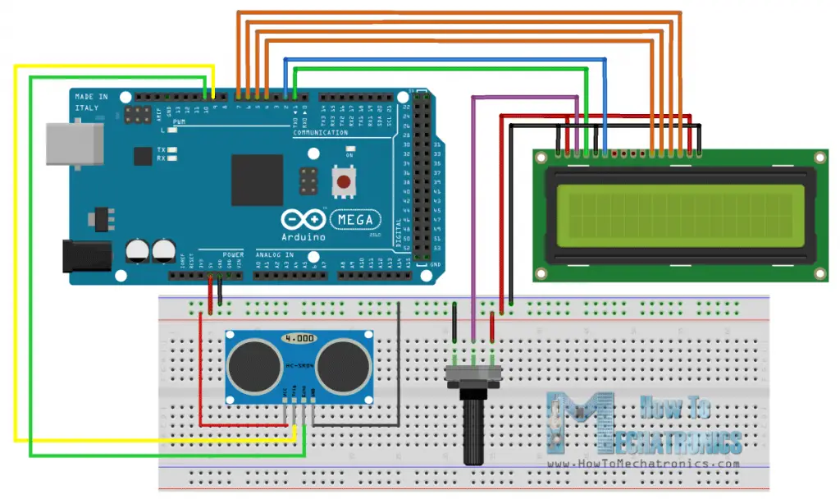
Figure 8.4: Arduino HC-SR04 Sensor Circuit Diagram

- HC SR501 Motion Detection Sensor
HC-SR501 is a low-cost PIR sensor that can detect the presence of humans or animals by sensing the Infrared Radiation coming out of the body. Its sensitivity can be controlled by sensitivity control potentiometer and it also has an onboard signal conditioning circuitry and Fresnel Lens to improve its field of view. It is used in Motion Activated lights in bathrooms, halls, rooms, etc. in alarm applications, etc. [20]
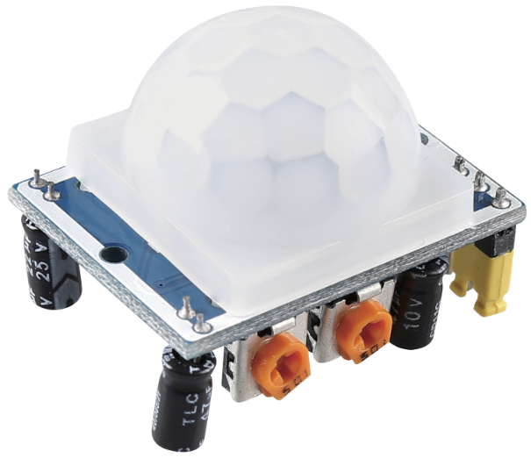
Figure 8.5: PIR Motion Module (HC-SR501)

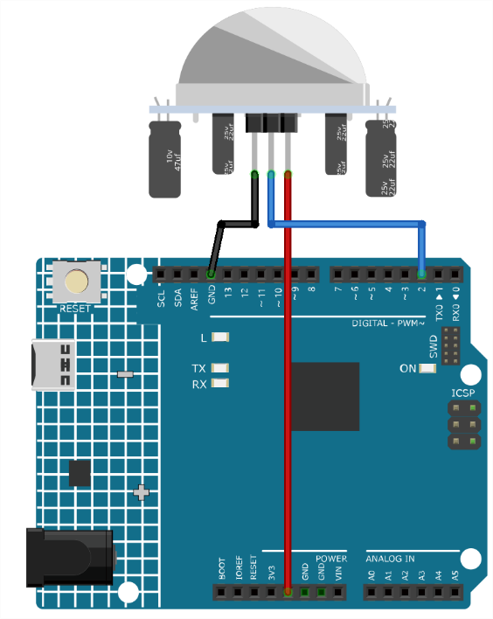
Figure 8.6: Arduino HC-SR501 Sensor Circuit Diagram

What is PCB?
A printed circuit board (PCB) is an electronic assembly that uses copper conductors to create electrical connections between components. PCBs also provide mechanical support for electronic components so that a device can be mounted in an enclosure.

All PCBs are built from alternating layers of conductive copper with layers of electrically insulating material. Conductive features on printed circuit boards include copper traces, pads, and conductive planes. The mechanical structure is made up of the insulating material laminated between the layers of conductors. The overall structure is plated and covered with a non-conductive solder mask, and silk screen is printed on top of the solder mask to provide a legend for electronic components. After these fabrication steps are completed, the bare board is sent into printed circuit board assembly, where components are soldered to the board and the PCBA can be tested. [21]
What is PCB Design?
PCB design refers to the process of planning, creating, and drafting the structure of a PCB using PCB design tools. This involves specifying how components will be laid out, designing the electrical connections, and ensuring compatibility with manufacturing processes.

The process merges creativity with precision, requiring designers to balance functionality, manufacturability, and performance; the result being compact, reliable boards that meet modern electronic demands. [22]
Steps to PCB Design:
- Schematic Design: Create a schematic diagram that represents the electrical connections between components
- Component Placement: Strategically position components for optimal performance and manufacturability
- PCB Layout Design: Translate the schematic into a physical layout considering size, shape, and interconnections
- Design Validation: Verify the design through simulations, prototypes, and testing
- Manufacturing Preparation: Generate Gerber files and other documentation for PCB fabrication. [23]

What is a Datasheet?
A datasheet is a document, printed or electronic that provides details about a product, like a computer, computer component, or software program. The datasheet includes information that helps in making a buying decision about a product by providing technical specifications about the product.

At the commercial level, it is the tool used by the importer or exporter to inform, in a standardized and simple way, the technical characteristics of their product. At the logistics level, it provides relevant information to service providers for transportation. [24]
How to Read Datasheets?
1. Summary
The first page is usually a summary of the part’s function and features. You can quickly find a description of the part's functionality, the basic specifications and sometimes a functional block diagram that shows the internal functions of the part.
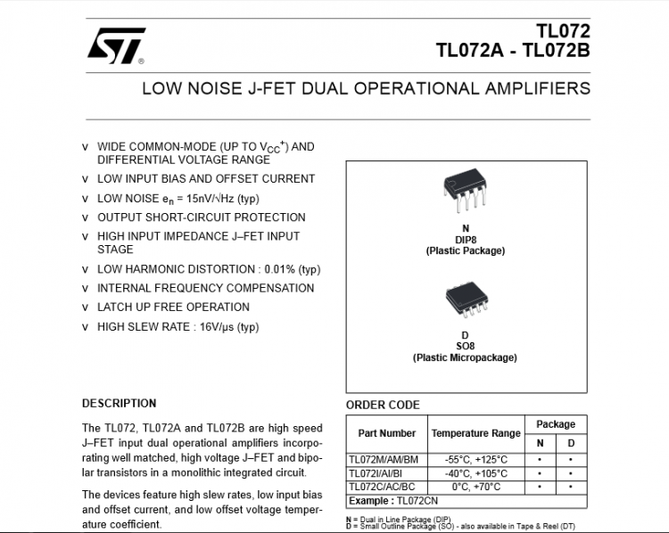
Figure 9.1: First page of a datasheet
2. Pinout
A pinout shows the part’s pins, their functions, and where they are physically located on the part for various packages the part might be available in. Note the special marks on the part for determining where pin 1 (typically a point on the package) is and how the pins are numbered. There are some acronyms here: VCC is the supply voltage (commonly 5V or 3.3V), CLK is clock, CLR is clear, OE is output enable, etc. These acronyms should be spelled out later in the datasheet.
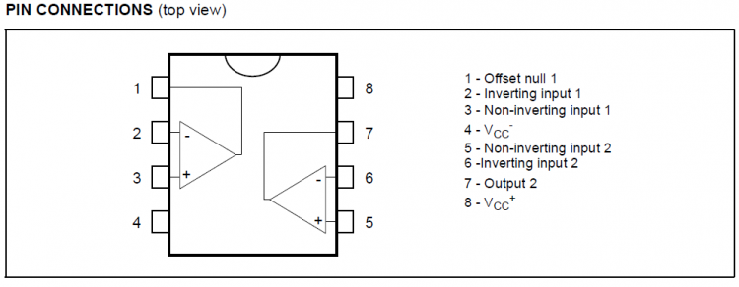
Figure 9.2: Pinout in Datasheet
3. Absolute maximum ratings
These data are detailed tables of electrical specifications. These will often list the absolute maximum ratings a part can withstand before being damaged.
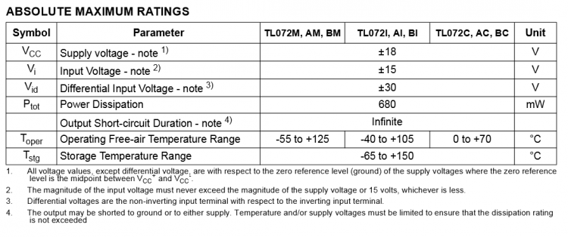
Figure 9.3: Absolute Maximum Ratings in Datasheet

4. Graphs
Some parts will have one or more graphs showing the part’s performance vs. various criteria (supply voltage, temperature, etc.).
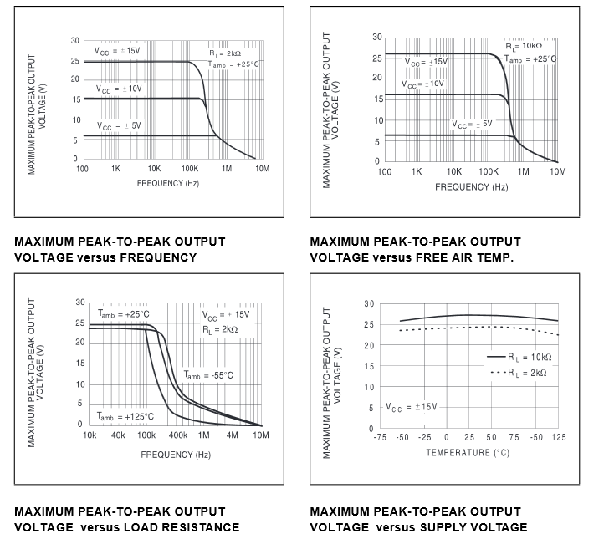

Figure 9.4: The Graphs in Datasheet

5. Truth tables
Some components may show one or more truth tables. Truth tables show how changing the inputs to a part will affect its output. Each line has all the part's inputs set to specific states, and the resulting output of the part. "H" means that input is a logical high (usually VCC), "L" means a logical low (usually GND), "X" means the chip doesn't care what the input is (could be H or L), and an arrow means that that you should change the state of that pin from L to H or H to L depending on the arrow direction. This is called "clocking" an input, and many chips rely on this for proper operation:
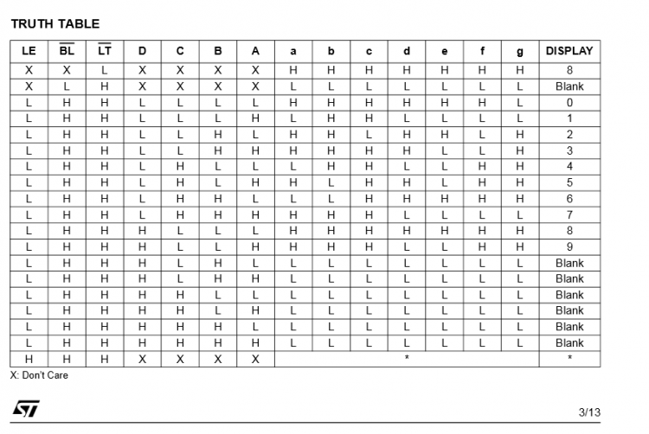

Figure 9.5: Truth Table in the Datasheet

6. Timing diagrams
Timing diagrams show how data should be sent to and received from the part, and what speed it should be sent/received. These are typically laid out with various inputs and outputs as horizontal lines, showing the logic transitions that happen to those lines over time. If the trace dips down, that's a L input or output. If the line rises higher, that's a H input our output. Timing specifications are laid out as arrows between transitions (names are referenced back to timing numbers in the electrical specs), and vertical bars or arrows will link related transitions.
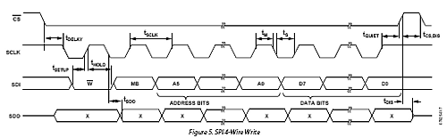
Figure 9.6: Timing Diagram in the Datasheet
7. Typical applications
Most components present this section which help you showing typical circuits where you can find the component.
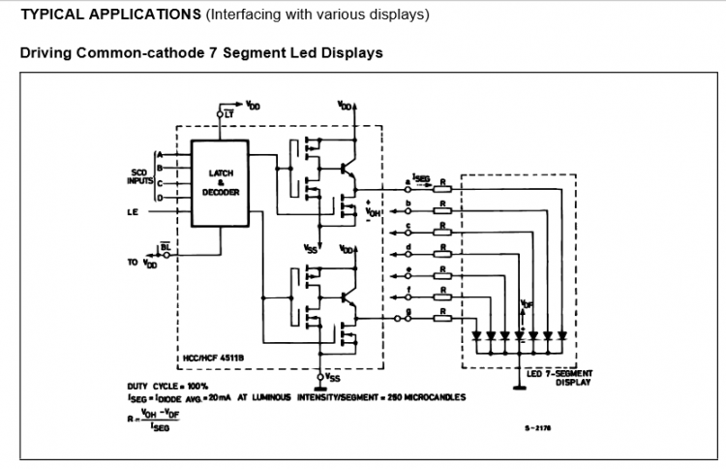
Figure 9.7: Typical Applications in the Datasheet
8. Package mechanical data
At the end of many datasheets you can find packaging information, which provides accurate dimensions of the packages a part is available in.
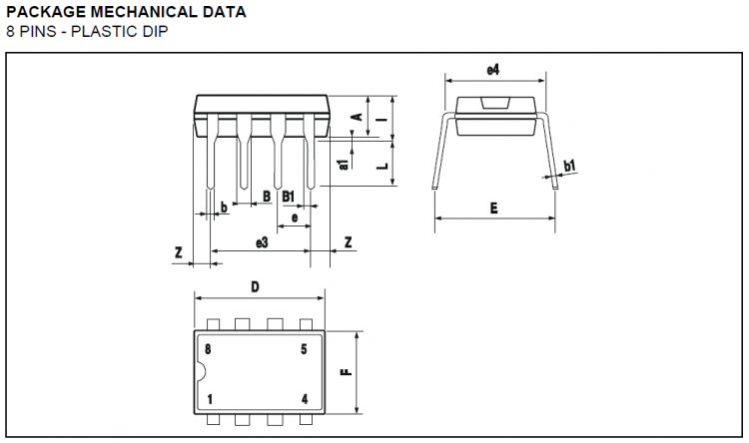
Figure 9.8: Package Mechanical Data in the Datasheet
[25].

What is ROS (Robot Operating System)?
Robot Operating System or simply ROS is a framework which is used by hundreds of Companies and techies of various fields all across the globe in the field of Robotics and Automation. It provides a painless entry point for nonprofessionals in the field of programming Robots.

ROS and underlying operating system - ROS depends on the underlying Operating System. ROS demands a lot of functionality from the operating system. On top of that ROS must be freely available to a large population, otherwise, a large population may not be able to access it. Much of the popularity of ROS is due to its open nature and easy availability to the mass population. It also needs an operating system that is open source so the operating system and ROS can be modified as per the requirements of application. Proprietary Operating Systems such as Windows 10 and Mac OS X may put certain limitations on how we can use them. This may lead to rigidity in the development process, which will not be ideal for an industry-standard like ROS. Hence, most people prefer to run ROS on Linux particularly Debian and Ubuntu since ROS has very good support with Debian based operating systems especially Ubuntu. That doesn’t mean that ROS can’t be run with Mac OS X or Windows 10 for that matter. But the support is limited and people may find themselves in a tough situation with little help from the community. There is close proximity between ROS and OS, so much so that it becomes almost necessary to know more about the operating system in order to work with ROS. Using Linux as a newbie can be a challenge, One is bound to run in issues with Linux especially when working with ROS, and a good knowledge of Linux will be helpful to avert/fix these issues.

- A Meta Operating system has a huge amount of functionality, so much that it cannot be classified as a framework or a cluster of libraries but not so much that it can be categorized as an operating system either. It provides functionalities of both Operating Systems as well as frameworks but not fully hence, it cannot be classified as either e.g, it does not provide the core functionalities that an operating system is supposed to provide but provides APIs.

- RViz is a 3D Visualization tool for ROS. It is one of the most popular tools for visualization. It takes in a topic as input and visualizes that based on the message type being published. It lets us see the environment from the perspective of the robot.

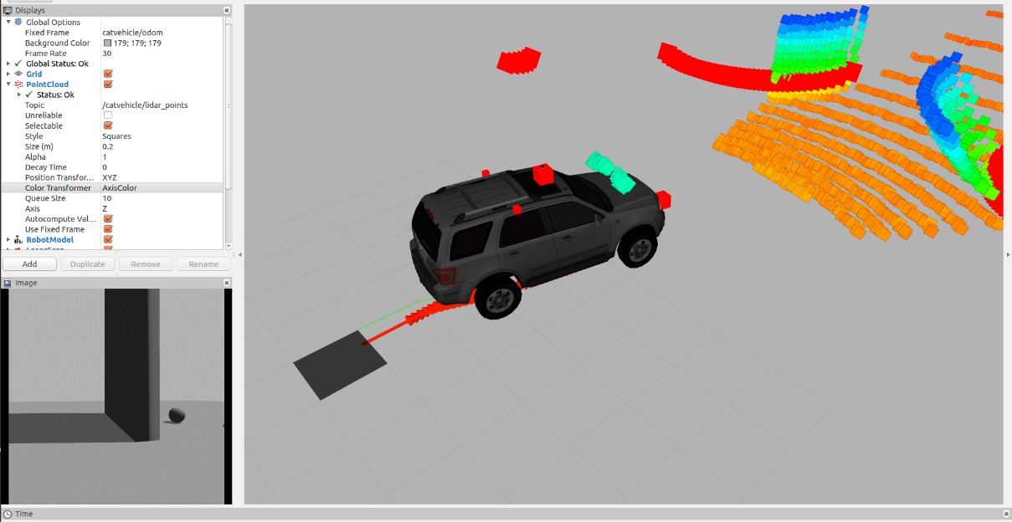
Fig.10.1: ROS Display

Once we have all the code ready and running, we need to test our code so that we can make changes if necessary. Doing this on a real robot will be costly and may lead to a wastage of time in setting up robot every time. Hence we use robotic simulations for that. The most popular simulator to work with ROS is Gazebo. It has good community support, it is open source and it is easier to deploy robots on it. [26]
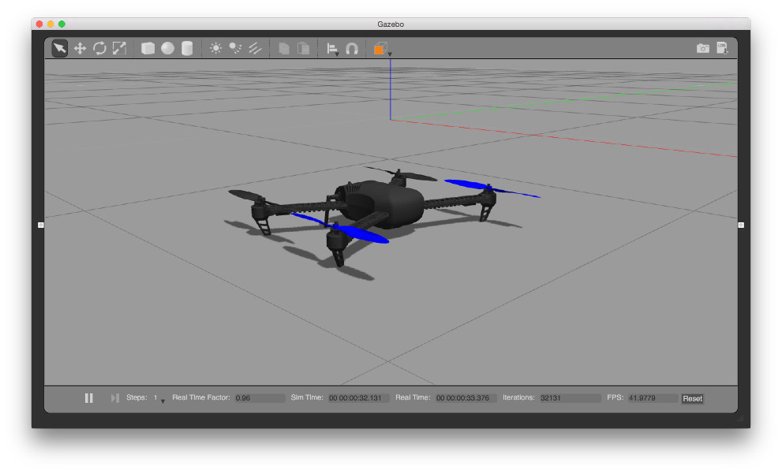
Fig.10.2: Gazebo

What is Gazebo Simulator?
Gazebo is a free, open-source robot simulation environment. The project is run by Open Robotics, the same group looking after ROS, however the projects are managed separately and Gazebo is not a "part of" ROS.

With Gazebo, we can create a virtual "world", and load simulated versions of our robots into it. Simulated sensors can detect the environment, and publish the data to the same ROS topics that real sensors would, allowing easy testing of algorithms. Then, forces can be applied to the simulated actuators on the robot, taking into account things like friction.
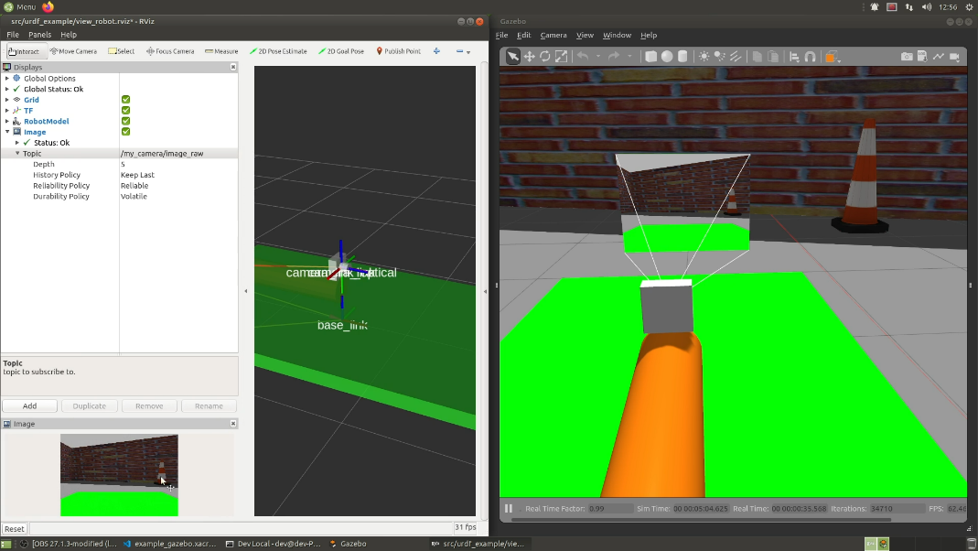
Sources:
[1] K. Malgorzata, “What are embedded IoT systems and how do they work?” Access Address: https://spyro-soft.com/blog/industry-4-0/what-are-iot-embedded-systems-and-how-do-they-work , Last Access Date: 24 February 2025

[2] “What Are the Top Embedded Programming Languages?” Access Address: https://www.windriver.com/solutions/learning/top-embedded-programming-languages#:~:text=C,use%20and%20fast%20compiling%20speeds. , Last Access Date: 2025 January

[3] F. Mesh & S. Ian , “What is Linux?” Access Address: https://www.ibm.com/think/topics/linux , Last Access Date: 2023 February

[4] N. P. Depak, “Why I use Linux and why you should too!” Access Address: https://medium.com/fossmec/why-i-use-linux-and-why-you-should-too-65f598a8cd2e , Last Access Date: 25 October 2023

[5] S. Sommaya , “What is Ubuntu? A Detailed Beginner’s Guide” Access Address: https://www.milesweb.com/blog/technology-hub/what-is-ubuntu/ , Last Access Date: 23 December 2024

[6] Z. A. Noor , “Exploring What Is Arch Linux: User Base And Unique Features” Access Address: https://www.milesweb.ae/blog/hosting/vps/what-is-arch-linux/ , Last Access Date: 17 January 2025

[7] “Microcontrollers vs. microprocessors: What’s the difference?” Access Address: https://www.ibm.com/think/topics/microcontroller-vs-microprocessor , Last Access Date: 2025

[8] “29 Microcontroller (MCU's) Manufacturers in 2025” Access Address: https://us.metoree.com/categories/5287/ , Last Access Date: 2025

[9] Ashish , “Microcontroller Basics – Applications, Working, Types, FAQs” Access Address: https://www.electronicsforu.com/technology-trends/learn-electronics/microcontroller-basics , Last Access Date: 17 September 2025

[10] B. Marshall & P. Chris , “How Microprocessors Work” , Access Address: https://computer.howstuffworks.com/microprocessor.htm , Last Access Date: 2025

[11] S. Jaya , “Difference Between Microprocessor and Microcontroller” , Access Address: https://www.shiksha.com/online-courses/articles/difference-between-microprocessor-and-microcontroller/ , Last Access Date: 9 April 2025

[12] N. Ayush , “What is Arduino?”, Access Address: https://www.geeksforgeeks.org/blogs/what-is-arduino/ , Last Access Date: 12 July 2025

[13] A. Emma , “What is Arduino UNO? Arduino UNO Pinout & Program” , Access Address: https://www.rs-online.com/designspark/what-is-arduino-uno-a-getting-started-guide , Last Access Date: 24 June 2021

[14] “Microchip Technology” , Access Address: https://en.wikipedia.org/wiki/Microchip_Technology , Last Access Date: 11 September 2025

[15] “Intel” , Access Address: https://en.wikipedia.org/wiki/Intel , Last Access Date: 19 November 2025

[16] “Microcontroller Peripherals: GPIO, Timers, ADC, UART & More” , Access Address: https://www.engineeracar.com/mcu-peripherals/ , Last Access Date: 14 June 2025

[17] D. Debashis, “How Does a LM35 Temperature Sensor Work and how to Interface it with Arduino?” , Access Address: https://circuitdigest.com/microcontroller-projects/interfacing-lm35-sensor-with-arduino , Last Access Date: 13 April 2022

[18] L. Luis “Measure light level with Arduino and LDR photoresistor (GL55)” , Access Address: https://www.luisllamas.es/en/measure-light-level-arduino-ldr-photoresistor/ , Last Access Date: 2025

[19] Dejan , “Ultrasonic Sensor HC-SR04 and Arduino – Complete Guide” , Access Address: https://howtomechatronics.com/tutorials/arduino/ultrasonic-sensor-hc-sr04/ , Last Access Date: 30 September 2025

[20] “PIR Motion Module (HC-SR501)” , Access Address: https://docs.sunfounder.com/projects/ultimate-sensor-kit/en/latest/components_basic/13-component_pir_motion.html , Last Access Date: 2025

[21] P. Zachariah , “What is a PCB and Intro to PCB Design” , Access Address: https://resources.altium.com/p/what-is-a-pcb , Last Access Date: 5 October 2020

[22] “What is PCB Design?” , Access Address: https://www.cadence.com/en_US/home/explore/what-is-pcb-design.html , Last Access Date: 2025

[23] “Basics of PCB Design” , Access Address: https://www.estcindia.com/PCBBlogs1.php#:~:text=PCB%20design%2C%20also%20known%20as,and%20manufacturability%20of%20electronic%20devices. , Last Access Date: 2025

[24] “What is a data sheet and what is it used for?”, Access Address: https://royal-courier.com/en/what-is-a-data-sheet-and-what-is-it-used-for/ , Last Access Date: 20 September 2021

[25] A. Scuola , “How to Read Datasheets” , Access Address: https://projecthub.arduino.cc/Arduino_Scuola/how-to-read-datasheets-946044 , Last Access Date: 15 June 2016

[26] K. Shashank , “Introduction to ROS (Robot Operating System)” , Access Address: https://www.geeksforgeeks.org/operating-systems/introduction-to-ros-robot-operating-system/ , Last Access Date: 14 January 2020

