AKDENİZ UNIVERSITY

TOROS SİHA

Education Research Report
___________________________________
Akdeniz University, Engineering Faculty, Electrical Electronics Engineering,
TR-07058, Konyaaltı/Antalya

Melek Naz ŞENGÜN
27.11.2025

EDUCATION DEPARTMENT REPORT

- What is Potentiometer? How does it work? In what areas it is used?
(How is it used in amplifiers, what is it used for?)
A potentiometer is a manually adjustable variable resistor with 3 terminals. Two of the terminals are connected to the opposite ends of a resistive element, and the third terminal connects to a sliding contact, called a wiper, moving over the resistive element.[1]
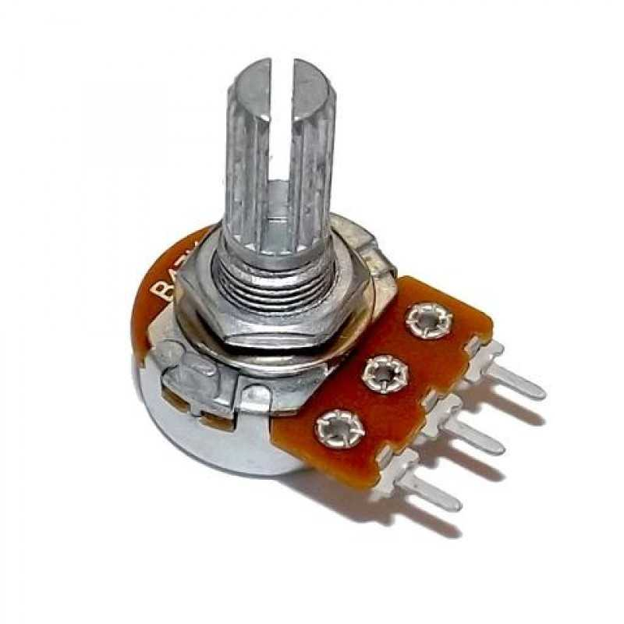
Figure 1.1: Potentiometer

Potentiometers work by picking up an input Voltage and transferring different amounts to a circuit. This amount is determined by the position of the wiper (sometimes also known as a slide) on a resistive track. This explanation briefly describes how potentiometers can be used as voltage regulators, but they can also be used to introduce different levels of resistance, to compare the electromotive force (EMF) of two cells, or to regulate the power in a circuit. In the latter case, it is a rheostat.
A typical example of a potentiometer application is the volume control on radio and stereo systems. Some still have analogue rotary potentiometers installed and despite increasing digitalisation, potentiometers are often used in electronics like these. Potentiometers may also be referred to as pots or potmeters.
Potentiometers are often used in various devices, in both industrial and consumer applications. Some common uses of potentiometers include:
•Mechanical rotary encoders for simple speed adjustment
•Comparing the EMF of a standard cell and a battery cell
•Controlling the electrical properties of various devices such as oscillators
•Volume control in audio equipment like amplifiers and radios
•Balancing or readjusting the resistance value to avoid undesirable changes [2]
Potentiometers are essential in audio equipment, where they serve to control parameters such as volume, tone, and balance. They can also function as passive volume controls, requiring no power supply to adjust the audio signal directly.[3]
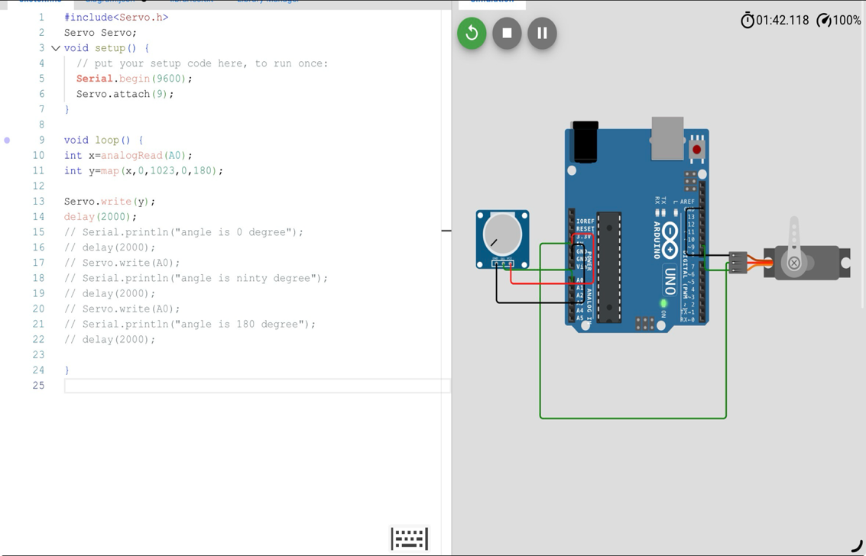
- Control the Servo Motor with a potentiometer.
Figure 2.1: Servo Motor Simulation Codes [4]
- Measure distance with HC-SR04. Connect Buzzer according to the incoming data. (Parking sensor)
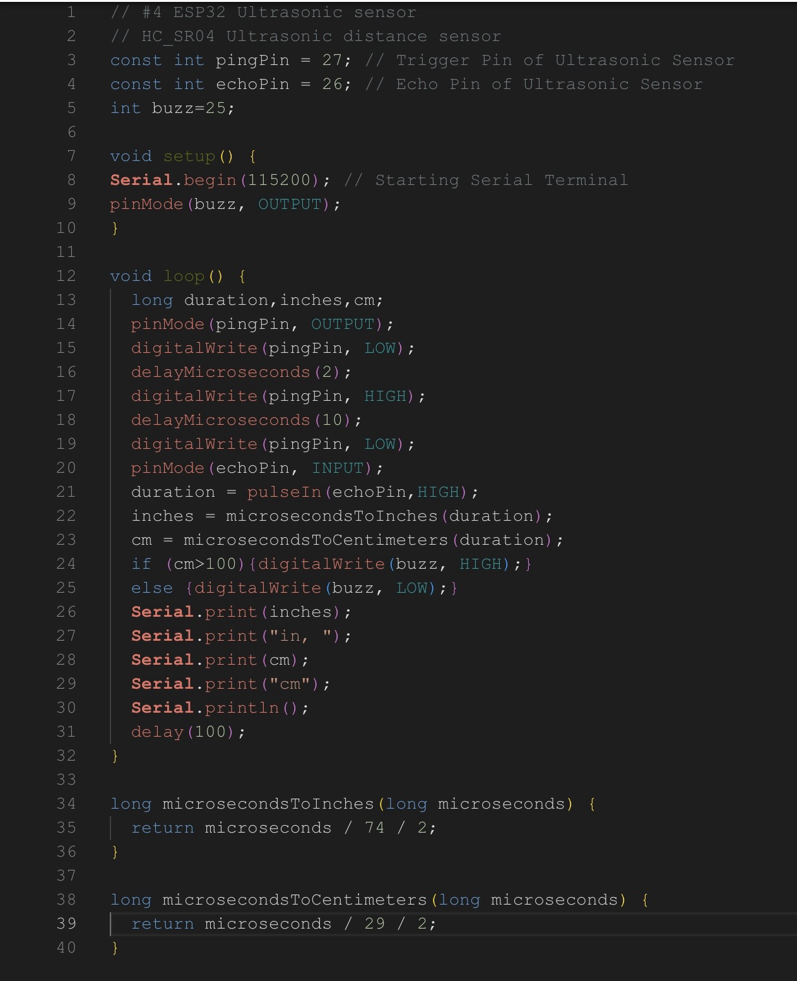
Figure 3.1: Parking Sensor Simulation Codes [5]
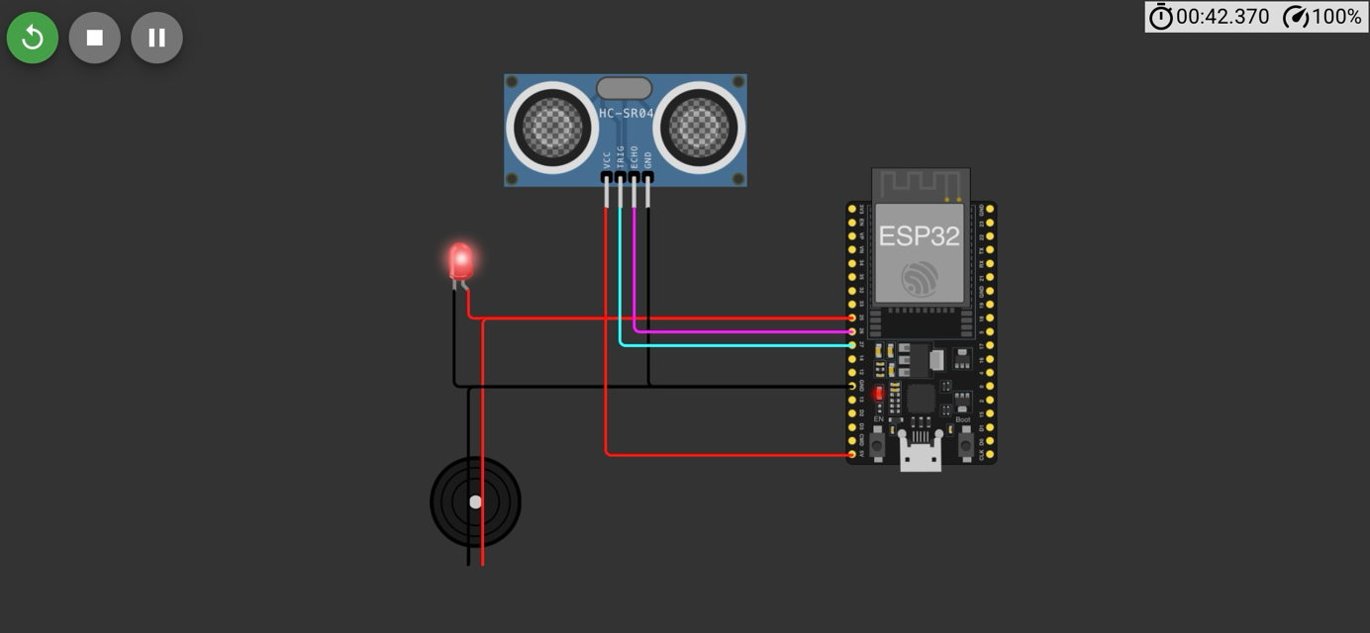
Figure 3.2: Parking Sensor

- What is the PWM signal? What applications it is used for? Why is PWM important?
Pulse width modulation (PWM) is a digital method for controlling analog power by rapdily switching a signal on and off and varying the proportion of “on-time” (duty cycle). Some applications that the PWM signal is used are:
•LED and incandescent lighting control
•Servo motor speed and angle control for robotics
•Solar panel output control
•Power supply output voltage control
•Dc motor speed control
•Heating element regulation
•Battery charging management
•Audio amplifier signal generation
•Message encoding in telecommunications
•Throttle and fuel injector control in automotive
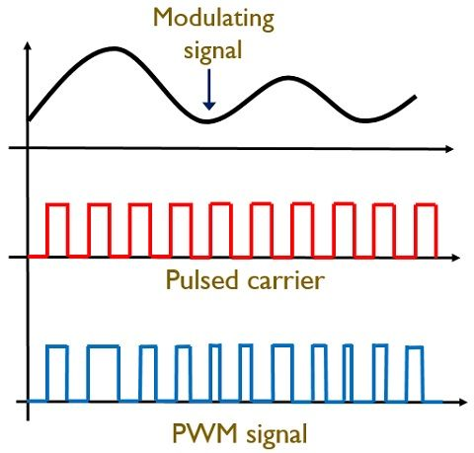
PWM is important because in electronics modulation is the process of converting data (or encoding information) into electrical signals in order to control the average power or amplitude of an electrical signal delivered to a load. This can be useful for tasks such as motor and power control, audio amplification, lighting control, and battery charging. The main advantage of pulse width modulation is high efficiency due to minimal power loss in switching devices. Since there is almost no current during the off-state, and no voltage drop across the switch while transferring power to the load during the on-state, power loss is very low.[6]
Figure 4.1: PWM signal

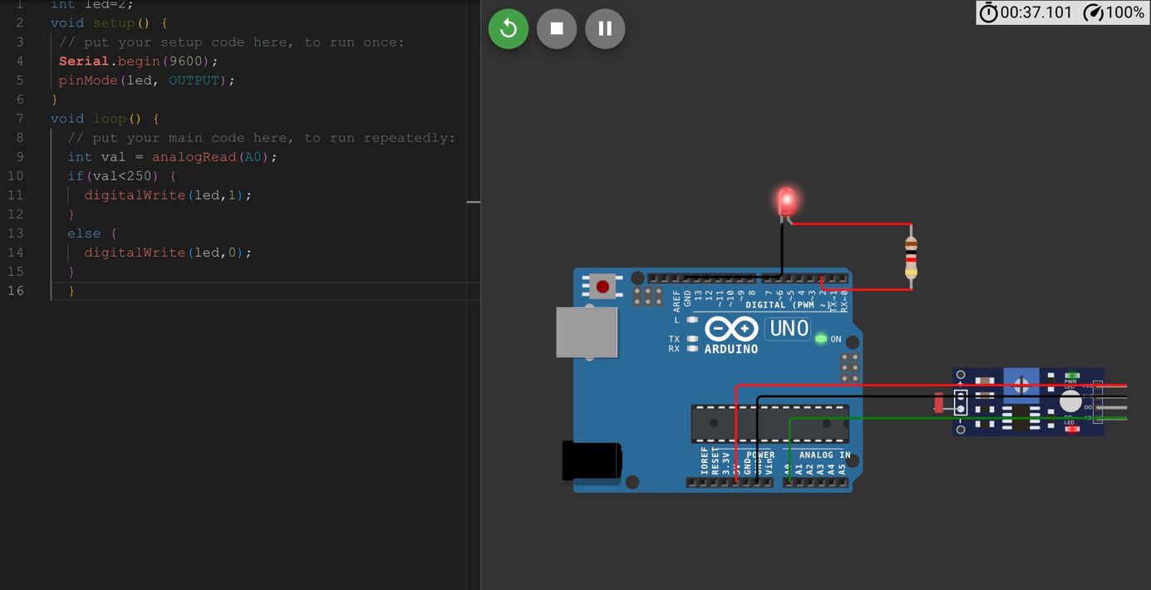
- Control LED brightness with LDR.
Figure 5.1: LED light control simulation codes [7]

- What is LIDAR, how does it work, what is it used for?
LiDAR is an active remote sensing system. An active system means that the system itself generates energy- in this case, light- to measure things on the ground.
In a LiDAR system, light is emitted from a rapidly firing laser. You can imagine light quickly strobing (or pulsing) from a laser light source. This light travels. Then the reflected light energy returns to the LiDAR sensor where it is recorded.
A LiDAR system measures the time it takes for emitted light to travel to the ground and back, called the two-way travel time. That time is used to calculate distance traveled. Distance traveled is then converted to elevation. These measurements are made using the key components of a lidar system including a GPS that identifies the X, Y, Z location of the light energy and an Inertial Measurement Unit (IMU) that provides the orientation of the plane in the sky (roll, pitch, and yaw).[8]

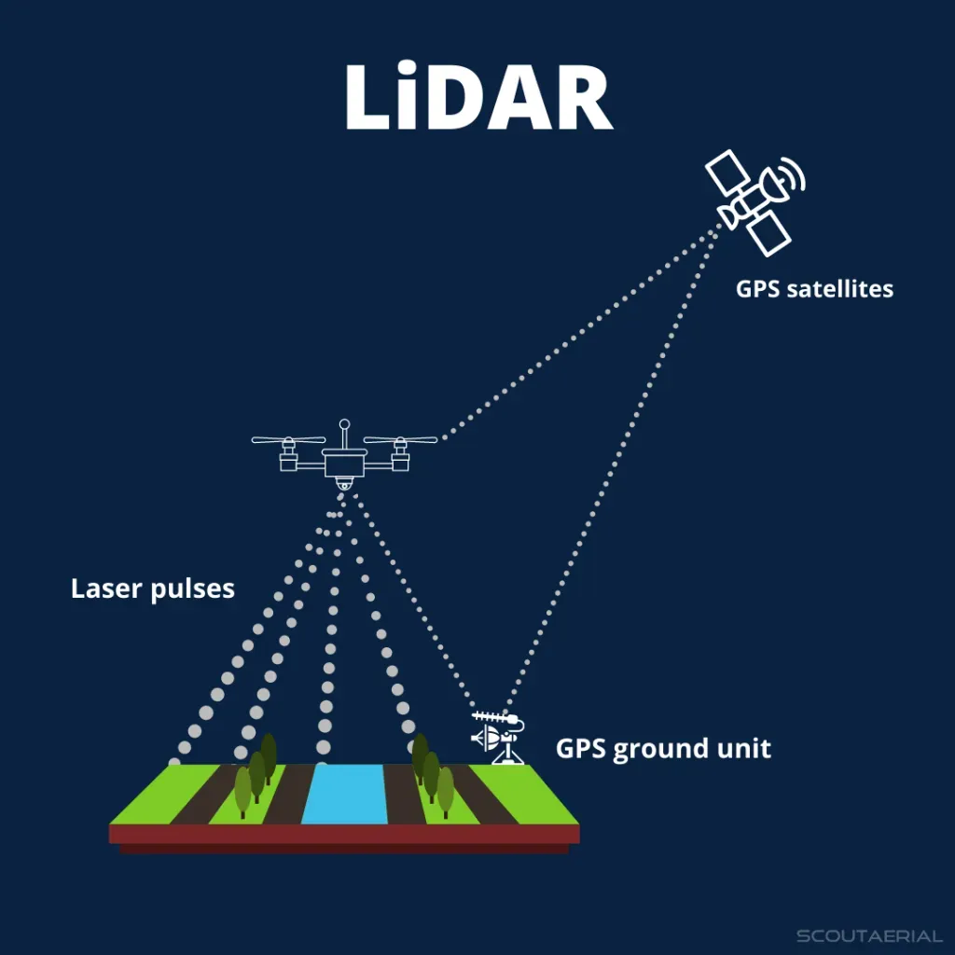
Figure 6.1: LIDAR

Some of the applications of LIDAR are:
•Aerospace and defense
LiDAR is used for terrain mapping, target tracking, mine hunting and imaging through clouds, and mission planning using sophisticated battlefield visualizations even in dense urban environments.
•Aviation
LiDAR can be used for accurate measurements of wind speed, and is also used by airports to track aircraft and foreign object debris (FOD).
•Manufacturing
LiDAR technology can be used to create 3D models of objects for use in manufacturing. It can also be used for quality control to detect anomalies and defects.
•Mapping
LiDAR is used to create digital elevation models and map roads, bridges and other geographic and infrastructure features.
•Weather forecasting
LiDAR sensors are used to measure temperature, cloud cover, wind velocity, air density and other atmospheric parameters, and provide vital data for weather forecasting models.[9]

RESOURCES:
[1] EEPOWER “Potentiometer” Access Addresse:
https://eepower.com/resistor-guide/resistor-types/potentiometer/#:~:text=A%20potentiometer%20is%20a%20manually,moving%20over%20the%20resistive%20element.
[2] RS “A Complete Guide to Potentiometers” Access Addresse:
https://uk.rs-online.com/web/content/discovery/ideas-and-advice/potentiometers-guide published: 17 Jan 2023
[3] ASCENDO “Potentiometer (Pot)” Access Addresse:
https://www.aia-cinema.com/index.php/glossary/potentiometer-pot#:~:text=The%20potentiometer%20consists%20of%20a,signal%20strength%20or%20control%20function.
[4] https://wokwi.com/projects/448606467406636033
[5] https://wokwi.com/projects/448657964639071233
[6] G. Nick “Pulse Width Modulation (PWM): How it Works and Why it’s Essential in Electronics” Access Addresse:
https://www.sameskydevices.com/blog/pulse-width-modulation-pwm-how-it-works-and-why-its-essential-in-electronics#what-is-pulse-width-modulation-
[7] https://wokwi.com/projects/448747566119535617
[8] Leah A. Wasser “The Basics of LiDAR- Light Detection and Ranging- Remote Sensing” Access Addresse:
https://www.neonscience.org/resources/learning-hub/tutorials/lidar-basics#:~:text=LiDAR%20is%20an%20active%20remote,from%20a%20laser%20light%20source. Last Updated: Sep 13, 2024
[9] IBM “What is LIDAR?” Access Addresse:
https://www.ibm.com/think/topics/lidar#:~:text=LiDAR%20is%20used%20to%20create,other%20geographic%20and%20infrastructure%20features.&text=LiDAR%20can%20be%20used%20to%20scan%20through%20the%20forest%20canopy,to%20utilities%20and%20other%20infrastructure.

