28.11.2025

T.C.
AKDENIZ UNIVERSITY



EDUCATION DEPARTMENT REPORT 2

GÖKÇE KARACA
20250805032

2025

ANTALYA

What Is A Potentiometer?

Potentiometers are adjustable resistors used in circuits for many things, such as to control the volume of an amplifier, control the brightness of a light, and much more.

It is like the resistor. But while the resistance value of a resistor stays the same, you can adjust the resistance value of a potentiometer. A potentiometer is also commonly known as a potmeter or pot.

A potentiometer has three pins and the schematic symbol looks like this:
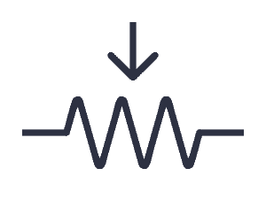
Figure 1.1: potentiometer symbol

Two of the terminals are connected to the opposite ends of a resistive element, and the third terminal connects to a sliding contact, called a wiper, moving over the resistive element. The potentiometer essentially functions as a variable resistance divider. The resistive element can be seen as two resistors in series (the total potentiometer resistance), where the wiper position determines the resistance ratio of the first resistor to the second resistor. If a reference voltage is applied across the end terminals, the position of the wiper determines the output voltage of the potentiometer. [1]
Rotary Potentiometer
This is the most common type. It has a shaft that can be turned, and the resistance changes as you turn the shaft. It’s often used for adjusting the volume on guitar pedals, audio amplifiers, and other audio equipment.
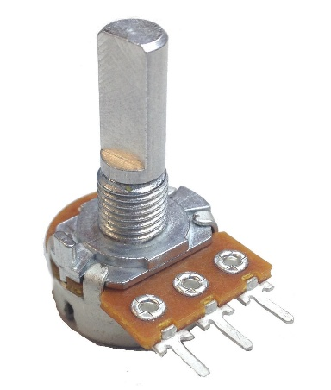
Figure 1.2: Rotary Potentiometer
This type of potentiometer can be found with values that change linearly or exponentially. The exponential version of the pot is usually used for adjusting audio volume.
Dual or Stereo Potentiometer
This is the same as the rotary potentiometer, just that it contains two potentiometers operated by a single shaft. This makes it possible to control two channels at the same time, such as the left and right channels of a stereo system.
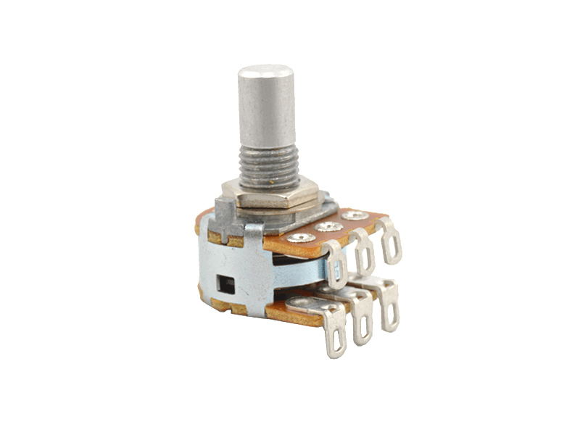
Figure 1.3: Dual Potentiometer
Using Potentiometer As A Volume Controller
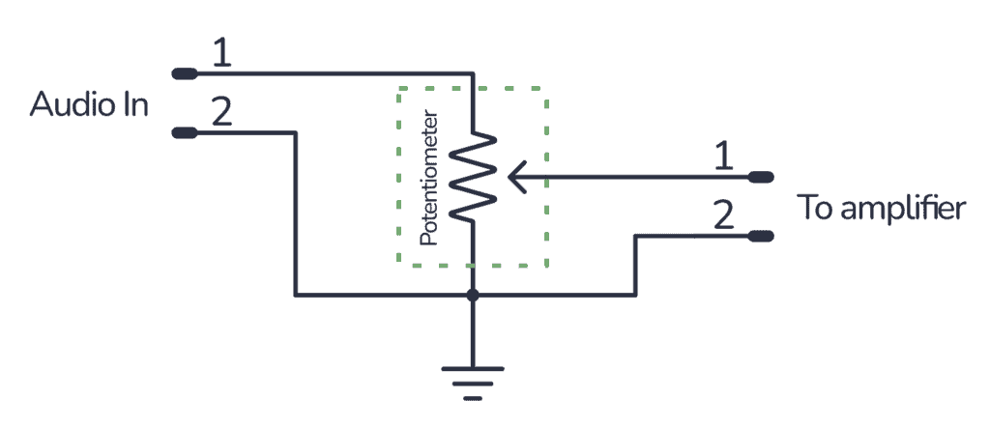
Figure 1.4: Audio Amplifier

By connecting it like this, you’ll get a voltage divider that decreases the voltage of the input signal. The more you turn the shaft, the more you decrease the volume.

This wiring is very common in audio equipment. [2]

Controlling Servo with a potentiometer

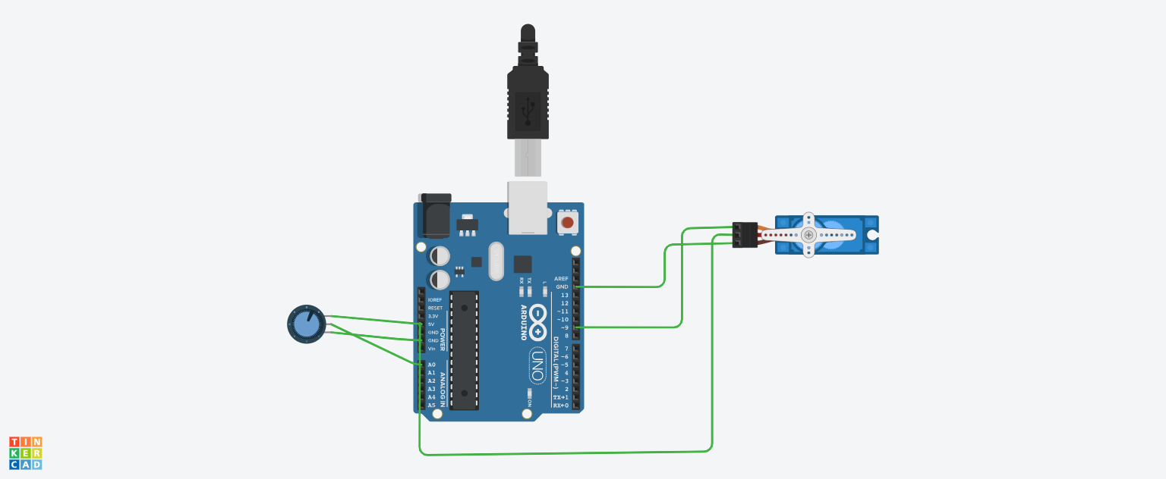
Figure 1.5: Project
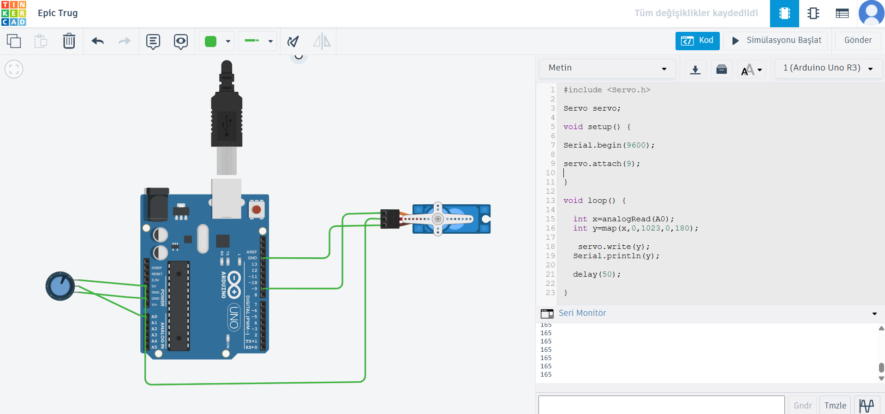
Figure 1.6: Codes [3]

Measuring Distance With HC-SR204
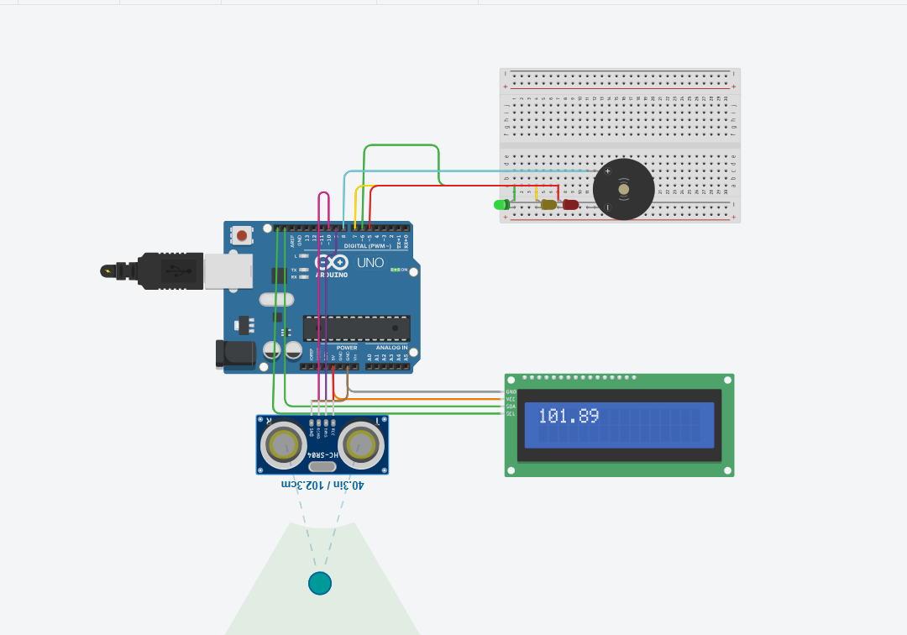
Figure 2.1: Park Sensor Simulation
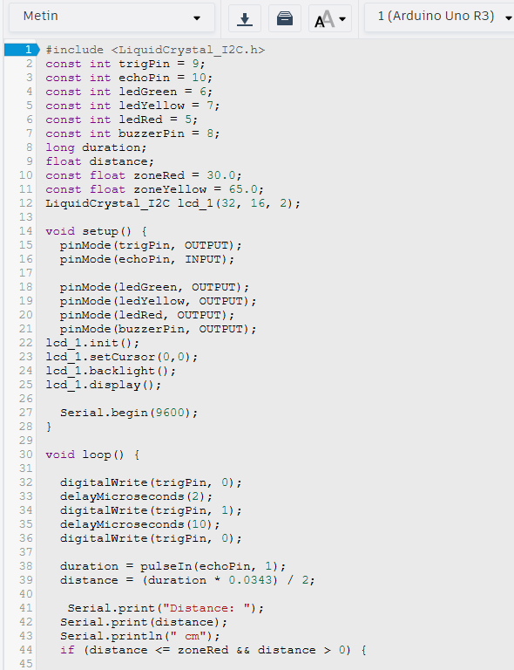
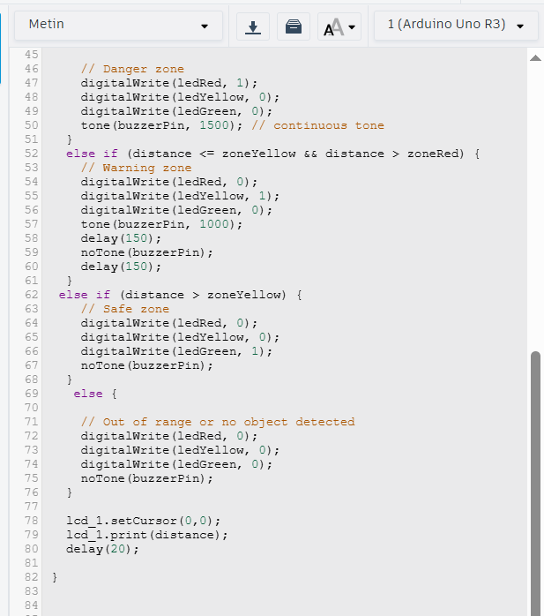
Figure 2.2: Codes [4]
This simulation that I made provides a park sensor that detects distance and illuminates green, yellow, and red LEDs based on the danger zones I’ve assigned. If the distance is within the danger zone, the buzzer sounds. We can also see our distance on the LCD screen that I’ve connected.

What is PWM Signal?
Application of Pulse Width Modulation (PWM)
PWM or Pulse Width Modulation is a technique used to control analog devices, using a digital signal. This technique can be used to output an analog-like signal from a digital device, like a microcontroller. We can control motors, lights, actuators, and more using the generated PWM signal. An important thing to note here is that PWM is not a true analog signal. The digital signal is modified in a way to fake an analog signal. [5]

Adjust Brightness of Screen using PWM
For PWM, adjusting the brightness of the screen does not rely on the power but by alternating on and off of the screen. When the PWM dimming screen is lit, it does not continuously emit light, but it constantly lights up and turns off the screen. If this changes fast enough, our eyes treat is as always on but with different brightness based on different duty cycles. The larger the duty cycle, the brighter the screen.
Other PWM Applications
There are other applications that use PWM technology, including:
- Drive buzzer with different loudness
- Control speed of the motor
- Control the direction of a servo
- Provide an analog output
- Generate audio signal
- Telecommunication: Encode message. [6]
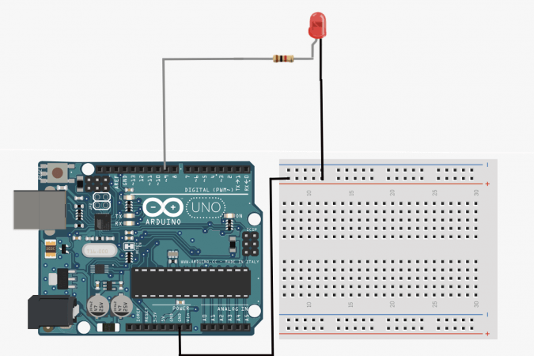
Figure 3.1: Controlling the Brightness of a LED with PWM Technique.

Controlling LED Brightness with LDR
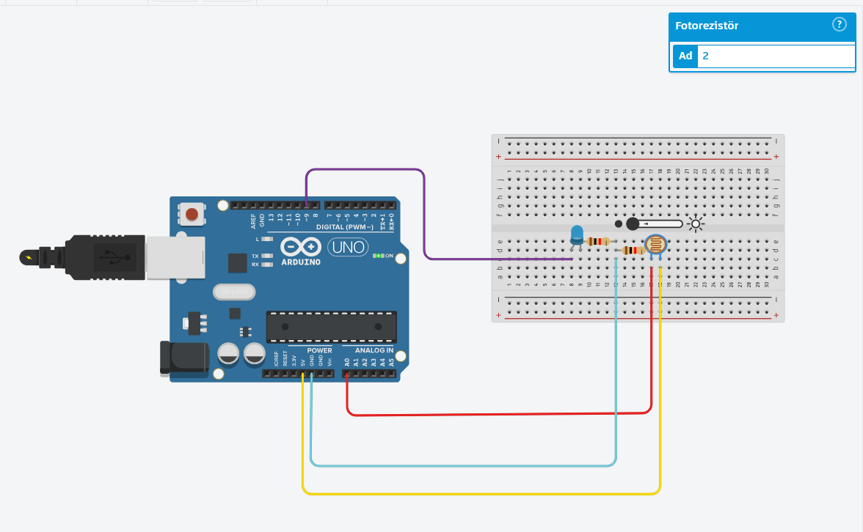
Figure 3.2: Controlling Brightness of LED with LDR
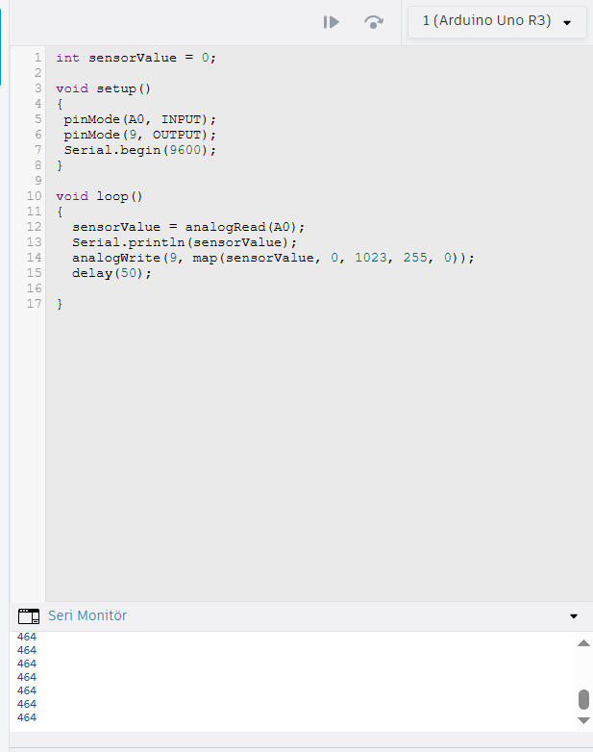
Figure 3.3: Codes [7]

What is LiDAR?
Light Detection And Ranging (LiDAR) is a laser-based remote sensing technology. The idea behind LiDAR is quite simple: pointing a small laser at a surface and measure the time it takes the laser to return to its source.

This technology is used in geographical information systems (GIS) to produce a digital elevation model (DEM) or a digital terrain model (DTM) for 3D mapping.
Operating System of LiDAR
Light Detection and Ranging (LiDAR) is a technology similar to radar, using laser instead of radio waves.
- It emits a laser pulse on a surface
- Catches the reflected laser back to the LiDAR pulse source with sensors
- Measures the time laser travelled
- Calculates the distance from source with the formula “Distance = (Speed of light x Time elapsed) / 2
This process is repeated a million times by LiDAR instruments and ends up producing a complex map of the surveyed area known as a 3D point cloud.
LiDAR systems pulse a laser light from various mobile systems (automobiles, airplanes, drones, UCAV…) through air and vegetation (aerial Laser) and even water (bathymetric Laser). A scanner receives the light back (echoes), measuring distances and angles. The scanning speed influences the number of points and echoes that are measured by a LiDAR system. The choice of optic and scanner influences greatly the resolution and the range in which you can operate the LiDAR system. [8]
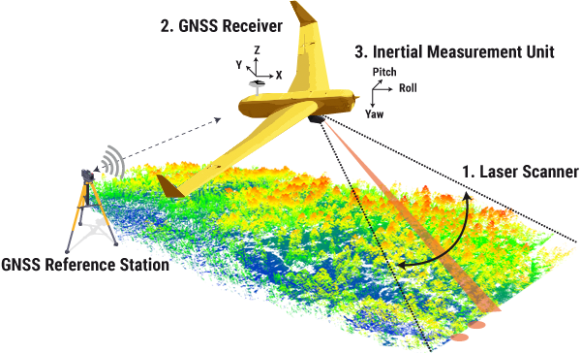
Figure 4.1: Schema For How LiDAR Works
Applications of LiDAR
Agriculture
LiDAR sensors are used to measure agricultural landscaping and topography, for crop biomass estimation, and to detect soil properties by mapping variations in depth, slope, moisture and aspect. LiDAR is also used to pilot autonomous farm vehicles.
Aerospace and defense
LiDAR is used for terrain mapping, target tracking, mine hunting and imaging through clouds, and mission planning using sophisticated battlefield visualizations even in dense urban environments.
Automotive
Advanced driver-assistance systems (ADAS) and autonomous vehicles like self-driving cars use 3D LiDAR map data to "see" and navigate roads and other environments.
Aviation
LiDAR can be used for accurate measurements of wind speed, and is also used by airports to track aircraft and foreign object debris (FOD).
Bathymetry
Bathymetric LiDAR uses green laser light to penetrate water and create digital elevation models of shallow water reservoirs, rivers and coastal sea floors. These can measure erosion, map wildlife habitat and assess risk inside flood zones.
Construction
LiDAR can quickly and accurately survey a construction site, calculate the volume of materials and be used to perform safety inspections and detect possible hazards.
Energy
LiDAR technology is used for wind resource assessment, oil and gas exploration, and vegetation management for the maintenance of power lines.
Entertainment
LiDAR is used for mapping environments in virtual reality and augmented reality applications.

Forestry
In addition to providing detailed topographic maps, LiDAR can be used to measure the structural characteristics of trees such as leaf area index and forest canopy volume, and is a valuable tool in vegetation management. It is also used to monitor and contain forest fires.
Geology and mining
Mines and quarries are difficult to access, and LiDAR is increasingly used for surveying, mapping and worker safety. LiDAR scans can also be used for volume measurements in quarries.
Manufacturing
LiDAR technology can be used to create 3D models of objects for use in manufacturing. It can also be used for quality control to detect anomalies and defects.
Weather forecasting
LiDAR sensors are used to measure temperature, cloud cover, wind velocity, air density and other atmospheric parameters, and provide vital data for weather forecasting models. [9]
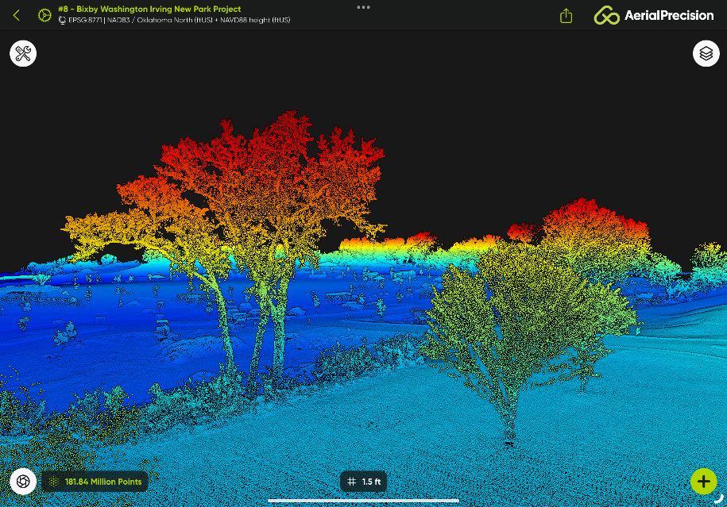
Figure 4.2: LiDAR Scanner

Sources:
[1] “Potentiometer” , Access Address: https://eepower.com/resistor-guide/resistor-types/potentiometer/# , Last Access Date: 2025

[2] D. Nydal , “The Potentiometer: Pinout, Wiring, and How It Works” , Access Address: https://www.build-electronic-circuits.com/potentiometer/ , Last Access Date: 11 August 2023

[3]“Servo with Potentiometer Simulation” , Access Address: https://www.tinkercad.com/things/6Ivs4Ot8tP2-servo-with-potentiometer?sharecode=YjqraLsj-hChm6Df4PKkDZGB61DGG2u4OSTx4Gf2ojg

[4]“Park Sensor HC-SR204 Simulation” , Access Address: https://www.tinkercad.com/things/dhpbjaAZi49-park-sensor-hc-sr204?sharecode=IPeL1gunsVztviyXA6xZ3VM6vAWlmt9DI2bnmkA2fhk
The tutorials I watched for this simulation:
https://www.youtube.com/watch?v=Zqzso_iJyok
https://www.youtube.com/watch?v=aRGprBppVHY
https://www.youtube.com/watch?v=nsjPjk7tiRw .

[5] U. Jayesh , “What is a PWM signal?” , Access Address: https://www.circuitbread.com/ee-faq/what-is-a-pwm-signal , Last Access Date: 14 February 2022

[6] ikikVC , “What is Pulse Width Modulation (PWM)? Applications and Accessories” , Access Address: https://www.seeedstudio.com/blog/2020/06/16/basic-electronics-pulse-width-modulationpwm-and-arduino-applications/?srsltid=AfmBOoqu2Zf493W5HcOtXgTJ_c2UQaL0A_EL2kmms9E_Z9jeNykkJJ3T , Last Access Date: 2020

[7] “LED Brightness Control with LDR Simulation” , Access Address: https://www.tinkercad.com/things/2MSUAjesIiB-led-brightness-control-with-ldr?sharecode=qiSgv6uP25ch7hR-aO9JOmmWAvihJcYBI0wrRoYjoPM
Tutorial video I watched for this simulation:
https://www.youtube.com/watch?v=0p1B74TosTs
[8] “What is LiDAR and how does it work ?” , Access Address: https://www.yellowscan.com/knowledge/how-does-lidar-work/ , Last Access Date: 25 August 2023

[9] “What is LiDAR?” , Access Address: https://www.ibm.com/think/topics/lidar , Last Access Date: 2025

