module12.R

Torrancew

2020-04-12

#This script creates three graphs for the purpose is displaying the functionality of a markdown in R  
  
  
  
#Lists of students and their grades in a class  
students = c("Dave", "Lucy", "Paul", "Mary")  
grades = c(50,60,70,80)  
  
print(students)

## [1] "Dave" "Lucy" "Paul" "Mary"

print(grades)

## [1] 50 60 70 80

#A data frame containing both student's name and their grades   
df = data.frame("Students" = students, "Grades" = grades)  
  
df

## Students Grades  
## 1 Dave 50  
## 2 Lucy 60  
## 3 Paul 70  
## 4 Mary 80

#A plot of their grades  
plot(df$Grades)

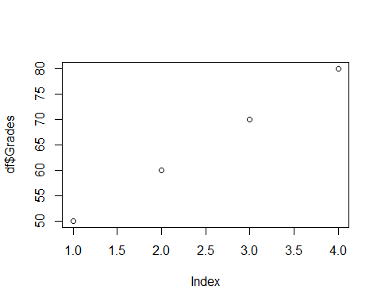

#A list of the grades students got on a particular exam  
gradesplus = c(50,50,50,60,60,70,80,85,90,90,90,100)  
  
  
#A histogram of those grades  
hist(gradesplus)

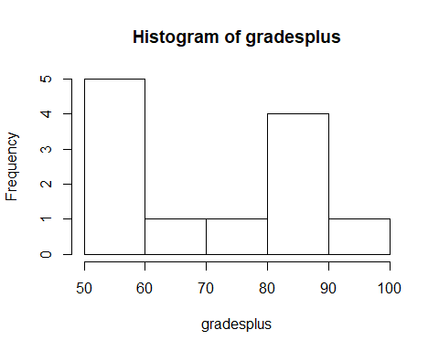

#A dotchart of those grades as well  
dotchart(gradesplus)

