Auction Experiment Prototype
Prototype File V1.1
[刘韩松 刘大同]
7/18/2012

Auction Experiment Prototype version 1.1
Table of Contents
1. Pages 3
1.1. Page Tree 3
1.2. Consent Page 4
1.2.1. User Interface 4
1.3. Participant View 5
1.3.1. User Interface 5
1.4. View Auction Detail(Full View) 6
1.4.1. User Interface 6
1.4.2. Widget Table 6
1.5. Popup Review(only in 7,8,9 round) 7
1.5.1. User Interface 7
1.6. Bid an Auction 8
1.6.1. User Interface 8
1.6.2. Widget Table 8
1.7. View Auction Result 9
1.7.1. User Interface 9
1.8. Administration View 10
1.8.1. User Interface 10
1.8.2. Widget Table 10
1.9. Set Up Reviews 11
1.9.1. User Interface 11
1.10. Set Up an auction 12
1.10.1. User Interface 12
1.10.2. Widget Table 12
1.11. View Auction Result by Group 13
1.11.1. User Interface 13

- Pages
  - Page Tree
Consent Page
Participant View
View Auction Detail(Full View)
Popup Review(only in 7,8,9 round)
Bid an Auction
View Auction Result
Administration View
Set Up Reviews
Set Up an auction
View Auction Result by Group
  - Consent Page
    - User Interface
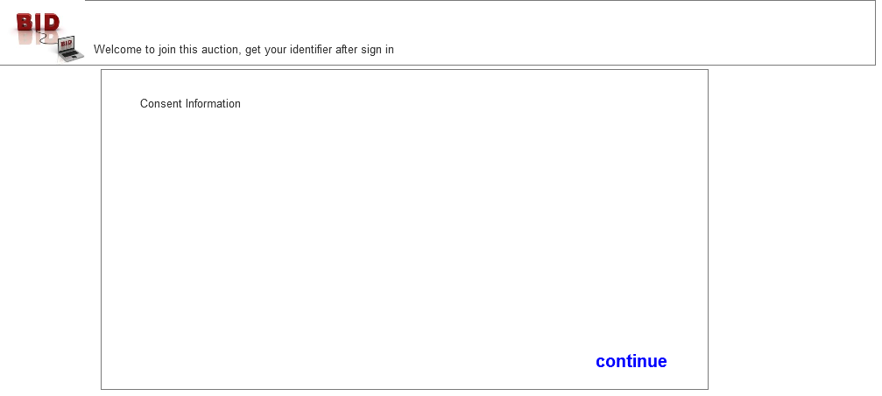
  - Participant View
    - User Interface
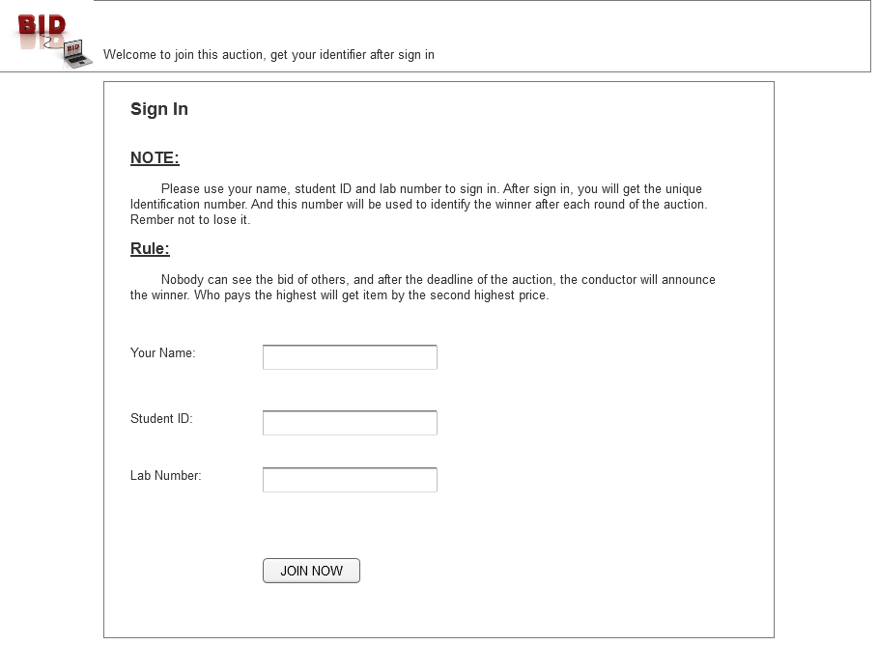
  - View Auction Detail(Full View)
    - User Interface
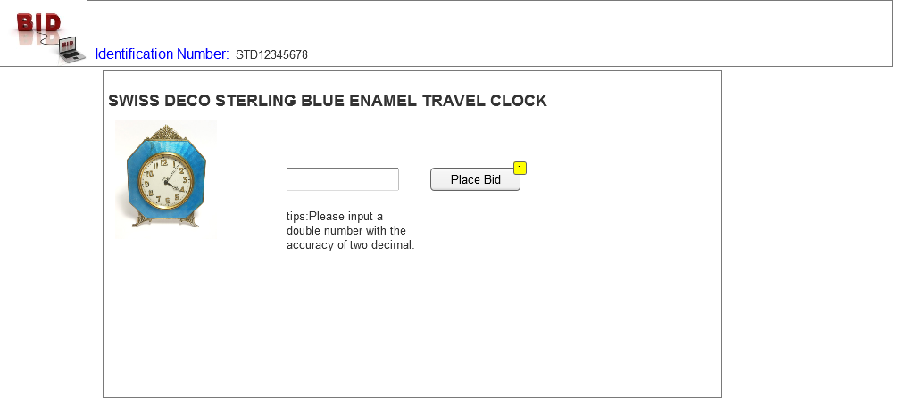
    - Widget Table
Footnote | Interactions
1 | OnClick:  Bind the Auction(if the conductor has not start the auction, alert warning info):
  - Pease input a …….
  - Popup Review(only in 7,8,9 round)
    - User Interface
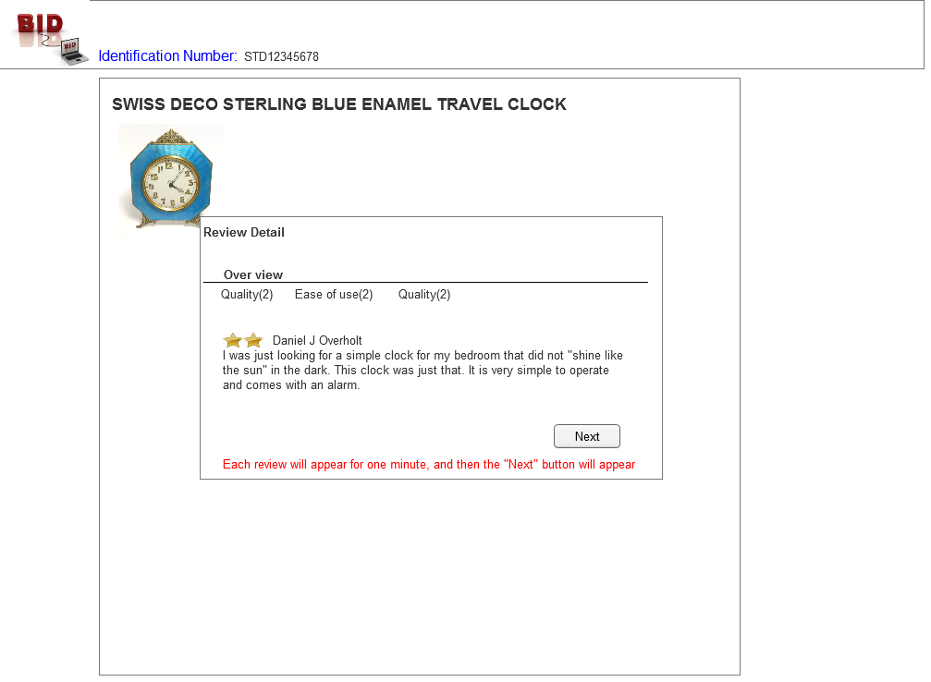
  - Bid an Auction
    - User Interface
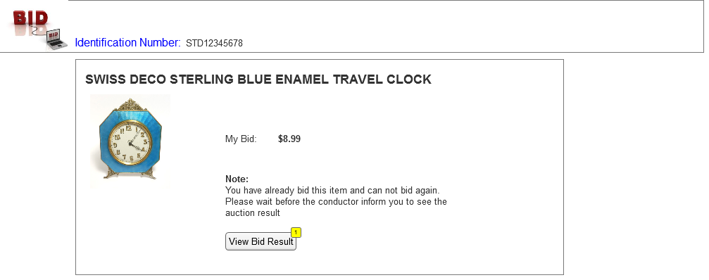
    - Widget Table
Footnote | Interactions
1 | OnClick:  Show Auction Result(if the conductor has not stopped the auction, show warning info):
  - View Auction Result
    - User Interface
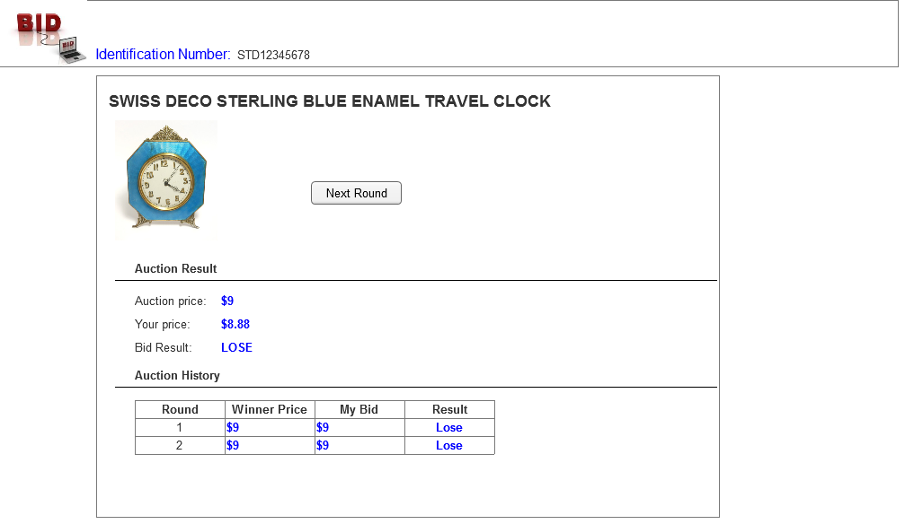
  - Administration View
    - User Interface
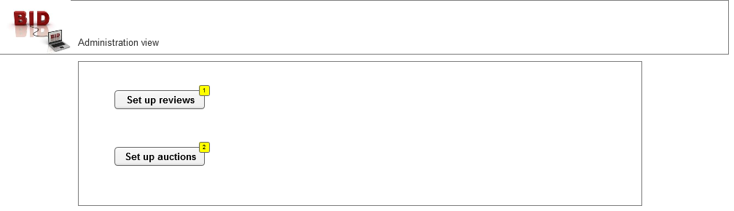
    - Widget Table
Footnote | Interactions
1 | OnClick:  Show setup reviews view:
2 | OnClick:  Show setup auction page:
  - Set Up Reviews
    - User Interface
      - summary
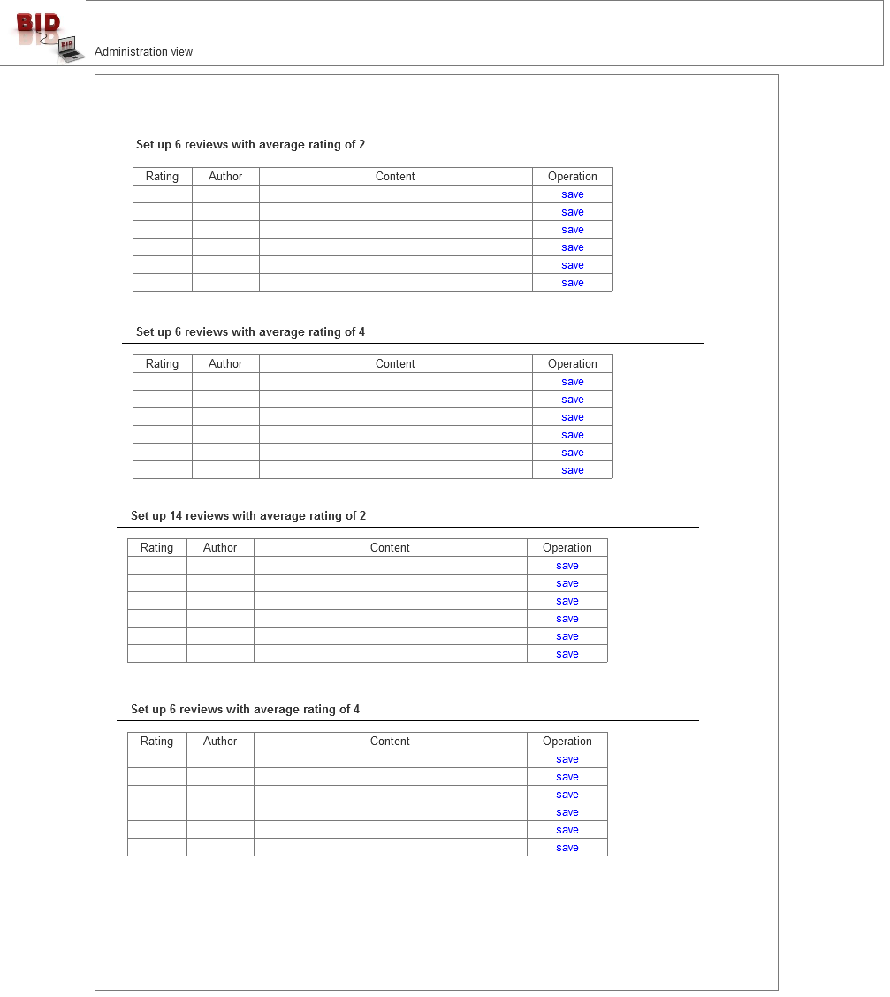
  - Set Up an auction
    - User Interface
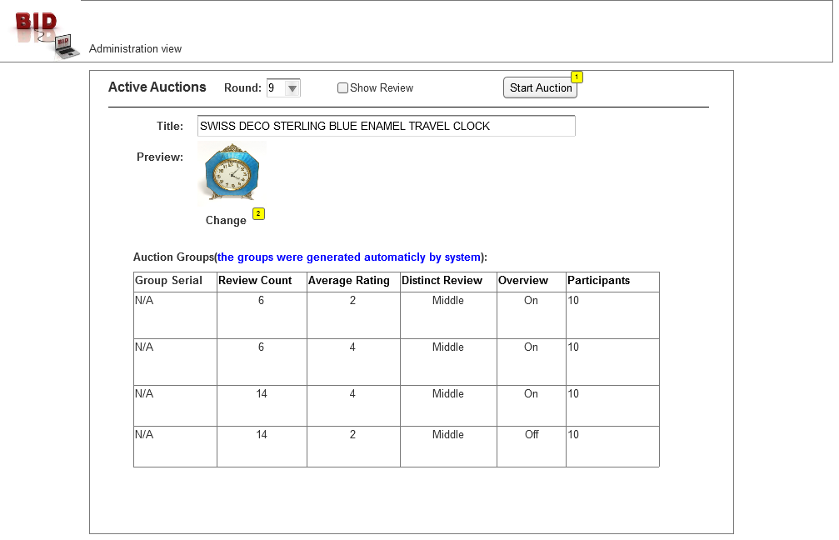
    - Widget Table
Footnote | Interactions
1 | OnClick:  Start Auction:
2 | OnClick:  Change image:
  - View Auction Result by Group
    - User Interface
