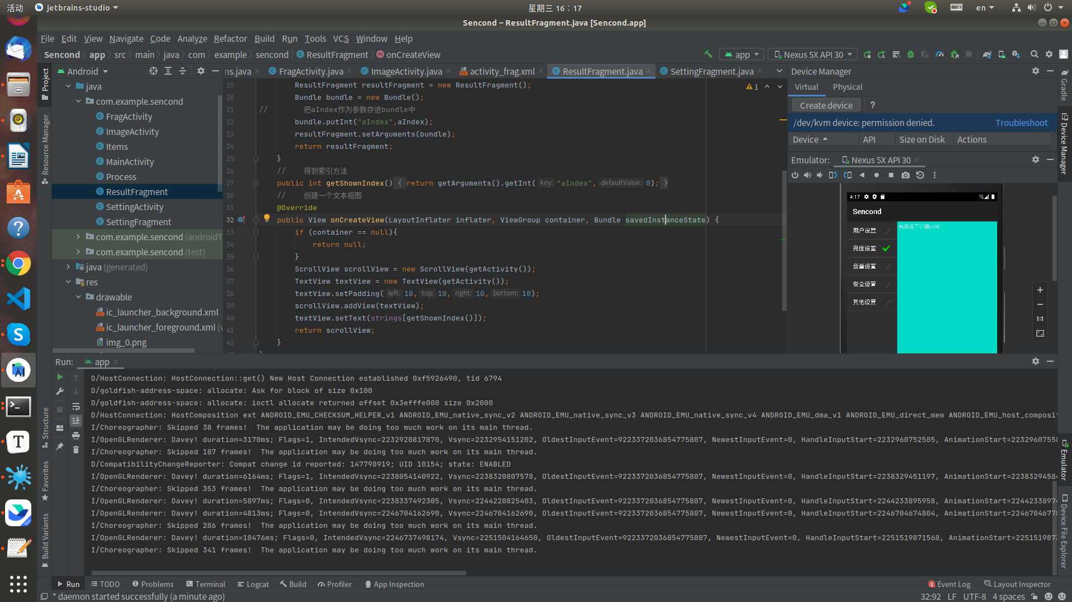

@Override
public void onActivityCreated(@Nullable Bundle savedInstanceState) {
super.onActivityCreated(savedInstanceState);
String[] strings = new String[]{"用户设置","亮度设置","音量设置","安全设置","其他设置"};
setListAdapter(new ArrayAdapter<String>(getActivity(),android.R.layout.simple_list_item_checked,strings));
if (savedInstanceState != null){
// 更新当前索引的位置
index = savedInstanceState.getInt("curChoice",0);
}
getListView().setChoiceMode(ListView.CHOICE_MODE_SINGLE);
showDetails(index);
}
@Override
public void onSaveInstanceState(Bundle outState) {
super.onSaveInstanceState(outState);
outState.putInt("curChoice",index);
}
@Override
public void onListItemClick(ListView l, View v, int position, long id) {
showDetails(position);
}
void showDetails(int aIndex){
getListView().setItemChecked(aIndex,true);
ResultFragment results = (ResultFragment) getFragmentManager().findFragmentById(R.id.result);
if (results == null || results.getShownIndex() != aIndex){
results = ResultFragment.newInstance(aIndex);
FragmentTransaction f = getFragmentManager().beginTransaction();
f.replace(R.id.result,results);
f.setTransition(f.TRANSIT_FRAGMENT_FADE);
f.commit();
}

