Integrated Sealed EO Vapour Test Cell
Dimensioning basis — current handoff release, 2026-09-03
Status: authoritative engineering concept; fabrication release is blocked by the open evidence gates.
NET-VOLUME TARGET / SIDE | MEMBRANE REGION | LOCAL GAPS
500.0 +/- 5.0 mL | 50 x 50 mm (25 cm2) | 1 / 2 / 4 mm

Selected physical system
Two equal sealed gas chambers, A and B, share the active membrane boundary. Each assembled chamber shall be calibrated to 500.0 +/- 5.0 mL net free-gas volume at 32 °C, 101325 Pa and 50% initial RH. The membrane coupon is 80 x 80 mm, the active region is 50 x 50 mm, the clear chamber face is 100 x 100 mm, and the outer plate envelope is 110 x 110 mm. The volume is a governing design target; traceable assembled-cell calibration remains open.
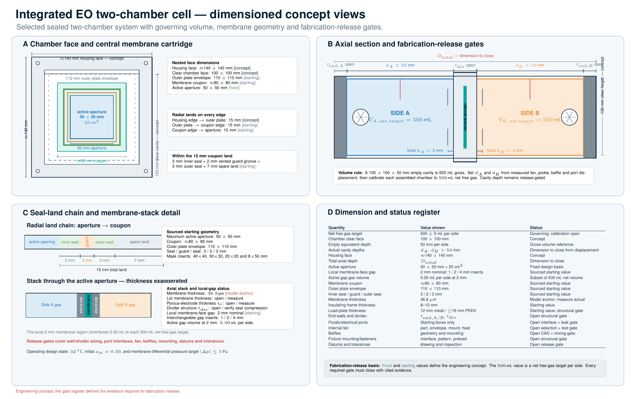
Figure 1. Dimensioned exterior and section engineering concept.

Volume derived from target drift and switching time
The declared target flux is 208 g m-2 h-1 across 25 cm2, giving 520.0 mg/h (0.144444 mg/s). A 5.0 s polarity segment transfers 0.722222 mg. Using V_required = transferred mass / (saturated vapour density x 0.05), the minimum net free-gas volume is 427.6 mL per side. The selected 500.0 mL target gives a ratio of 1.169 and a predicted change of 4.276 RH percentage points in either chamber at the first switching point.

Local, bulk, net and gross volume
Gap | Local membrane region | Bulk free gas | Net-volume target
1 mm | 2.5 mL | 497.5 mL | 500.0 mL
2 mm | 5.0 mL | 495.0 mL | 500.0 mL
4 mm | 10.0 mL | 490.0 mL | 500.0 mL
The local membrane-region volume is included in the net-volume target. Gross empty-cavity volume is released from gross = calibrated net + installed component displacement after the internal hardware inventory is measured. The rendering does not define any dimension stored as null in the configuration.

Ideal ABBA transient
Time | RH A | RH B | Transfer A to B
0 s | 50.000% | 50.000% | +0.000000 mg
5 s | 45.724% | 54.276% | +0.722222 mg
10 s | 50.000% | 50.000% | +0.000000 mg
15 s | 54.276% | 45.724% | -0.722222 mg
20 s | 50.000% | 50.000% | +0.000000 mg
The analytic +1, -1, -1, +1 sequence conserves total water inventory, gives equal and opposite chamber changes, and returns both chambers to the initial state at 20 s. The gas-only pressure diagnostic reaches 406.9 Pa at an extremum. Pressure management remains open pending verification against the 5.0 Pa target.

Engineering register for fabrication release
Fabrication release ready: false. Every required register item must be closed with cited evidence before this may be set to true. The gates explicitly cover walls and divider, ports and feedthroughs, fan, baffles, fixture mounting, fasteners, datums, tolerances, gap uniformity, pressure management, mixing response and net-volume calibration.
Item | Status | Closure evidence
Net Free Gas Volume Target | Defined | Configuration-controlled 500.0 +/- 5.0 mL net free-gas acceptance target per assembled side
Gross Empty Cavity Volume And Depth | Open | Released cavity geometry and dimensional inspection
Installed Component Displacement | Open | Displacement inventory for fan, probes, baffles and ports
End Wall And Central Divider Structural Sizing | Open | Selected materials and thicknesses supported by structural calculation and loaded-deflection inspection
Fluidic And Electrical Port Interfaces | Open | Released interface specification covering threads, seals and feedthroughs plus an assembled leak test
Internal Fan Selection And Mounting | Open | Selected fan, envelope and mount with measured heat load and chamber displacement
Baffle Geometry And Mounting | Open | Released baffle CAD and mounting details supported by the chamber mixing test
Differential Pressure Management | Open | Transient pressure test across the full polarity sequence
Fixture Mounting Fastener Pattern And Preload | Open | Released external mounting interface, bolt-load calculation and torque map
Seal Geometry And Compression | Open | Seal supplier limits and compression inspection
Drawing Datums And Dimensional Tolerances | Open | Released datum and tolerance scheme with completed dimensional inspection
Loaded Flatness And Gap Uniformity | Open | Mapped 1, 2 and 4 mm gaps under operating preload
Internal Mixing Time | Open | Humidity step-response test in each chamber
Net Volume Calibration | Open | Traceable measured 500.0 +/- 5.0 mL free-gas volume calibration for each assembled side

Reproduction and verification
Run scripts/design_eo_vapor_test_cell.py to regenerate the volume basis, 0.1 s transient, engineering register, audit and source manifest. Run pytest -q tests/test_eo_vapor_test_cell_design.py for the formula, conservation, symmetry and packaged-output checks.

