Integrated Sealed EO Vapour Test Cell
Dimensioning basis — current handoff release, 2026-09-03
Status: engineering concept, not a fabrication drawing.
NET VOLUME / SIDE | MEMBRANE REGION | LOCAL GAPS
500.0 +/- 5.0 mL | 50 x 50 mm (25 cm2) | 1 / 2 / 4 mm

Selected physical system
Two equal sealed gas chambers, A and B, share the active membrane boundary. Each assembled chamber is calibrated to 500.0 mL net free-gas volume at 32 °C, 101325 Pa and 50% initial RH. The membrane coupon is 80 x 80 mm, the active region is 50 x 50 mm, the clear chamber face is 100 x 100 mm, and the outer plate envelope is 110 x 110 mm.
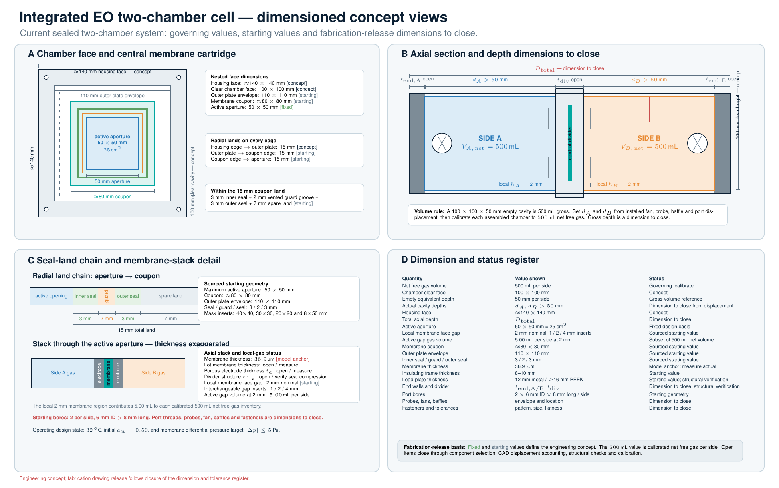
Figure 1. Dimensioned exterior and section engineering concept.

Volume derived from target drift and switching time
The declared target flux is 208 g m-2 h-1 across 25 cm2, giving 520.0 mg/h (0.144444 mg/s). A 5.0 s polarity segment transfers 0.722222 mg. Using V_required = transferred mass / (saturated vapour density x 0.05), the minimum net free-gas volume is 427.6 mL per side. The selected 500.0 mL gives a ratio of 1.169 and a predicted 4.276-percentage-point change in either chamber at the first switching point.

Local, bulk, net and gross volume
Gap | Local membrane region | Bulk free gas | Calibrated net free gas
1 mm | 2.5 mL | 497.5 mL | 500.0 mL
2 mm | 5.0 mL | 495.0 mL | 500.0 mL
4 mm | 10.0 mL | 490.0 mL | 500.0 mL
The local membrane-region volume is included in the calibrated net value. Gross empty-cavity volume is released from gross = calibrated net + installed component displacement after the internal hardware inventory is measured.

Ideal ABBA transient
Time | RH A | RH B | Transfer A to B
0 s | 50.000% | 50.000% | +0.000000 mg
5 s | 45.724% | 54.276% | +0.722222 mg
10 s | 50.000% | 50.000% | +0.000000 mg
15 s | 54.276% | 45.724% | -0.722222 mg
20 s | 50.000% | 50.000% | +0.000000 mg
The analytic +1, -1, -1, +1 sequence conserves total water inventory, gives equal and opposite chamber changes, and returns both chambers to the initial state at 20 s. The gas-only pressure diagnostic reaches 406.9 Pa at an extremum. Pressure management closes through verification against the 5.0 Pa target.

Engineering register for fabrication release
Item | Status | Closure evidence
Gross Empty Cavity Volume And Depth | Open | Released cavity geometry and dimensional inspection
Installed Component Displacement | Open | Displacement inventory for fan, probes, baffles and ports
Differential Pressure Management | Open | Transient pressure test across the full polarity sequence
Fastener Pattern And Preload | Open | Bolt-load calculation and torque map
Seal Geometry And Compression | Open | Seal supplier limits and compression inspection
Loaded Flatness And Gap Uniformity | Open | Mapped 1, 2 and 4 mm gaps under operating preload
Internal Mixing Time | Open | Humidity step-response test in each chamber
Net Volume Calibration | Defined | Traceable 500.0 +/- 5.0 mL free-gas volume calibration per assembled side

Reproduction and verification
Run scripts/design_eo_vapor_test_cell.py to regenerate the volume basis, 0.1 s transient, engineering register, audit and source manifest. Run pytest -q tests/test_eo_vapor_test_cell_design.py for the formula, conservation, symmetry and packaged-output checks.

