EO Vapour Test Cell
Selected design basis for net-transient measurement
Engineering working basis · calculation-backed concept · not released for fabrication
ACTIVE MEMBRANE | NET VOLUME / SIDE | WORKING SEGMENT
50 x 50 mm (25 cm²) | 500 ± 5 mL | 12 s

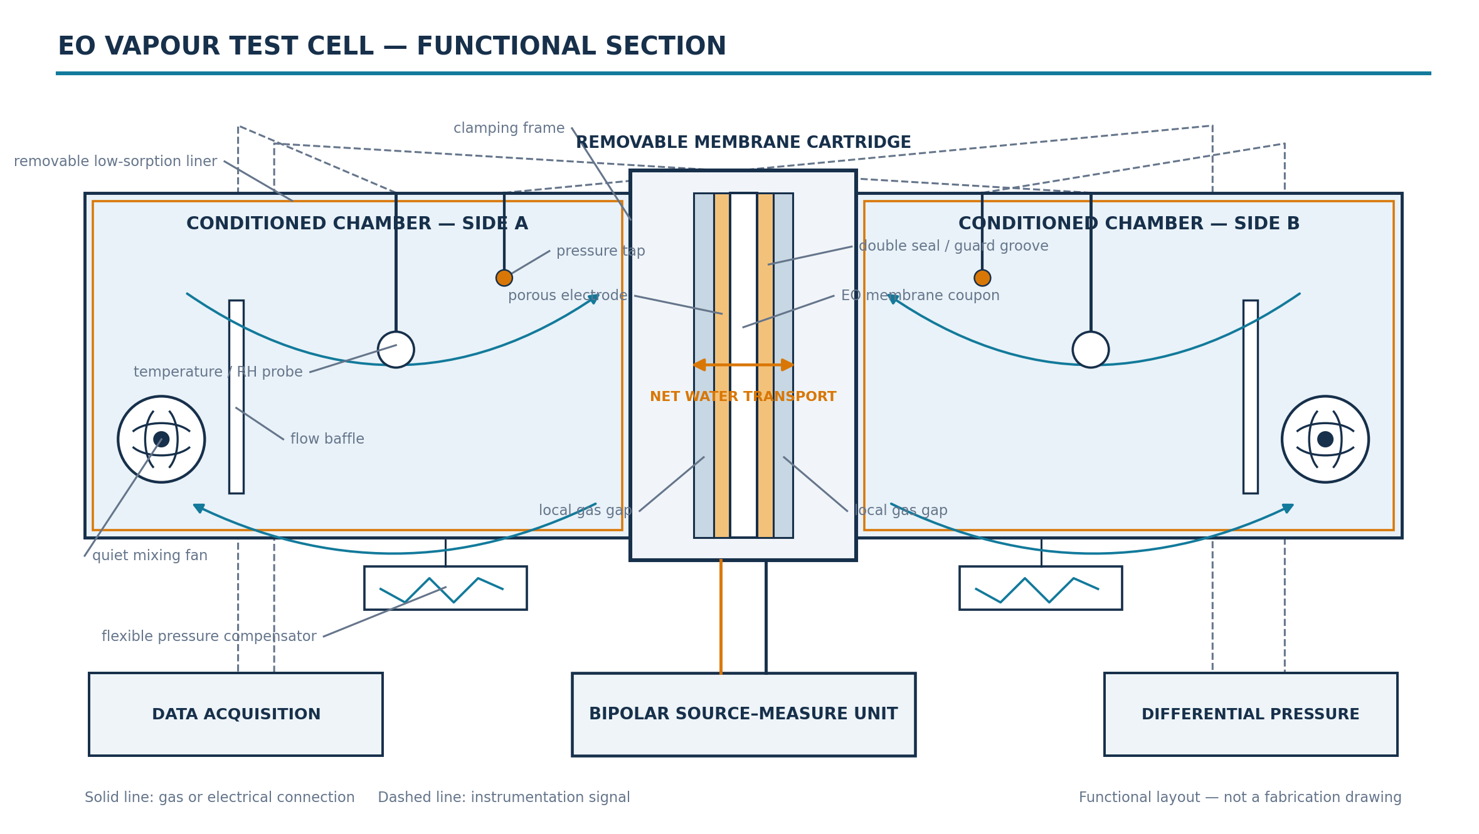
Figure 1. Two-dimensional functional blueprint of the complete test setup. Values and dimensions are kept in the calculation basis; this is not released fabrication CAD.

Selected values and reasons
Quantity | Selected value | Why it was selected
Active membrane | 50 x 50 mm = 25 cm² | Largest existing aperture; strong signal and lower edge-to-area ratio.
Membrane coupon | 80 x 80 mm | Provides land for double seals, guard groove and clamping.
Local gas gap | 2 mm per side | Matches the local transport model; active-gap volume is only 5.0 mL per side.
Calibrated net gas volume | 500 ± 5 mL per side | Retains the illustrated 0.50 L cell and slows the transient for the present instrumentation.
Bulk plenum | 165 x 165 x 20 mm | Provides gross volume without changing the 25 cm² active membrane.
Polarity sequence | 12 s each; +I, −I, −I, +I | Measures net transfer by polarity while suppressing fixed and linear drift.

Calculation basis
The calculation is conditional on 208 g m⁻² h⁻¹ at 32 °C, 101.325 kPa and 50% initial RH. The flux is a test-sizing target, not a measured material property.
ṁ = J A = 208 × 0.0025 = 520 mg/h = 0.144444 mg/s
Δm = ṁ Δt = 0.144444 × 12 = 1.733333 mg
ΔRH = Δm / (ρsat Vnet) = 10.261 percentage points per chamber
After the first positive segment, the ideal well-mixed endpoints are 39.739% and 60.261% RH. The differential RH signal is 20.523 percentage points.

Volume closure
544.5 mL gross − 22.6 mL components − 21.9 mL trim = 500.0 mL net
The gross 165 x 165 x 20 mm plenum is 544.5 mL. After the conservative 22.6 mL component bound, 521.9 mL remains. Removable inserts must cover 21.9–44.5 mL until actual solid displacement is measured.

Instrument and pressure implications
The SHT45 step-response fraction over 12 s is 95.0%. This does not mean exact ramp tracking: a simple first-order model indicates only 68.3% of a linear endpoint change. Use a faster calibrated reference if the transient shape is required. The rigid-cell pressure diagnostic is 976 Pa, compared with the 5 Pa target. The ideal pressure-management screen therefore requires about ±2.40 mL travel per side and 4.79 mL full stroke.

Interpretation boundary
Report: integrated net water moved through the membrane during each segment under evolving RH conditions. Do not claim: constant-boundary intrinsic EO flux or sustained dehumidification from the closed symmetric sequence alone. One four-segment block lasts 48 s and returns the ideal inventory to its initial state.
Fabrication remains conditional on measured mixing, leakage, fan thermal bias, differential pressure, component displacement, seal performance and assembled net volume.

Error-controlled construction
The cell geometry is now tied to an explicit error budget. Calculation is used for stiffness and inventory scaling; physical blanks and scaling tests control effects that cannot be credibly removed by geometry alone.
Control | Selected design / acceptance criterion
Structural wall | 12 mm EN AW-6082-T6 aluminium; 1.33 µm pressure-only proof deflection.
Insulating plate | 20 mm Unfilled PEEK; 4.51 µm pressure-only proof deflection.
Loaded local gap | 2.00 ± 0.02 mm with hard stops and a loaded gap map.
Wetted surfaces | Smooth removable non-porous metal liners; exposed PEEK restricted to the insulating cartridge land.
Edge effect | Primary 50 mm aperture plus 30/40/50 mm area–perimeter regression. A 1 mm band is already 7.84% of active area.
Wall-storage blank | ≤ 0.01733 mg per segment, equivalent to 0.256 nm reversible water film.
Sensors / mixing | 2 T/RH locations per chamber; relative calibration ≤ 0.10 RH point and spatial disagreement ≤ 0.15 RH point.
State / leakage | Chamber ΔT ≤ 0.05 K; volume uncertainty ≤ 1.0 mL; cross-leak screen ≤ 6.25 mL/min at peak RH difference.

Acceptance logic
The planning root-sum-square allocation is 3.36% of the corrected segment signal. This is not demonstrated accuracy. Accept data only after individual volume calibration, pressure-decay and guard-leak testing, an impermeable-coupon wall/thermal blank, a zero-current diffusion blank, three-aperture edge regression, spatial mixing verification and post-run drift checks.
Wall thickness cannot eliminate membrane-edge transport or reversible water storage. These are controlled by the liner, guard, blanks and aperture regression.

