Platform Modernization Proposal (Warning Probe)
Companion corpus to validate strict-mode fail-closed behavior with controlled dropped content
This corpus models a realistic modernization proposal for a legacy enterprise platform using a dual-track migration strategy with strict governance and measurable outcomes.
Table of contents placeholder
Quick links: Dual-Track Strategy | Implementation Roadmap | Risk Register
Formatting showcase: bold, italic, underline, strike, all caps, small caps, and monospace accent run.
1. Executive Summary and Recommendation
This section summarizes practical modernization tradeoffs across product delivery, platform ownership, and cloud economics.
Structured findings include measurable delivery acceleration, tighter operational feedback loops, explicit cost attribution, and a plan to replace fragmented release orchestration. The target operating model remains standards-led and cloud-ready.
Program note: the transition must preserve service continuity while reducing coupling between framework internals and product delivery teams.
Shaded insight: overprovisioned shared runtime pools hide unit economics and reduce incentives for efficiency by service ownership.
Background-only text after plain reset. Highlight wins when both controls exist.Back to background color.
Unicode marker check: — modernization € and © policy baseline.
Open technical appendix 1
Contact platform office
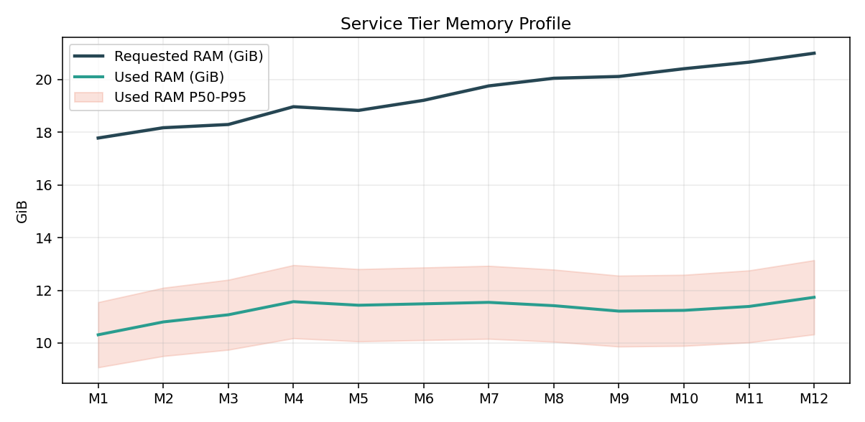
- Primary finding 1: delivery throughput grew while operational risk remained bounded.
  - Supporting evidence A.1: demand spikes were absorbed via autoscaling policy.
  - Supporting evidence B.1: tenant cost variance became measurable per service.
- Action item 1: publish target-state API contracts and migration checkpoints.
- Metric | - Baseline vs Current |  | - Notes
- Throughput | - 86 -> 98 | - cadence stabilized | - Governance owner assigned
- Throughput | - Defect rate 18 | - targeted hardening | - cross-team review in 4 weeks
Governance checkpoint 1 confirmed with legal and operations sign-off.
2. Historical Context and Stakeholder Alignment Gaps
This section summarizes practical modernization tradeoffs across product delivery, platform ownership, and cloud economics.
Structured findings include measurable delivery acceleration, tighter operational feedback loops, explicit cost attribution, and a plan to replace fragmented release orchestration. The target operating model remains standards-led and cloud-ready.
Program note: the transition must preserve service continuity while reducing coupling between framework internals and product delivery teams.
Shaded insight: overprovisioned shared runtime pools hide unit economics and reduce incentives for efficiency by service ownership.
Background-only text after plain reset. Highlight wins when both controls exist.Back to background color.
Unicode marker check: — modernization € and © policy baseline.
Open technical appendix 2
Contact platform office
Return to Executive Summary
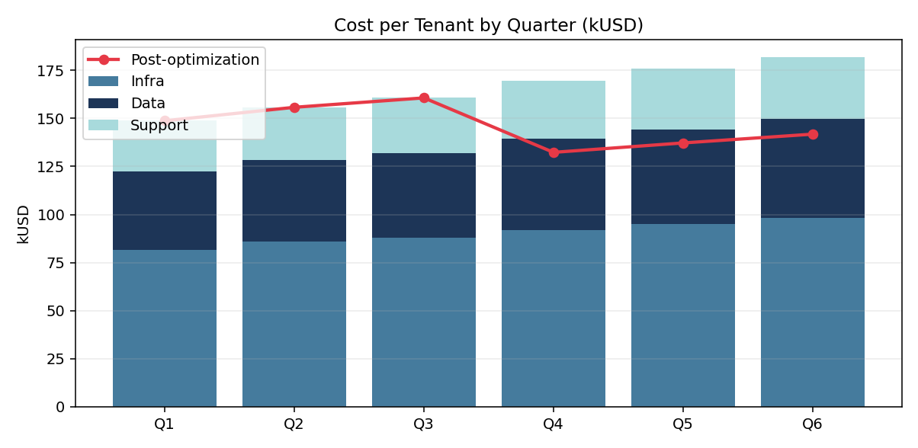
- Primary finding 2: delivery throughput grew while operational risk remained bounded.
  - Supporting evidence A.2: demand spikes were absorbed via autoscaling policy.
  - Supporting evidence B.2: tenant cost variance became measurable per service.
- Action item 2: publish target-state API contracts and migration checkpoints.
- Metric | - Baseline vs Current |  | - Notes
- Throughput | - 89 -> 101 | - cadence stabilized | - Governance owner assigned
- Throughput | - Defect rate 17 | - targeted hardening | - cross-team review in 5 weeks
Strategic note 2 includes staged compliance rolloutEndnote 2: Modular certification reduces audit blast radius and shortens remediation lead-time..
3. Status Quo Constraints
This section summarizes practical modernization tradeoffs across product delivery, platform ownership, and cloud economics.
Structured findings include measurable delivery acceleration, tighter operational feedback loops, explicit cost attribution, and a plan to replace fragmented release orchestration. The target operating model remains standards-led and cloud-ready.
Program note: the transition must preserve service continuity while reducing coupling between framework internals and product delivery teams.
Shaded insight: overprovisioned shared runtime pools hide unit economics and reduce incentives for efficiency by service ownership.
Background-only text after plain reset. Highlight wins when both controls exist.Back to background color.
Unicode marker check: — modernization € and © policy baseline.
Open technical appendix 3
Contact platform office
Return to Executive Summary
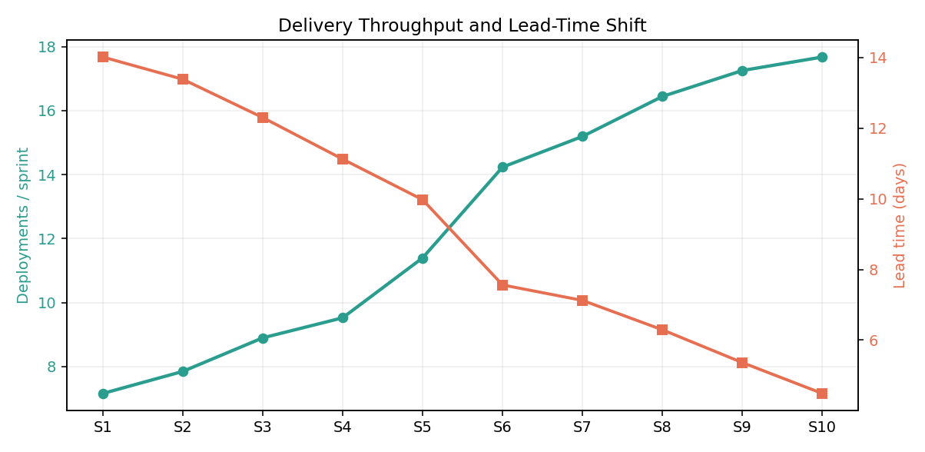
- Primary finding 3: delivery throughput grew while operational risk remained bounded.
  - Supporting evidence A.3: demand spikes were absorbed via autoscaling policy.
  - Supporting evidence B.3: tenant cost variance became measurable per service.
- Action item 3: publish target-state API contracts and migration checkpoints.
- Metric | - Baseline vs Current |  | - Notes
- Throughput | - 92 -> 104 | - cadence stabilized | - Governance owner assigned
- Throughput | - Defect rate 16 | - targeted hardening | - cross-team review in 6 weeks
4. FinOps and Operations
This section summarizes practical modernization tradeoffs across product delivery, platform ownership, and cloud economics.
Structured findings include measurable delivery acceleration, tighter operational feedback loops, explicit cost attribution, and a plan to replace fragmented release orchestration. The target operating model remains standards-led and cloud-ready.
Program note: the transition must preserve service continuity while reducing coupling between framework internals and product delivery teams.
Shaded insight: overprovisioned shared runtime pools hide unit economics and reduce incentives for efficiency by service ownership.
Background-only text after plain reset. Highlight wins when both controls exist.Back to background color.
Unicode marker check: — modernization € and © policy baseline.
Open technical appendix 4
Contact platform office
Return to Executive Summary
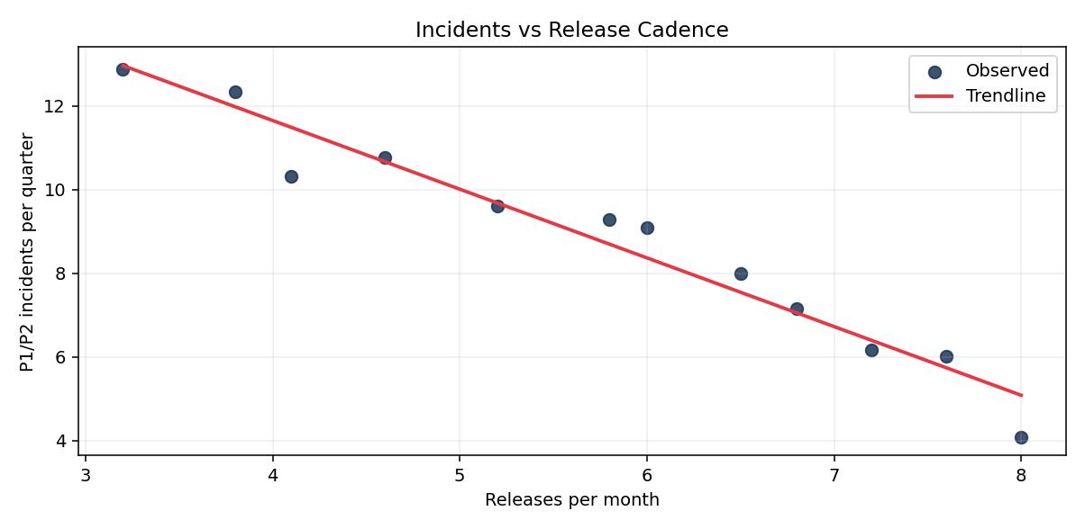
- Primary finding 4: delivery throughput grew while operational risk remained bounded.
  - Supporting evidence A.4: demand spikes were absorbed via autoscaling policy.
  - Supporting evidence B.4: tenant cost variance became measurable per service.
- Action item 4: publish target-state API contracts and migration checkpoints.
- Metric | - Baseline vs Current |  | - Notes
- Throughput | - 95 -> 107 | - cadence stabilized | - Governance owner assigned
- Throughput | - Defect rate 15 | - targeted hardening | - cross-team review in 7 weeks
Governance checkpoint 4 confirmed with legal and operations sign-off.
5. Target Platform Vision
This section summarizes practical modernization tradeoffs across product delivery, platform ownership, and cloud economics.
Structured findings include measurable delivery acceleration, tighter operational feedback loops, explicit cost attribution, and a plan to replace fragmented release orchestration. The target operating model remains standards-led and cloud-ready.
Program note: the transition must preserve service continuity while reducing coupling between framework internals and product delivery teams.
Shaded insight: overprovisioned shared runtime pools hide unit economics and reduce incentives for efficiency by service ownership.
Background-only text after plain reset. Highlight wins when both controls exist.Back to background color.
Unicode marker check: — modernization € and © policy baseline.
Open technical appendix 5
Contact platform office
Return to Executive Summary
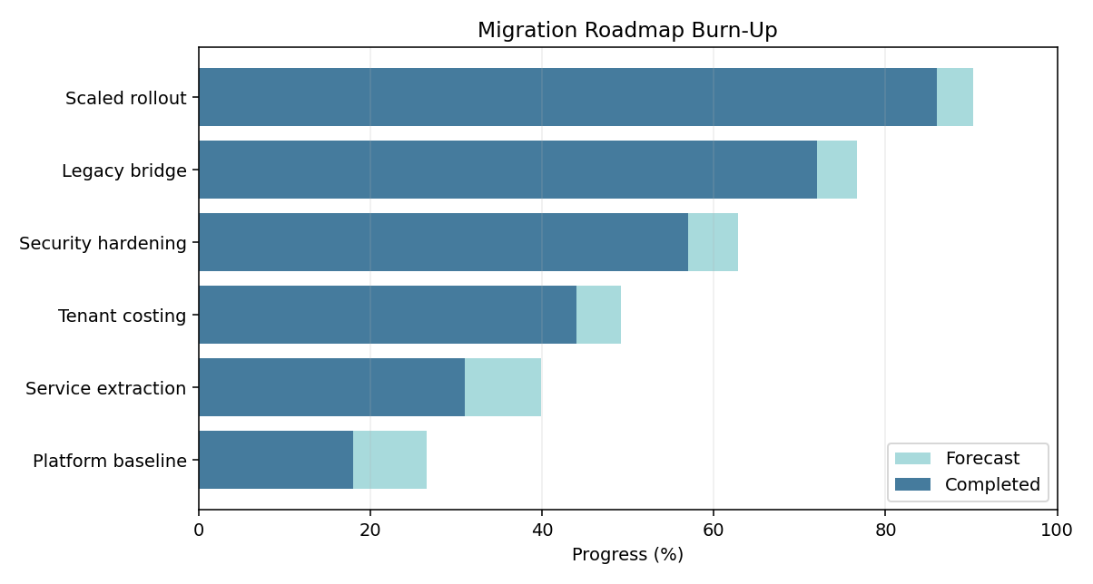
- Primary finding 5: delivery throughput grew while operational risk remained bounded.
  - Supporting evidence A.5: demand spikes were absorbed via autoscaling policy.
  - Supporting evidence B.5: tenant cost variance became measurable per service.
- Action item 5: publish target-state API contracts and migration checkpoints.
- Metric | - Baseline vs Current |  | - Notes
- Throughput | - 98 -> 110 | - cadence stabilized | - Governance owner assigned
- Throughput | - Defect rate 14 | - targeted hardening | - cross-team review in 8 weeks
6. Dual-Track Strategy
This section summarizes practical modernization tradeoffs across product delivery, platform ownership, and cloud economics.
Structured findings include measurable delivery acceleration, tighter operational feedback loops, explicit cost attribution, and a plan to replace fragmented release orchestration. The target operating model remains standards-led and cloud-ready.
Program note: the transition must preserve service continuity while reducing coupling between framework internals and product delivery teams.
Shaded insight: overprovisioned shared runtime pools hide unit economics and reduce incentives for efficiency by service ownership.
Background-only text after plain reset. Highlight wins when both controls exist.Back to background color.
Unicode marker check: — modernization € and © policy baseline.
Open technical appendix 6
Contact platform office
Return to Executive Summary
- Primary finding 6: delivery throughput grew while operational risk remained bounded.
  - Supporting evidence A.6: demand spikes were absorbed via autoscaling policy.
  - Supporting evidence B.6: tenant cost variance became measurable per service.
- Action item 6: publish target-state API contracts and migration checkpoints.
- Metric | - Baseline vs Current |  | - Notes
- Throughput | - 101 -> 113 | - cadence stabilized | - Governance owner assigned
- Throughput | - Defect rate 13 | - targeted hardening | - cross-team review in 4 weeks
Strategic note 6 includes staged compliance rolloutEndnote 6: Modular certification reduces audit blast radius and shortens remediation lead-time..
7. Pilot Proof: Service Operations Console
This section summarizes practical modernization tradeoffs across product delivery, platform ownership, and cloud economics.
Structured findings include measurable delivery acceleration, tighter operational feedback loops, explicit cost attribution, and a plan to replace fragmented release orchestration. The target operating model remains standards-led and cloud-ready.
Program note: the transition must preserve service continuity while reducing coupling between framework internals and product delivery teams.
Shaded insight: overprovisioned shared runtime pools hide unit economics and reduce incentives for efficiency by service ownership.
Background-only text after plain reset. Highlight wins when both controls exist.Back to background color.
Unicode marker check: — modernization € and © policy baseline.
Open technical appendix 7
Contact platform office
Return to Executive Summary
- Primary finding 7: delivery throughput grew while operational risk remained bounded.
  - Supporting evidence A.7: demand spikes were absorbed via autoscaling policy.
  - Supporting evidence B.7: tenant cost variance became measurable per service.
- Action item 7: publish target-state API contracts and migration checkpoints.
- Metric | - Baseline vs Current |  | - Notes
- Throughput | - 104 -> 116 | - cadence stabilized | - Governance owner assigned
- Throughput | - Defect rate 12 | - targeted hardening | - cross-team review in 5 weeks
Governance checkpoint 7 confirmed with legal and operations sign-off.
Nested Table and Embedded Image Showcase
Outer narrative before nested controls.
Nested-A | Nested-B
8. Security and Compliance Implications
This section summarizes practical modernization tradeoffs across product delivery, platform ownership, and cloud economics.
Structured findings include measurable delivery acceleration, tighter operational feedback loops, explicit cost attribution, and a plan to replace fragmented release orchestration. The target operating model remains standards-led and cloud-ready.
Program note: the transition must preserve service continuity while reducing coupling between framework internals and product delivery teams.
Shaded insight: overprovisioned shared runtime pools hide unit economics and reduce incentives for efficiency by service ownership.
Background-only text after plain reset. Highlight wins when both controls exist.Back to background color.
Unicode marker check: — modernization € and © policy baseline.
Open technical appendix 8
Contact platform office
Return to Executive Summary
- Primary finding 8: delivery throughput grew while operational risk remained bounded.
  - Supporting evidence A.8: demand spikes were absorbed via autoscaling policy.
  - Supporting evidence B.8: tenant cost variance became measurable per service.
- Action item 8: publish target-state API contracts and migration checkpoints.
- Metric
- Throughput
- 9. Implementation Roadmap
This section summarizes practical modernization tradeoffs across product delivery, platform ownership, and cloud economics.
Structured findings include measurable delivery acceleration, tighter operational feedback loops, explicit cost attribution, and a plan to replace fragmented release orchestration. The target operating model remains standards-led and cloud-ready.
Program note: the transition must preserve service continuity while reducing coupling between framework internals and product delivery teams.
Shaded insight: overprovisioned shared runtime pools hide unit economics and reduce incentives for efficiency by service ownership.
Background-only text after plain reset. Highlight wins when both controls exist.Back to background color.
Unicode marker check: — modernization € and © policy baseline.
Open technical appendix 9
Contact platform office
Return to Executive Summary
- Primary finding 9: delivery throughput grew while operational risk remained bounded.
  - Supporting evidence A.9: demand spikes were absorbed via autoscaling policy.
  - Supporting evidence B.9: tenant cost variance became measurable per service.
- Action item 9: publish target-state API contracts and migration checkpoints.
- Metric
- Throughput
Landscape Risk Matrix
Region
North America
EMEA

10. Risk Register and Mitigations
This section summarizes practical modernization tradeoffs across product delivery, platform ownership, and cloud economics.
Structured findings include measurable delivery acceleration, tighter operational feedback loops, explicit cost attribution, and a plan to replace fragmented release orchestration. The target operating model remains standards-led and cloud-ready.
Program note: the transition must preserve service continuity while reducing coupling between framework internals and product delivery teams.
Shaded insight: overprovisioned shared runtime pools hide unit economics and reduce incentives for efficiency by service ownership.
Background-only text after plain reset. Highlight wins when both controls exist.Back to background color.
Unicode marker check: — modernization € and © policy baseline.
Open technical appendix 10
Contact platform office
Return to Executive Summary
- Primary finding 10: delivery throughput grew while operational risk remained bounded.
  - Supporting evidence A.10: demand spikes were absorbed via autoscaling policy.
  - Supporting evidence B.10: tenant cost variance became measurable per service.
- Action item 10: publish target-state API contracts and migration checkpoints.
- Metric
- Throughput

Footnote 1: Shared ownership remains acceptable when service boundaries and incident budgets are explicit.
Footnote 4: Shared ownership remains acceptable when service boundaries and incident budgets are explicit.
Footnote 7: Shared ownership remains acceptable when service boundaries and incident budgets are explicit.

