Image correlation coefficient calculator (Parallel & Distributed)

The application relies on the correlation coefficient formula for 2d arrays listed below:

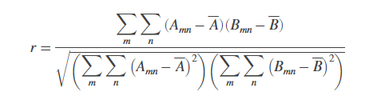

However, for obtaining a correlation coefficient on 2 distinct pictures of the same size (or the same picture with different filters applied) this formula cannot be used as the pixel of an image cannot be treated as one number. Instead, the application splits the image into color channels and computed a correlation coefficient between the 2 pictures for each color channel.

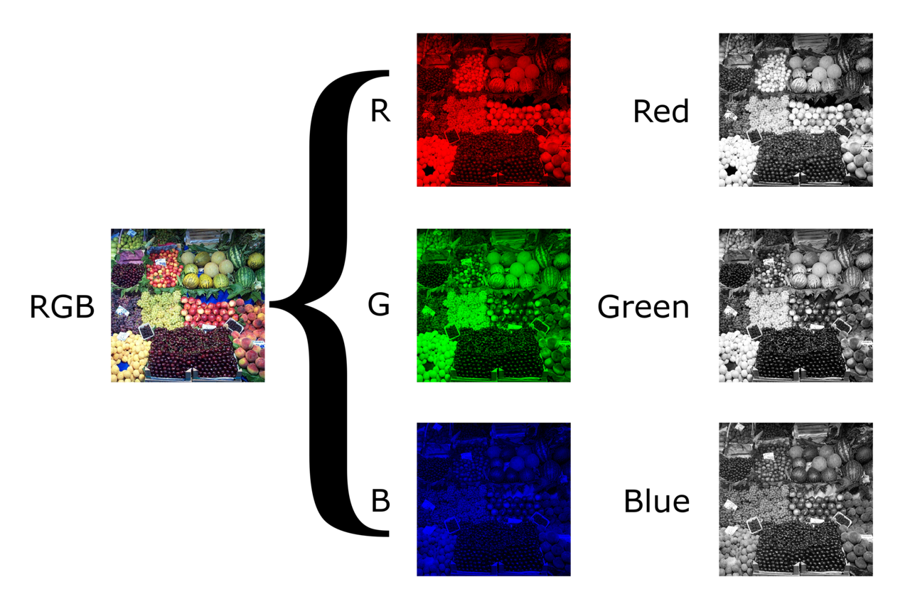

For parallel execution, a number of threads can be provided to the application such that parallel processing can be used by splitting the image into parts (dividing the height by the given number of threads) and computing the sums as seen in the formula.

For distributed execution, the application starts a server configured to listen (via sockets) to worker processes and then treats them similar to the threaded execution, where it partitions the picture into multiple parts that are distributed iteratively to each incoming process connection.

The client application is also provided for connecting to a server process and executing the given task.