Software Requirements Specification
for
ARcardapp
Version 0.1 approved
Prepared by Lauren Keenan
UHI
09.12.24
Table of Contents
Table of Contents ii
Revision History ii
1. Introduction 1
1.1 Purpose 1
1.2 Document Conventions 1
1.3 Intended Audience and Reading Suggestions 1
1.4 Project Scope 1
1.5 References 1
2. Overall Description 2
2.1 Product Perspective 2
2.2 Product Features 2
2.3 User Classes and Characteristics 2
2.4 Operating Environment 2
2.5 Design and Implementation Constraints 2
2.6 User Documentation 2
2.7 Assumptions and Dependencies 3
3. System Features 3
3.1 System Feature 1 3
3.2 System Feature 2 (and so on) 4
4. External Interface Requirements 4
4.1 User Interfaces 4
4.2 Hardware Interfaces 4
4.3 Software Interfaces 4
4.4 Communications Interfaces 4
5. Other Nonfunctional Requirements 5
5.1 Performance Requirements 5
5.2 Safety Requirements 5
5.3 Security Requirements 5
5.4 Software Quality Attributes 5
6. Other Requirements 5
Appendix A: Glossary 5
Appendix B: Analysis Models 6
Appendix C: Issues List 6

Revision History
Name | Date | Reason For Changes | Version

Introduction

Purpose
This document specifies the software requirements of the ARcardapp application version 0.1.
The document covers the scope of the Minimal Viable Product of the full software system.

Document Conventions
Very few typographical conventions are followed in this document. Images are used as a visual aid to explain descriptions of relationships between application components. Feature priorities are given a number between 1-9 where 1 is of Low priority and 9 is of High priority.

Intended Audience and Reading Suggestions
This document is intended for software developers and documentation writers. The rest of the SRS contains descriptions of suggested solutions for meeting requirements outlined in a sister document - ARcard-requirement-document.pdf.
It is suggested that the document is read from beginning to end, but specific points can be navigated to via their headers. System Features for example may be most pertinent to developers reading the document.

Project Scope
The software specified is a lightweight Android application that uses an Augmented Reality (AR) user interface and Artificial Intelligence (AI) to produce a multimedia visual and audio experience triggered by scanning an individual’s business card.
The traditional business card industry faces challenges by using an increasingly obsolete technology that is losing relevance in a digitized world. This technology can be revitalized and brought into the growing world of technology by revisiting the original model and empowering it with AR and AI to create a 3D and audio experience, potentially also making the technology more connective/accessible.

References
ARcard-requirement-document.pdf

Overall Description

Product Perspective
This project is one of many experiments using the emerging technologies of Augmented reality (AR) and Artificial Intelligence (AI). It is a standalone product in that it bears no affiliation with any other product. It should be considered a potential replacement for the traditional, physical business card.

An overview of the software system components and interactions:
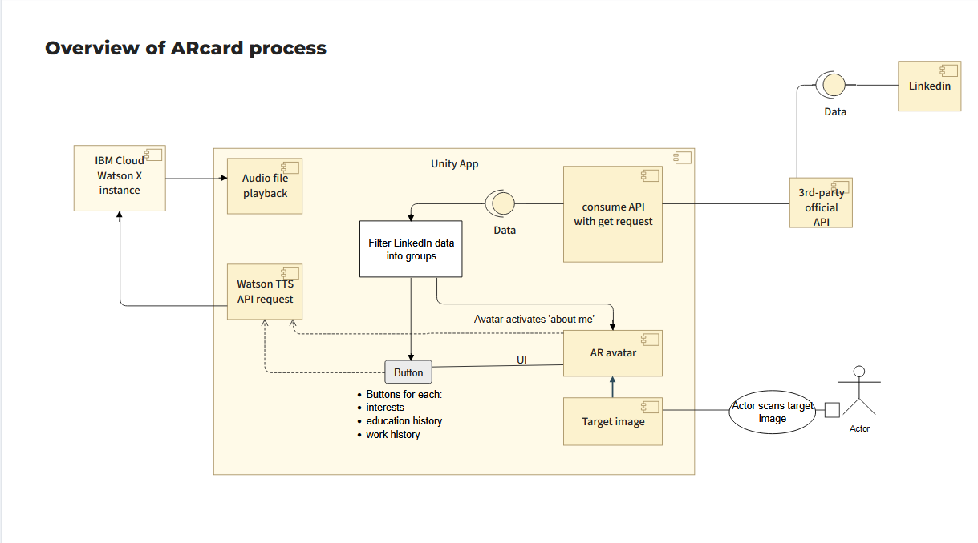

Activity flowchart of the same software system:

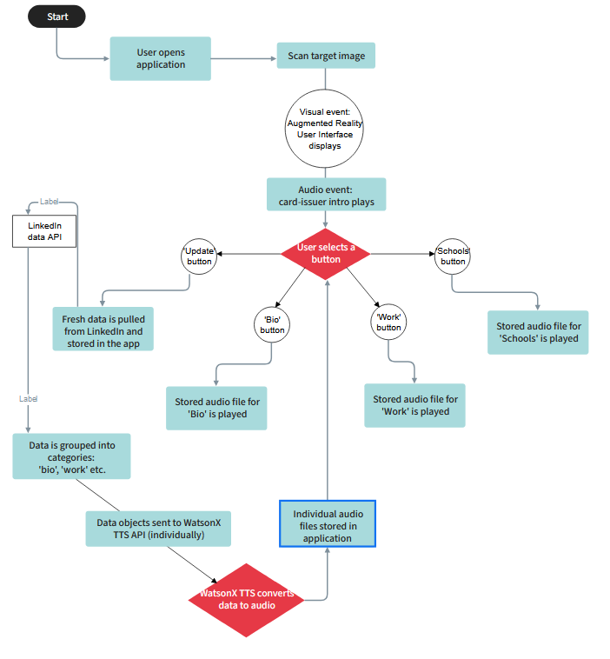

Product Features
An Android app that runs an Augmented Reality User Interface (AR UI)
Scans a specific image to present a 3D AR Avatar
Avatar “reads aloud” card-issuers LinkedIn profile data
Different information can be “read aloud” depending on which UI component is pressed
Users can contact the card-issuer via application

User Classes and Characteristics
User classes expected to use the product are:
Job seekers: High frequency of use, technical expertise insofar as adding their LinkedIn profile
Employers: Low frequency of use, low technical expertise for downloading the app and pressing buttons
Recruiters: Medium frequency of use, low technical expertise as above

Operating Environment
The software will operate on Android devices running Android OS 8.0 Oreo and upwards
It will use data provided from ProxyCurl, an official third-party API of LinkedIn
It will use AI TTS services from the IBM Cloud official domain

Design and Implementation Constraints
The brief requests using LinkedIn profile data in the application.
The application must run on Android devices.
ProxyCurl terms of use must be adhered to and documentation followed.
WatsonX TTS service terms of use must be adhered to and documentation followed.

User Documentation
Instructions to be included in the repository README file.
Video walkthrough of application functionality to be included.

Flowchart to instruct end-users on product use:
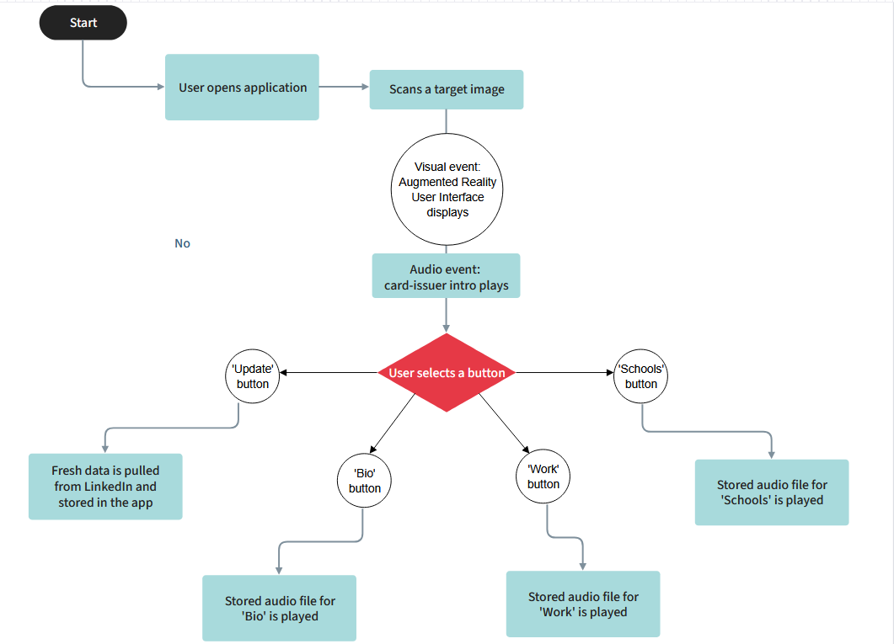

Assumptions and Dependencies
Assuming LinkedIn data or the ProxyCurl API are not always available, requirements to source the data could be subject to change.
Assuming IBM Cloud services become unreachable, requirements to query WatsonX TTS for audio conversion could be subject to change

System Features

App scans target image and produces 3D AR Avatar
3.1.1 Description and Priority
Application allows the user to scan a specific image and produce a 3D AR Avatar onscreen. High priority (9) as visually it is the crux of the software frontend and a leading theme of the project brief. Low cost and high benefit, the feature is foundational to the rest of the software.
3.1.2 Stimulus/Response Sequences
The user should scan a target image to trigger the AR UI and Avatar event. This should in turn trigger an audio event that retrieves an audio file previously stored in the app from an earlier WatsonX request and play it.

3.1.3 Functional Requirements

REQ-1: An AR library must be integrated into the application.
REQ-2: A 3D Avatar must be installed on the app for use.
REQ-3: App must use an AR camera with a registered target image to respond to.

Avatar “reads aloud” card-issuer LinkedIn profile data
3.2.1 Description and Priority
Avatar event plays back an audio file of card-issuers LinkedIn profile data, with specific portions of the data assigned to different buttons in the AR UI. Each button within the AR UI should play-back a different audio file of a different portion of the LinkedIn profile data.
This is high priority (8) as adding this functionality completes the core of what is expected from the project brief. Of medium cost and high benefit, this feature completes the Minimum Viable Product stage of the software.
3.2.2 Stimulus/Response Sequences
The user scans a target image, and an Avatar and AR UI are produced. On sight of the avatar an audio file stored within the app should be retrieved and played, simultaneously “reading aloud” an introduction of the card-issuer. Pressing additional buttons in the AR UI should either update the LinkedIn profile data stored in the app or access an audio file to read aloud a specific portion of the LinkedIn profile data.
3.2.3 Functional Requirements

REQ-1: Application must access LinkedIn profile API data and store it in-app.
REQ-2: Application must access IBM Clouds WatsonX text-to-speech (TTS) service.
REQ-3: LinkedIn data must be organized into categories to be converted into separate files and sent to Watson for conversion
REQ-4: WatsonX response audio files must be stored and played back separately relative to each button in the AR UI

End-users can contact card-issuers from application
3.2.1 Description and Priority
An end-user can contact the card-issuer from through the applications AR UI. This is covered vaguely in the project brief and is of low importance compared to other key features. As the feature’s functionality is only loosely defined and not prioritized in the brief, it is of both low priority and high cost because it requires further research and planning.
3.2.2 Stimulus/Response Sequences
The user could possibly press a button that sends an automatic message to the card-issuers LinkedIn profile or Email address.
Other options include using Watson Speech-to-text STT to allow the user to speak a command to the Avatar to execute the previously explained function. TBD
3.2.3 Functional Requirements

REQ-1: TBD.

External Interface Requirements

User Interfaces
There will be only one app screen, produced with the Avatar AR event
The purpose of each button should be recognizable to the user, using standard icons where possible
The UI should involve as few components as is necessary for the application to function fully.
The UI should meet basic Human Computer Interaction (HCI) standards by being uncluttered and by using recognizable icons where possible
The UI layout should be intuitive and informed by research into customer sentiment

Hardware Interfaces
Application should be supported by Android devices running Android OS 8.0 Oreo and upwards

Software Interfaces
Application communicates with IBM Cloud WatsonX TTS service and server
Communicates with an official third-party LinkedIn Profile API
Application uses Vuforia AR library for Unity
LinkedIn profile data is pulled into the application and stored, categorized and grouped into separate data objects
In the application, data objects are sent as payloads in Watson TTS requests, returning an audio file response
The Watson audio files are stored in the application and played back on button press

Communications Interfaces
Using standard protocols HTTP and TLS in API requests to secure the data packets in transit

Other Nonfunctional Requirements

Performance Requirements
To mitigate overuse of the ProxyCurl LinkedIn API and prevent unnecessary waiting times, request calls will be limited to a specific button in the UI.
This will limit exposure to the API and make the application more secure and resource conscious.

To ensure reuse of the same data, the retrieved LinkedIn data will be stored and used from within the application.

To mitigate overuse of the WatsonX TTS service and over-burdening the application with unnecessary stored files, Watson generated audio files will be stored within the application and overwritten when new files are generated.

New requests for the Watson TTS service will be executed only when the new request payload is different from the previous.

Where possible data will be stored and reused in the application to limit API response waiting times and keep data stored securely within the application.

Safety Requirements
Where possible, data will be stored and reused in the application to limit access and prevent exposure to unnecessary vulnerability outside of the application.

Caching the data will also allow the app to continue to run as normal in the event of external dependencies becoming inaccessible.

The data will be minimally in transit and instead will be held safely within the application, the security of which can be bolstered by following the best practices for the technologies used.

Security Requirements

Accessing ProxyCurl API will be done following the documented best practices for the technology to ensure data security.

Accessing IBM WatsonX TTS service will be done following the documented best practices for the technology to ensure data security.

Software Quality Attributes
Software will be available and accessible, with the UI being simple and intuitive to use.
It will function correctly, as a simple combination of a few core components and an application that stores data to help maintain its integrity.
It will be portable and lightweight, usable on any Android device from Android OS 8.0 Oreo and upwards.
The application will function reliably using a cache of stored data if external data sources cannot be reached.

Other Requirements
The LinkedIn profile data is public, but LinkedIn asks that it is accessed through an official means.

Appendix A: Glossary
Augmented Reality (AR)
Artificial Intelligence (AI)
Application Programming Interface (API)
Text To Speech (TTS)

