MAUIScreenTime – UI usability questionnaire
A combination of questions to collect qualitative feedback on the usability of the UI.

Likert scale for (on a scale of 1-5) questions:
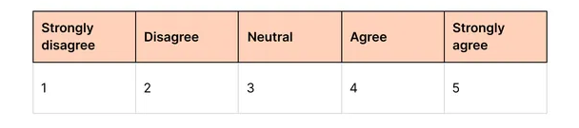

Opening & Warm-up Questions
Can you tell what this product does, just by looking at it? Y/N

On a scale of 1-5, how trustworthy do you find the app based on the layout?

What about the layout makes you feel it’s trustworthy or not?

Where would you look on the screen to find your CO2 emissions per minute?

Usability & Navigation Questions
- Did you find it easy to look for the CO2e of your screen time? Y/N

- On a scale of 1-5, how easy was it to navigate this screen?

- What is the most confusing part of this layout?

Visual Design & Emotional Response Questions
- On a scale of 1-5, how eco-friendly does the colour scheme feel?

- Does this design look trustworthy and professional to you? Y/N

- Does anything make you feel frustrated while looking at this, if so, what?

Feature & Functionality Questions
- Can you clearly see where data is displayed on this screen layout? Y/N

- On a scale of 1-5, how clear and organised do you find this layout?

- What do you think is missing from this interface?

Closing & Strategy Questions
- What, if anything, about this layout would make you stop using this application?

- Based on what you've seen, what would make you want to use this product daily?

Thanks for your time and participation

