APPLIED SOFTWARE DEVELOPMENT

Software Project Initiation and Planning UI110021

COURSEWORK REPORT

Software Requirements Specification

Student Name:......Lauren Keenan........................................
Student ID: ....19015831..............................

SUBMISSION DATE: ………………………………..

WORD COUNT: ................... Words

Declaration by the student: | Tick
I have completed this assigned work by myself, in my own words and using my own notes, figures or rough workings (except where group work specifically forms part of the assignment). | X
I have acknowledged fully any sources used by means of in-text citations, and the creation of a List of References in the UHI approved system of UHI referencing. | X
I have endeavoured to ensure that my work has not been made available for copying by other students (with or without my permission). | X
In submitting this work for assessment, I agree to be bound by the conditions laid out above, and by the latest version of the UHI academic regulations. | X
I confirm that I received information about the use of Turnitin and was directed to Turnitin training. | X
I understand that this assignment will be submitted to Turnitin for originality checking. | X
In submitting this work, I confirm that I have read and understood UHI regulations and am aware of the possible penalties. | X

Project Details
Project Title: MauiScreenTime
Course: BSc (Hons) Applied Software Development
Team Members: Lauren Keenan, Martin Cameron, Marta Grazia, Gracjan Blazejowski, Dainis Lektovskis, Matthew MacLellan, Kenneth Douglas

Revision History
Version | Date | Description
1.0 |  | Initial Draft
1.1 | 20/11/2025 | Final Draft

Definitions, Acronyms, and Abbreviations
Table of abbreviations etc. used.
Term | Definition
API | Application Programming Interface
GDPR | General Data Protection Regulation (EU)
MAUI | Multi-platform App UI
SRS | Software Requirements Specification
SQLite | Self-contained, serverless database engine
WCAG | Web Content Accessibility Guidelines
App | Application

Introduction (200 words)

Overview
This SRS includes a complete description of all functional and non-functional requirements for the development of the MauiScreenTime screen time tracker. Designed as a digital wellbeing tool to help users track screen time across social media applications, the application will convert minutes spent into CO2e and compare the physical impact of digital behaviours with natural world CO2 sink events.

Purpose
The application is designed as a tool for mitigating social media and phone addiction, as “In 2025, 61% of smartphone addicts said social media was the primary reason they couldn’t reduce their phone usage.” (Lee. 2025). By tracking user digital habits, weighing usage data against their CO2eq cost and comparing the cost to natural world events, the application aims to offer alternative reading and outdoor activities. The end goal is to help wean users off of highly addictive social media apps by encouraging engagement with the outdoors, to benefit both the health of the user and the greater environment as it is widely documented that exposure to our natural environment is greatly beneficial to our overall physical and psychological health (Surg. A. et al. 2023), (Jimenez. Et al. 2021).

Scope
In Scope:
- Local tracking of social media application usage time
- Conversion of app usage minutes into CO2eq (Derudder. 2021)
- Weekly usage reports of usage increase and decrease
- Local tree planting coordination, rewards for meeting screen time reduction goal
- GDPR-compliant consent management
- Local SQLite database storage
- Daily and weekly usage statistics and summaries
- Monitoring major social media platforms
- User data deletion and consent withdrawal
Out of Scope:
- Cloud synchronization or backup
- Multi-device data aggregation
- Social media content analysis
- Screen recording or screenshot capture
- Network traffic monitoring
- Browser-based social media tracking
- Push notifications and reminders (future enhancement)
- Usage goals and limits enforcement (future enhancement)
- Detailed analytics and data visualisation (future enhancement) (Keenan, 2025)

2. Overall Description (equivalent to 300 words)

2.1 Product Perspective
The application exists on an android device and using the native Android API, retrieves phone usage data. This data is relayed back to the MauiScreenTime app for CO2eq conversion and is displayed to the user (Figure 1).
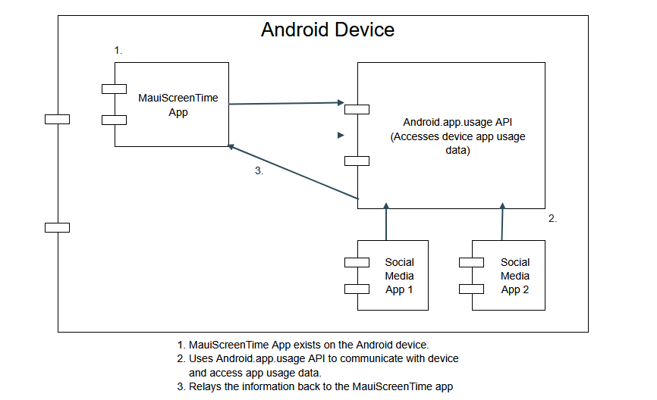
Figure 1: Component Diagram (Keenan, 2025a)

2.2 Product Functions
The application tracks social media screen time, converts usage to CO2eq, comparing the CO2e cost to natural CO2 sink events. Habitual usage is logged and reported, and decreases in user activity are summed to meet predetermined goals that equal tree planting aided by local initiatives (e.g. “Xg = 1 Tree planted”).

2.3 User Classes and Characteristics
The application should meet WCAG (For non-web and software) success criteria for accessibility (WCAG Consortium. 2025) such as:
(WCAG 1.3.1, 1.3.2, 2.4.3, 3.2.4) – Application presentation should be intuitive or labelled, and follow a meaningful sequence. Page navigation should be clearly signposted, with focussed components repeating in design for consistency identification .
(WCAG 1.3.3, 1.4.1, 2.4.2, 2.4.6) – Pages should be titled and app to be clearly signposted with appropriate headings and labels, not relying on the sole use of colour, shape and design to describe the sequence or functionality of the app.
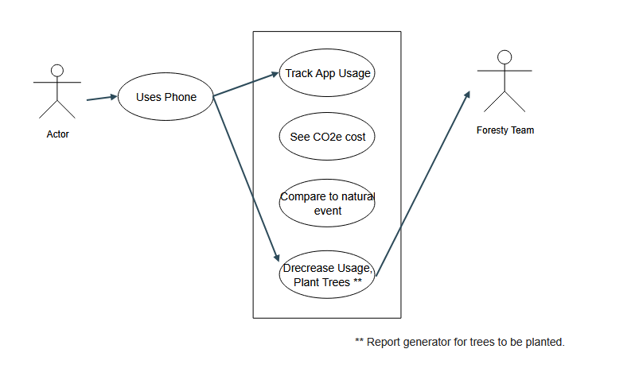
Figure 2: Use case diagram (Keenan. 2025a)
A use case diagram (Figure 2) features an actor visiting apps on their phone, screen time data being collected and processed, and CO2eq reduction goals being generated into a report for outside actors (UHI Forestry and Sustainability students) to plant trees equivalent to users decreased phone activity.

2.4 Operating Environment
The application must be low-performance and require maximum 50MB of space in device storage. It must be readable and usable “on-the-go” or in any environment.

2.5 Design and Implementation Constraints
Programming language must be accessible to the development team for streamlined onboarding. Framework must build to Android, ideally to cross-platform for future enhancements. Development environment must integrate with git source control for ease and robustness during development. Application must be built to follow GDPR when handling data, to be legally compliant.

2.6 User Documentation
A small video of the wireframe prototype will be recorded, with an audio instructional overlay recorded to explain in simple terms the functionality of the app, frame by frame.
Should the application be published to the Google play store, additional screenshots and an app description will be added to the listing also. The project README.md file will also include information on key features and points of functionality.

2.7 Assumptions and Dependencies
Assumptions:
- Users will have Android 5.0+ (API 21+) devices
- Users will be willing to grant permissions for data collection
- Users will understand basic smartphone use
- Targeted Social media apps will be installed through official app stores
- User Devices will have sufficient storage space (Min 50MB)
- Users read and understand English (initial version)
- Users will be 18+ and have legal capacity to provide consent

Dependencies:
- .NET MAUI 9.0+ framework and runtime
- Android UsageStatsManager API
- SQLite database engine
- Device file system access for local data storage
- Google play store distribution
- GDPR Compliance framework and legal review

3. Specific Requirements (equivalent to 400 words)

3.1 Functional Requirements
**App launch and Consent Management System:**
- 1. App Launch and Initialisation: The system should initialise the database, check for permissions and verify user consent upon the app launch
- 2. Permission request: The system should use Android API to request usage permissions through the device system settings
- 3. Consent Management: The system should present a clear privacy notice and receive explicit user consent before tracking any personal data
- 4. Consent Withdrawal: The system should allow for users to withdraw their consent at any time for data collection.
- 5. Data deletion: The system should allow users to delete their data at any time
- 6. Consent versioning: The app should track policy versions users have consented to, in order to ask for consent on updated data policies

**Screen Time Data Collection & Processing**
- 7. Usage Data Collection (Android API): The system should collect usage statistics like foreground time from the Android UsageStatsManager API for a predetermined list of social media applications
- 8. Social media app detection: The system should identify and only track a predetermined list of social media apps
- 9. Data Storage: System should store all usage data locally on the device
- 10. Daily, Weekly usage display: The application should display the current day or weeks usage statistics including daily and weekly total time spent per application
- 11. Data Insights: Daily and weekly total usage should be compared with previous entries to report any increase/decrease in app usage
- 12. Data and Insights should be mapped and displayed clearly and understandably to the user
- 13. Usage Time formatting: The system should convert milliseconds into hours and minutes for readability
- 14. Data retention: The system should only retain personal data for as long as is necessary for the app to function
- 15. Total usage calculation: The app should show the sum of each tracked apps usage

**Error Handling and Usability**
- 16. Error handling: The system should handle errors gracefully and direct users to potential fixes within the app, or return empty datasets when errors occur to prevent system crashes.
- 17. Loading indicators: The app should show loading indicators to show the application is running and not broken

** CO2eq Conversion and Comparisons**
- 18. CO2 calculation: The app should show the sum of CO2eq accumulated by app usage
- 19. Natural World Comparisons: A data table of natural world CO2 events should be accessed to present users with natural CO2 sink events, approximate to their decrease in CO2e emissions
- 20. Reporting: User daily and weekly decrease in app usage should show in CO2e and log to local data table, displaying by order descending as a "personal best" score board
- 21. Tree Scoring: App should accumulate user decrease in CO2 and when target "Xge" is met, "Tree Planted" database value is increased by 1
- 22. Tree Planting: App should report monthly to an external database where trees planted by all users can be totalled and the information passed on to forestry team

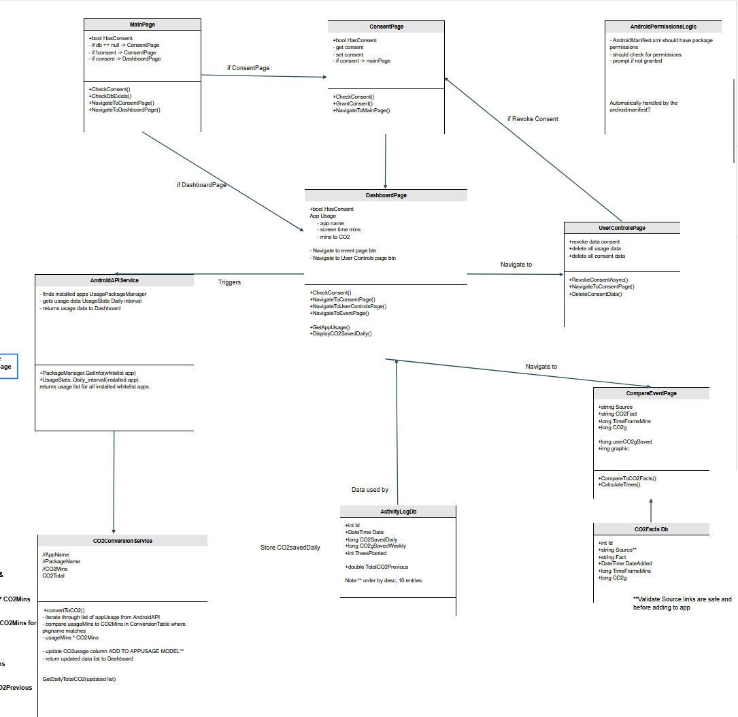
Figure 3: Overall system UML (Keenan. 2025a)
Figure 3 explains the overall architecture of the application by page and logic service. The top half concerns the user journey through the consent system. The lower half explains the Dashboards’ use of the android API service and CO2eq conversion service. The collected and processed usage data is then stored locally in a data table ActivityLogDb, and cross referenced to entries in the CO2 facts data table of nature facts where an approximate comparison between the user activity and natural world is then displayed in the Event page.

3.2 Non-Functional Requirements
Performance -
- Low Resource Consumption, app should avoid impacting device battery and overall performance
- Reasonable Start up Time, app should launch within 4 seconds when tapped
- Low Crash Rate, app should handle errors gracefully by returning empty datasets on failed database operations, and providing users with useful error messages as an alternative to system crashes.
- Accurate Data Collection, app should collect data accurately, ideally without missing session information.
- Timely data delivery, app should deliver up-to-date (to the day) and relevant usage tracking
Security -
- All personal data should be stored in a private storage directory, inaccessible to other applications.
- Ideally no direct, unprocessed personal data will be transmitted over any network connection
- Sensitive data will not be logged in system or debug logs in production
- Database queries should use parametrised statements
- The app should use proper disposal patterns for database connections to prevent memory leaks
- User consent should be logged with timestamps for tamper-proofing and app auditing
- The app should operate with POLP (Principle of Least Privilege) to prevent unnecessary exposure of sensitive data
Usability (ICO)
- Logical flow, app structure and layout should be logical, intuitive and easy to navigate
- The privacy notice should include a summarised cliff-notes version easily understandable by the user.
- Text should remain at a standardised size ratio for readability
- Critical actions like data deletion should require confirmation before execution
- Tracked app usage data should be readable, simple and understandable within the layout

3.3 External Interface Requirements

User Interfaces
The basic user interface is modelled on the standard Android wellness app. Unique features are being mapped in a full wireframe to reflect the overall UML.
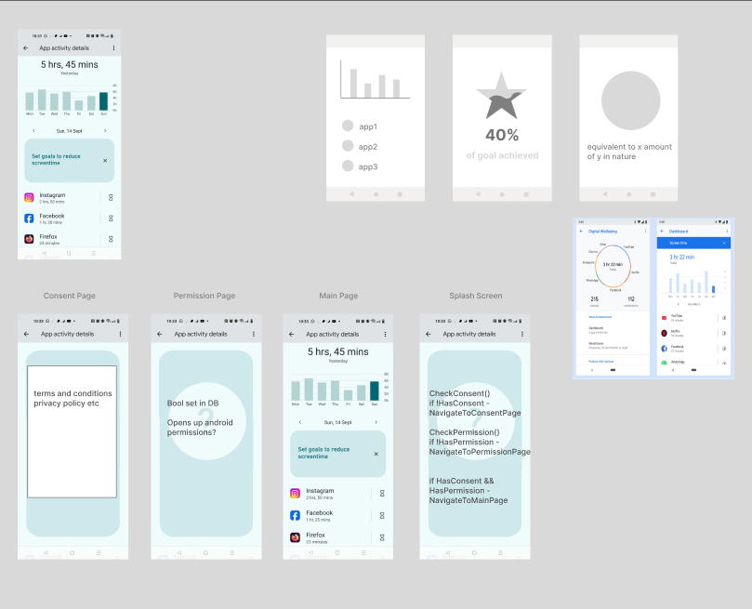
Figure 4: Initial stages of wireframe (Keenan, 2025)

Hardware Interfaces
Hardware interfaces required are any android device featuring Android v 5.0 api 21+

Software Interfaces
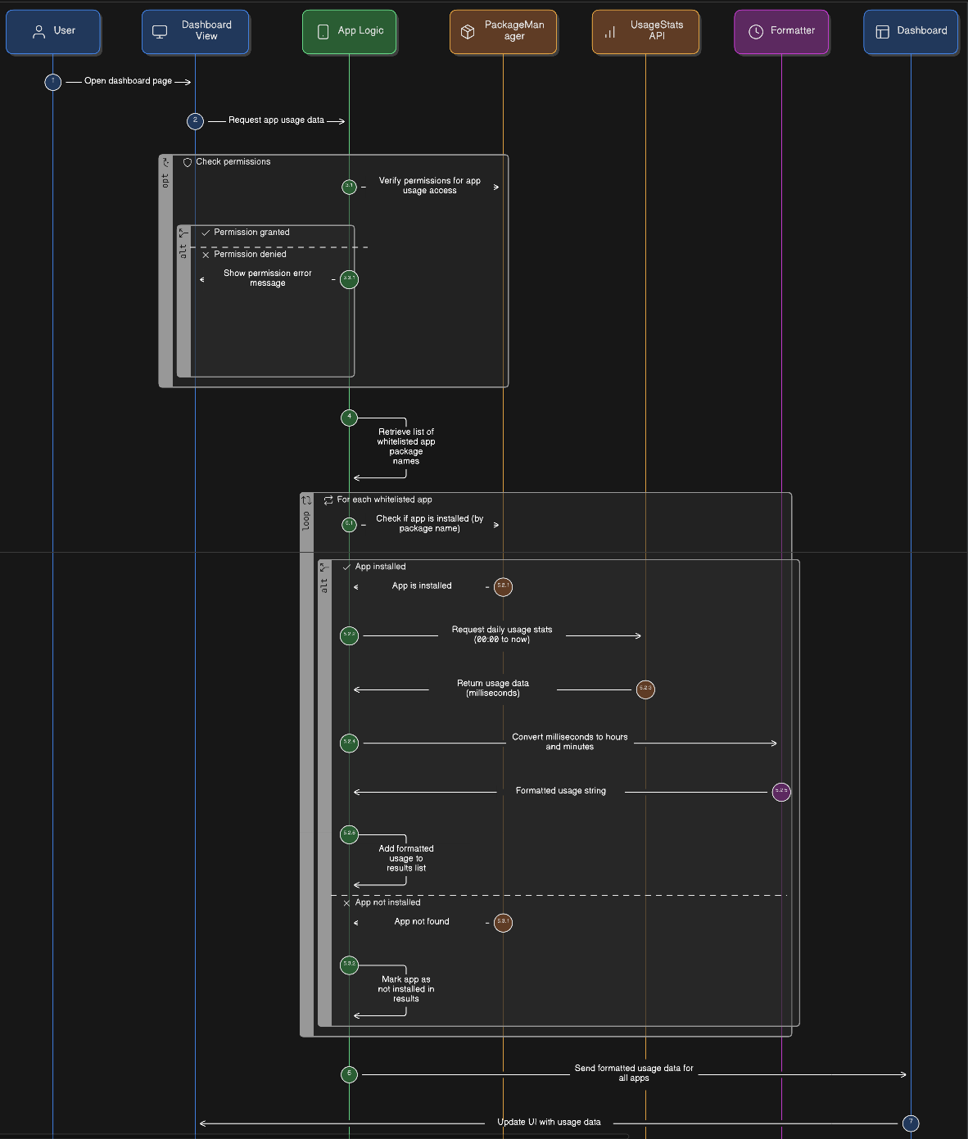
Figure 5: Android API UML (Keenan. 2025b)
The Android Usage API (Figure 5) is consumed by the MauiScreenTime application in a service that checks for API permissions granted by the user, and retrieves usage data collected natively by the android device.

Communication Interfaces
The Android.app.usage API will require and request user permissions to track and collect app usage data by AndoidUsageManager.

4. Other Requirements (100 words)
The application is designed with user data protections in mind, as such everything that can be achieved offline will be built to happen offline in order to mitigate risk to the users personal data.
The database shall use SQLite version 3.x or higher. The database file will be located in the application's LocalApplicationData directory and should maintain an index on (PackageName, Date) for AppUsages table to optimise common queries.
- The app should comply with GDPR Article 6 (Lawfulness of processing) through explicit consent.
- The app should comply with GDPR Article 7 (Conditions for consent) with direct and understandable consent requests.
- The app should comply with GDPR Article 15 (Right of access) by displaying all stored user data.
- The app should comply with GDPR Article 17 (Right to erasure) through users ability to completely delete their data. (Intersoft Consulting. 2018)

Researched and applied to funding from the Prickly Thistle Rebel Fund for innovative project ideas (Keenan. 2025c).

A risk register has been compiled based on research into common risks to other relevant software, identifying and prioritising each risk by likelihood and level of significance. Sorted risks are then reviewed for mitigation strategies (Keenan. 2025d).

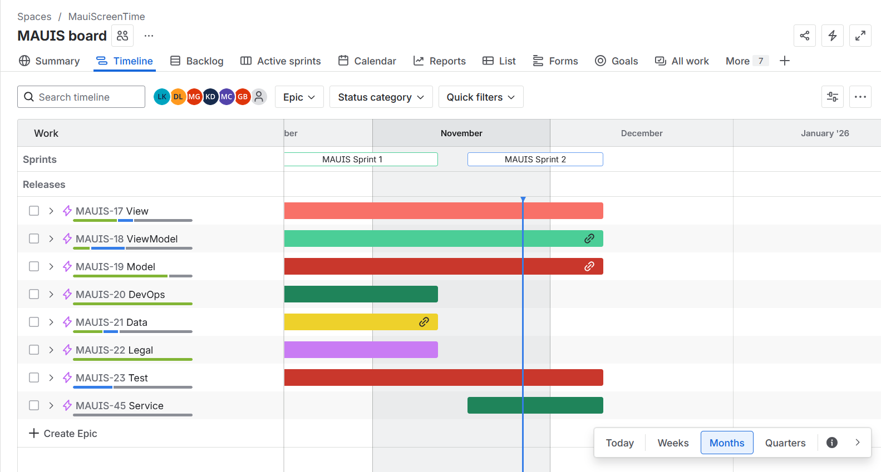
Figure 7: MAUIS board Gantt Chart (Keenan. 2025e)
(Figure 7) Evidence of tasks viewed by task-type, spanning across first sprints of the project within the JIRA tool used for project management.

5. References
Lee, R. (2025) Smartphone Addiction Statistics 2025: Alarming Trends and Insights, Smartphone Addiction Statistics 2025: Alarming Trends and Insights - SQ Magazine. Available at: https://sqmagazine.co.uk/smartphone-addiction-statistics/ (Accessed: 25 November 2025).
Surg, A. et al. (2023) Link between excessive social media use and psychiatric disorders, Link between excessive social media use and psychiatric disorders - PMC . Available at: https://pmc.ncbi.nlm.nih.gov/articles/PMC10129173/ (Accessed: 11 November 2025).
Jimenez, M. et al. (2021) Associations between Nature Exposure and Health: A Review of the Evidence, Associations between Nature Exposure and Health: A Review of the Evidence | MDPI. Available at: https://www.mdpi.com/1660-4601/18/9/4790 (Accessed: 26 November 2025).
WCAG Consortium (2025) Guidance on Applying WCAG 2.2 to Mobile Applications (WCAG2Mobile). Available at: https://www.w3.org/TR/wcag2mobile-22/ (Accessed: 20 November 2025).
Intersoft Consulting (2018) General Data Protection Regulation GDPR, General Data Protection Regulation (GDPR) - Legal Text. Available at: https://gdpr-info.eu/ (Accessed: 22 November 2025).
Keenan, L. (2025c) laurenk_personal_repository_2025/daily_logs /09.15-simpleplan.md, laurenk_personal_repository_2025/daily_logs /09.15-simpleplan.md at main. Available at: https://github.com/TortoiseLeaf/laurenk_personal_repository_2025/blob/main/daily_logs/09.15-simpleplan.md#rebel-fund-notes (Accessed: 26 November 2025).

6. Appendices
Derudder, K. (2021) What is the environmental footprint for social media applications? 2021 Edition, What is the environmental footprint for social media applications? 2021 Edition - Greenspector. Available at: https://greenspector.com/en/social-media-2021/ (Accessed: 25 November 2025).
Keenan, L. (2025) MauiScreenTime, MauiScreenTime - Figma. Available at: https://www.figma.com/design/SBJZizpiDgiixLuUBQQSz8/MauiScreenTime?node-id=0-1&p=f&t=Yqg0SGbOJdoGvsi3-0 (Accessed: 22 November 2025).

Keenan, L. (2025a) UML Component Diagram, UML Component Diagram - UML Component Diagram - Moqups. Available at: https://app.moqups.com/D97l8oJK6qShGe2DNts1beDq3X2Ts90W/view/page/ab0c2effe (Accessed: 11 November 2025).
Keenan, L. (2025b) androidAPIUML.png, MauiScreenTime/images/androidAPIUML.png at documentation - TortoiseLeaf/MauiScreenTime. Available at: https://github.com/TortoiseLeaf/MauiScreenTime/blob/documentation/images/androidAPIUML.png (Accessed: 25 November 2025).
Keenan, L. (2025d) laurenk_personal_repository_2025/UI_Enterprise_Transformation /LO1.xlsx, laurenk_personal_repository_2025/UI_Enterprise_Transformation /LO1.xlsx at main. Available at: https://github.com/TortoiseLeaf/laurenk_personal_repository_2025/blob/main/UI_Enterprise_Transformation/LO1.xlsx (Accessed: 26 November 2025).
Keenan, L. (2025e) MAUIS board, MAUIS board - Timeline - JIRA. Available at: https://uhimoraydev.atlassian.net/jira/software/c/projects/MAUIS/boards/4/timeline (Accessed: 26 November 2025).

