End-Report MauiScreenTime
To summarise activities, we have designed and developed the full minimum viable product for Android devices and it’s being released on Google Play. Development is still underway for iOS. Lauren travelled to Inverness to introduce the app to forestry students, Desi and Lauren created marketing materials to advertise the app to more students across UHI and the app was sent to students who wanted to participate in beta testing.
Feedback was slim compared even though a large group of testers participated! Feedback that was collected provided useful insights into technical problems that the team then resolved, and also gave insights into how to make the app a better experience for future users. This has all been integrated into project planning and has been either actioned already or infused into plans for future development. A key insight identified is that not all users consume the same amount of media, even within the same demographics and focus groups.
Overall feedback and community response to the app idea was positive, with a niche audience across demographics showing definite genuine interest into using the product.
The forestry department were unable to arrange an event with local authorities for tree planting operations, Desi then tried herself and was unable to arrange with the local authorities either, and Lauren then tried a personal contact who had nothing available themselves; by which point the project deadline had been reached.
Pictures of the app – Minutes screen and Carbon screen:
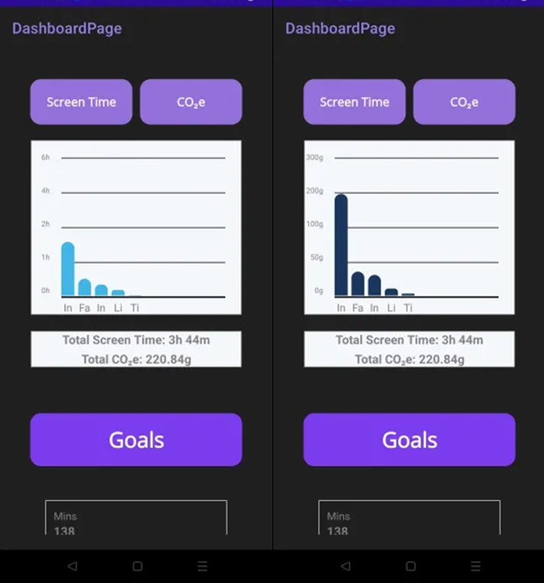

Poster/digital flyer made by Lauren and Desi:
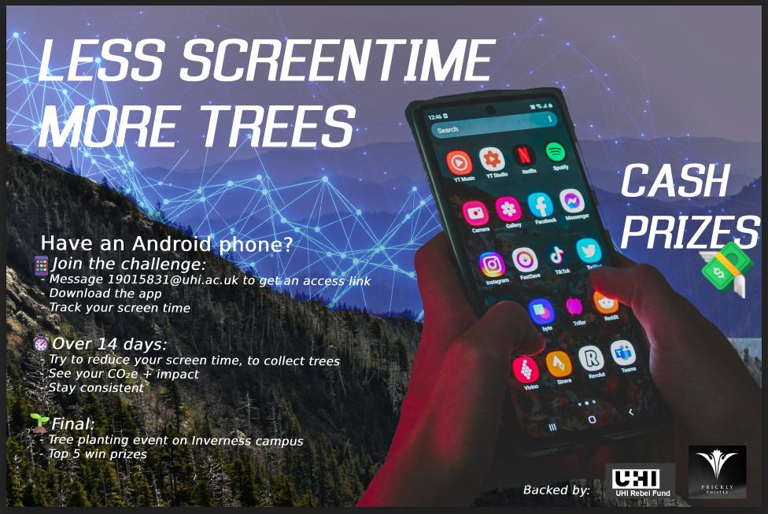

Social media post links:
First: link to first post
Second: Link to second post
Third: Link to third post
Final: Link to final post

