Quality Assurance Plan
Advanced Research
Lauren keenan
2025

Contents
1. Introduction & Objectives 3
2. QA Roles & Responsibilities 3
3. Quality Standards & Best Practices 3
4. Agile Testing Approach 3
5. Test Strategy 3
6. Continuous Integration & Deployment (CI/CD) 4
7. Defect Management & Tracking 4
8. Acceptance Criteria & Definition of Done (DoD) 4
9. Risk Management & Mitigation 4
10. Continuous Improvement & Feedback Loops 4
11. Compliance & Regulatory Requirements 5
12. Tools & Technologies 5
13. Conclusion 5
References 6

1. Introduction & Objectives

The purpose of this QA plan is to outline the scope of the project for both developers and stakeholders to be transparent on the project stages, goals, and their definition of done (DoD).

The original project scope as defined by the brief is to produce an application that runs on Android devices, and uses Augmented Reality (AR) and Artificial Intelligence (AI) to scan a traditional business card and create an audio and 3D visual experience. The application should produce a 3D avatar that receives data from the cardholders LinkedIn profile, and using IBM Watson’s text-to-speech AI reads the information aloud to the end user.

Criteria to be met for this projects success are:
Application should run on Android devices – scene render tests
Application can scan cardholders business card, and produce an AR UI with Avatar – test AR camera runs
Avatar should appear on scanning – test the game object has rendered
AR Buttons should appear on scanning – test the game object has rendered
On the AR UI event, Avatar should briefly introduce the cardholder and application – test Watson event
Buttons should provide audio playback – test audio file is played on button press
Data should be pulled into the app - test LinkedIn data is received
Data should be sent to Watson – test the data is sent to Watson

The Projects’ Key quality goals and their alignment with Agile principles are:
The project aims to deliver value early in order to initiate the stakeholder feedback loop from as early as possible in the product development lifecycle. “Early and continuous delivery of value to customer…Deliver working software frequently.” (AgileAlliance, 2025a)
This is achieved by establishing a Continuous Integration/Continuous Development (CI/CD) pipeline which builds releases of a minimum viable product (MVP) from early in the project.
Feedback is collected at regular sprint reviews and suggestions are made for product improvement. This ensures the product is developed with stakeholders needs constantly in consideration at every stage. “Welcome changing requirements, even late in development.” (AgileAlliance, 2025b)
Delivering a bare minimum of working features ensures the software always comprises of basic functionality. “Working software is the primary measure of progress.” (AgileAlliance, 2025c)

2. QA Roles & Responsibilities
What to Include:
Team Roles:
- Lauren Keenan – Project lead, Developer, Delivery Operations (DevOps), Testing
- Marta Grazia – Developer, Frontend, WatsonX integrations

Responsibilities:
- Project lead is Scrum master, should facilitate the team in self-organizing. Evidenced by the team JIRA scrum board. (Jira, 2025)
- DevOps ensures the a production pipeline is in place to build and ship the product.
- Developers design and execute test cases to find bugs, thoroughly testing functionalities.
- WatsonX integrations are essential for the product main USP, a “talking” app. Evidenced in Marta’s development branch. (Github, 2025)

3. Quality Standards & Best Practices
Following descriptive naming conventions and using camel case per official technology best practices keeps the code readable and functional.
Basic Unit tests ensure the application functions correctly when built. These added to the production build pipeline ensure the application is only published if it builds correctly, protecting the end product from being incorrectly built. (GitHub, 2025a)
Security and compliance has been considered by following best practices for the APIs the application uses. As the data is public and the application does not require authentication, accessing the appropriate endpoints for example is a way in which we comply with security.
This complies with GDPR because API developers are compelled to build APIs with inbuilt security protocols to ensure safe data transfer. (Author, 2023)

4. Agile Testing Approach
Test-Driven Development is a methodology characterised by writing specific tests to test functionality before any functions are programmed. As the test precedes the code, the functions are then written to fit the specification of the tests. This ensures functionality of the application.
Although this is a thorough strategy that ensures quality, as a team of two the process is simply too resource-consuming to be used efficiently. This would push project development beyond release deadlines.
The project instead uses Test-Later Development (TLD) which as the name suggests is the opposite of TDD. A benefit of this methodology is that with a better understanding of the code, tests can be written in a more bespoke manner and arguably can be more effective and reduce redundancy in unnecessary tests. (Hu, 2022)

5. Test Strategy
Manual testing is when humans manually test the software themselves whereas automated testing relies instead on written tests in code to automatically test the software. Automated testing is resource-conservative, is useful for software scalability and is also highly accurate for repetitive tests.
Manual testing can be useful for testing features that require human intuition, and is essential for assessing user experience. (Son, 2024)
The project uses automated unit testing, with plans to use integration or API testing as a means of end-to-end testing to better check the health of component interactions. The project also plans to introduce manual testing later in development in order to gauge ease of use and effectiveness of the user experience (UX).

6. Continuous Integration & Deployment (CI/CD)
The version control used it GitHub, it maintains a version of the project that all team members can access and contribute to.
Builds are automated in Unity’s own solution Unity Cloud where the project is built to publish. Automated tests are added as a stage of the production build, to ensure functionality of the published application and deny builds which fail tests.
Using a Blue-Green strategy of having two almost identical releases in production, where one can be live when another undergoes updates is a deployment strategy that would be useful for the project when the final release is met and published. In this way development can continue to the product without downtime. For now, in development, this deployment strategy is not yet necessary.
(BasuMallick, 2022)

7. Defect Management & Tracking
JIRA is used for project management and for bug reporting. Developers log bugs they encounter in tickets marked with the “bug” flair. They are added to the sprint and treated as objectives/deliverables for that sprint.
Bugs are prioritised by their severity and by the time predicted to be taken resolving them.
By logging bugs transparently and dealing with them in a timely manner, the team will be following JIRA best practices for bug reporting.
https://deviniti.com/blog/application-lifecycle-management/bug-tracking-in-jira-software/

8. Acceptance Criteria & Definition of Done (DoD)

Creating test cases based on user stories, when the tests for these cases pass the criteria for DoD can be considered fulfilled. Guidelines for defining acceptance criteria for user stories. (Keenan, 2025)
Each change pushed to the code undergoes code review, and automated tests are run before merging. Automated tests are again run in the production CI/CD pipeline and changes are published when tests pass.

9. Risk Management & Mitigation
The International Organization of Standardisation (ISO) have published a risk management framework ISO 31000 that names identifying, categorising and prioritising risks by probability and severity as essential for security and performance compliance.
https://www.techtarget.com/searchsecurity/definition/ISO-31000-Risk-Management
This can be followed successfully by creating risk matrices. This is one created for the project.
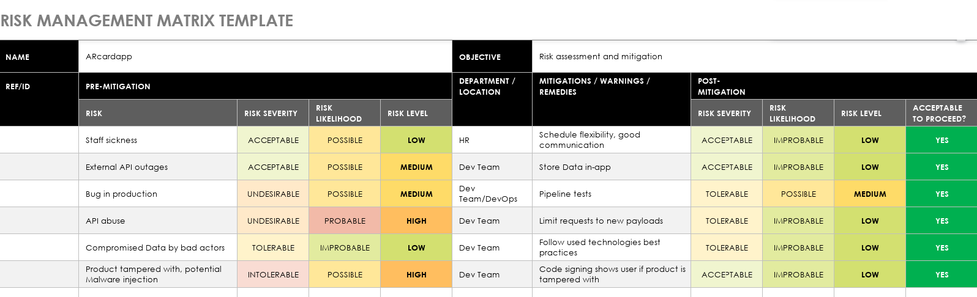
(Keenan, 2025a)

10. Continuous Improvement & Feedback Loops
Sprint retrospectives are held continuously to garner and action stakeholder feedback. This ensures product development aligns closely with customer needs.
Root cause analysis (RCA) is used to focus on the root cause of an issue to resolve the problem directly, rather than to simply treat the symptoms.
Defects are treated in situ during sprints and releases consist of reviewed and user tested code.

11. Compliance & Regulatory Requirements
Using official APIs correctly and safely according to documentation. Only storing public non-sensitive data on the app. Application requires no special permissions to run on end-user devices. These things all comply with GDPR as the safest way to deal with data is to only collect and use what is bare minimum necessary.

12. Tools & Technologies
The project uses GitHub and Git for version control, which allows different versions of the project to be saved and accessible to all team members during development.
Testing framework used is the Unity Test Framework (UTF), an inbuilt library provided by the Unity Editor that project is developed in. This allows for functions of the application to be tested thoroughly ensuring functionality.
CI/CD tools for the project are GitHub and Unity Cloud, where the GitHub source control works with Unity’s cloud solution to take changes from the source code and build the application where it will be published for production. The output published is then available for installation on end-users devices.
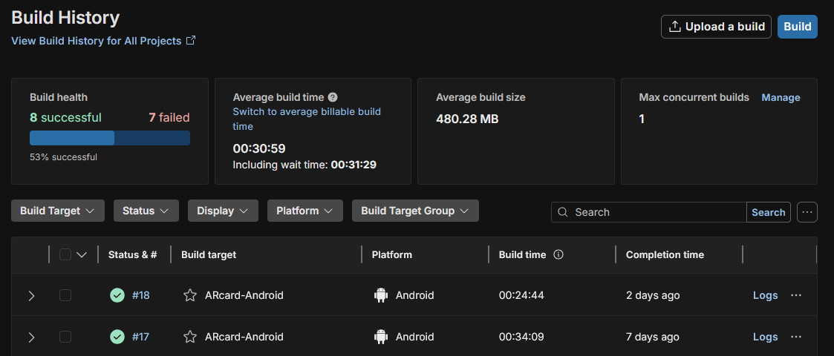
(Unity, 2025)

Bug tracking system used for the project is JIRA, where the bulk of the project management takes place. Bugs are logged as tickets and addressed within active sprints, or shelved in the project backlog depending on their severity. (Jira, 2025)

13. Conclusion
In this document we have explored in detail the scope of the project and DoD for both developers and stakeholders to be transparent on the project stages, goals, and their measures of completion.
This process has involved looking at the technical and project management tools including software source control and production build pipelines, along with security and risk mitigation which has given me a renewed interest and clearer understanding of where Quality Assurance procedurally fits into these software development tools which I am already quite familiar with.
I am hopeful to continue my learning by further integrating these practices into future projects.

References

AgileAlliance (2025) The 12 Principles behind the Agile Manifesto, The 12 Principles behind the Agile Manifesto | Agile Alliance. Available at: https://www.agilealliance.org/agile101/12-principles-behind-the-agile-manifesto/ (Accessed: 04 April 2025).
Jira (2025) ARC Sprint 4, ARC Sprint 4 - AR-card-project board - Scrum board - Jira. Available at: https://uhi.atlassian.net/jira/software/projects/ARC/boards/210 (Accessed: 09 April 2025).
Github (2025) Commits, Commits . TortoiseLeaf/ARcardapp. Available at: https://github.com/TortoiseLeaf/ARcardapp/commits/arc-47 (Accessed: 09 April 2025).
GitHuba (2025) ARcardapp/Assets/Tests /SceneTest.cs, ARcardapp/Assets/Tests /SceneTest.cs at main . TortoiseLeaf/ARcardapp . GitHub. Available at: https://github.com/TortoiseLeaf/ARcardapp/blob/main/Assets/Tests/SceneTest.cs (Accessed: 2025).
Author, G. (2023) GDPR Compliance For API Developers, GDPR Compliance For API Developers . Available at: https://www.cookielawinfo.com/gdpr-compliance-api/ (Accessed: 2025).
Hu, T. (2022) Test-driven vs. test-later development: when should you write your tests?, Test-driven vs. test-later development: when should you write your tests? - Codecov. Available at: https://about.codecov.io/blog/test-driven-vs-test-later-development-when-should-you-write-your-tests/ (Accessed: 2025).
Son, H. (2024) Manual Testing vs Automated Testing: Key Differences. Available at: https://www.testrail.com/blog/manual-vs-automated-testing/ (Accessed: 2025).
BasuMallick, C. (2022) What Is Blue Green Deployment? Meaning, Benefits, and Challenges, What Is Blue Green Deployment? Available at: https://www.spiceworks.com/tech/devops/articles/what-is-blue-green-deployment/ (Accessed: 2025).
Keenan, L. (2025) 04.11-userStories.md, BitLaurenK / laurenk_personal_repository_2024 / daily_logs / 04.11-userStories.md -- bitbucket. Available at: https://bitbucket.org/BitLaurenK/laurenk_personal_repository_2024/src/master/daily_logs/04.11-userStories.md (Accessed: 2025).

Keenan, L. (2025a) arcard-risk.png, BitLaurenK / laurenk_personal_repository_2024 / notes/ arcard-risk.png -- bitbucket. Available at: https://bitbucket.org/BitLaurenK/laurenk_personal_repository_2024/src/master/notes/arcard-risk.png (Accessed: 2025).
Unity (2025) Build History, ARcardapp | Build History - Unity Build Automation | Unity Cloud. Available at: https://cloud.unity.com/home/organizations/5773728346579/projects/01eb85a9-4e74-474c-995a-9dd78047e8ea/cloud-build/history (Accessed: 09 April 2025).
Jira (2025) Issues, AR-card-project - Issues - Jira. Available at: https://uhi.atlassian.net/jira/software/projects/ARC/issues/?jql=project%20%3D%20%22ARC%22%20ORDER%20BY%20created%20DESC (Accessed: 10 April 2025).

