- Identified Problem
Software across different deployment strategies can vary in environmental cost and also in cost to software sustainability. For the sake of responsible climate-consciousness and software longevity, it is necessary to identify which deployment strategy best serves these environmental considerations. This applied research document will explore which software deployment strategy is generally the greenest and most sustainable option.

- Defined Research Questions
Which software deployment strategy is most effective, while remaining energy conservative and sustainable for software maintainability in the long term?

- Chosen Methods
Empirical Software Engineering (ESE) Evidence-based inquiry.

- Collected Data
Collected and collated data from different sources across the internet about energy consumption of native vs web applications.
Activity | Native | Web
Energy (Joules) | 371.1275 | 567.4365
Network Traffic (Bytes) | 39,422,545 | 21,956,270
CPU utilisation (Percentage) | 24.22059 | 35.89417
Memory Load (kB) | 238,682.8 | 1,756,048
Frame time (ns) | 12,205,412 | 13,691,591
Figure 1: Data collected by Vrije Universiteit, Netherlands on the expenditure of Native vs Web deployed applications (cite)

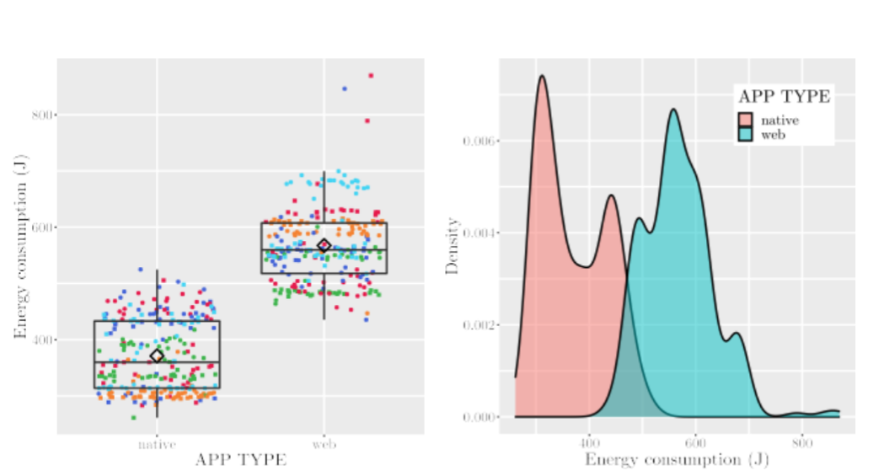
Figure 2: Energy consumption tables Native vs Web apps (cite)

- Analysis & Evaluation
From the empirical data in Figure 1 we can see that web apps use more energy than native apps, but that they also consume less network traffic. Researchers posit this could be due to web developers being incentivized to reduce bandwidth consumption as web apps often have to reload on startup which draws more network traffic.
It has also been noted that there is a substantial difference in mean memory load between deployment types, where web apps generally use just over 1.5 GB more memory than native apps. (cite)
Figure 2 also demonstrates that the energy consumption of web apps is significantly greater than that of native apps.

- Communicating Findings
In conclusion, this research has found that deploying software as a native application is the more energy conservative alternative to deploying web applications. While network traffic may be slightly more, native apps overall consume significantly less energy and computing power. This reduces the software’s impact on the environment and also supports longevity of the application by minimising resource consumption and running costs.

References:
https://www.theregister.com/2023/09/04/web_native_apps/
https://arxiv.org/pdf/2308.16734

