R&D Base 9.0.10 Micro-Release Test Plan

Artifact Status: RELEASED

# Section I. Plan outline and Schedule

# General Plan Outline

Currently accepted Base Release development cycle spans 2 months. Each cycle results in new Base micro-release being deployed to production that can contain 2 main types of deliverables:

1. New Base Features

2. Base Defect Fixes

Accompanying documentation is presented by:

1. Base Release Notes:

<https://ipipeline.sharepoint.com/sites/rad/igo/Base%20Release%20Notes/iGO%20Internal%20Base%20Release%20Notes.aspx>

2. Micro-Release Test Plan (this document)

Each deliverable is analyzed from the standpoint of its possible effect on:

* Current base functionality
* Current project specific functionality
* Other areas of application (Illustrations, Disconnected, Mobile, Admin Tool, etc.)
* Integration points (Agent One, etc.)
* The risk of regression issues

Based on this analysis the **testing types** are selected for each deliverable.

This document describes these testing types in detail and contains the list of 9.0.10 micro-release deliverables with the testing types proposed (**Appendix 1**).

# Schedule

**Phase I. Base R&D testing**

Starts with a creation of a new branch of Base code and continues till the actual Base Code Freeze.

Performed by the R&D QA team in QD1 and QD2 environments. QD5 and TD2 are refreshed with Alpha builds of the release up to the Code Freeze date.

Types of testing performed:

* Base Features regression testing
* New Base Features functional testing
* Defect fixes testing

**Phase II. PS QA testing**

Starts with deployment of base micro-release to PS QA environments and spans for 2 weeks.

Performed by the PS QA and R&D QA teams in QD3, QD4 and QD5 environments.

Types of testing performed:

* Defect fixes validation
* “Organic” testing
* Automation
  + Where possible the L1 Automation Solution will be used to pre-populate test cases.
  + The Regression Automation using the Key Word Driven approach will be used for Next Gen Screen Designer carriers.
  + Tools like Beyond Compare will be used for validation of PDF forms and the 103-submission record.

**Transition (In Flight) Case Testing:**

As part of the review of new features and high risk defect fixes (performed by R&D) the need for testing Transition cases will be identified and specifically called out.

**Before and After Comparison:**

Targeted validation of the 103-submission record and PDF data values and mapping being present prior to a base release deployment and the validation that the values and mapping haven’t changed after a base release deployment will be specifically called out.

**Phase III. UAT testing**

Starts with deployment of base micro-release to UAT environments (TD1, TD2, TD3) and spans for 2 weeks.

Organic testing should be performed by customer through the course of testing normal project deliverables, and validation of customer reported defect fixes where applicable.

The only type of testing that should be performed by R&D and PS QA teams in UAT is testing that can’t otherwise be performed in QA environments (SSO validation or any integrations that only exist within UAT environments).

# 9.0.10 Release Calendar

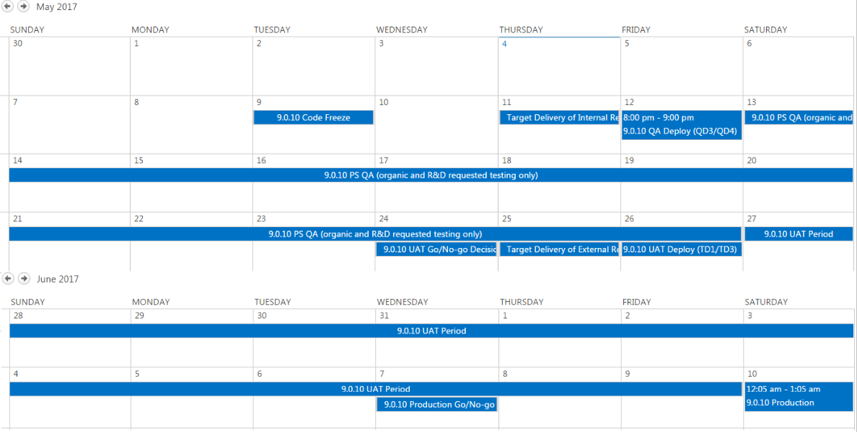

<https://ipipeline.sharepoint.com/sites/rad/igo/Lists/iGO%20RD%20Release%20Calendar/calendar.aspx>

# Section II. Testing Types Detailed

# Phase I. Base R&D testing

## Base Features regression testing

The Base Regression Test Suite consists of a number of test cases, where each test case represents a single Base Feature that is tested with one of the carriers that employ this feature. (**Appendix 2**)

Performed in R&D QA environment that receives daily incremental base code updates (QD1). Results Report contains test cases spreadsheet with testing results and the list of newly found and existing reproducible defects.

There are two versions of Base Regression Test Suite:

1. **Full.** Contains all prepared test cases.

Schedule: Once a Sprint (2 weeks) during base release development.

Purpose: Ensure that main base features are not affected/broken by base code check-ins. This will be done with a small subset of carriers, selected based on the types of features and defect fixes being deployed in each release.

1. **Smoke.** The selection of test cases is tailored to target the base features and carriers that are most likely to be affected by base code changes.

Schedule: Twice a week during base release development. The schedule may be adjusted depending on the regression risk of items deployed with the build.

Purpose: Ensure that base code check-ins did not break the selected base features and ability to create End-to-End cases (Create, Lock, Sign and Submit). This will be done with a small subset of carriers, selected based on the types of features and defect fixes being deployed in a given release.

## New Base Features functional testing

Time slot: This type of testing is performed when development of a new base feature is finished and it is deployed and properly configured in R&D QA environment.

Purpose: Ensure that new base feature functions in accordance with requirements.

Process:

Each new base feature should have a Test Plan document that includes:

1. High-level description if the feature and its purpose.
2. Testing approach.
3. Test Cases.
4. Pass/Fail criteria.

* Passing criteria: All test cases have passed, with no open associated High/Critical defects.

When testing of a feature is completed, the test plan and test cases with results are uploaded to SharePoint.

Risks:

1. Absence of well-defined, clear requirements. Blocks the development of an effective Test Strategy.
2. Developed features are not testable in R&D QA environment during R&D testing phase.

Possible reasons:

- Required project code changes are not made.

- Open defects that block the testing of a feature.

1. Late release of new features (after official Code Freeze, during PS and UAT testing phases). Does not allow for the preparation of documentation and thorough testing.
   * Potential exceptions to the code freeze will be reviewed collaboratively between R&D and QA teams.

## Defect fixes testing

Testing of defect fixes included into micro-release is performed by steps in description of a corresponding CESBASE Jira defect.

# Phase II. PS testing

## Time Logging:

To streamline time integration to projector for the PS teams that have additional testing to perform, as noted in Appendix 1, an Epic (pictured below) has been set up in the CES Base JIRA project.

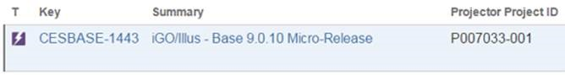

Backlog stories with tasks underneath them can be linked to this epic so that time spent on testing for the 9.0.10 Micro-Release will automatically be integrated to projector under the correct project in projector.

## Backward compatibility testing (In-Flight Cases)

Time slot: This kind of testing is performed when the new base micro-release is first deployed to PS QA environments.

Purpose: Ensure that the insurance cases that were started with old base version (e.g. 9.0.9) can be continued and completed without any issues with new base version (e.g. 9.0.10).

Process:

1. Prepare cases in different statuses in environment with old base version (9.0.9):

- Started

- Locked

- Signed, but not submitted

2. New base micro-release deployment (9.0.9 -> 9.0.10) to environment occurs.

3. Continue and complete the prepared cases. No issues should occur.

Risks:

Testing environment should have a stable project build that allows end-to-end case completion. Any project issues that block the ability to complete the case would render this kind of testing useless.

## “Before and After” comparison validation

Time slot: This kind of validation is performed when new base micro-release is first deployed to PS QA environments.

Purpose: Ensure that new base micro-release does not introduce unexpected changes to or loss of data.

Process:

1. Create and complete an End-to-End case and get the resulting PDF and Acord files in environment with old base version (9.0.9)

2. New base micro-release deployment (9.0.9 -> 9.0.10) to environment occurs.

3. Create and complete **fully identical** End-to-End case and get the resulting PDF and Acord files in environment with new base version (9.0.10)

4. Compare the resulting PDF and Acord files. There should be no changes in mapping and data, unless the change is explicitly communicated as expected.

Risks:

1. Testing environment should have a stable project build that allows end-to-end case completion. Any project issues that block the ability to complete the case would render this kind of testing useless.

2. The project release deployed to the testing environment should have exactly the same version when performing steps 1 and 3 of the Process.

## Defect fixes validation

Testing of defect fixes included into micro-release is performed by steps in description of a corresponding Jira defect.

## “Organic” Testing

Most of the changes that come as a result of the micro-release will be tested through ‘Organic’ testing, or testing of the new features as a result of regular project development.

# Phase III. UAT testing

Organic testing should be performed by customer through the course of testing normal project deliverables, and validation of customer reported defect fixes where applicable.

The only type of testing that should be performed by R&D and PS QA teams in UAT is testing that can’t otherwise be performed in QA environments (SSO validation or any integrations that only exist within UAT environments).

# Appendix 1. The 9.0.10 micro-release scope

|  |  |  |  |  |  |  |  |
| --- | --- | --- | --- | --- | --- | --- | --- |
| **Scope of Change** | **Carriers** | **Description** | **Risk** | **Project Code Change Required?** | **Defect Fix?** | **In Flight Case Required?** | **Testing Approach** |
| Lexis Nexis Instant ID Integration Phase2 | Amica |  | High |  | No |  | Use Amica (1st carrier to implement feature) to test an end to end case through submission. Ensure the attachments are added to the submission. Consider adding a carrier that has not implemented feature and ensure submissions process is not impacted in a case without the Lexis Nexis integration. |
| Tabbing Issue(s) | Manulife and Thrivent | When beginning Tabbing from "Select Language" field and tabbing into "Need Assistance?" or "Welcome", there isn't a clear indicator that you're in those fields​ | Low |  | Yes | No | Testing will validate that the tabbing issues is resolved, and that the release has not introduced any additional tabbing issues. Should also be able to test other MUL Tabbing issues.  Thrivent use cases will be included that tab through grids and grid pop ups to validate those are functioning as expected.  [CESBASE-1514](https://jira.ipipeline.com/browse/CESBASE-1514)  [CESBASE-1489](https://jira.ipipeline.com/browse/CESBASE-1489) |
| ~~AgentOne Page Length~~ | ~~AAA~~ | ~~AgentOne is configured to show the entire iGO max screen length as opposed to encapsulating iGO inside a smaller frame. Placing iGO in a frame would result in a double scroll bar inside AgentOne. The desire is to only show the part of the iGO screen that is necessary, so to dynamically grow and shrink the screen and not show excess white/blank space.~~ | ~~Medium~~ | ~~No~~ | ~~No~~ | ~~No~~ | ~~Testing will look at iGO screens as well as the A1 workflows and screens. Cases will be created to validate that page length is correct when starting a new case.~~  **This was removed from the 9.0.10 release** |
| Retrofit 9.1 Mobile app changes into 9.0.10 | Erie |  | High |  |  | No | Changed mobile to use new bootstrap UI. Will use Erie to run full end to end cases to ensure java script is not impacted. |
| Disconnected (Win 10 Issue) | Bankers |  | Low |  | Yes | Yes | Testing will be focused on a long running performance test done by TPC. Perf test will be updated to focus on running a smaller set of active users with a larger spread of use case types |
| Thrivent Hashing - Back Out/Block Exclusion Hashing Request | Thrivent | Thrivent Hashing - Log Usage on Exclusion List Request, Back out/ block exclusion hashing request | Medium |  | Yes | Yes | Create in-flight cases that will be used to validate that no issues exist with data hashing after the 9.0.10 upgrade has been applied to QD. Should also test Log Usage on Exclusion List Request |
| IPLNSCRD-4679 Make iGoRuntimeVersion and iGoScreensPackageName child elements of Product/ExtendedProperties | Guardian and AmFam |  | Medium |  |  |  | These two NGSD items can be tested together. Will use Guardian and AmFam projects to execute full end to end test case that also specifically test the OBO function - both Single (Guardian) and Many (AmFam). |
| FF Only - Deposit Allocation Screen: JS Error message is displayed after adding new items to the grid. | Manulife | FF Only - Deposit Allocation Screen: JS Error message is displayed after adding new items to the grid. | Medium | No | Yes |  | Validate with MUL on FF |
| Illustration Post-back / PDF render separation | SFG Illustrations and Erie |  | Medium | Yes | Yes | No | SFG Illus must do implementation work to exploit. Ensure this is done and then execute Use Case that executes function. Additional Illustrations carrier (Erie) that has not made change should validate no regression issues have been introduced. |
| Optimization of Base Function cdcsjs_SetGridCellValue | SFG Illustrations | Optimization of Base Function cdcsjs_SetGridCellValue | Medium | No | Yes | No | Performance improvement change is applied globally. There is a key to disable it.   SFG Illus executes a use case that exercises the specify values grid - i.e. illus case with loans & withdrawals.  [CESBASE-1386](https://jira.ipipeline.com/browse/CESBASE-1386) |
| Sync Error - System Exception: The Request has been Altered | SFB | Agents who have an apostrophe in their name are experiencing a sync error when attempting to sync cases that have a status of ‘Sync to e-Submit’. | Medium | No | Yes | Yes | Disconnected   Fix involved adding an escape of the single quote character. Create in-flight disconnected cases that include this character in names - i.e. O'Douls - and validate sync works ok afterwards.  [CESBASE-1148](https://jira.ipipeline.com/browse/CESBASE-1148) |
| IPLNSCRD-4485 - IGo: Able to access Quote/Illustration tab from application tab after application is locked | American Family and Erie |  | Medium | No | Yes |  | Test case for both a NGSD (AmFam) and a classic carrier (suggest Erie) should be executed. Need to validate that Illustrations tab cannot be accessed on a locked case. |
| IPLNSCRD-4628 - Values are mapped to PDF even if Dictionary.json file was deleted from Application level | American Family and Thrivent (Classic SD) |  | Medium |  |  |  | Require both NGSD (AmFam) and classic (Thrivent) execute before and after case. Validate that before and after mapping on form passes validation. Pay attention especially to values that map from dropdown lists, checkboxes or radio buttons. |
| IPLNSCRD-4839 - QD1: Exception message on Application tab for Speed eTicket (1903 carrier) | Guardian |  | Low > Medium |  |  |  | NGSD Only. Should create a new case in NGSD project (Guardian) and verify that Exception error is not thrown when navigating to Application tab |
| NGSD-254 - Switching Product/State not causing Screen Sequence Reset | American Family/ Thrivent (Classic SD) |  | Medium |  |  |  | Must execute destructive style testing outlined in Jira. Execute w/NGSD (AmFam) as well as classic (Thrivent) projects. Additionally validate that issue in [CESBASE-1566](https://jira.ipipeline.com/browse/CESBASE-1566) does not exist (i.e. a change in Case Description after submit causes sequence to reset) |
| NGSD-312, NGSD-~~313 and IPLNSCRD-4926 - iGo: when duplicating submitted case its duplicate is locked~~ | American Family | When submitted cases were duplicated, the duplicate case was locked when it should have been unlocked and able to be edited. | Medium |  |  |  | NGSD Only. Need targeted testing with duplicated cases. Validate that when duplicating a submitted case that the duplicate is not locked and is instead open  **NGSD 313 was removed from the 9.0.10 release as it is not ready for testing.** |
| IPLNSCRD-4565 - [iGo] Pass User Data from iGO to NGSD | Thrivent(Classic SD) / VOYA | Adding the ability to pass User Data from iGO to NGSD | High |  |  |  | Login method using SSO and BGA access should be executed for NGSD & Classic (Thrivent) carrier projects. Suggest including validating that in flight cases for agent are present after deploy |
| Upgrade signature controls (jSignature) | Foresters, Sammons, Bankers |  | High |  |  | YES | Testing should cover net new cases and in flight cases. Please validate that signatures are present on both the PDF form and the 103 submission. Please use the UAT environments (still on 9.0.9) to get the ‘Before’ picture and use QD environments (after R&D deploys fix) for the after |
| CESBASE-1598: DocuSign Inaccessible | TransAmerica, AXA |  | HIGH |  |  |  | Testing should validate that the DocuSign link is generated and that the signing ceremony is able to be completed. |

# Appendix 2. Base Regression Test Suite