Assignment 1

Computer Organization

Deadline: 11:55pm, Monday, Oct 08, 2024

Student ID:_________________________ Name:____________________________

1. 1) Define what a Turing machine is. 2) What does UTM stand for? Explain what it is. (10 points)
2. Describe the seven levels of transformations of a computer system. (10 points)
3. Explain the fetch-decode-execute cycle of the von Neumann Architecture. (10 points)
4. Given 8 bits, represent the numbers +53 and -109 into binary using the following approach: 1) Signed-magnitude; 2) One’s complement; 3) Two’s complement. Show your steps. (12 points)
5. Convert -57.625 into binary using 32 bits floating number representation. Show your steps. (6 points)
6. The following Turing Machine is supposed to count in base 2.

{

"name": "Count in Base 2",

"max_state": 2,

"symbols": "0,1",

"tape": "0",

"position": 0,

"rules": [

[_______________________],

[_______________________],

[_______________________],

[_______________________],

[_______________________],

[_______________________]

]

}

1. Please use ChatGPT or other generative AI tools to fill in the missing rules and attach a screenshot of your attempt. (5 points)
2. Do you think the answer provided is correct? If yes, test it on the website we used in the lab. If not, modify it accordingly. After making your adjustments, paste the runnable JSON content below. (6 points)
3. Compare this Turing Machine program with Lab0 Exercise 2. Are there any differences? (4 points)

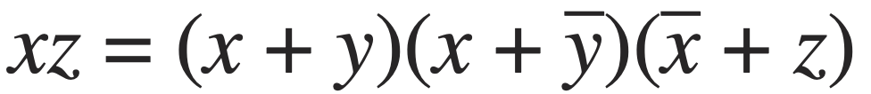

1. Show that
2. Using truth table; (5 points)
3. Using Boolean identities; (5 points)
4. Use ChatGPT or other generative AI tools to attempt the proof and attach a screenshot of your attempt. (5 points)
5. The truth table for a Boolean expression is shown below. (16 points)
   1. Write the Boolean expression in sum-of-products form. (4 points)
   2. Write the Boolean expression in product-of-sums form. (4 points)
   3. Simplify the sum-of-products form using Boolean identities; (4 points)
   4. Draw the logical circuit diagram for the simplified Boolean expression;(4 points)

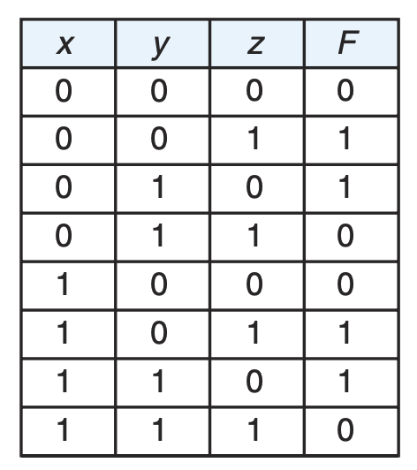

1. Simplify the above Boolean expression using K-MAP by hand. (6 points )