**Question 1**

Code:

|  |
| --- |
| {  "name": "Binary Inverse",  "description": "",  "max_state": 1,  "symbols": "01",  "tape": "010010",  "position": 5,  "rules": [  [ 0, "#", "#", 1, "R" ],  [ 0, "0", "1", 0, "L" ],  [ 0, "1", "0", 0, "L" ],  [ 1, "#", "#", "h", "L" ],  [ 1, "0", "*", 1, "R" ],  [ 1, "1", "*", 1, "R" ]  ]  } |

Before: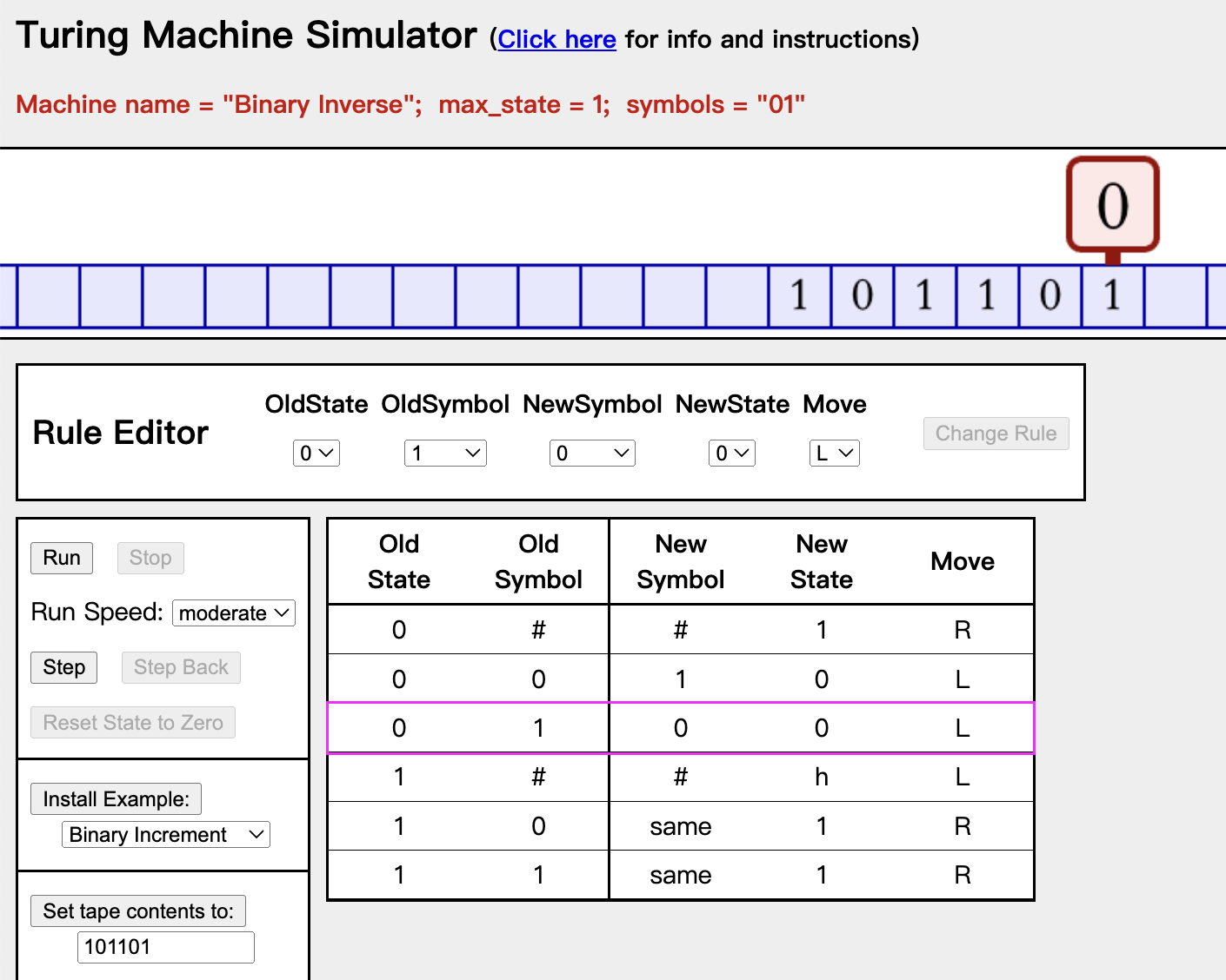

After:

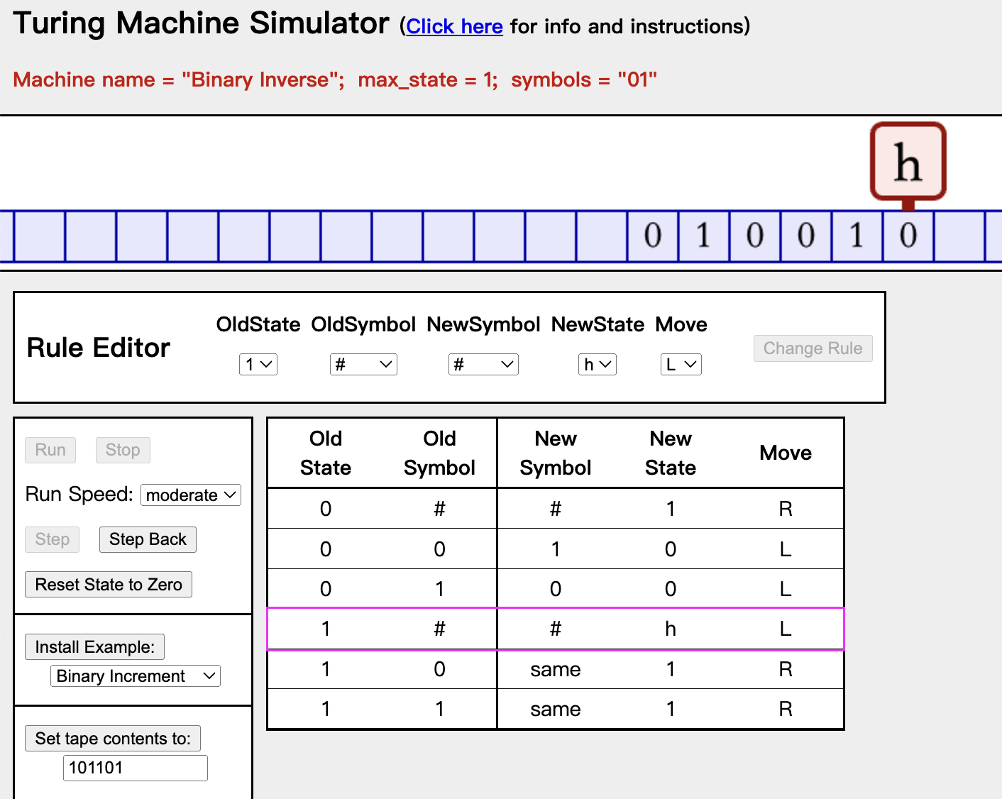

**Question 2**

Code:

|  |
| --- |
| {  "name": "Binary Count",  "description": "",  "max_state": 3,  "symbols": "01",  "tape": "",  "position": 3,  "rules": [  [ 0, "#", "0", "h", "S" ],  [ 0, "*", "*", 1, "S" ],  [ 1, "#", "1", 2, "R" ],  [ 1, "0", "1", 2, "R" ],  [ 1, "1", "0", 1, "L" ],  [ 2, "#", "#", "h", "L" ],  [ 2, "*", "*", 2, "R" ]  ]  } |

Before:

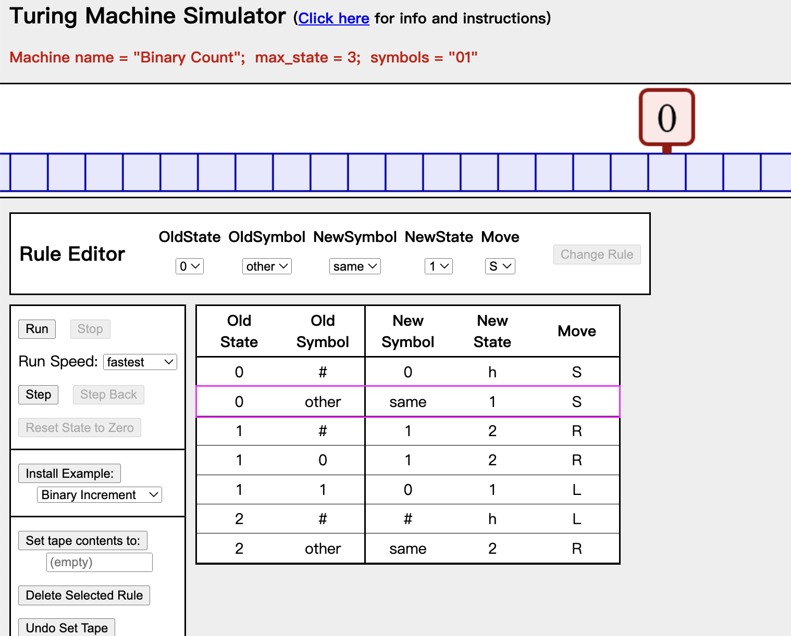

After 1st run:

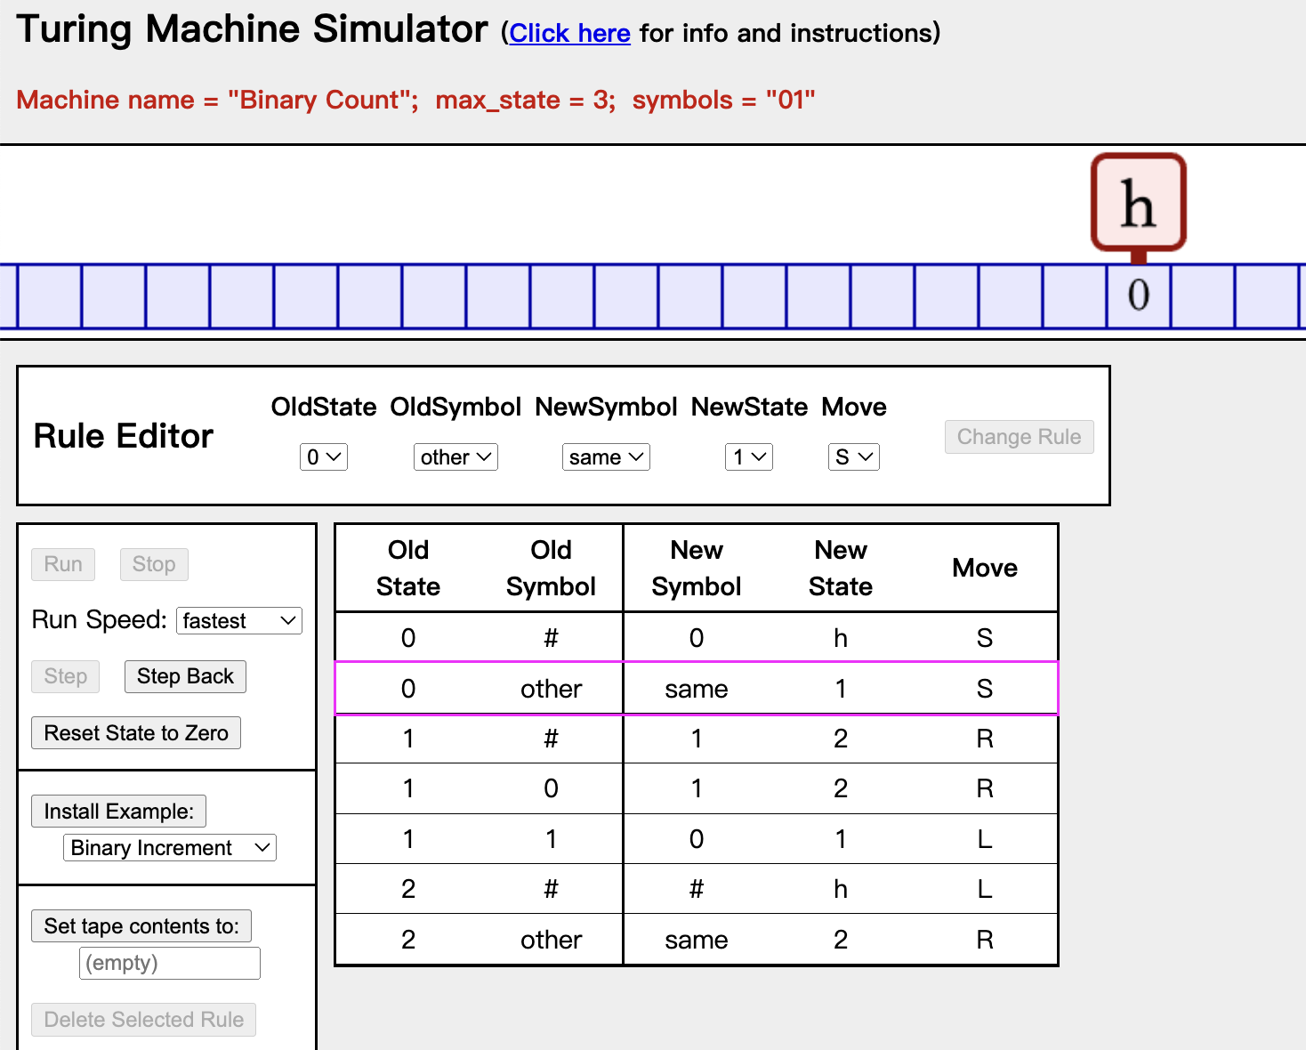

After 2nd run:

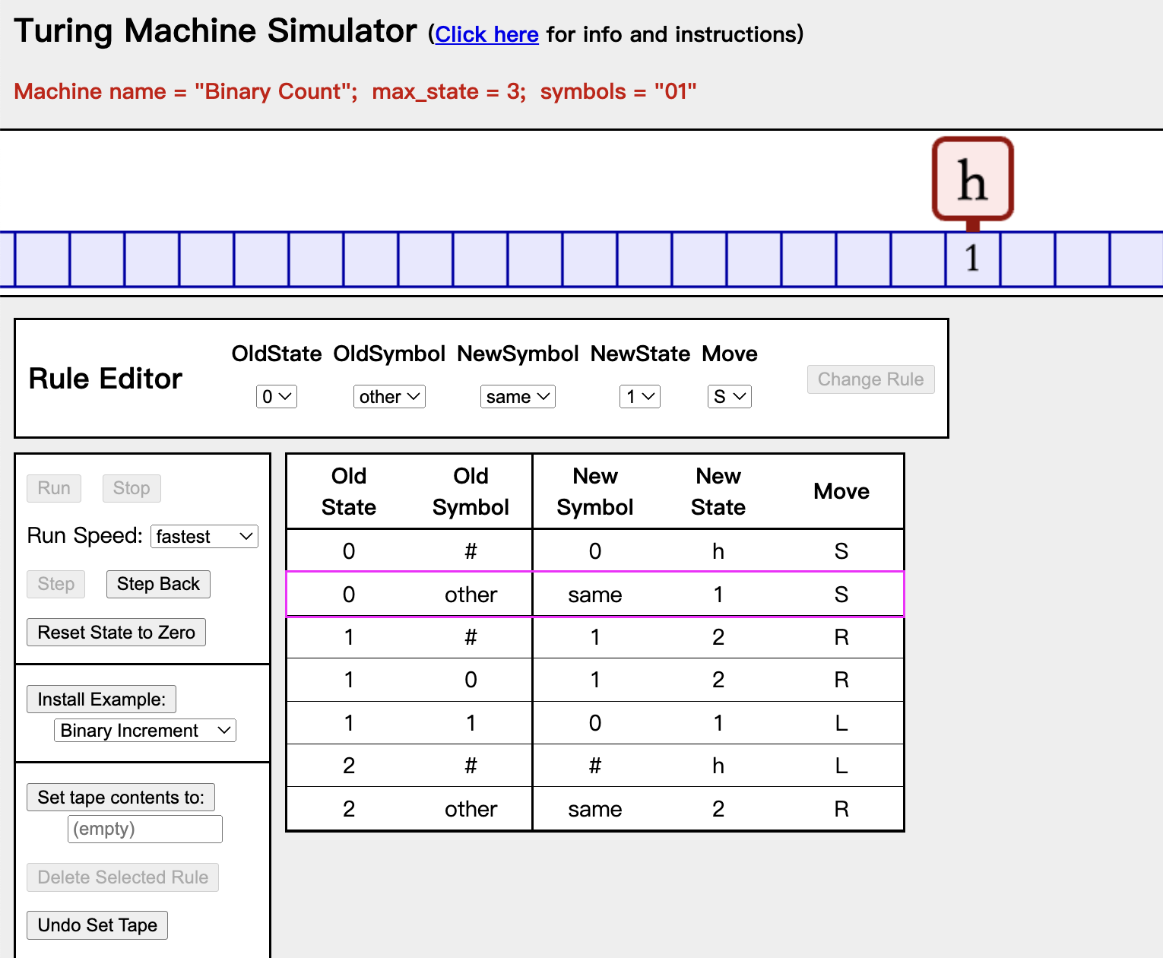

After 3rd run:

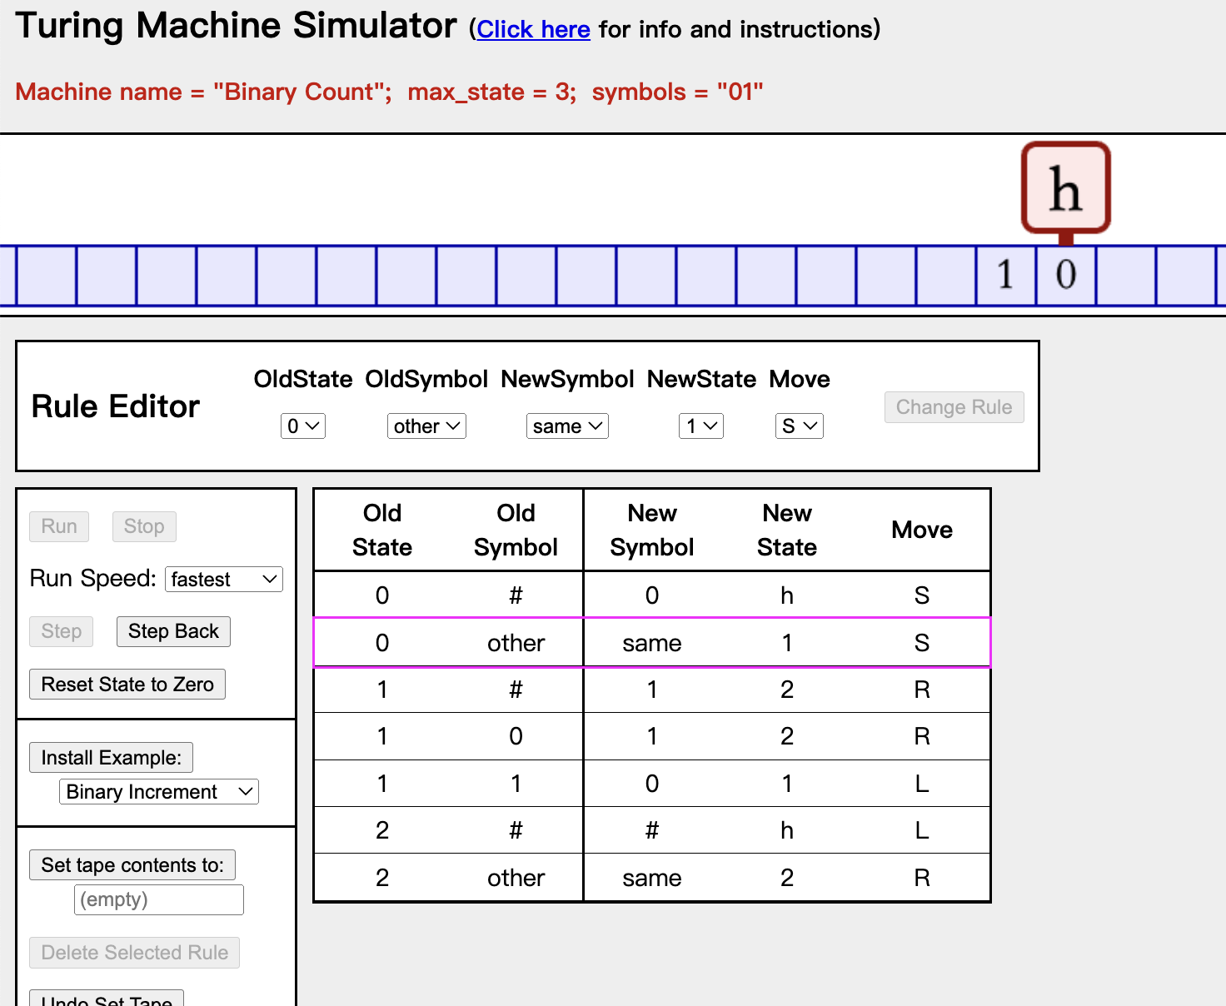

**Question 3**

ChatGPT vs. UTM

From my point of view, UTM is more powerful.

In this investigation, I used ChatGPT. ChatGPT is easier to use than UTM. And it excels at natural language processing and generating human-like text. We can often use ChatGPT in our daily life, but we rarely use UTM in our daily life.

But in terms of computational power, the UTM can solve any computable problem through a series of well-defined steps (from Church–Turing thesis), whereas ChatGPT is limited to something specific tasks. In other words, we can use UTM to implement ChatGPT, but we cannot use ChatGPT to implement UTM.

So theoretically UTM is more powerful.