**Computer Organization**

**Lab2: From Transistors to Gates**

**Objective**

To understand how logic gates can be constructed by connecting transistors together.

**Introduction**

A computer consists of different circuits that are constructed by **logic gates**, which in turn are constructed by **transistors**. In this lab, we will use transistors to construct logic gates in a simulation software named Electronics Workbench.

Electronics Workbench is a design tool that provides you with all the components and instruments to create board-level designs on your PC. It is very useful to simulate and test a circuit before you build it. Prior to this lab, you should finish reading section 3.1 and 3.2 (page 51-58) of the textbook “Introduction to Computer System from Bits to Gates to C and beyond”.

**Lab Instruction**

**Step 1: Download the Electronic Workbench (EWB) ewb5.zip file from ISpace, unzip files, double click the icon “WEWB32” under the directory “Ewb50” to launch the Electronic Workbench software.**

**Step 2: Get familiar with the interface**

Read the EWB_Introduction.pdf file and try out the examples in the file.

**Step 3: Construct a NOT gate in Electronic Workbench (Figure 1)**

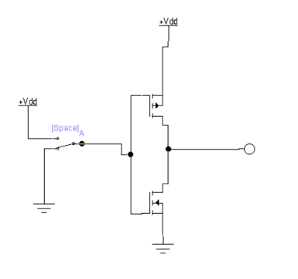

**Figure 1**

**Lab Exercise**

Construct **AND**, **OR** gates using transistors.

Challenge: how to make a XOR gate using transistors? (no need to submit, try to use chatGPT to solve it)

Hints:

1. draw the truth table for XOR;
2. write the Boolean expression in Sum of Production form;
3. simplify the Boolean expression;
4. draw the logic circuit diagram based on logic gates;
5. convert the logic gates into transistors;

**Submission**

Submit the Electronics Workbench model files. Please named **AND**, **OR** gates with LastnameF_L02a.ewb and LastnameF_L02b.ewb respectively. And zip these files then submit through the link “Lab2” on Ispace. (where Lastname is your last name and F is you first initial.)