**Computer Organization**

**HKBU-BNU United International College**

**Lab 4: Sequential Circuits**

# Lab Objective

To understand how to analyze and design basic sequential circuits.

# Introduction

The output of the sequential circuits circuit depends not only on the current input values, but also on the previous input values. In some senese, they have “memory” that can can remember and store the past inputs. The building blocks of sequantial circuits are RS-Latches, or RS Flipflops. Typical sequential circuits include RS Flipflops (Figure 1), JK Flipflops, D Flipflops (Figure 2), Registers and Binary Counters.

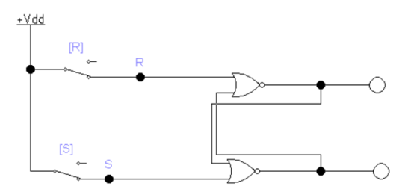

Figure 1 RS Flipflop

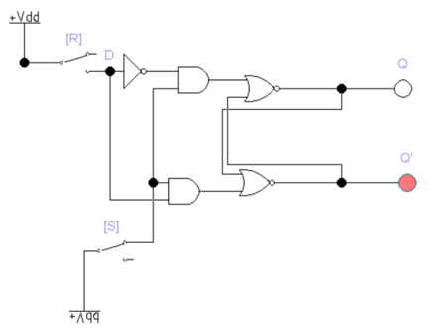

Figure 2 D Flipflop

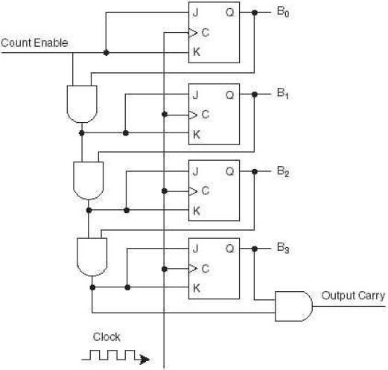

Figure 3 Four-Bits Counter

# Lab Instruction

**Step 1: Implement RS Flipflop, D Flipflop, and JK Flipflop.**

**Step 2: Change the 4 bits counter to 3 bits counter.**

**Step 3: Use the 3-Bit synchronous counter you just modified as inputs to drive a 7 segment LED. As time changes by clock, your LED should display “0, 1, 2, 3, 4, 5, 6, 7, 0, 1, 2, 3...”.**

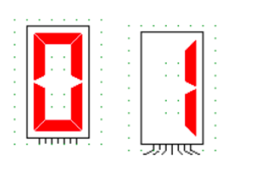

# Lab Exercise & Group Project

1. Each group should have 5 or 6 students;
2. Each group needs to design a sequential circuit using a 4-Bits binary counter as inputs to drive at least two 7 segment LEDs in EWB.
3. As time changes by the clock, your LED should display some meaningful information that you arrange.
4. Your group needs to develop a ppt to present your design process and ideas and make a video clip to explain and demo how your sequential circuit works.

# Submission

Zip and submit your Electronics Workbench model file, the ppt file and the video clip of your group presentation. Each group only needs to submit one ppt, one model file and one video clip of your group presentation.