**Lab Exercise**

1. **What does the following code? (There are 3 instructions.)**

0011000000000000

1001001001111111

0001010001100001

0001010000000010

1001001001111111: NOT R1, R1

0001010001100001: ADD R2, R1, #1

0001010000000010: ADD R2, R0, R2

1. Input the following code and try to understand what it does by executing it step by step. (There are 6 instructions.)

0011000000000000

1110001111111101

0001010001101110

0101010010100000

0001010010100101

0111010001001110

1010011111110111

**Analyze and explain what these instructions do one by one. You need to explain the opcode, the addressing mode and the meaning and function of these instructions.**

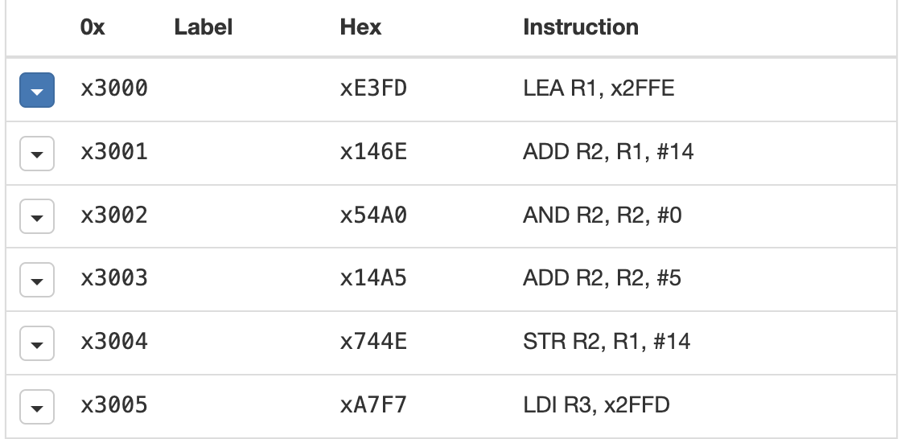

* 1. **1110001111111101: LEA R1, x2FFE**

**Opcode**: LEA (Load Effective Address)

**Addressing** **Mode**: Direct Addressing Mode (with an immediate value)

**Meaning**: Load the effective address x2FFE into register R1

* 1. **0001010001101110：ADD R2, R1, #14**

**Opcode**: ADD (Add)

**Addressing Mode**: Register Addressing Mode with an Immediate Operand

**Meaning**: Add the value of R1 and 14 (immediate) and store the result in R2.

* 1. **0101010010100000：AND R2, R2, #0**

**Opcode:** AND (Logical AND)

**Addressing Mode:** Register Addressing Mode with an Immediate Operand

**Meaning:** Perform a bitwise AND operation between R2 and 0 (effectively clearing R2).

* 1. **0001010010100101：ADD R2, R2, #5**

**Opcode:** ADD (Add)

**Addressing Mode:** Register Addressing Mode with an Immediate Operand

**Meaning:** Add 5 (immediate) to the value in R2 and store the result back into R2.

* 1. **0111010001001110：STR R2, R1, #14**

**Opcode: STR (Store)**

**Addressing Mode:** Indexed Addressing Mode

**Meaning:** Store the value in R2 into memory at the address R1 + 14.

* 1. **1010011111110111：LDI R3, x2FFD**

**Opcode:** LDI (Load Indirect)

**Addressing Mode:** Indirect Addressing Mode

**Meanign:** Load the value from the memory address x2FFD into register R3.

1. Write a LC3 machine code program to print out “Hello World!”. Hint: consider to use Trap instruction PUTS.

|  |
| --- |
| 0011000000001010  0101001001100000  1110000000000010  1111000000100010  1111000000100101  0000000001001000  0000000001100101  0000000001101100  0000000001101100  0000000001101111  0000000000100000  0000000001010111  0000000001101111  0000000001110010  0000000001101100  0000000001100100  0000000000100001 |