Assembly Process (from .asm to .obj)

**First Pass:**

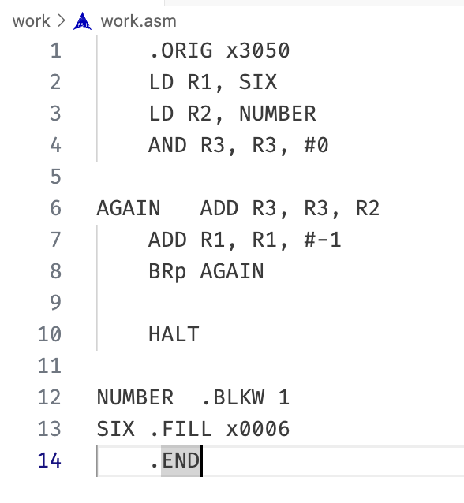

scan program file, find all labels and calculate the corresponding addresses, which is called Symbol Table (work.sym)

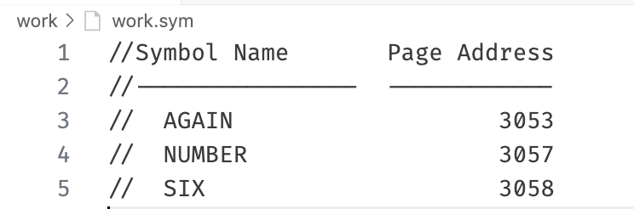

**Second Pass:**

convert instructions to machine language, using information from symbol table.

