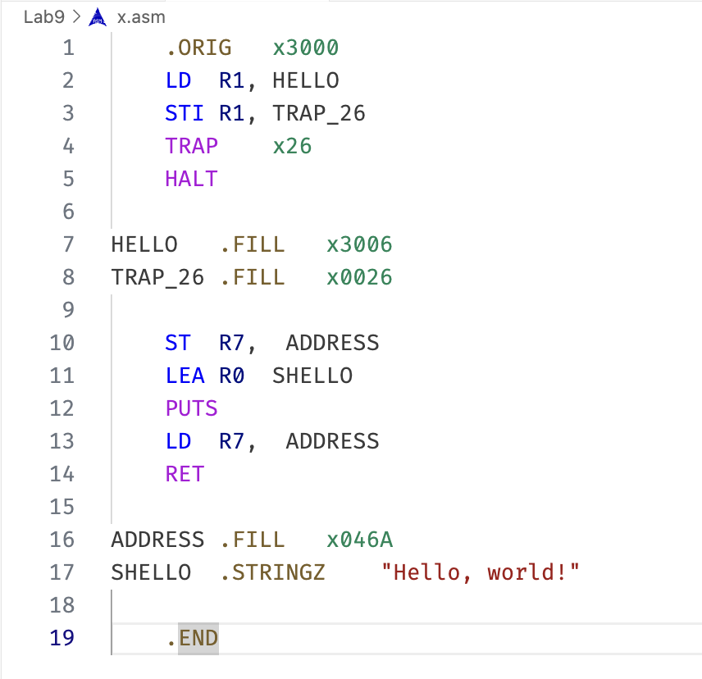

1. Trap Vector Table

The address of the service routine for each TRAP is stored at a specific offset corresponding to the TRAP number. For example:

TRAP x20 (for "GETC") is stored at x0020 in the TVT.

TRAP x26 (our custom TRAP) will be stored at x0026 in the TVT.

1. Coding
2. Setup the Trap Vector Table

TRAP_26 .FILL x0026

1. Defining the Service Routine (TRAP x26)

ST R7, ADDRESS

LEA R0 SHELLO

PUTS

LD R7, ADDRESS

RET

1. Code in Memory

