Bit stuffing
Compute the resultant bitstring after bit stuffing for 0111110001111110
011111000011111010

CRC
Data:101110, Generator: x^3 + 1
Compute CRC result.
What if data change to 100110

Hamming Code
Compute the resultant bitstring with Hamming code for 0101000110
11001010000110

Subnet
compute ip address range with this subnet 192.78.18.0/21
subnet mask: 11111111.11111111.11111000.00000000 (255.255.248.0)
192.78.18.0 in binary: 11000000.01001110.00010010.00000000
Do bitwise AND: 11000000.01001110.00010000.00000000 (which is 192.78.16.0)
So, the network address is 192.78.16.0
The broadcast address is found by setting all the host bits (the bits not covered by the subnet mask) to 1.
Setting the last 11 bits to 1 gives: 11000000.01001110.00010111.11111111 (which is 192.78.23.255)
Therefore, the range of IP addresses in the 192.78.18.0/21 subnet is from 192.78.16.1 to 192.78.23.254.

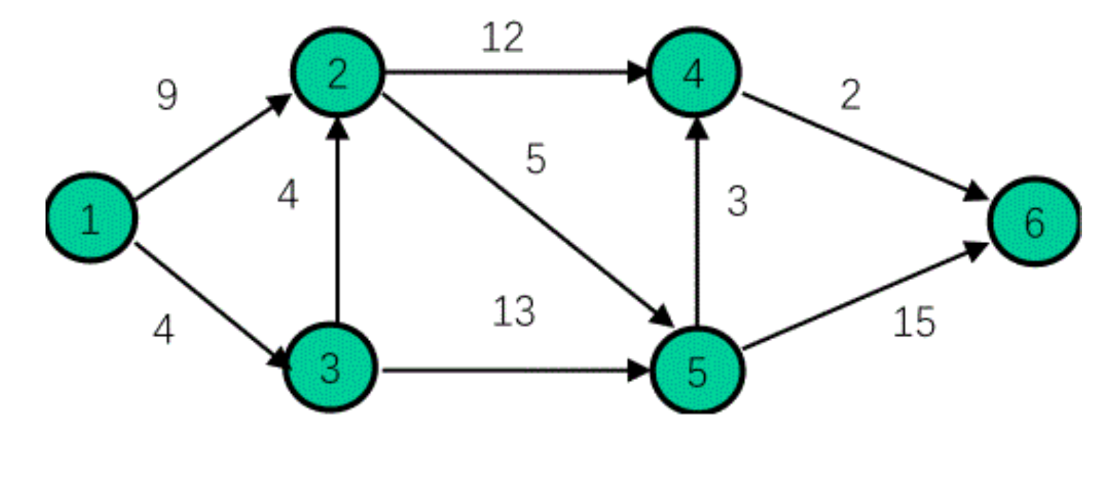
Shortest path from 1 to other nodes, try to practice

