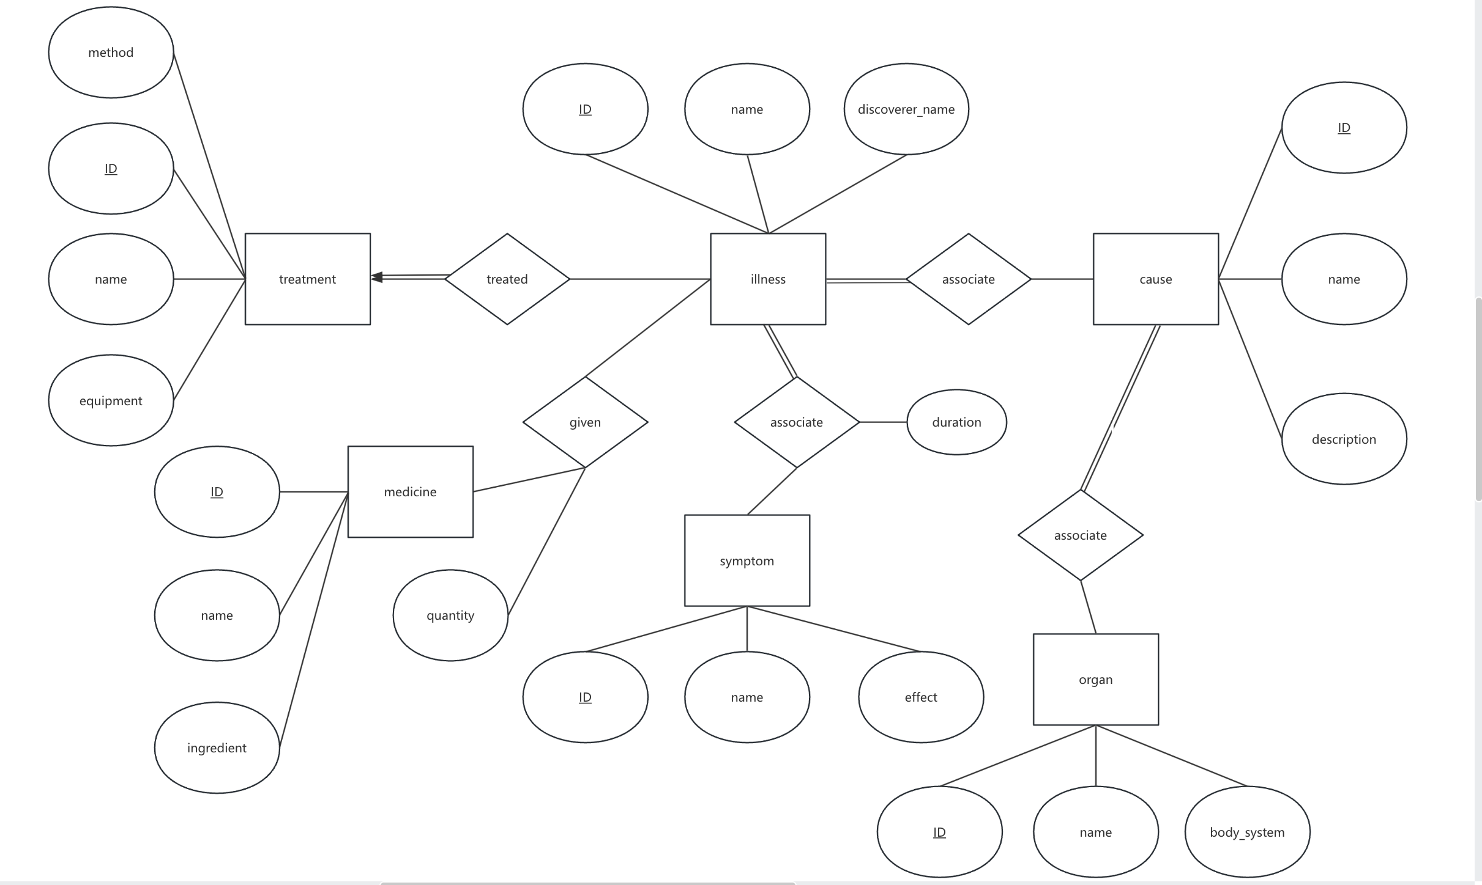

Q3.
a)
sID | course | score | sID | course | remark
101 | Database | 80 | 101 | Database | Only a joke
102 | Database | 65 | 101 | Database | Only a joke
b)
sID | course | sname | age | score | remark
101 | Database | Alice | 19 | 80 | Only a joke
c)
sID | course | remark | score
101 | Database | Only a joke | 80
102 | Discrete Math | Excellent course | NULL
d) It is a wrong operation.
Column 'sID' in field list is ambiguous
Column 'course' in field list is ambiguous

