What is Django?
Django is a high-level Python web framework that enables rapid development of secure and maintainable websites. Named after the jazz guitarist Django Reinhardt, it is used by some of the largest websites in the world including Instagram, Mozilla, and NASA, but also lightweight enough to be a popular choice for weekend side projects and startups.
Built by experienced developers, Django takes care of much of the hassle of web development, so you can focus on writing your app without needing to reinvent the wheel. Its "batteries-included" approach means a powerful website can be generated quickly in the hands of a skilled developer.
It is free and open source, has a thriving and active community, great documentation, and many options for free and paid-for support.
Django has become the preferred framework for web developers and is a framework that follows the Model View Controller (MVC) design pattern. Moreover, Django is actually also a Model Template View (MTV) design pattern. in Django, the Controller that accepts user input is handled by the framework itself, so Django is more concerned with the MTV pattern. Their respective responsibilities are as follows:
Level | Responsibility
Model, the data access layer | Handles all matters related to data: how to access it, how to validate its validity, what behaviors it contains, and how it relates to each other, etc.
Template, the presentation layer | Handles decisions related to presentation: how it is displayed on a page or other type of document.
View, the logic layer | Accesses the model and the logic associated with calling up the appropriate template. Bridges the model to the template.

Why we use it?
Based on the number of high profile sites that use Django, the number of people contributing to the codebase, and the number of people providing both free and paid for support, Django is a popular framework!
Django helps us write software that is:
Complete
Django follows the "Batteries included" philosophy and provides almost everything developers might want to do "out of the box". Because everything you need is part of the one "product", it all works seamlessly together, follows consistent design principles, and has extensive and up-to-date documentation.
Versatile
Django can be (and has been) used to build almost any type of website — from content management systems and wikis, through to social networks and news sites. It can work with any client-side framework, and can deliver content in almost any format (including HTML, RSS feeds, JSON, XML, etc). The site you are currently reading is built with Django!
Internally, while it provides choices for almost any functionality you might want (e.g. several popular databases, templating engines, etc.), it can also be extended to use other components if needed.
Secure
Django helps developers avoid many common security mistakes by providing a framework that has been engineered to "do the right things" to protect the website automatically. For example, Django provides a secure way to manage user accounts and passwords, avoiding common mistakes like putting session information in cookies where it is vulnerable (instead cookies just contain a key, and the actual data is stored in the database) or directly storing passwords rather than a password hash.
A password hash is a fixed-length value created by sending the password through a cryptographic hash function. Django can check if an entered password is correct by running it through the hash function and comparing the output to the stored hash value. However due to the "one-way" nature of the function, even if a stored hash value is compromised it is hard for an attacker to work out the original password.
Django enables protection against many vulnerabilities by default, including SQL injection, cross-site scripting, cross-site request forgery and clickjacking (see Website security for more details of such attacks).
Scalable
Django uses a component-based "shared-nothing" architecture (each part of the architecture is independent of the others, and can hence be replaced or changed if needed). Having a clear separation between the different parts means that it can scale for increased traffic by adding hardware at any level: caching servers, database servers, or application servers. Some of the busiest sites have successfully scaled Django to meet their demands (e.g. Instagram and Disqus, to name just two).
Maintainable
Django code is written using design principles and patterns that encourage the creation of maintainable and reusable code. In particular, it makes use of the Don't Repeat Yourself (DRY) principle so there is no unnecessary duplication, reducing the amount of code. Django also promotes the grouping of related functionality into reusable "applications" and, at a lower level, groups related code into modules (along the lines of the Model View Controller (MVC) pattern).
Portable
Django is written in Python, which runs on many platforms. That means that you are not tied to any particular server platform, and can run your applications on many flavours of Linux, Windows, and Mac OS X. Furthermore, Django is well-supported by many web hosting providers, who often provide specific infrastructure and documentation for hosting Django sites.

What does Django code look like?
In a traditional data-driven website, a web application waits for HTTP requests from the web browser (or other client). When a request is received the application works out what is needed based on the URL and possibly information in POST data or GET data. Depending on what is required it may then read or write information from a database or perform other tasks required to satisfy the request. The application will then return a response to the web browser, often dynamically creating an HTML page for the browser to display by inserting the retrieved data into placeholders in an HTML template.
Django web applications typically group the code that handles each of these steps into separate files:
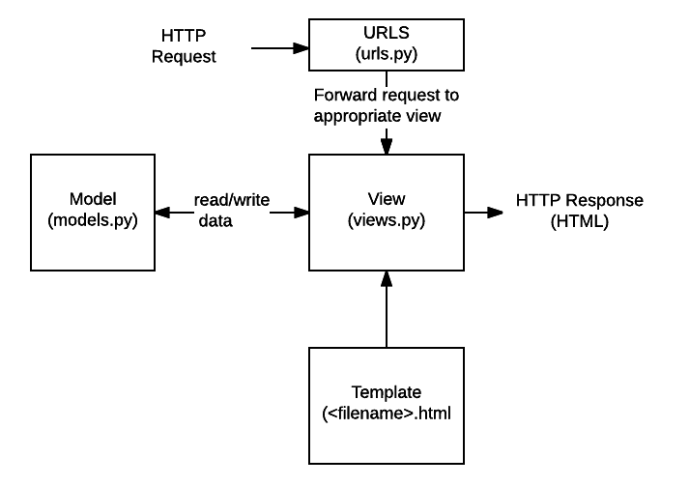

Compare Django with Flask:
These days, it is rare to write a website from scratch. Web frameworks exist for every modern programming language including Rails for Ruby, Express for JavaScript, and Django or Flask for Python.
Beyond the underlying programming language, the major difference between competing web frameworks is one approach: Ruby on Rails and Django adopts a "batteries-included" frameworks approach whereas Flask and Express are minimal microframeworks. You can think of it as the difference between being given a bag of Legos or a pre-built truck made out of Legos. Django and Rails are faster to start using and come with many built-in guardrails to prevent bad practices. Flask and Express require more customization upfront but allow for total control.
Generally, Flask is lightweight and more flexible, while Django is more consistent and provides a larger developer community. The following is a table comparing Django with Flask. You can see Django vs Flask for a detailed comparison of the two most popular Python web frameworks and the pros/cons of each approach.
 | Django | Flask
Framework | A full featured "batteries-included" framework | A simple, lightweight, microframework
Functionality | Almost every feature a website will need built-in including database connections, fantastic security, forms, a powerful user admin, and a robust ecosystem of 3rd party packages | Basic functionality such as URL routing, templates, cookies, a debugger, and a development server
Consistency and secure | Better. Django provides almost every feature a website will need. | Worse. The developer is solely responsible for building out common website functionality such as connecting to a database, handling forms, security, authentication, and so on.
Learning difficulty | More difficult. The larger codebase takes much longer to master. | Simpler. Arguably simpler to start with.
Community | Larger. There are over 1,800 committers to the Django codebase vs around 550 for Flask. On StackOverflow there are ~212,500 Django questions compared to ~31,500 Flask questions. | Smaller.

Now give a "Hello, World" comparison:
For Django:
(Actually, you have used it in the first week of SDW!)
- use cmd to install Django:
pip3 install django

- Create a hello_django.py file with the following code:
# hello_django.py
from django.conf import settings
from django.core.handlers.wsgi import WSGIHandler
from django.core.management import execute_from_command_line
from django.http import HttpResponse
from django.urls import path

settings.configure(
ROOT_URLCONF=__name__,
DEBUG=True,
)

def hello_world(request):
return HttpResponse("Hello, Django!")

urlpatterns = [
path('', hello_world)
]

application = WSGIHandler()

if __name__ == "__main__":
execute_from_command_line()

- Use cmd, enter the same file location as hello_django.py. Then, start Django's built-in web server with the following command:
python hello_django.py runserver 0.0.0.0:8000

- After that, you can navigate to Django's standard port of 8000, http://127.0.0.1:8000/, to see the Django Welcome page:
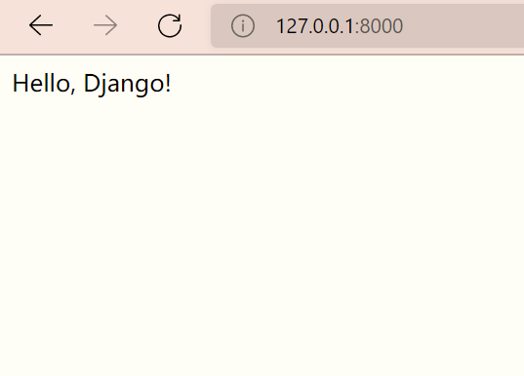

For Flask:
- use cmd to install Flask, just the same as installing Django.
pip3 install flask
- Create a new file, hello_flask.py, and populate it as follows:
# hello_flask.py
from flask import Flask, escape, request

app = Flask(__name__)

@app.route('/')
def hello():
name = request.args.get("name", "World")
return f'Hello, {escape(name)}!'

- Use cmd, and enter the same file location as hello_flask.py. Then, start the Flask server from the command line:
set FLASK_APP=hello_flask.py
flask run

- Navigate to http://127.0.0.1:5000/ and there is a nice "Hello, World!" message.
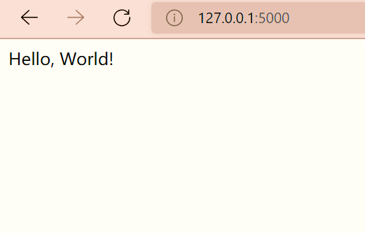
Links to go tutorials:
If you want to learn more about Django, refer to the following website:
Django documentation 4.0 (djangoproject.com)

