**GTSC2143 Machine Learning for Business Analytics**

**Tutorial 1 – Python Basics**

**Please write down your answers in this document and submit it at iSpace by the end of this tutorial.**

### Jupyter Notebook Experience

1. Launch Jupyter Notebook using one of these methods:

1. Command line: Type jupyter notebook

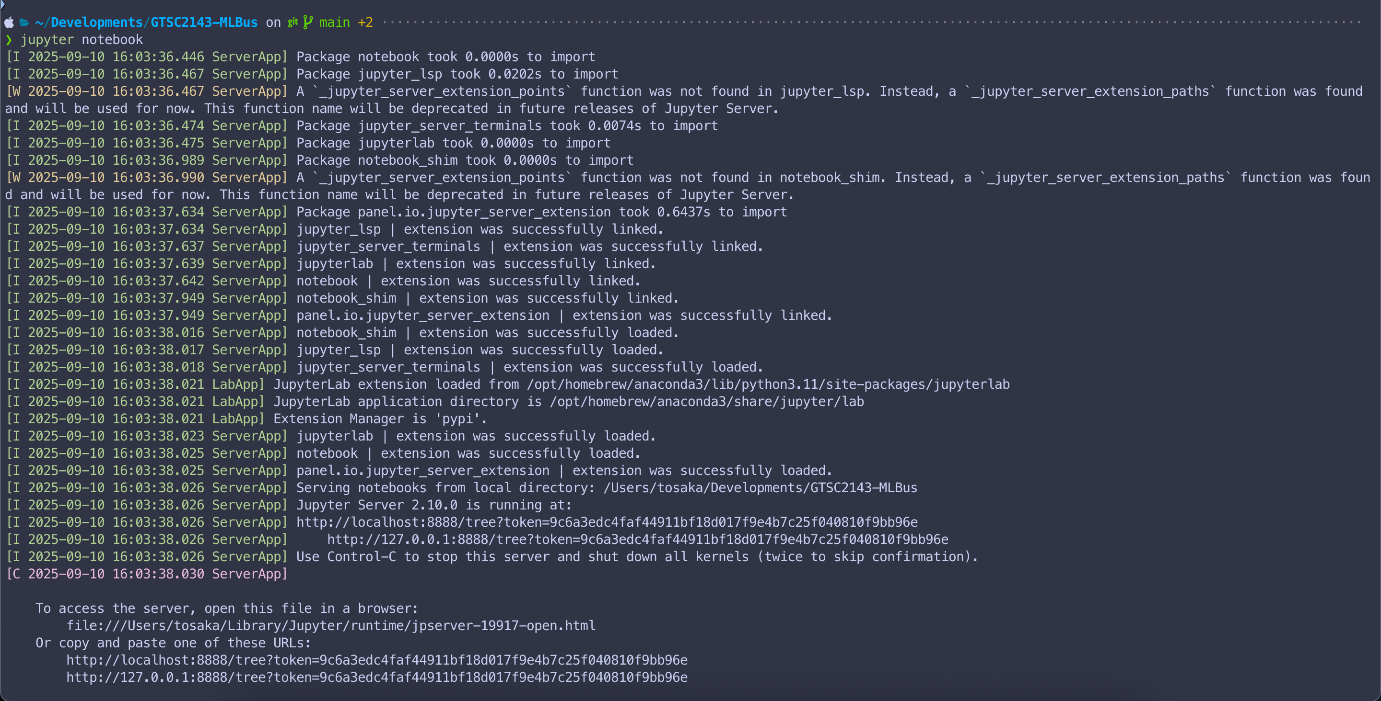

1. Anaconda Navigator: Click the Jupyter Notebook icon

2. Create New Notebook

1. Create a new notebook and name it: Tutorial1_<your_student_id>

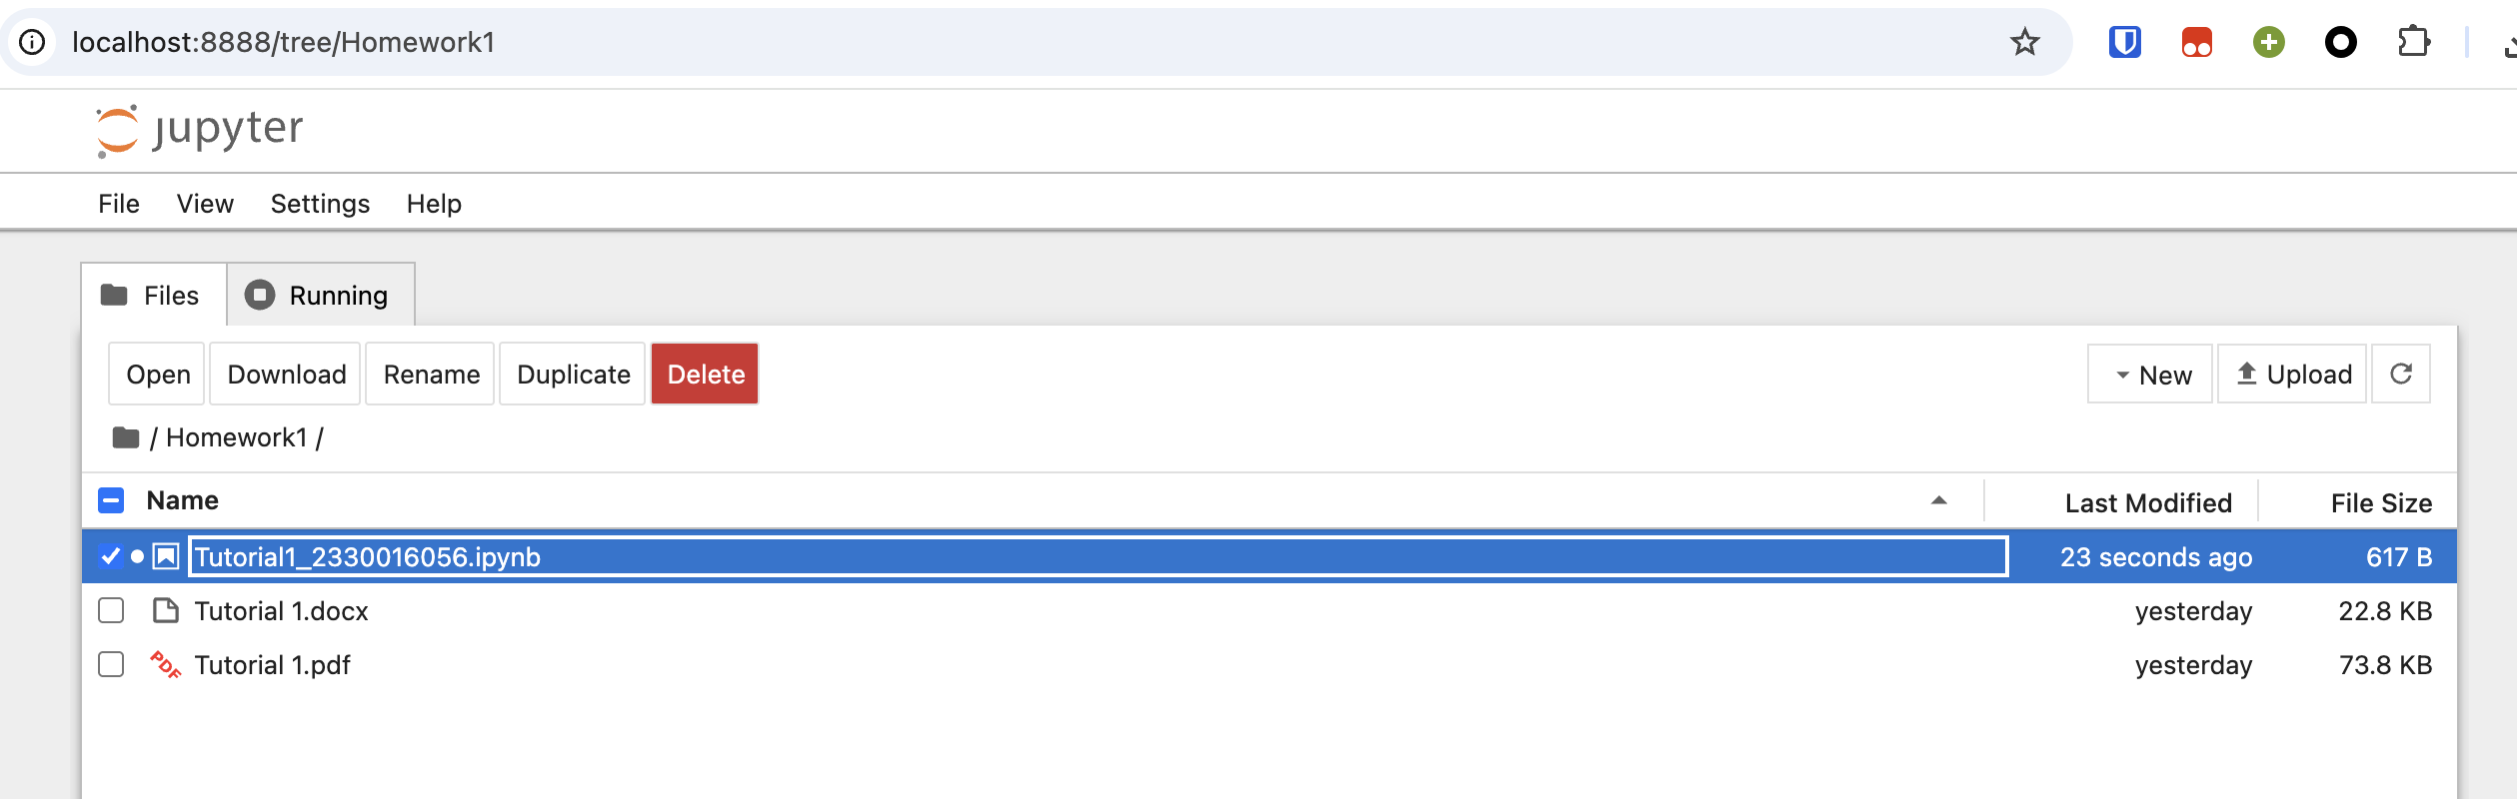

3. Execute Python Exercises

1. Complete Activity 2 exercises in separate Jupyter notebook cells

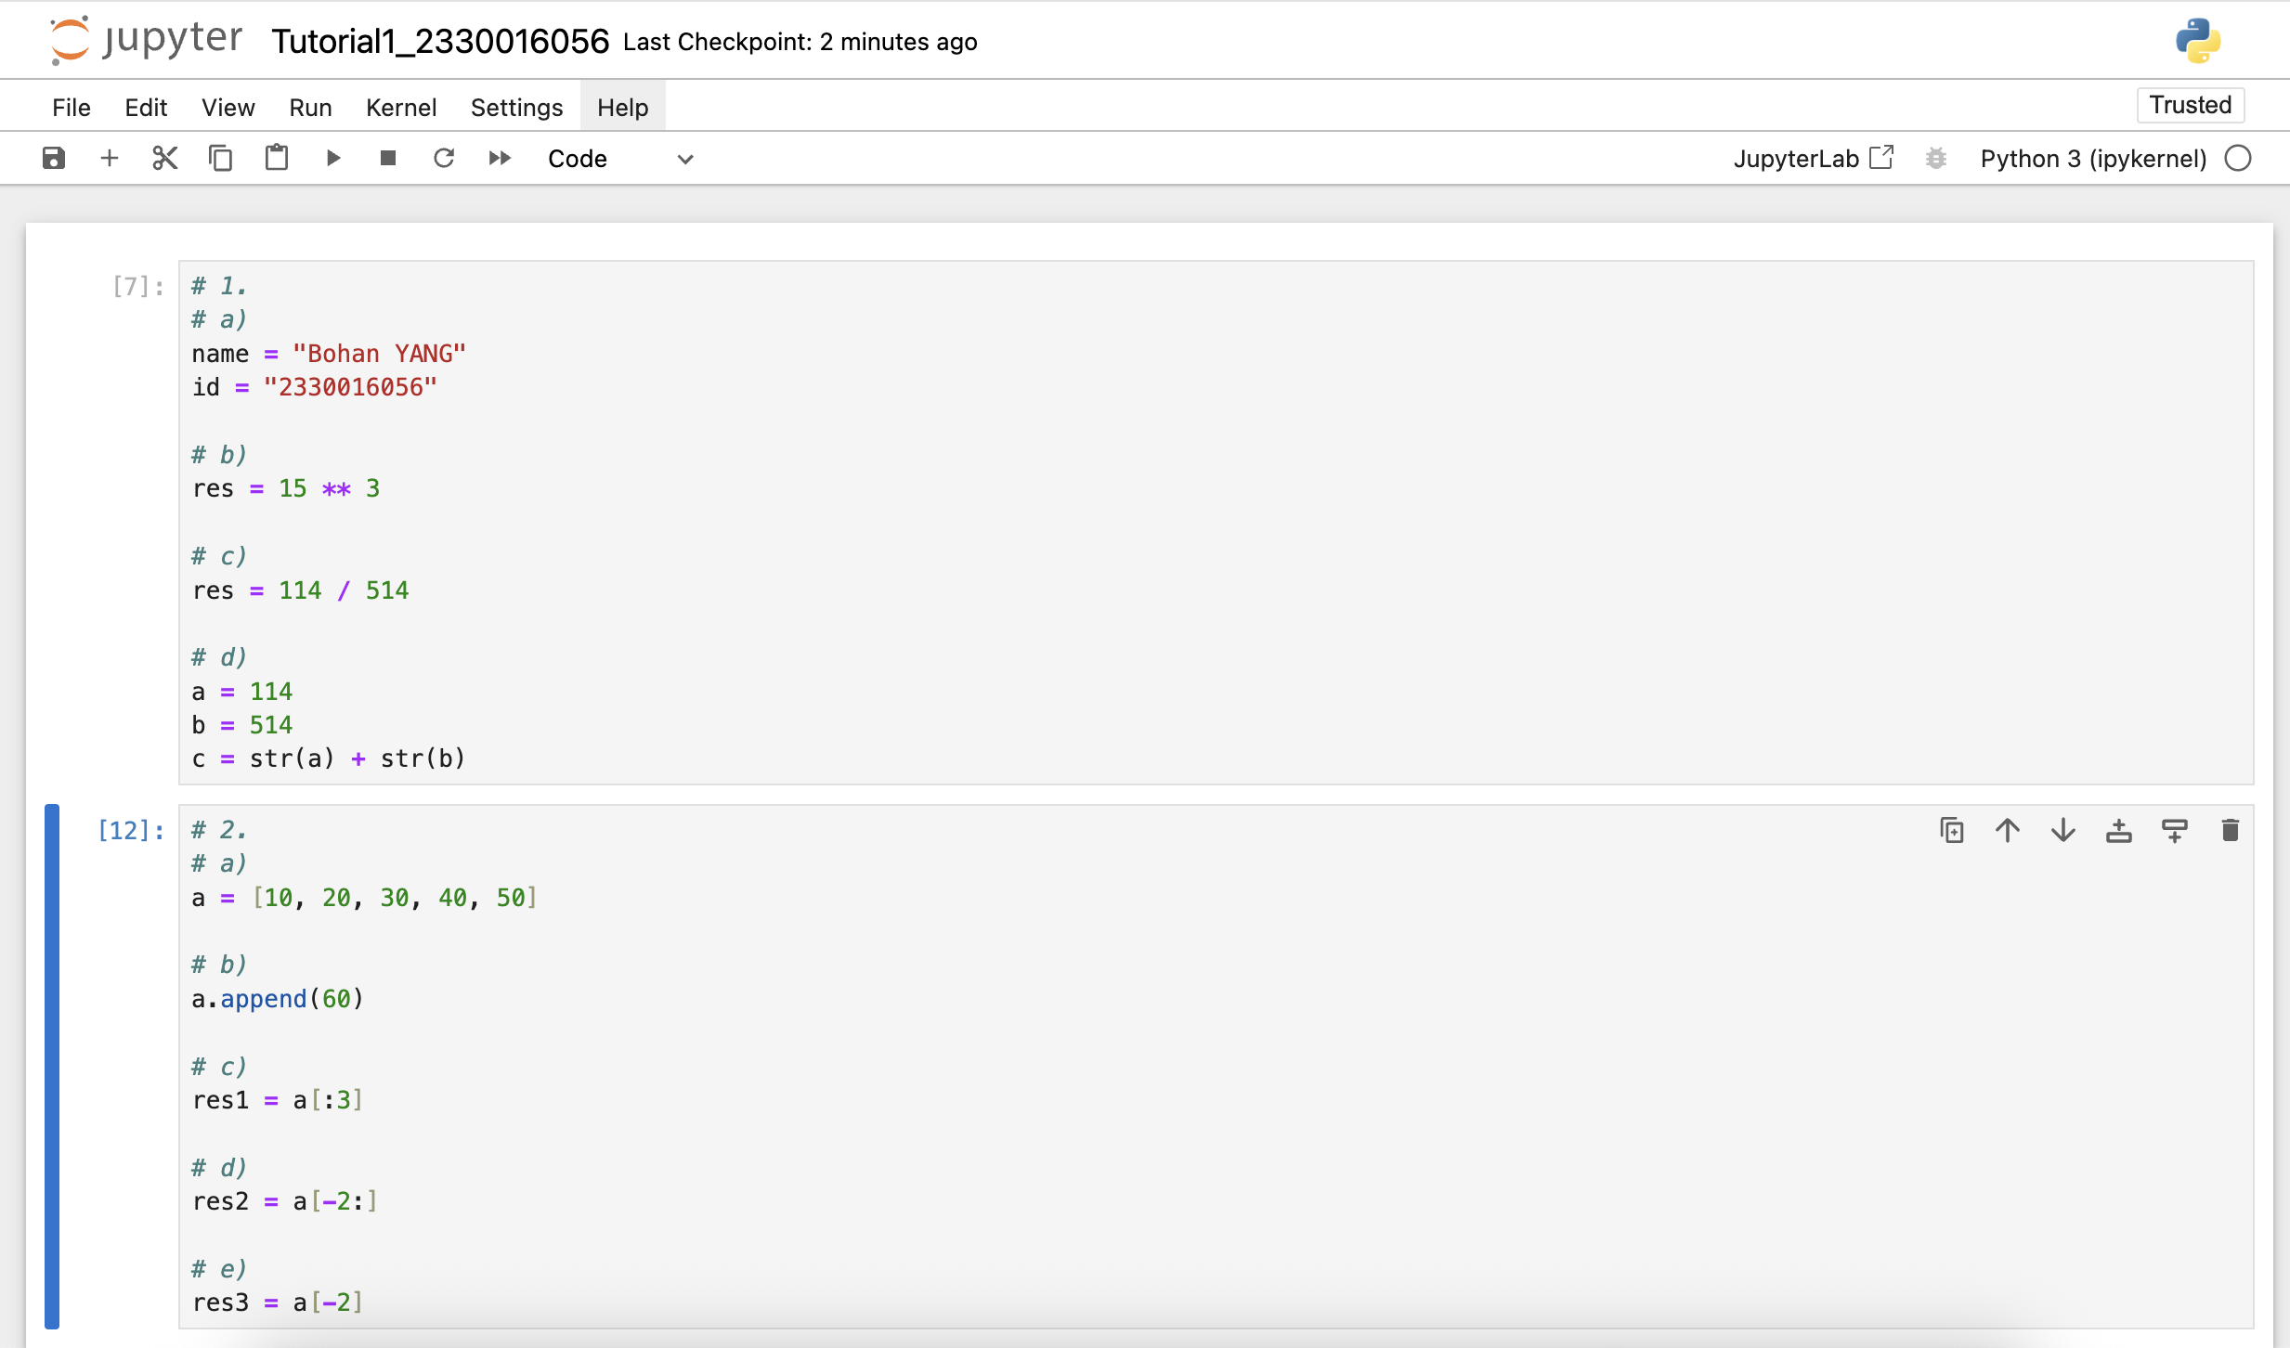

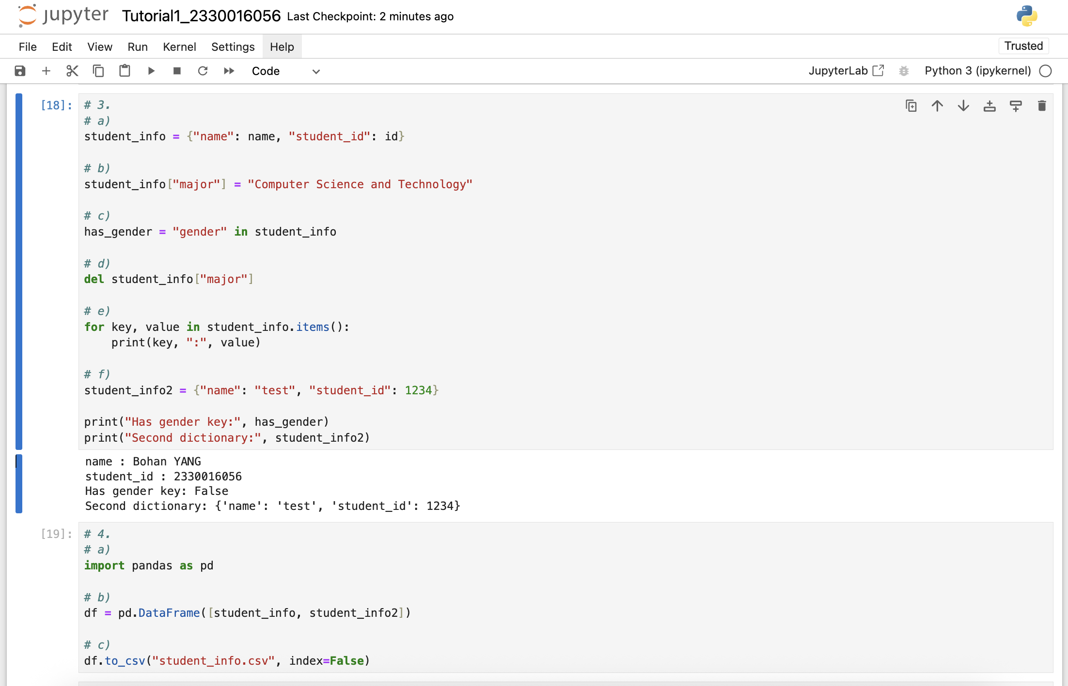

### Python Basic Exercise

1. Basic Data Types and Operations

1. Create variables to store your name and student ID
2. Calculate 15 to the power of 3
3. Divide two integers to get a float result
4. Convert numbers to strings and perform string concatenation

|  |
| --- |
| # 1.  # a)  name = "Bohan YANG"  id = "2330016056"  # b)  res = 15 ** 3  # c)  res = 114 / 514  # d)  a = 114  b = 514  c = str(a) + str(b) |

2. List Operations

1. Create a list containing 5 numbers
2. Append a new element to the end of the list
3. Get the first 3 elements of the list
4. Get the last 2 elements of the list
5. Access the second-to-last element using negative indexing

|  |
| --- |
| # 2.  # a)  a = [10, 20, 30, 40, 50]  # b)  a.append(60)  # c)  res1 = a[:3]  # d)  res2 = a[-2:]  # e)  res3 = a[-2] |

3. Dictionary Operations

1. Create a student information dictionary containing your name and student ID
2. Add a new key-value pair to include your major information
3. Check if a certain key (“gender”) exists in the dictionary
4. Delete the key-value pair (major information) from the dictionary
5. Iterate through all key-value pairs in the dictionary
6. Create another student information dictionary with name: “test” and student ID: 1234

|  |
| --- |
| # 3.  # a)  student_info = {"name": name, "student_id": id}  # b)  student_info["major"] = "Computer Science and Technology"  # c)  has_gender = "gender" in student_info  # d)  del student_info["major"]  # e)  for key, value in student_info.items():  print(key, ":", value)  # f)  student_info2 = {"name": "test", "student_id": 1234}  print("Has gender key:", has_gender)  print("Second dictionary:", student_info2) |

4. Package Import and Usage

1. Import Pandas
2. Create a DataFrame from the two student information dictionary
3. Export the DataFrame to a CSV file

|  |
| --- |
| # 4.  # a)  import pandas as pd  # b)  df = pd.DataFrame([student_info, student_info2])  # c)  df.to_csv("student_info.csv", index=False) |

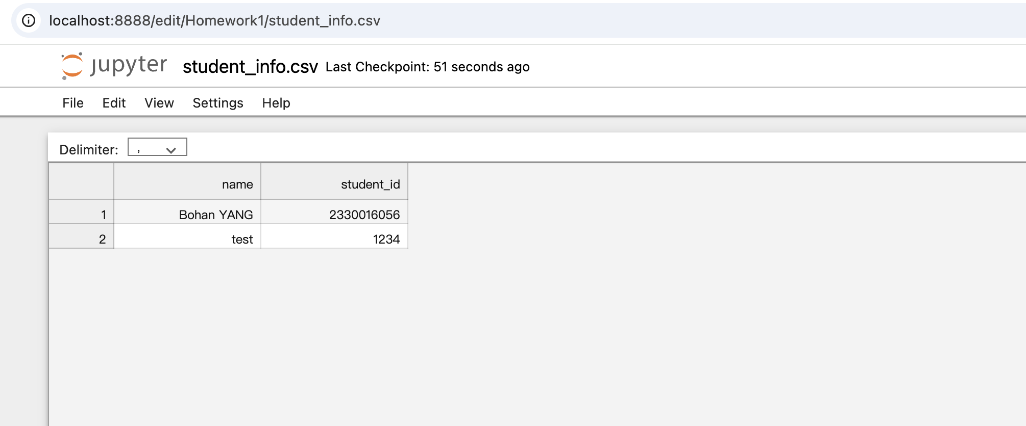

- End of Tutorial 1 -