File name: Index1.php

Link: http://localhost/sms2/index1.php



#About



In the unifast application form, the student must login first in order to apply for a scholarship.

Note: If wala pa ka login, mo pop-up ang message na “Log in to Apply for a scholarship” then naay button na “login”, once click ma proceed sa login PAGE. (newstudent login)

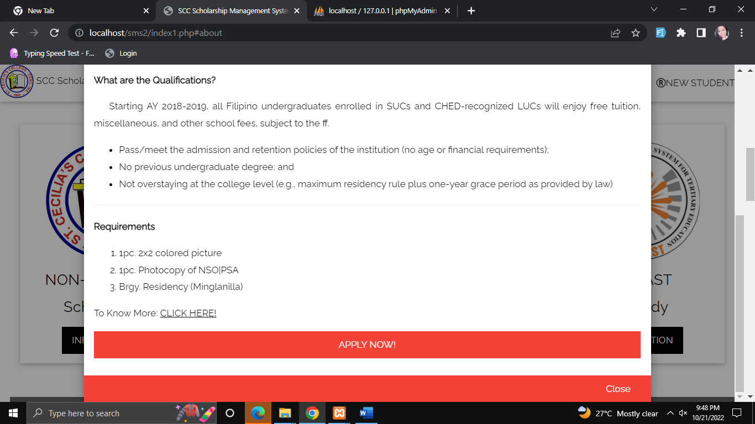

Unifast.php

Not working: All inputted information must be saved in the database, including the image.

Note:

* If possible, the student can save their information in each tab. “Save and Next” Button ang makita dili “next”ra.

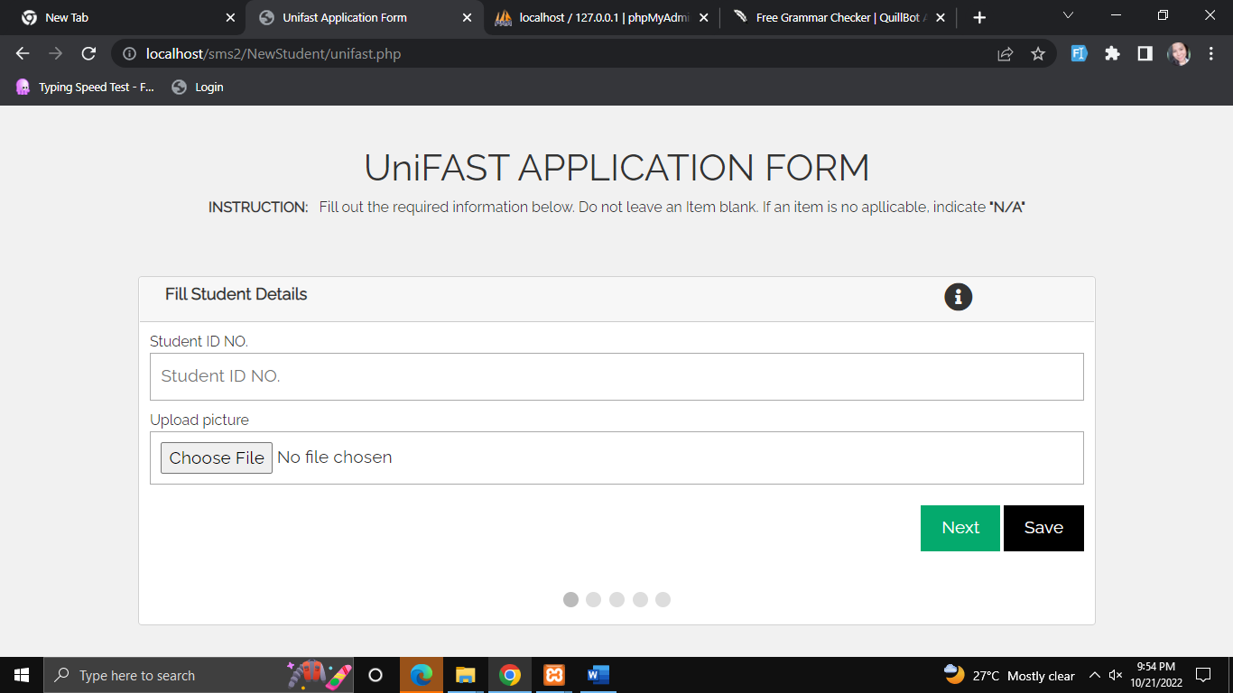

In the Last tab:

Note: please add text field above “Signature of Applicant Over Printed name”. Name sa student ang makabutang (Last Name, Given Name , Middle Name) and ang date pod please ko add.

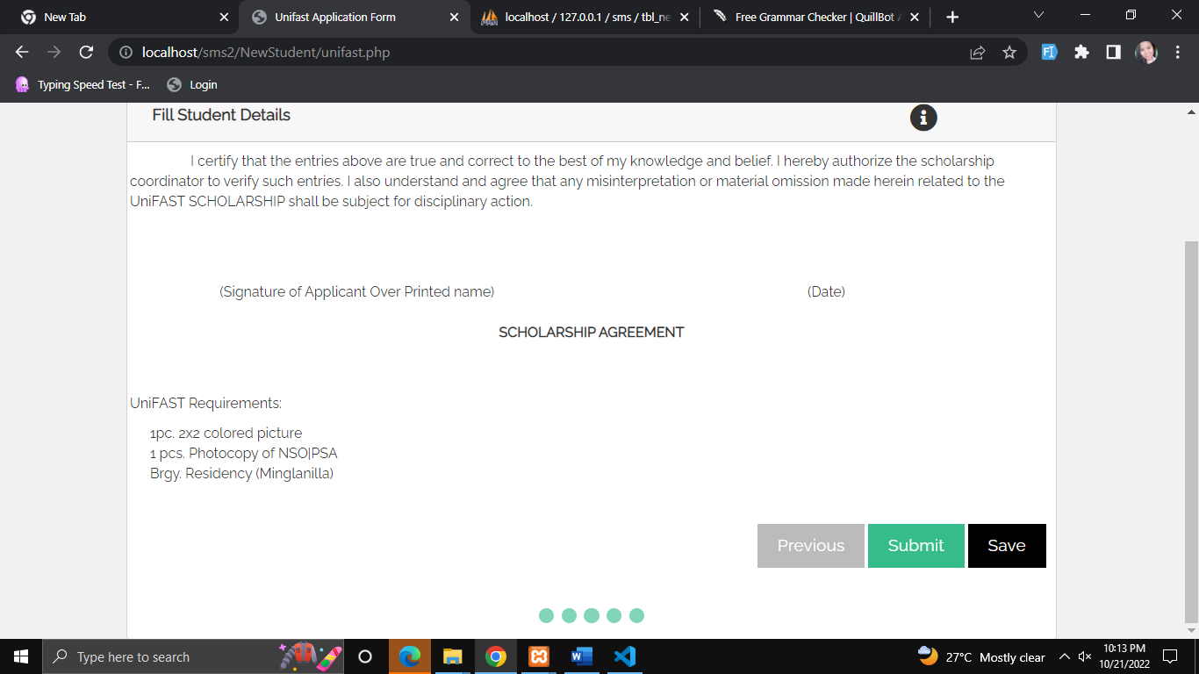

“Submit” button- once click masave na ang tanan info sa database and makita ni na output (picture below) (tanang gi input sa student Nakita diha, if possible same format na naa sa picture.)

Note: please ko add new data sa Database “s_year” para sa School Year (S.Y)

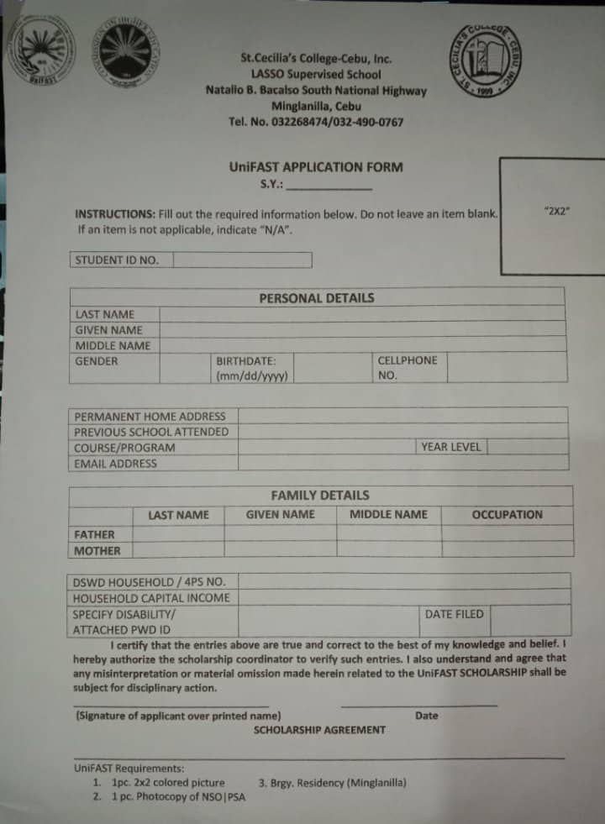

Submit Application

Please add button “submit application”- once click ma proceed sya sa next page - grats,php

“Go to homepage”button- pabalik sa homepage.

Print.php- (katong application form picture)



Profile.php- (same style lang sa old student profile, but ang information kay katong naa sa Tbl_newstudent na table/ unifast application. (same sa print.php na info)

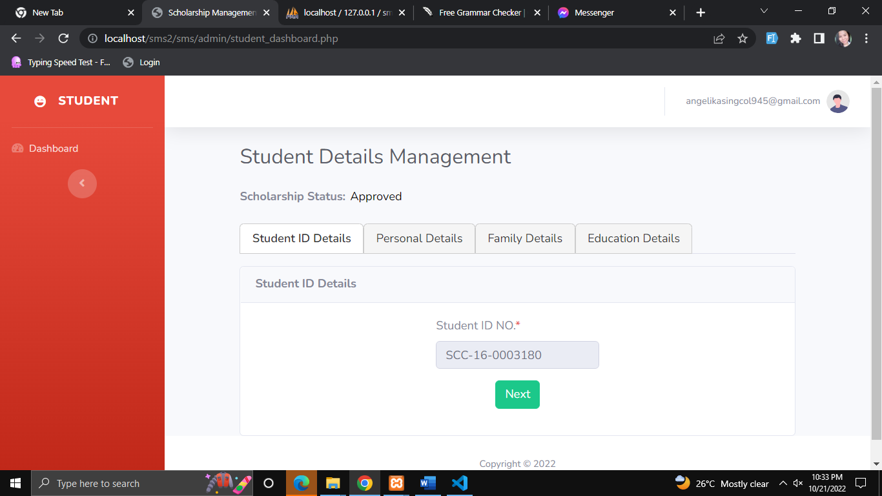

In admin portal- nag add mig unifast sa sidenav. Dira makita ang status sa student application, same format sa “Student management but ang info kay gikan sa tbl_newstudent/unifast application form.

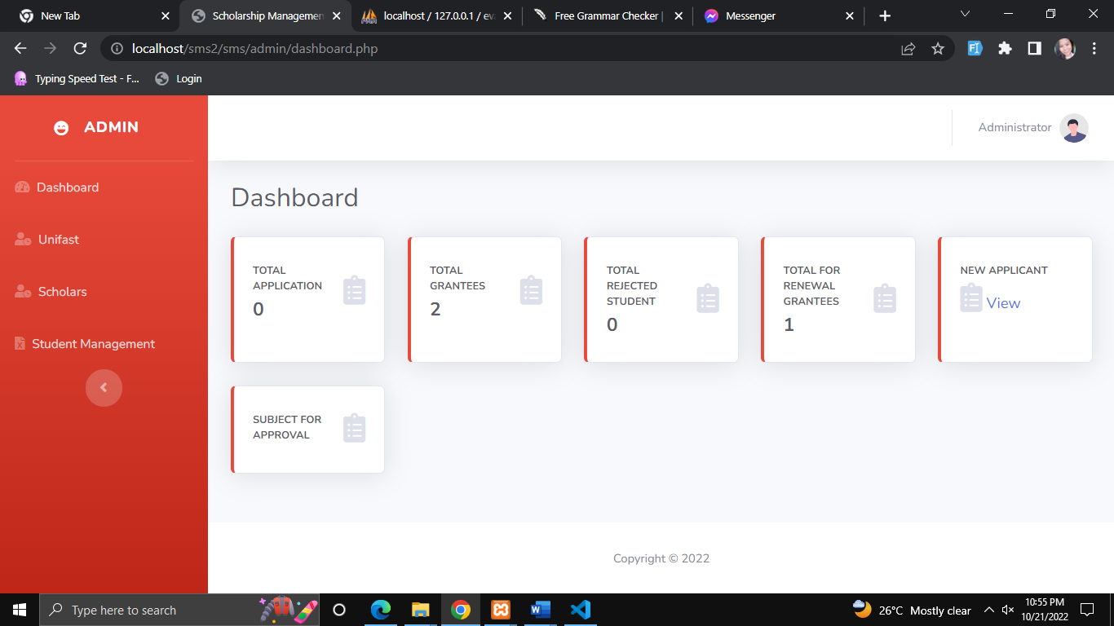

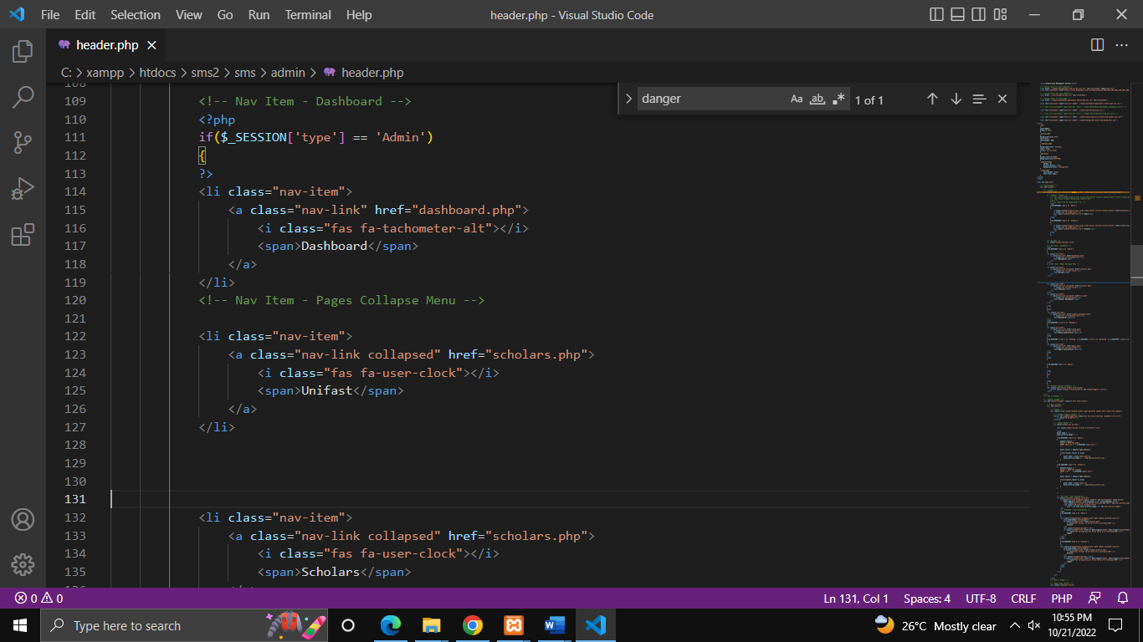

Please ko add ug 1 table sa data base to filter the status of application of students scholarship.

table name: Unifast_status

* to be verified- new student n ani apply (need pa mo pass sa requirements)
* Waiting for approval- naka pass na sa mga requirements
* Approved
* Renew
* Reject- wla ka passer/ wala ni pass sa mga requirements

For verification:

* Admin can send email and messages to the student to notify them about the status of their application.

(nana sya sa system but need to check if working paba.

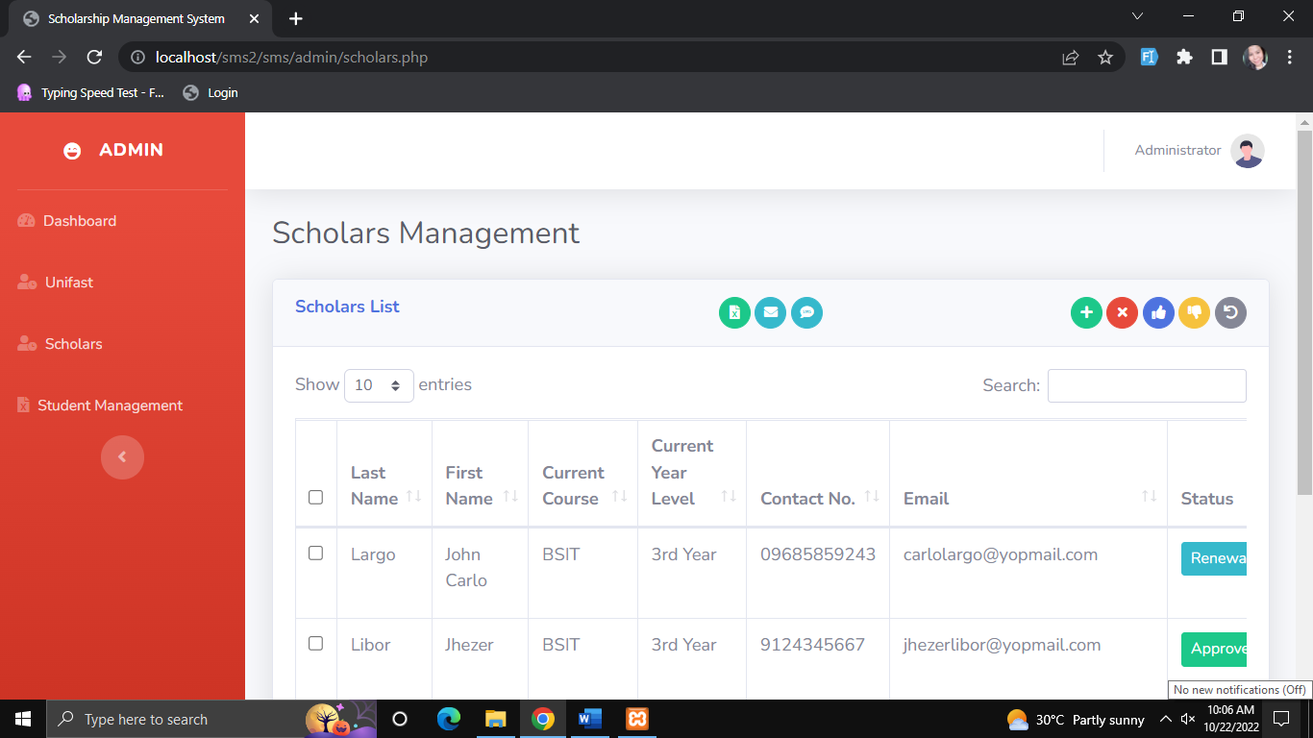4568890900--==rewfqcfabsvzmn /ghjgteb