Block 2: Back-end development

St. Alphonsus Primary School

Report

By Toseef Ashraf Parveen

Table of Content

Introduction 2

ER diagram: 3

PHP Code: 4

HTML Validation: 4

Login Page: 17

Logout Page: 19

Functions Page: 19

Index Page: 22

Table Pages: 24

Add new record: 26

Edit record: 28

Delete record: 31

Form: 32

Reflecting on the technologies used: 35

References: 37

# Introduction

The assignment for this project was to create a back-end development database for St. Alphonsus primary school because previously they were using a pen and paper model which was very time consuming and inefficient. For this reason, the assignment was to create a web-based digital system, including a relational database to hold all the data digitally and make the system more efficient. Before making the database, an entity relationship diagram had to be made to not only describe the relationship between tables but to also get a preview of what the database would look like.

ER diagram: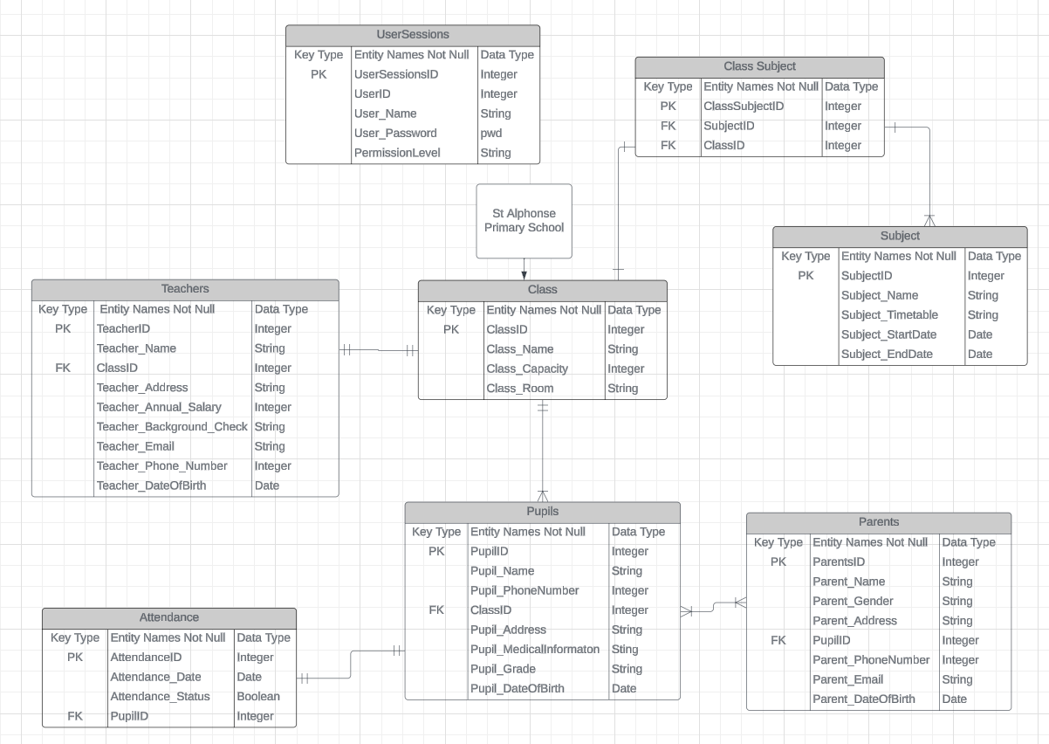

Figure 1

# PHP Code:

## HTML Validation:

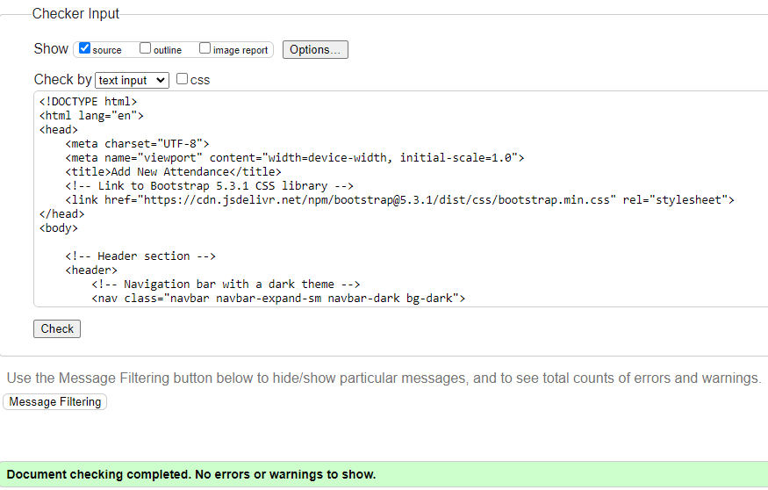

Figure 2

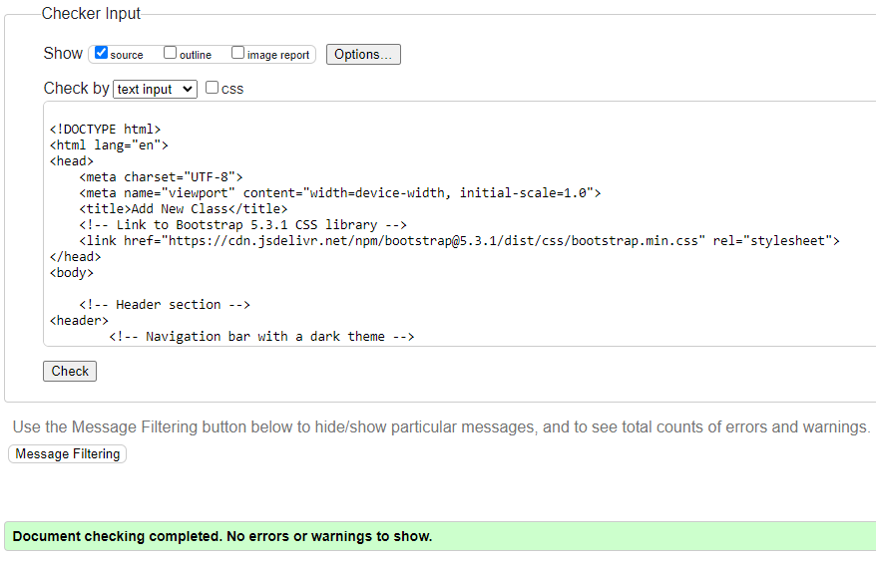

Figure 3

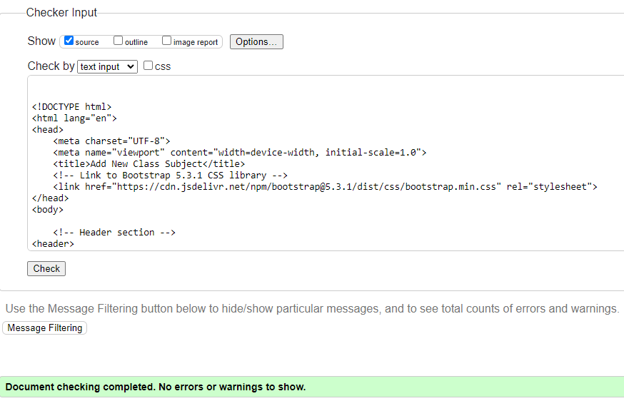

Figure 4

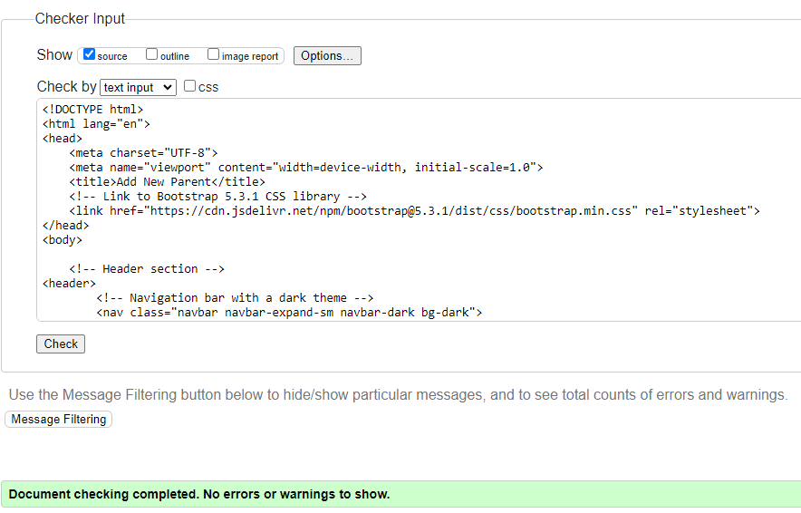

Figure 5

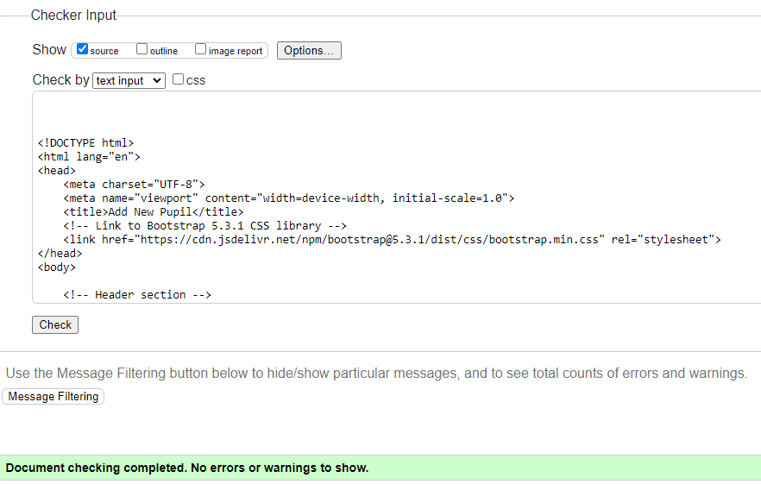

Figure 6

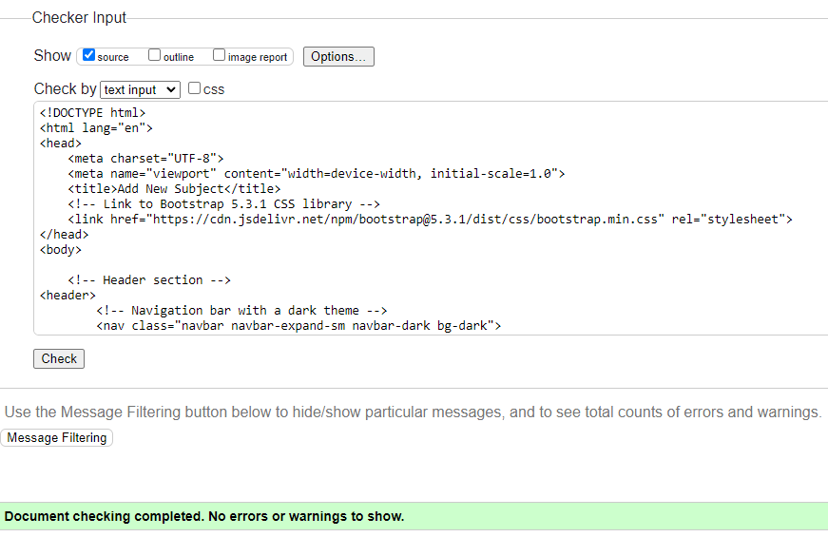

Figure 7

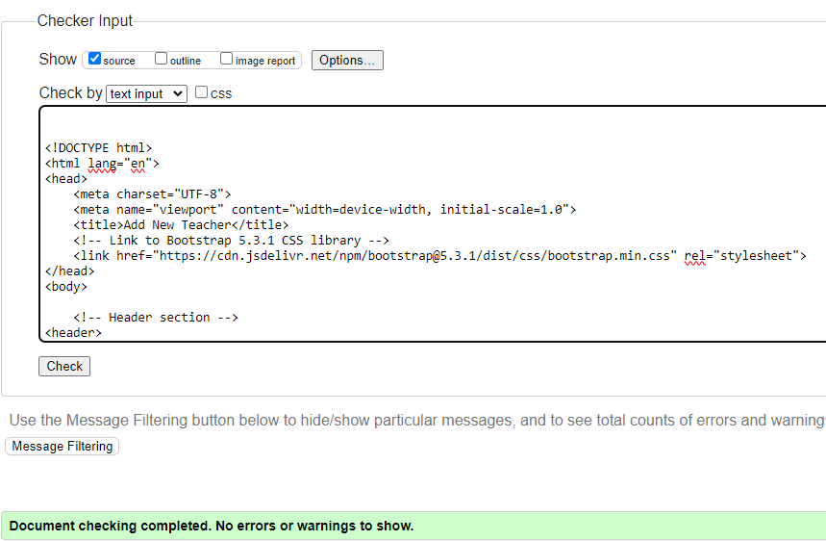

Figure 8

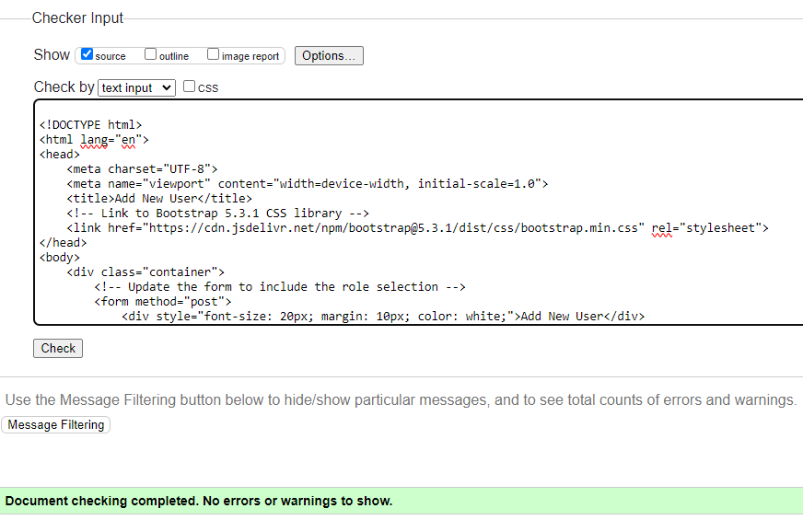

Figure 9

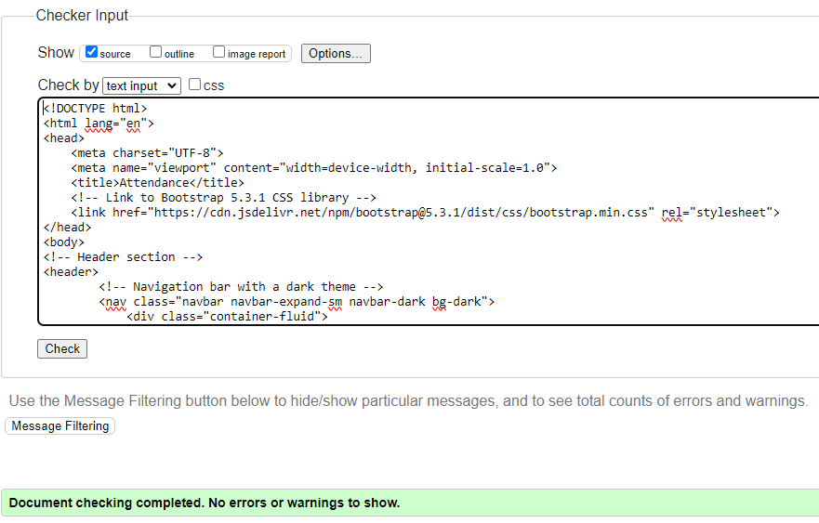

Figure 10

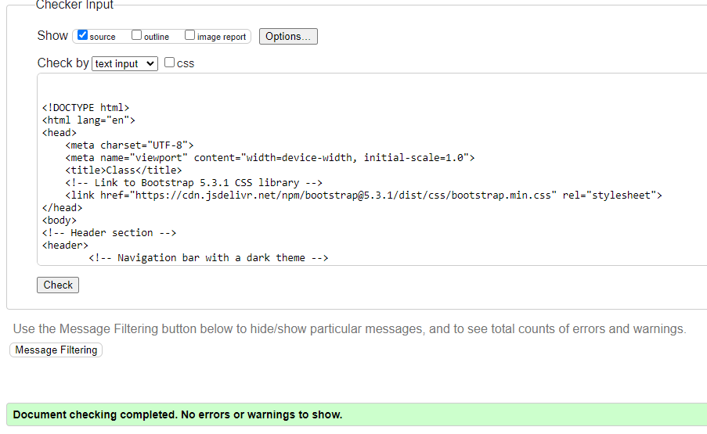

Figure 11

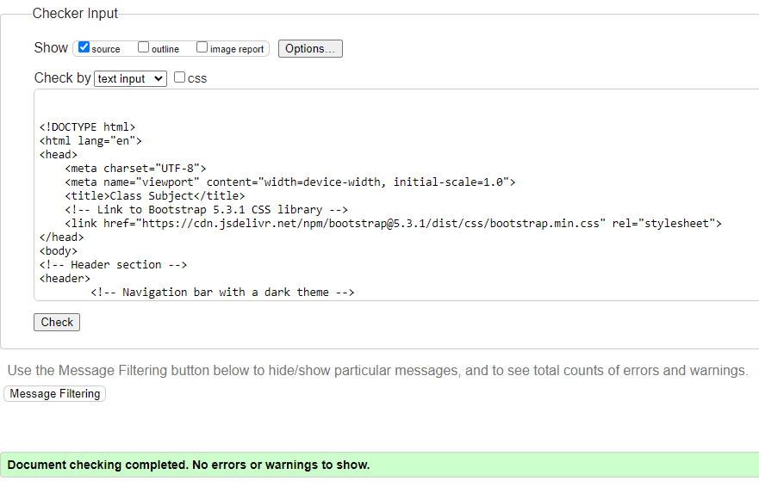

Figure 12

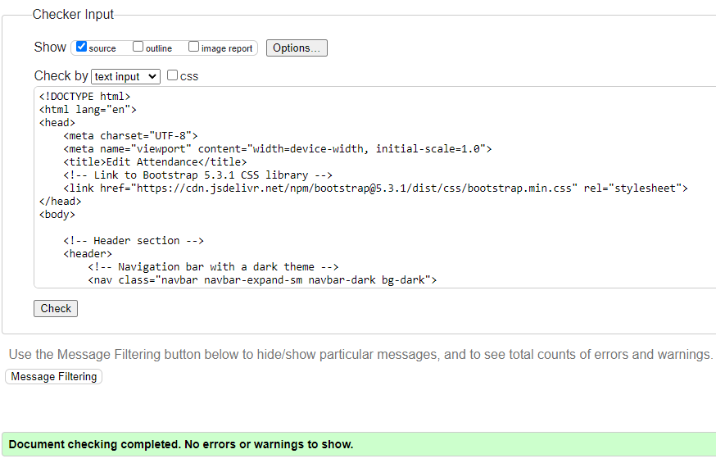

Figure 13

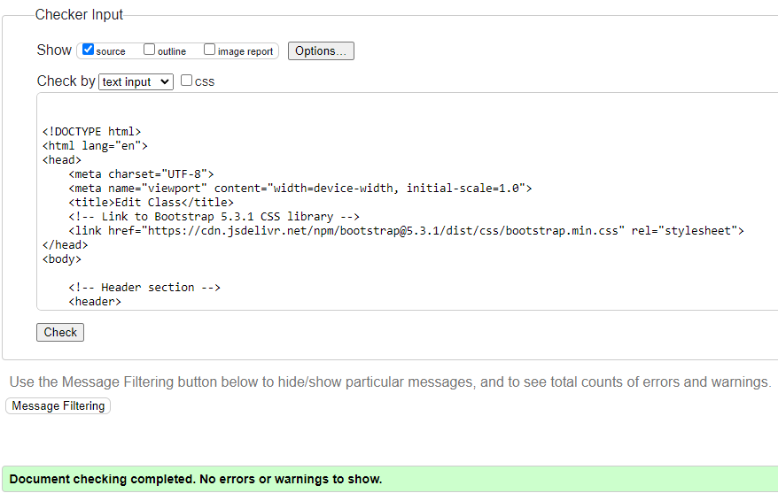

Figure 14

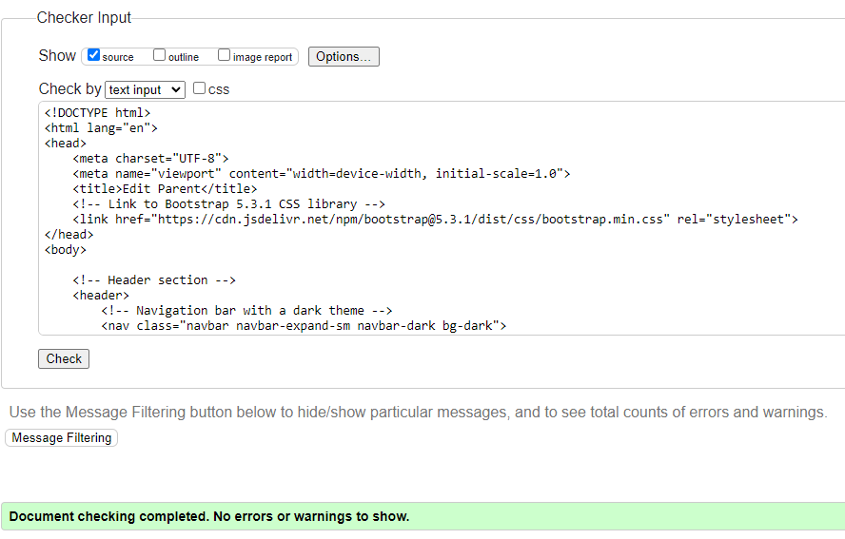

Figure 16

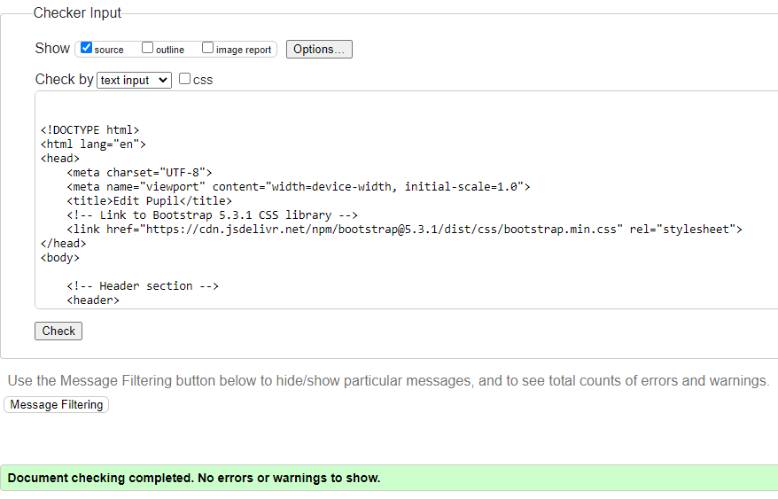

Figure 17

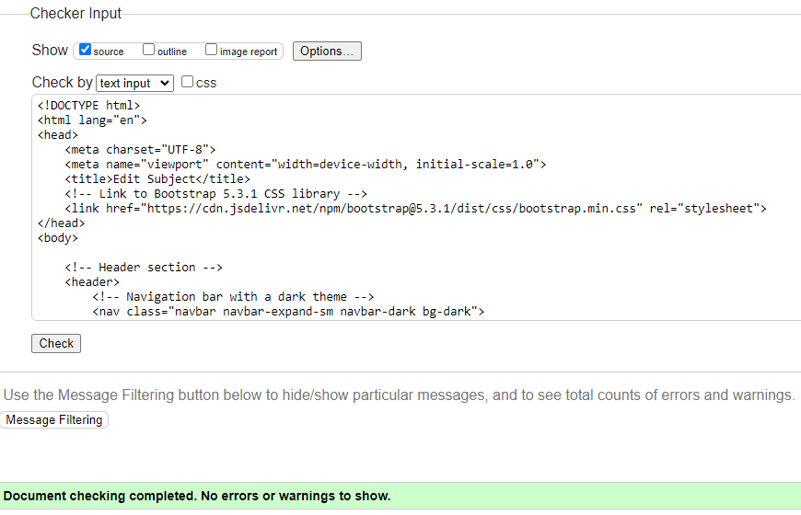

Figure 18

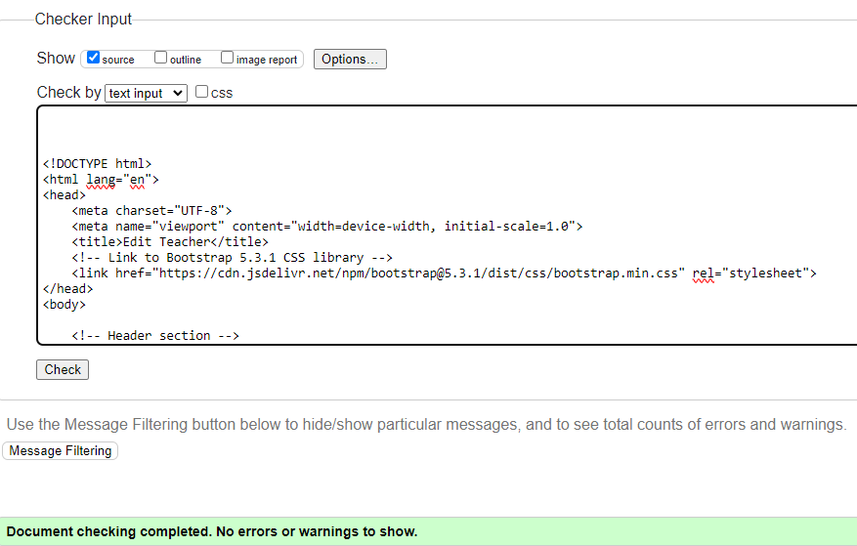

Figure 19

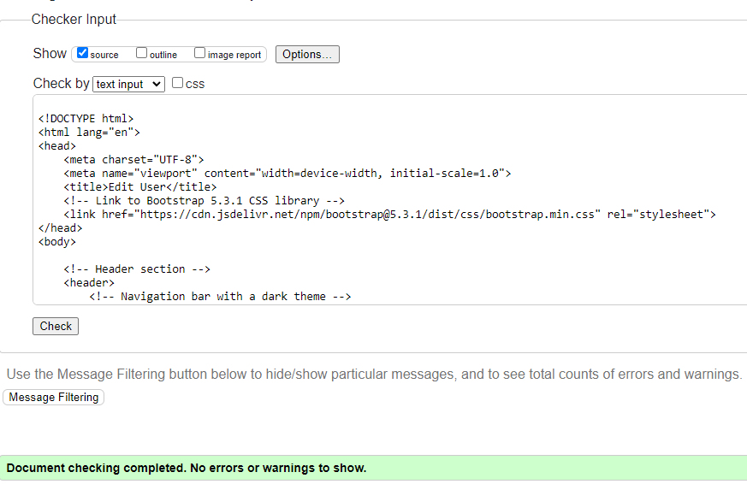

Figure 20

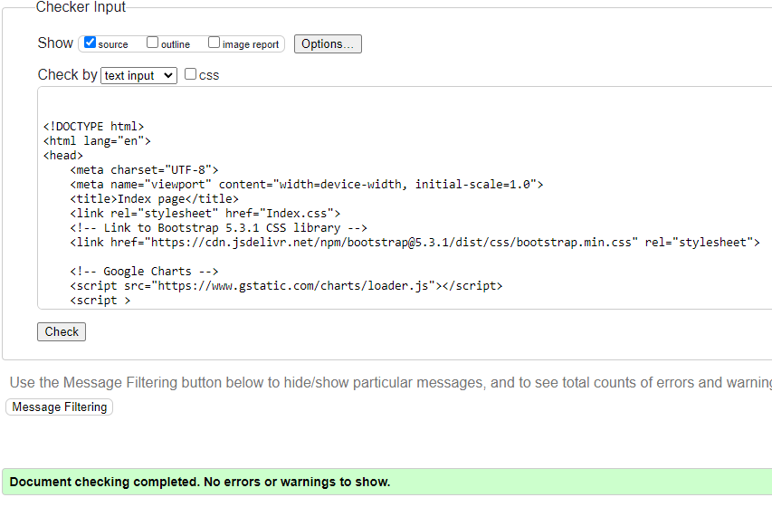

Figure 21

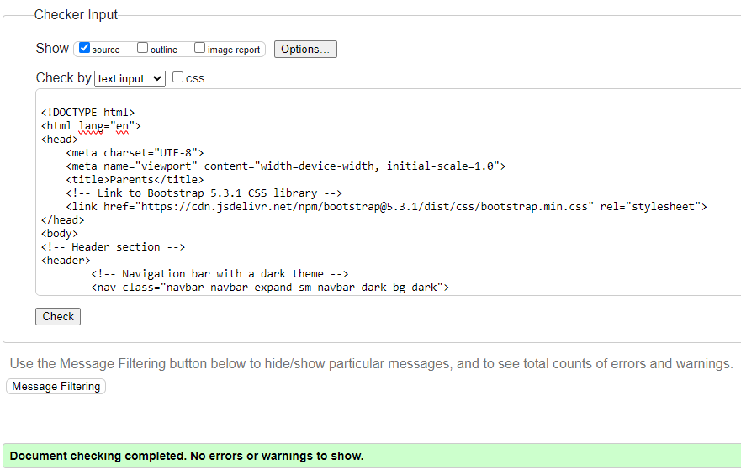

Figure 22

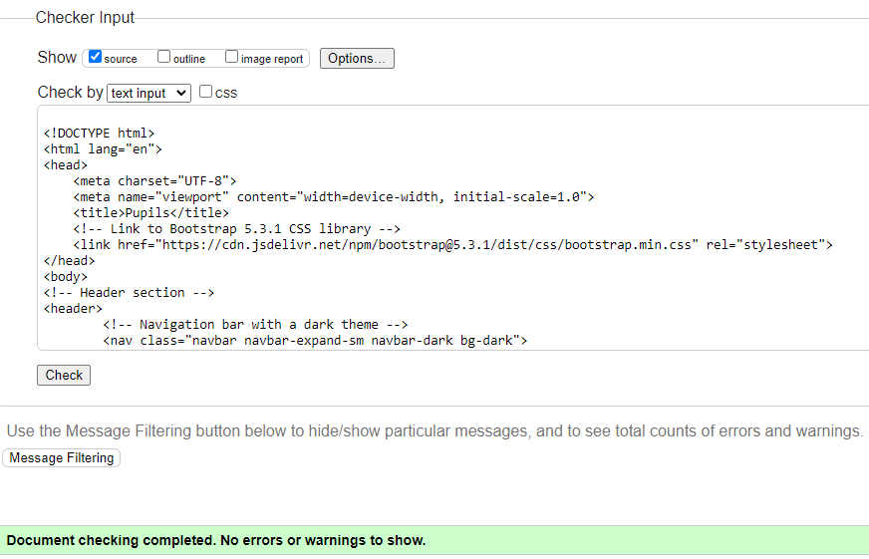

Figure 23

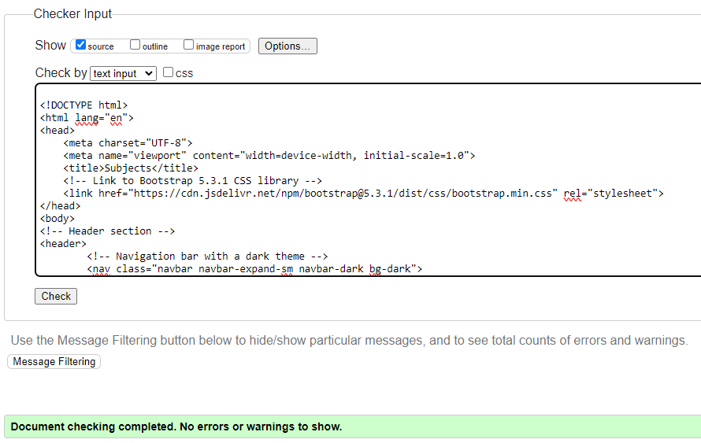

Figure 24

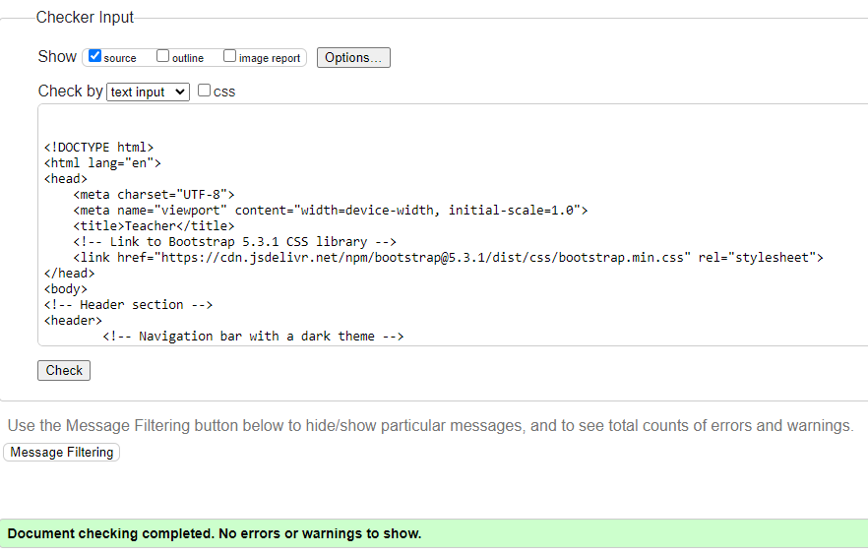

Figure 25

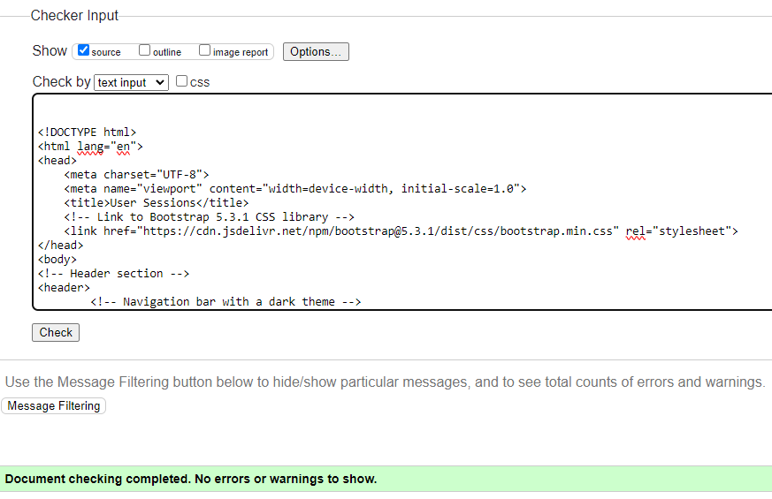

Figure 26

From Figure 1 to Figure 26 it shows that all the HTML is correct and there are no errors, it also shows that the structure is also correct and in the proper way.

## Login Page:

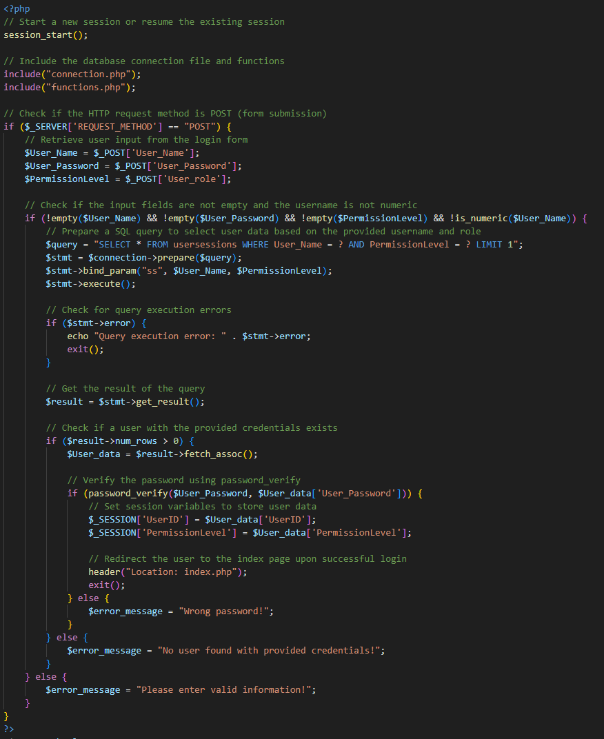

Figure 27

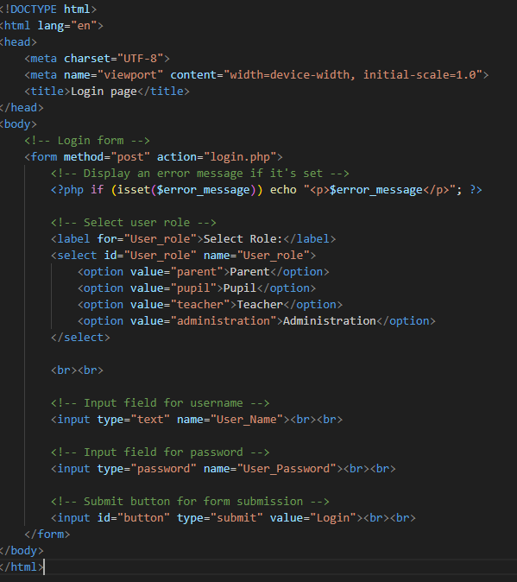

Figure 28

(*Signup and Login with PHP and MySQL*. [online])The login page consists of connecting to the database, getting the information from the form submission, and checking that it matches the data in the database. If it does match it will let the user proceed, if not, an error message will appear.

## Logout Page:

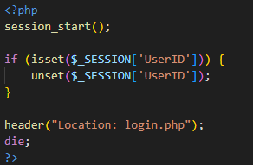

Figure 29

The logout page consists of ending the session.

## Functions Page:

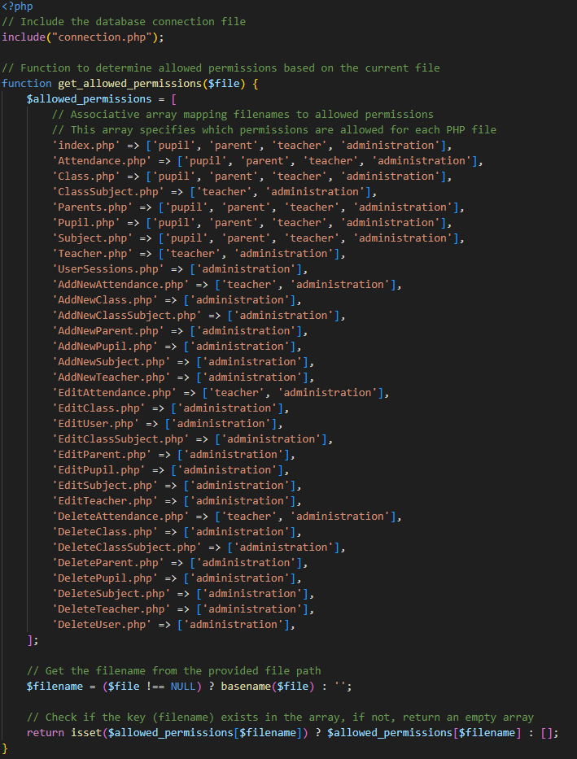

Figure 30

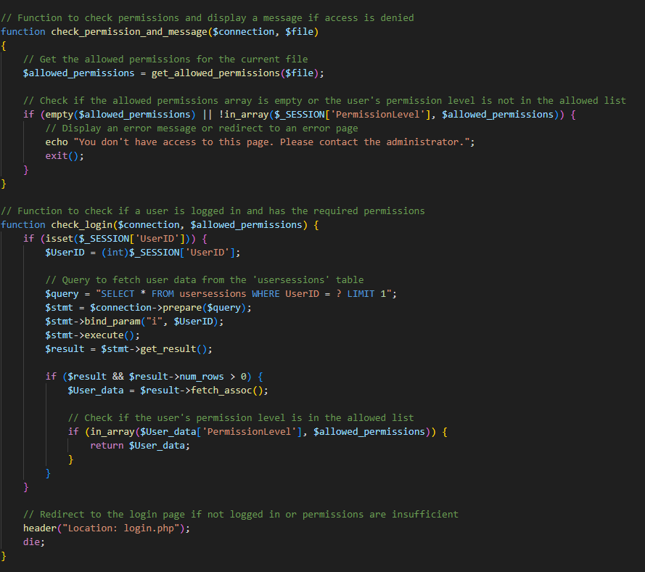

Figure 31

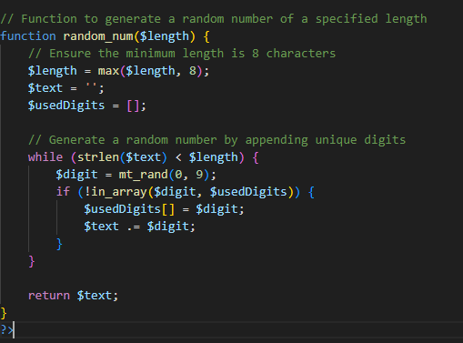

Figure 32

(*Signup and Login with PHP and MySQL*. [online])The function page consists of various functions that are implemented on each page. It has a permission level function that restricts certain users from entering and using some of the pages according to their user type.

It also has a function that creates random numbers or the UserId that are not the same. The login features were inspired by video that will be linked later in the references.

## Index Page:

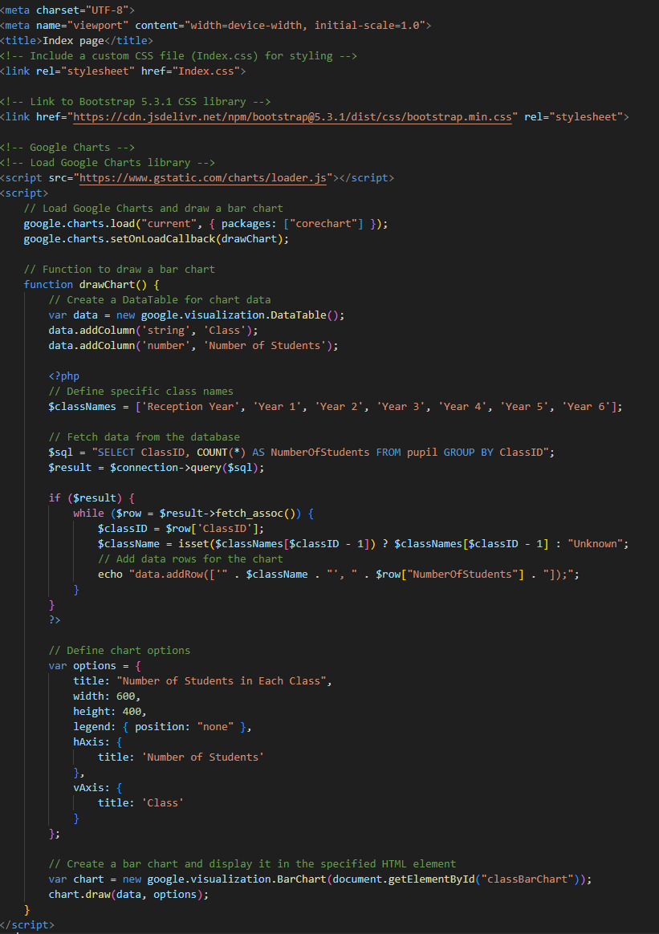

Figure 33

(Google Developers. (n.d.). *Charts*. [online])The index page consists of navigation bar from bootstrap with the links of the other pages and this chart from google that was changed to adapt this assignment and it shows how many students ae in a class.

## Table Pages:

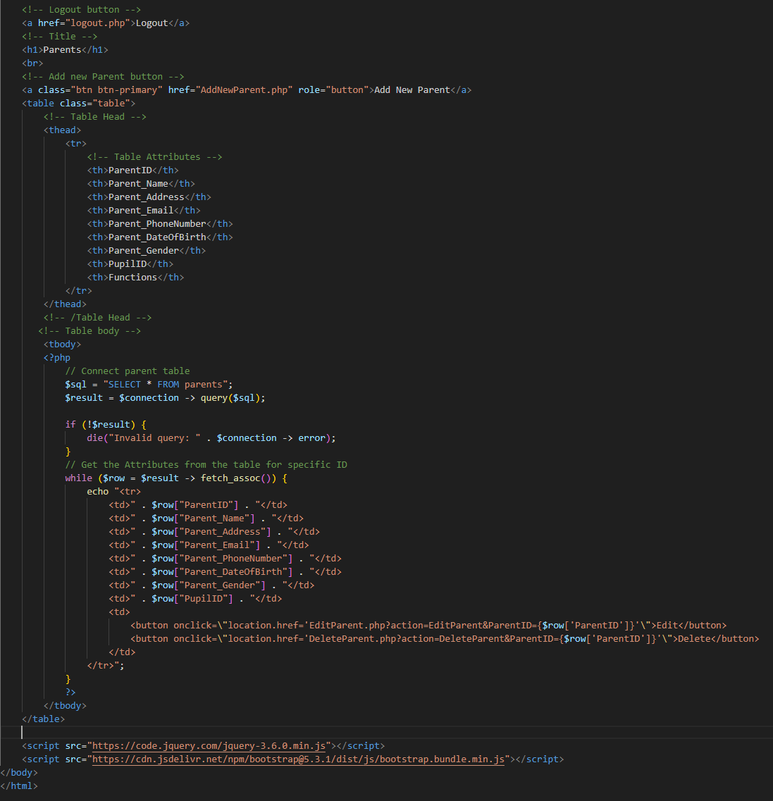

Figure 34

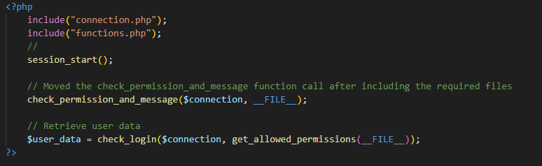

Figure 35

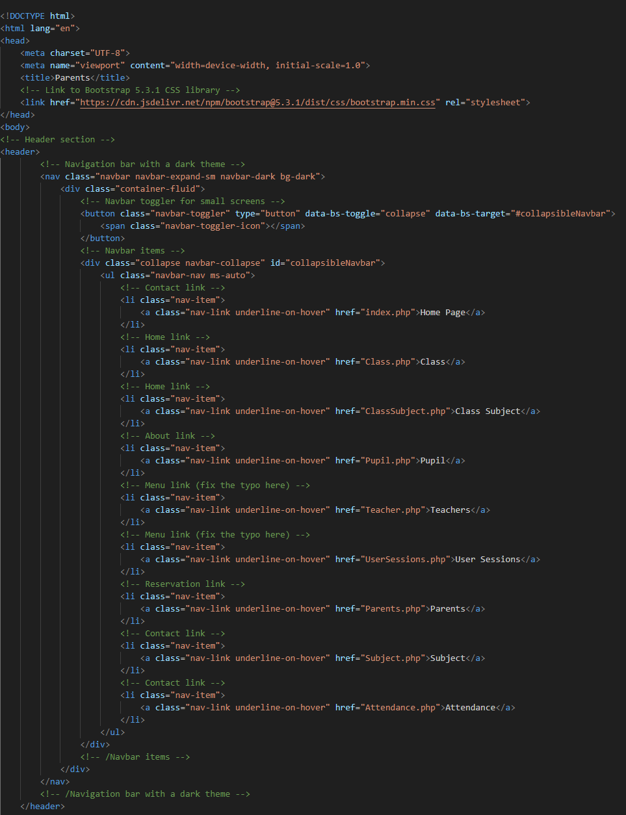

Figure 36

((BoostMyTool (2022). *PHP and MySQL with CRUD Operations: Create, Read, Update, Delete*. *YouTube*.)There is only 1 table shown here, but all the other tables are similar, they just have different var names. It consists of a session that checks what type of user you are, and it will let those that are allowed. It also has a nav bar to navigate to other pages. Finally, it has a table containing the head which has the titles of the attributes and a body which pulls the data from the database and inserts it into the body of the table.

## Add new record:

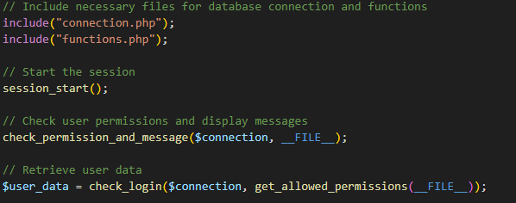

Figure 37

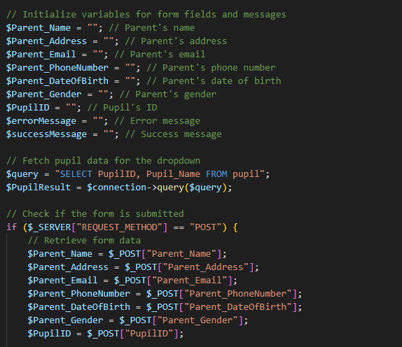

Figure 38

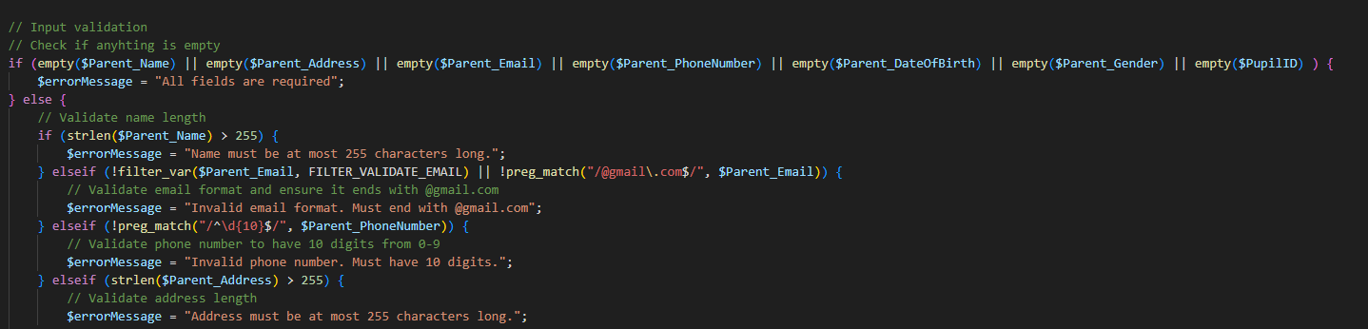

Figure 39

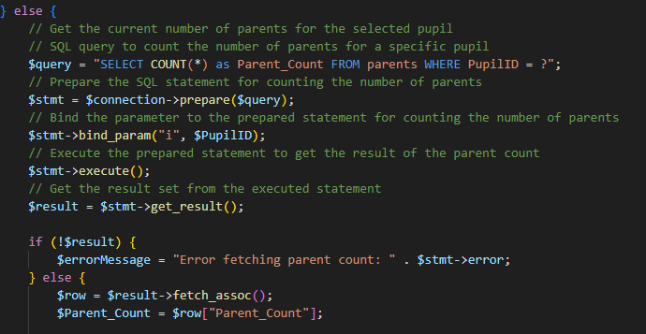

Figure 40

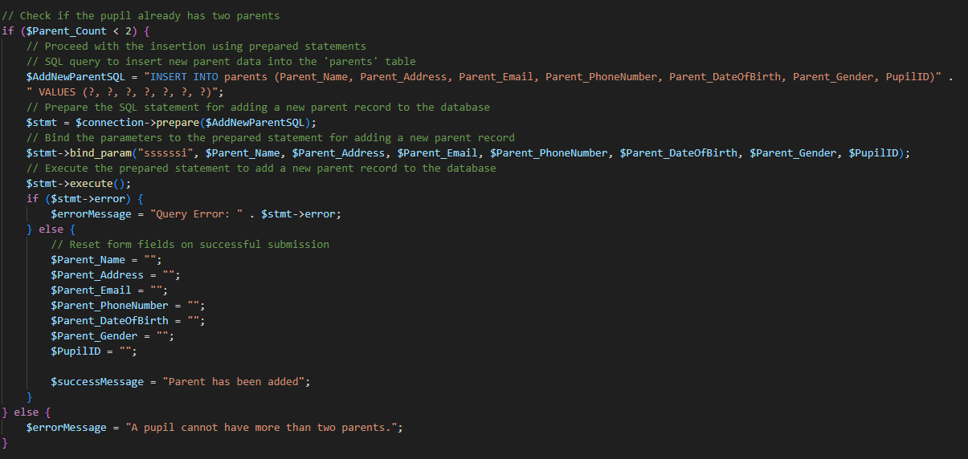

Figure 41

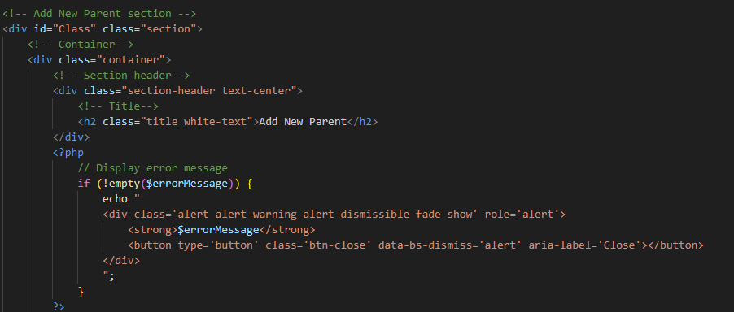

Figure 42

(BoostMyTool (2022). *PHP and MySQL with CRUD Operations: Create, Read, Update, Delete*. *YouTube*.)The add function consists of a session start because only admins can add, after empty variables will be populated later with the form. Then it will check if the form is submitted and if it is it will check a couple of conditions to check if the data is clean with a validation and it will also secure the submission, so SQL injection does not happen. After this, it will insert it into the database and refresh the variables. After the PHP code, there is also a form code that I will show later and is where the data is entered.

## Edit record:

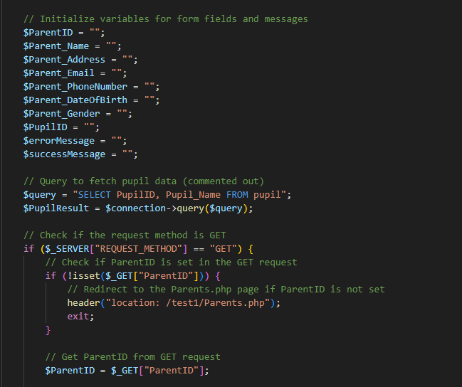

Figure 43

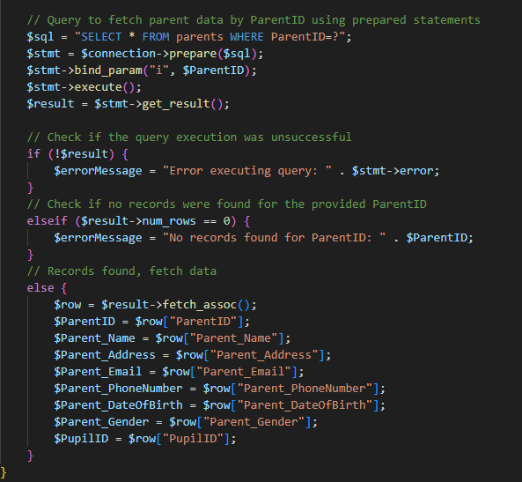

Figure 44

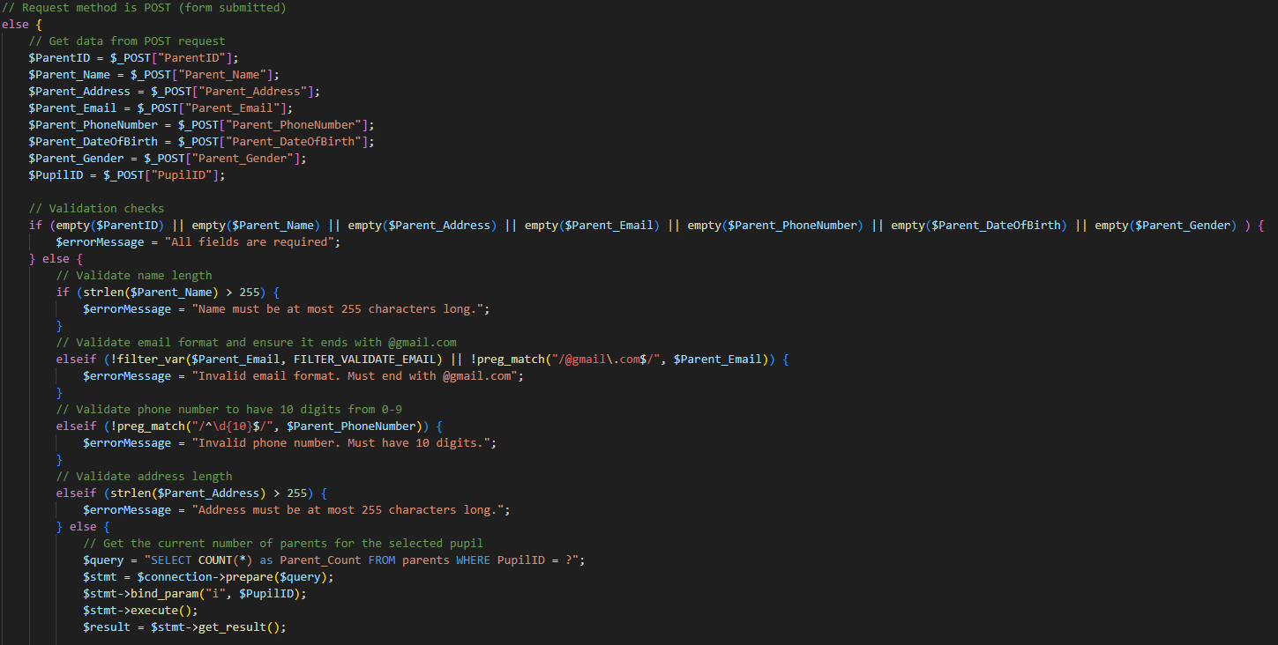

Figure 45

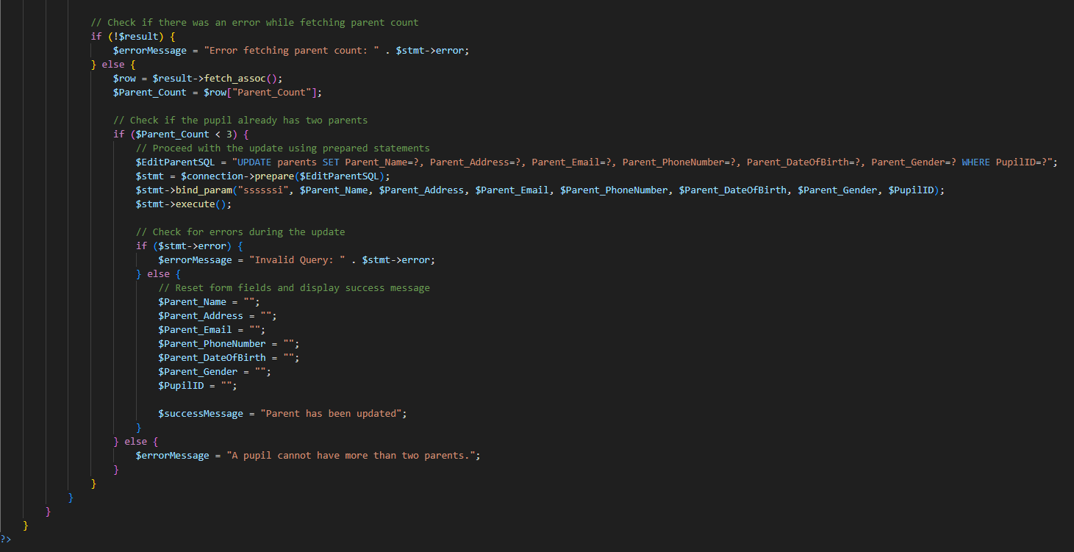

Figure 46

(BoostMyTool (2022). *PHP and MySQL with CRUD Operations: Create, Read, Update, Delete*. *YouTube*.)Editing the record is like the add function but this time it will fetch the information stored in the database and display it to the end user. And another difference is that instead of inserting the data, it will update it into the database.

## Delete record:

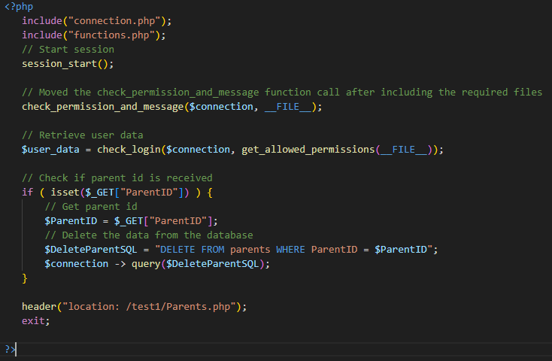

Figure 47

(BoostMyTool (2022). *PHP and MySQL with CRUD Operations: Create, Read, Update, Delete*. *YouTube*.)Deleting the record consists of starting the session to check that only allowed users are in and it will use the Delete command of SQL to delete the specific record that the user picked. Deleting entries is not recommended because the data might also impact other tables that have foreign keys, so companies store that data in another table, but for this assignment it was used to prove that it can be done.

## Form:

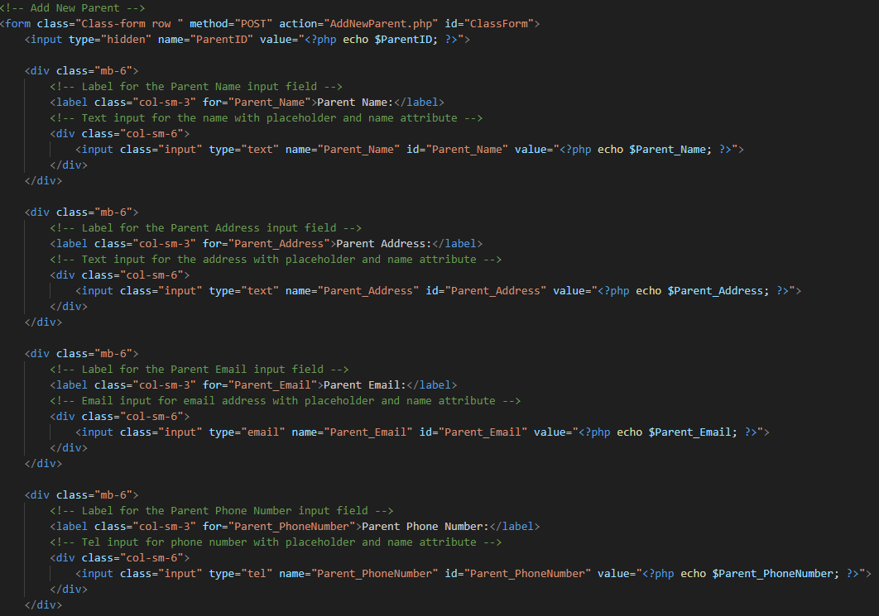

Figure 48

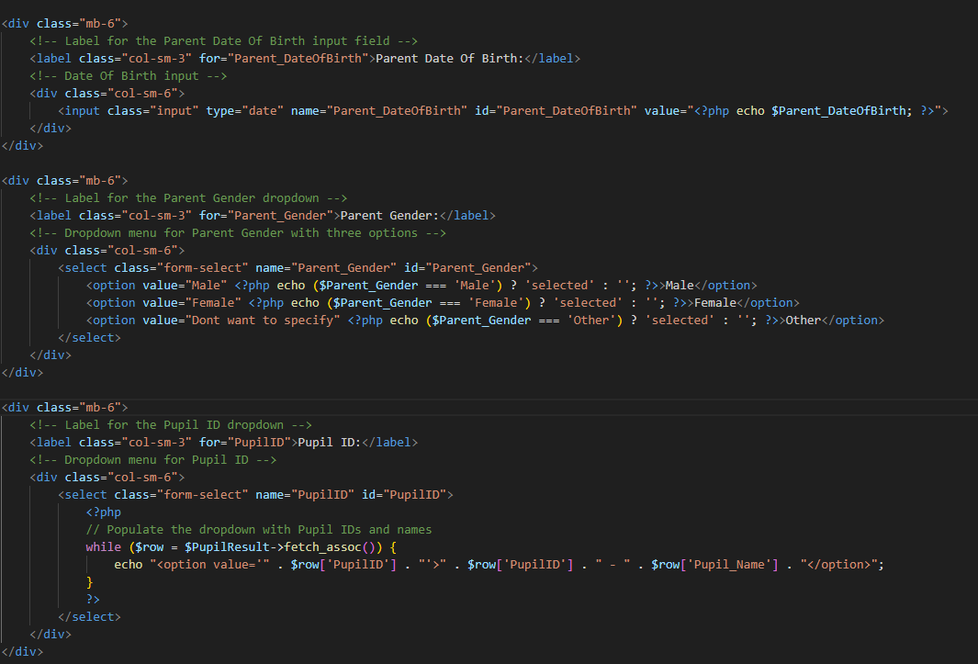

Figure 49

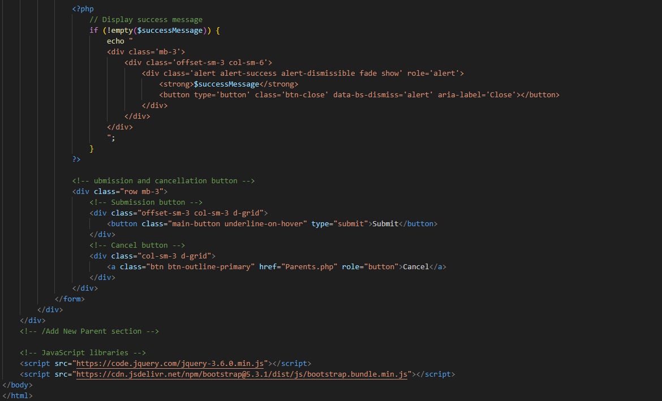

Figure 50

(BoostMyTool (2022). *PHP and MySQL with CRUD Operations: Create, Read, Update, Delete*. *YouTube*.)The form consists of getting the id and inputting the data into the appropriate box and submitting it. If the data is wrong it will send an error message, if the data is correct, it will display the success message.

# Reflecting on the technologies used:

MySQL is a widely used technology to use CRUD operations as it is quite simple yet complete software that has many advantages. One of the biggest advantages is that it is free software, so it is widely available to everyone. This is helpful for students because they get a lot of experience about databases, and it is remotely accessible, allowing it to be dynamic and an accessible learning environment. Another advantage is that it is simple software that is easy to learn, which makes it user-friendly. It is also one of the software’s most used in databases “MySQL claims that their software products now represent over 20% of all RDBMS installations”.

Another software used is PHP. PHP is a back-end language that is used alongside MySQL to interactively make a web server. PHP has an in-built framework that helps it make coding easier as it already has all the code made so there is no need to make new code every time and the code is reusable. It is also a language that has been documented a lot so there are a lot of resources out there on the internet. It is also the 5th most used language in the world as shown in Figure 51.

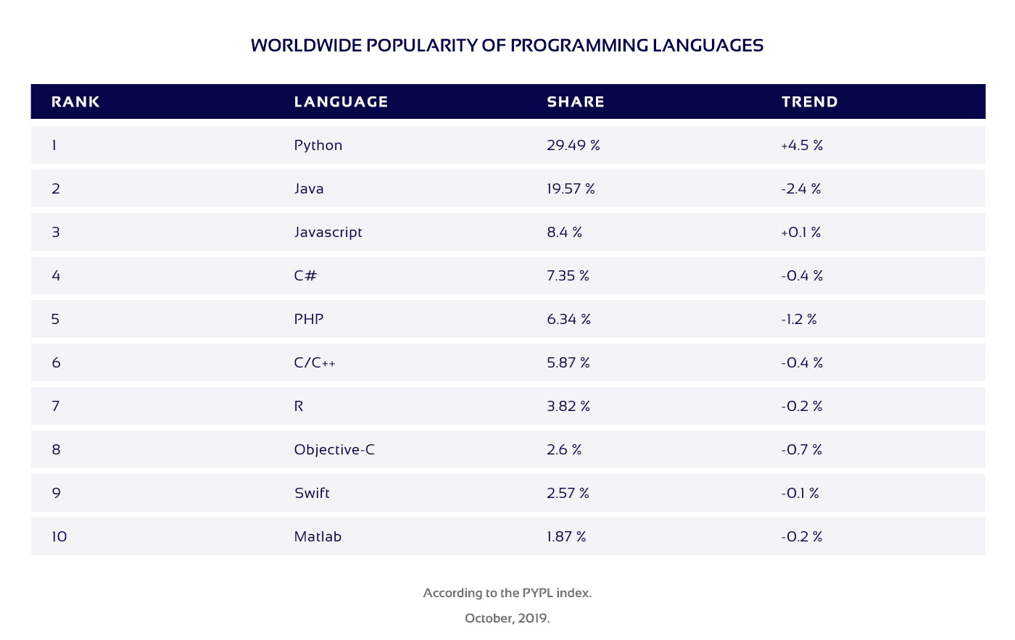

Figure 51

Both MySQL and PHP are open-source projects. This means that it does not need licenses. It also makes it easier to identify bugs or errors and it also helps when testing or debugging.

# References:

Denton, J. and Peace, A. (2003). Selection and Use of MySQL in a Database Management Course. *Journal of Information Systems Education*, [online] 14(4). Available at: <https://jise.org/volume14/n4/JISEv14n4p401.pdf> [Accessed 14 Dec. 2023].

W3.org. (2013). *The W3C Markup Validation Service*. [online] Available at: <https://validator.w3.org/#validate_by_upload>.

W3Schools (2019). *PHP Tutorial*. [online] W3schools.com. Available at: <https://www.w3schools.com/php/default.asp>.

Roznovsky, A. (n.d.). *Why Use PHP in 2020? Main Advantages and Disadvantages*. [online] light-it.net. Available at: <https://light-it.net/blog/why-use-php-main-advantages-and-disadvantages/>.

Google Books. (2023). *Learning PHP & MySQL*. [online] Available at: <https://books.google.co.uk/books?hl=en&lr=&id=IpuT0GxHvAkC&oi=fnd&pg=PR5&dq=advantages+of+using+php&ots=8ar_Ax79yE&sig=t11XK3S8-YbJzbR3nUvG8pQzjyE&redir_esc=y#v=onepage&q=advantages%20of%20using%20php&f=false> [Accessed 14 Dec. 2023].

www.youtube.com. (n.d.). *Part (01)- Dropdown value insert, edit & update in PHP MySQL Database with Source Code*. [online] Available at: <https://www.youtube.com/watch?v=2DCDzAMIFsU> [Accessed 15 Dec. 2023].

www.youtube.com. (n.d.). *Signup and Login with PHP and MySQL*. [online] Available at: <https://www.youtube.com/watch?v=5L9UhOnuos0>.

BoostMyTool (2022). *PHP and MySQL with CRUD Operations: Create, Read, Update, Delete*. *YouTube*. Available at: <https://www.youtube.com/watch?v=NqP0-UkIQS4>.

Google Developers. (n.d.). *Charts*. [online] Available at: <https://developers.google.com/chart>.