Lab Task 1 – Create Color Palette
Requirements:
- Create a palette with 4 colors
- Choose one primary color
- Choose two supporting colors
- Add one accent color
Design:


Lab Task 2 – Shape Practice
Requirements:
- Draw at least 5 shapes
- Use circles, rectangles, or triangles
- Apply colors from your palette
- Arrange shapes creatively
Design:
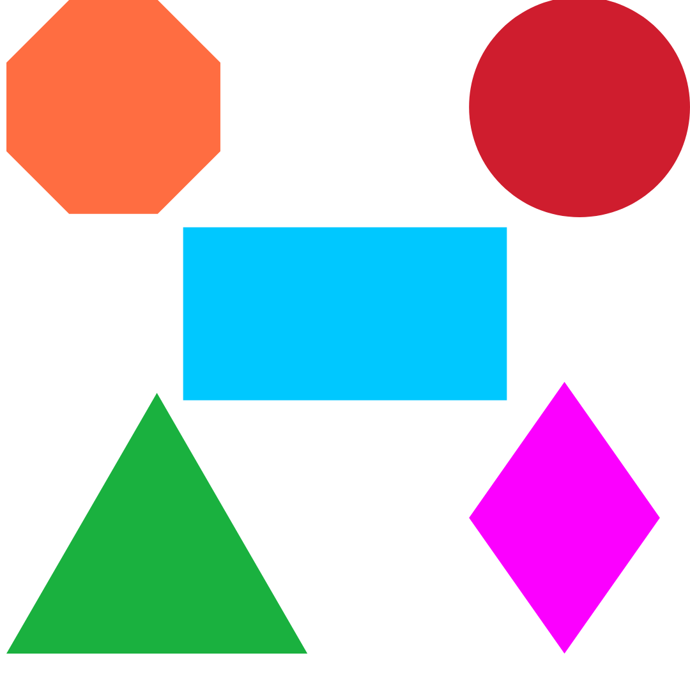

Lab Task 3 – Abstract Composition
Requirements:
- Create an abstract artwork using shapes
- Use your selected color palette
- Focus on balance and contrast
- Fill the canvas creatively

Design:
