NEW PAGE

**Apostrophes**

We use apostrophes for two reasons: to make contractions and to show possession.

**Contractions**

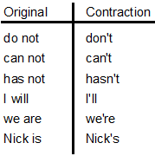

That’s obviously not an exhaustive list of every possible contraction, but, hopefully, it indicates the pattern.

Common verbs can be combined and contracted with **not**. For example, **do not** becomes **don’t**. We push the two words together, then replace the **o** in **not** with an apostrophe.

Pronouns and names can also combine with common verbs and be contracted. Hence, **she is** becomes **she's**.

NEW PAGE

Sometimes students avoid contractions on the test because they think that they aren't allowed in formal writing. They get a bad rap from grammatical atrocities like *ain't*, but contractions are generally fine on the test (and in your own writing).

NEW PAGE

**Possession**

We also use apostrophes to indicate possession.

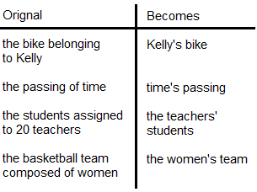

NEW PAGE

**Kelly's bike**

For many nouns, we denote possession by sticking an apostrophe at the end of the word and gluing on an *s*.

**time's passing**

We can also do this for an abstract concept like time, even though time doesn't physically possess like a person does.

**the 20 teachers’ students**

For common nouns that already end in an s, however, we don't need to glue another *s* on after the apostrophe. Before we started assigning possession, teachers already ended with an *s*. Hence, we’ll just attach the apostrophe after the original *s*.

NEW PAGE

**women's basketball team**

It's a common misconception that we put the apostrophe after the s for all plural nouns. Indeed, this is often the case, as most nouns take on an *s* when they become plural.

However, there are some nouns where we do something else to another part of the word to make it plural. Here, wom*a*n becomes wom*e*n. Even though women is plural, it doesn't have an *s*. That means it works like **Kelly's** or **time's**: we need to glue the *s* on after the apostrophe.

There are three similar words that also show up on the test: men, children, and people.

**men's restroom**

**children's hospital**

**people's republic**

NEW PAGE

**Just so you know…**

With names that end in an *s*, we have two perfectly acceptable options:.

**Dr. Seuss's rhymes** or **Dr. Seuss’ rhymes**

**Louis's homework** or **Louis’ homework**

**Cyrus's car** or **Cyrus’ car**

Both options are fine. Since this is really dealer’s choice, it doesn’t show up on the test. When it comes up in your own writing, you can choose to add the *s* or not. Either way, just be consistent. Add the apostrophe every time or avoid it every time.

NEW PAGE

**How would we use apostrophes to simplify the following phrases?**

he does not want to

the ball belonging to Alex

toys belonging to the three dogs

the playground for children

NEW PAGE

**Review**

We can use an apostrophe to combine and contract a verb plus *not*: **has not** becomes **hasn’t**.

We can also combine and contract a pronoun or name with a verb: **he is** becomes **he’s**.

We use apostrophes to show possession. For words that don’t normally end in *s*, we add an apostrophe and an *s*: **April’s showers**.

For **common nouns** that do end in *s*, we usually place the apostrophe at the end without adding another *s*: **the two classes’ assignments**.