Monitoring and Evaluation of Sediment Yield by IoT Technology in the upstream of the Reservoir Watershed

Chin-Shou Lin 1, Bor-Shiun Lin2 , Je-Yi Jhang, and YI-DA JIAN

1 Affiliation 1; orin@sinotech.org.tw

2 Affiliation 2; bosch.lin@sinotech.org.tw

**Keywords:** Reservoir watershed area, IOT, sediment

1. Introduction

The loss of topsoil fines in the reservoir watershed area and the inflow into the reservoir is one of the key factors affecting the increase of water turbidity and the reduction of reservoir capacity. Therefore, if the supply of sediment sources in the upstream watershed can be effectively quantified, soil and water conservation strategies can be formulated to reduce the inflow of sediment into the reservoir. In order to discuss the actual amount of sediment entering the reservoir capacity and the spatial distribution of sediment production, the real-time water level and turbidty monitoring data should be used to analyze the actual rainfall in the current year.

In this paper, IOT environmental monitoring equipment will be used in the watershed area of 4 reservoirs of De-Ji, Wu-She, and Zeng Wen to monitor the changes of water level and turbidity, to discuss the relative relationship between the amount of sediment entering the reservoir and the amount of sediment produced in the upstream stream watershed area. The spatial distribution of monitoring points in the watershed area of each reservoir is shown in Figure 1.

|  |  |  |
| --- | --- | --- |
|  |  |  |
| (a) De-Ji Reservoir | (b) Wu-She Reservoir | (c) Zeng-Wen Reservoir |

**Figure 1 The spatial distribution of monitoring points in the watershed area**

2. Materials and Methods

This paper develops a water level and turbidity monitoring module through a Micro-electromechanical system (MEMS) sensor and an open source microcontroller (Micro Control Unit, MCU), and uses the Internet of Things technology to transmit data. Combined with the flow calculation formula, we can estimate the flow of stream and the amount of suspended sediment, and then evaluate the production and supply of sediment in important treatment areas, as well as the supply and migration of sediment under specific rainfall events. The formulas for calculating the cross-section flow and sediment transport volume are as follows. Referring to Hsu, Y.S. *et al.* (2007), the research results of the relationship between suspended load turbidity(ntu) and concentration(ppm) ratio (as shown in Figure 2.b) are used to convert ntu into ppm. Then calculate the suspended load transport volume Qs of the stream, then estimate the total sediment transport volume through formula (3-1) with the α of general rivers at 0.25.

|  |  |
| --- | --- |
|  |  |
| (a) The formulas for calculating the cross-section flow | (b)turbidity and concentration ratio |

**Figure 2 Schematic diagram of the calculation method of flow and sediment**

|  |  |
| --- | --- |
|  | (3-1) |

3. Results and Discussion

The monitoring results during the flood season of 2021 as show in figure 3 to figure 5, and the amount of sediment entering the reservoirs of De-Ji, Zeng-Wen, and Wu-She reservoirs was approximately 204,000 cubic meters, 1.213 million cubic meters, and 603,000 cubic meters, respectively, as shown in Table 1. Typhoon rainfall events are the main source of sediment for reservoir siltation..

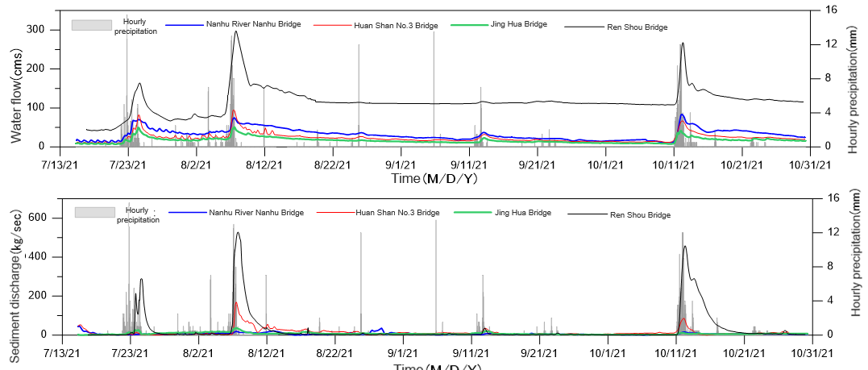

**Figure 3 Flow and sediment transport changes of De-Ji Reservoir**

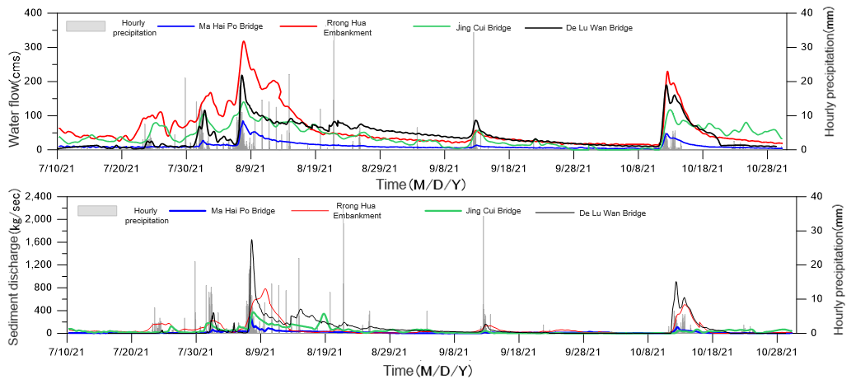

**Figure 4 Flow and sediment transport changes of Wu-She Reservoir**

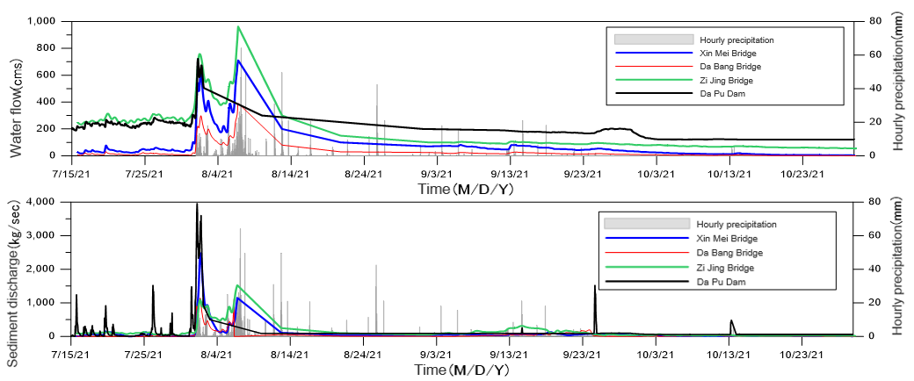

**Figure 5 Flow and sediment transport changes of Zeng-Wen Reservoir**

**Table 1 Monitoring sediment Volume of Three Reservoirs including De-Ji and other reservoirs**

|  |  |  |  |
| --- | --- | --- | --- |
| **Reservoir**  **watershed** | **Monitoring period** | **rainfall(mm)** | **Total sediment outflow volume(10k m3)** |
|
| De-Ji | 2021/7/15-2021/10/30 | 556.5 | 20.4 |
| Zeng-Wen | 1,976 | 121.3 |
| Wu-She | 980 | 60.3 |

4. Conclusions

The monitoring shows that during the flood season of 2021, the amount of sediment entering the reservoirs of De-Ji, Zeng-Wen, and Wu-She reservoirs was approximately 204,000 cubic meters, 1.213 million cubic meters, and 603,000 cubic meters, respectively, its mean that Typhoon rainfall events are the main source of sediment for reservoir siltation. It is suggested that UAV telemetry or river channel topography measurement can be carried out for specific main sediment-producing watersheds, so as to actually explore the changes of river bank collapse and mainstream river flushing.

References

1. Soil and Water Conservation Bureau, “Assessment on Sediment Control Effectiveness for 13 Major Reservoir Watersheds in 2021 and Sediment Outflow Monitoring” ,2021.
2. Hsu, Y.S. *et al.*, “Rating Relations between Turbidity and Suspended Solids Concentration of Reservoir Sediment -A Case Study of Shi-Men Reservoir”, Journal of Chinese Agricultural Engineering Vol. 53, No. 1, March 2007