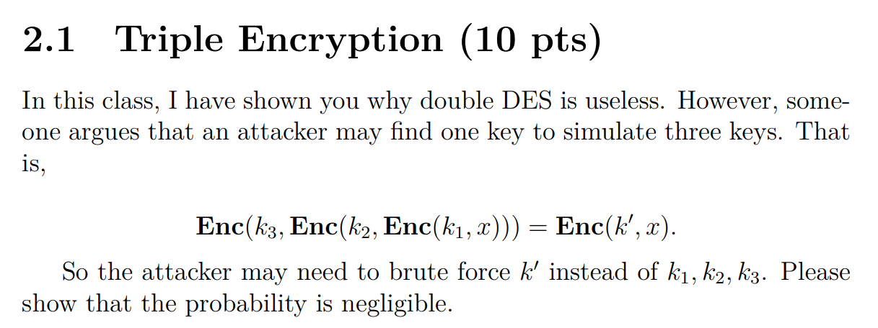

3DES: k1加密 -> k2解密 -> k3加密

DES 加密算法使用64位元的區塊大小和56位元的金鑰。在一個金鑰空間中，有256個可能的金鑰，3DES用三個金鑰，所以是256*3 = 2168種組合

讓3DES等同於只用一把金鑰的可能情況:

情況1. 如果k1=k2，相當於只用k3加密

情況2. 如果k2=k3，相當於只用k1加密

如果k1, k2, k3是各自獨立選擇，情況1和情況2的機率就都是1/256*2 = 1/2112

總體發生的機率是2/2112，小於1/288，所以可以忽略

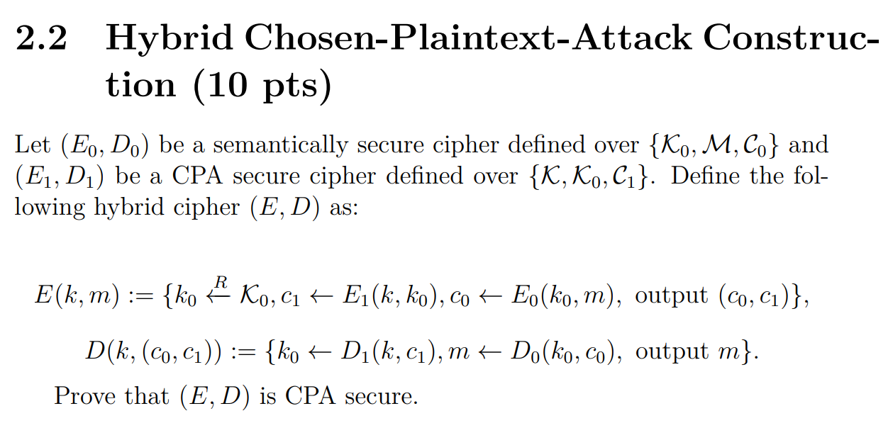

CPA安全性要求對於任何給定的兩個m0和m1，如果攻擊者只能進行加密和解密操作，那麼他在區分兩個c0和c1的能力應該是可忽略的

用反證法證明(E,D)是CPA安全：

設(E,D)不安全(存在一個CPA攻擊者可以在可忽略的時間內區分兩個密文)

建構攻擊者A’，它是兩個子加密方案E0和E1的攻擊者

用A的結果區分(E,D)的密文 -> 違反(E0,D0)和(E1,D1)的安全性假設

由於A’和A的時間複雜度相同，且(E0,D0)和(E1,D1)是安全的

所以A’也無法區分(E,D)的密文

因此，如果(E0,D0)和(E1,D1)抗CPA攻擊，那(E,D)也是CPA安全

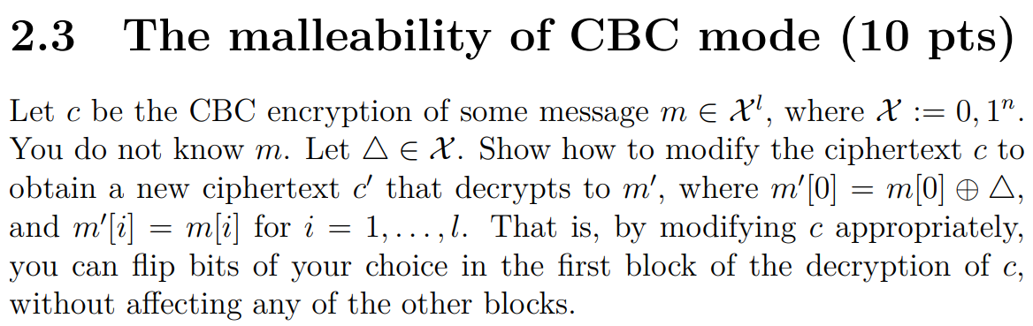

1. 解密c，得到m0, m1, m2,…,mn

2. 修改m0的位元，使m0[0] = m[0]⊕Δ

3. 將修改後的m0和原本的m1, m2,…,mn重新組合成新的m’

4. 將m’進行CBC加密，得到c’

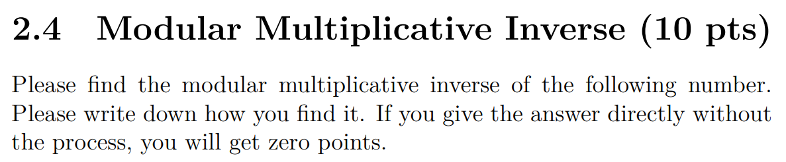



**找到b使得 400b≡1(mod997)**

997 = 2*400 + 197

400 = 2*197 + 6

197 = 32*6 + 5

6 = 1*5 + 1

​**反回去**

1 = 6 − 1*5

= 6 – 1*(197 − 32*6)

= 33*6 – 1*197

= 33*(400 – 2*197) – 1*197

= 33*400 – 67*197

= 33*400 – 67*(997 − 2*400)

= 167*400 – 67*997

​b = 167



**找到b使得 472b≡1(mod16651)**

16651 =35*472+431

472 = 1*431 + 41

431 = 10*41 + 21

41 = 1*21 + 20

21 = 1*20 + 1

**反回去**

​1 = 21 – 1*20

= 21 – 1*(41 – 1*21)

= 2*21 – 1*41

= 2*(431 – 10*41) – 1*41

= 2*431 – 21*41

= 2*431 – 21*(472 – 1*431)

= 23*431 – 21*472

= 23*(16651 – 35*472) – 21*472

= −803*472 + 23*16651

​b = −803 但要找正的，所以是b = 16651−803 = 15848

​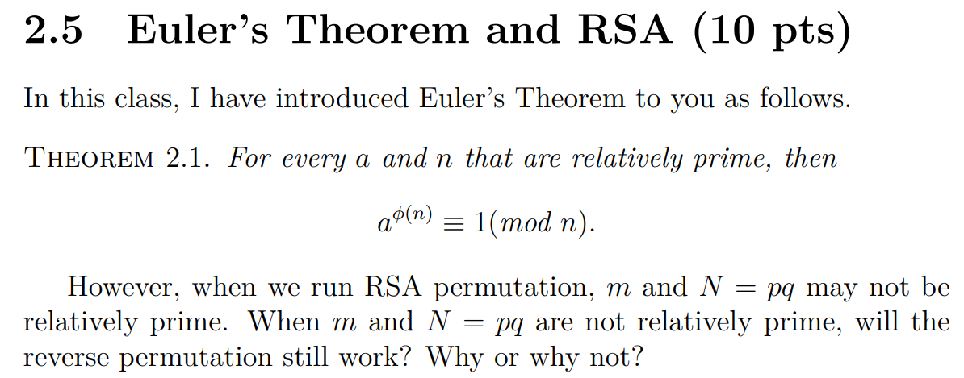

在RSA加密中，我們選擇兩個大質數p和q，然後計算它們的乘積N = pq作為模數，當m和N不互質(m不是N的倍數)，Euler's Theorem不再適用

因為Euler's Theorem僅適用於互質的a和n，這樣才能確保 aϕ(n) ≡ 1(mod n)，當m和N不互質時，m就不會滿足Euler's Theorem的條件，因此反向置換不正確

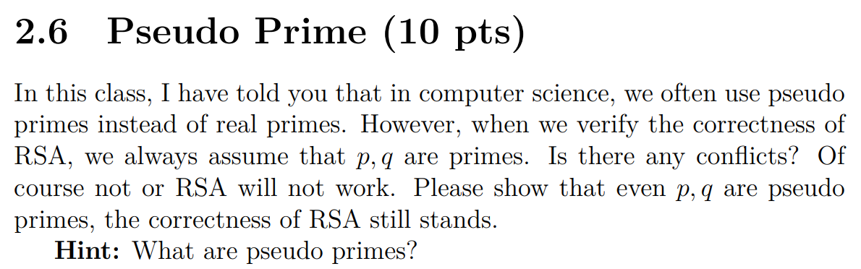

因為RSA難解的原因是N = pq的p和q不好找，不是因為其他特殊的質數性質，所以只要p和q夠大，加上N的因數分解夠困難，就會讓RSA達到安全的效果。

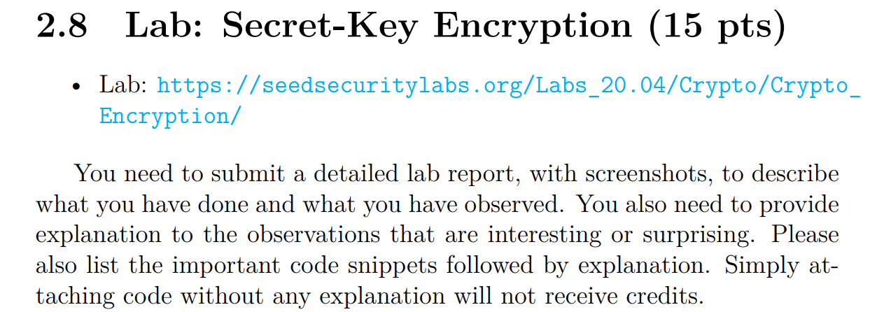







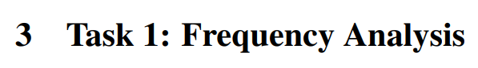

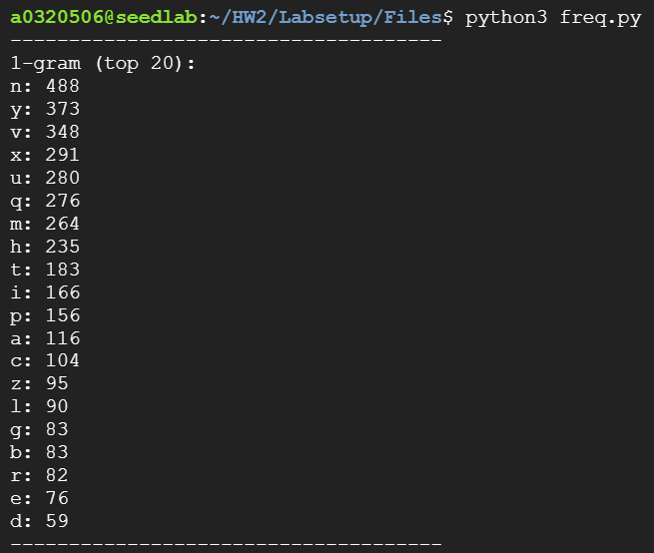 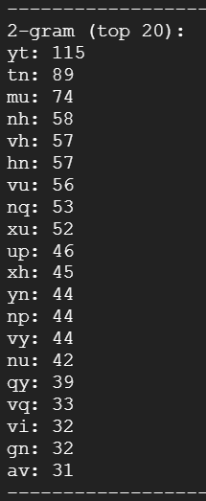 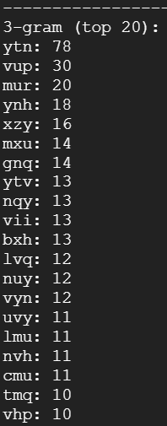

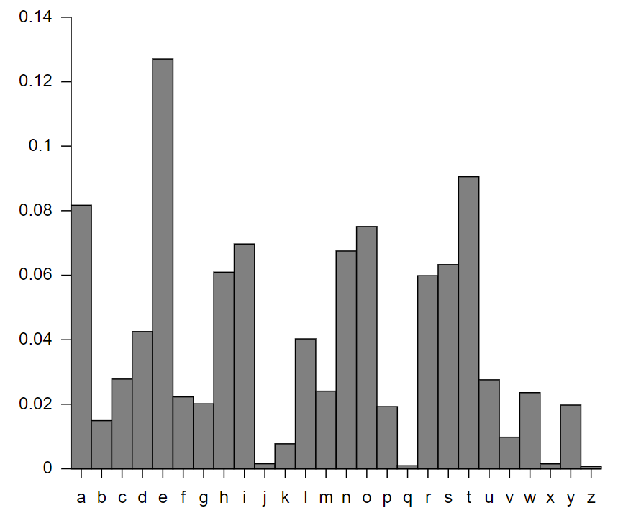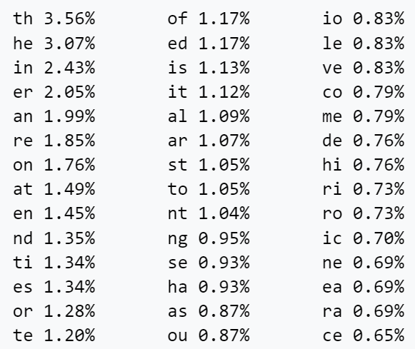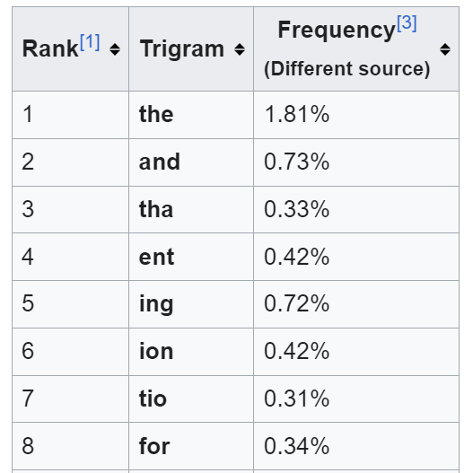

解密過程

sudo tr ’mnrtuvy’ ’IEGHNAT’ <ciphertext.txt> message.txt

sudo tr ’mnrtuvybp’ ’IEGHNATSD’ <ciphertext.txt> message.txt

sudo tr ’mnrtuvybpx’ ’IEGHNATSDO’ <ciphertext.txt> message.txt

sudo tr ’mnrtuvybpxh’ ’IEGHNATSDOL’ <ciphertext.txt> message.txt

sudo tr ’mnrtuvyqpxh’ ’IEGHNATSDOL’ <ciphertext.txt> message.txt

sudo tr ’mnrtuvyqpxhb’ ’IEGHNATSDOLF’ <ciphertext.txt> message.txt

sudo tr ’mnrtuvyqpxhb’ ’IEGHNATSDORF’ <ciphertext.txt> message.txt

sudo tr ’mnrtuvyqpxhbi’ ’IEGHNATSDORFL’ <ciphertext.txt> message.txt

sudo tr ’mnrtuvyqpxhbiz’ ’IEGHNATSDORFLU’ <ciphertext.txt> message.txt

sudo tr ’mnrtuvyqpxhbizg’ ’IEGHNATSDORFLUB’ <ciphertext.txt> message.txt

sudo tr ’mnrtuvyqpxhbizgd’ ’IEGHNATSDORFLUBY’ <ciphertext.txt> message.txt

sudo tr ’mnrtuvyqpxhbizgds’ ’IEGHNATSDORFLUBYK’ <ciphertext.txt> message.txt

sudo tr ’mnrtuvyqpxhbizgdsl’ ’IEGHNATSDORFLUBYKW’ <ciphertext.txt> message.txt

sudo tr ’mnrtuvyqpxhbizgdslc’ ’IEGHNATSDORFLUBYKWC’ <ciphertext.txt> message.txt

sudo tr ’mnrtuvyqpxhbizgdsla’ ’IEGHNATSDORFLUBYKWC’ <ciphertext.txt> message.txt

sudo tr ’mnrtuvyqpxhbizgdslac’ ’IEGHNATSDORFLUBYKWCM’ <ciphertext.txt> message.txt

sudo tr ’mnrtuvyqpxhbizgdslace’ ’IEGHNATSDORFLUBYKWCMP’ <ciphertext.txt> message.txt

sudo tr ’mnrtuvyqpxhbizgdslacef’ ’IEGHNATSDORFLUBYKWCMPV’ <ciphertext.txt> message.txt

sudo tr ’mnrtuvyqpxhbizgdslacefj’ ’IEGHNATSDORFLUBYKWCMPVQ’ <ciphertext.txt> message.txt

sudo tr ’mnrtuvyqpxhbizgdslacefjw’ ’IEGHNATSDORFLUBYKWCMPVQM’ <ciphertext.txt> message.txt

sudo tr ’mnrtuvyqpxhbizgdslacefjwo’ ’IEGHNATSDORFLUBYKWCMPVQMJ’ <ciphertext.txt> message.txt

sudo tr ’mnrtuvyqpxhbizgdslacefjwok’ ’IEGHNATSDORFLUBYKWCMPVQMJX’ <ciphertext.txt> message.txt

sudo tr ’mnrtuvyqpxhbizgdslacefjwok’ ’IEGHNATSDORFLUBYKWCMPVQZJX’ <ciphertext.txt> message.txt

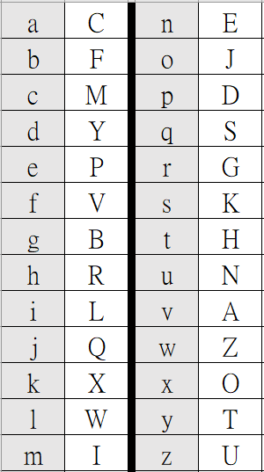 整理後的對照表

abcdefghijklmnopqrstuvwxyz -> cfmypvbrlqxwiejdsgkhnazotu

解密結果在message.txt





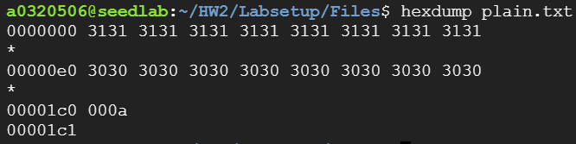

openssl enc -aes-128-cbc -e -in plain.txt -out cipher.bin -K 00112233445566778889aabbccddeeff -iv 0102030405060708



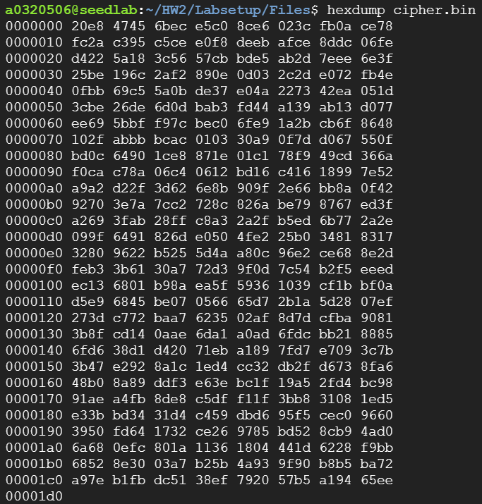 aes-128-cbc加密結果

openssl enc -bf-cbc -e -in plain.txt -out cipher.bin -K 00112233445566778889aabbccddeeff -iv 0102030405060708



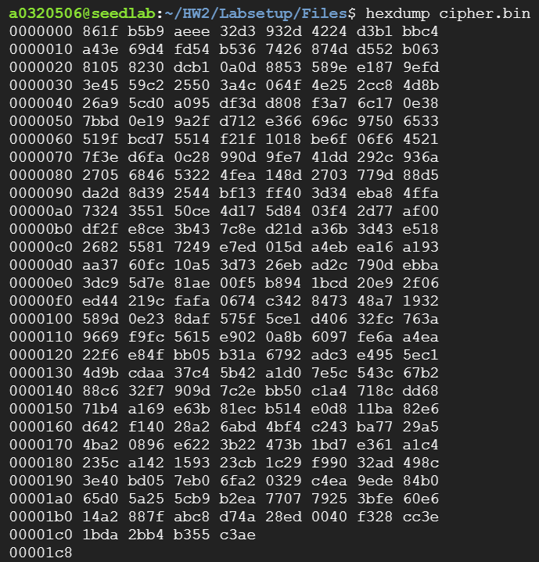 bf-cbc加密結果

openssl enc -aes-128-cfb -e -in plain.txt -out cipher.bin -K 00112233445566778889aabbccddeeff -iv 0102030405060708



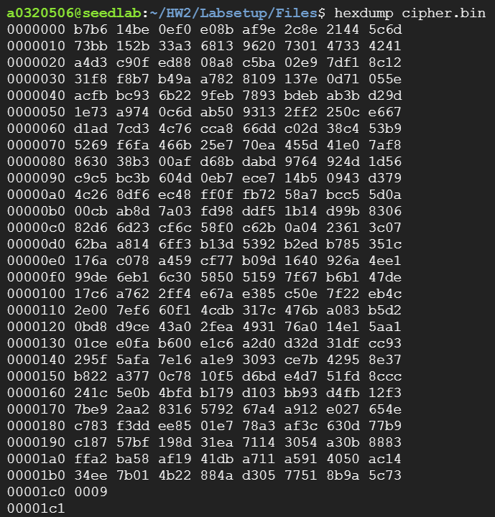 aes-128-cfb加密結果

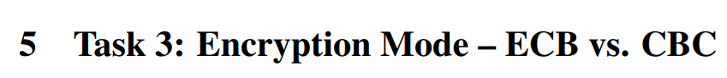

openssl enc -aes-128-ecb -e -in pic_original.bmp -out encrypted_ecb.bmp -K 00112233445566778889aabbccddeeff



openssl enc -aes-128-cbc -e -in pic_original.bmp -out encrypted_cbc.bmp -K 00112233445566778889aabbccddeeff -iv 0102030405060708



修改標頭

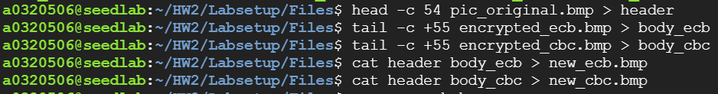

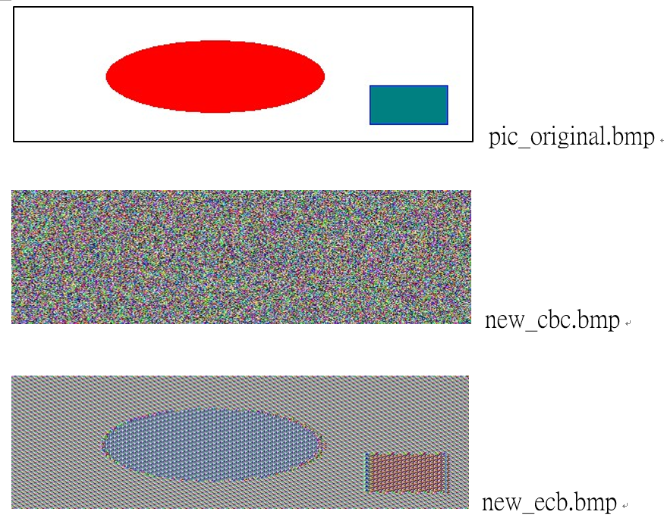 結果

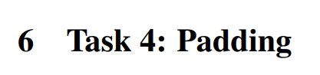

創建三種長度的原文檔案



**aes-128-cbc**

**5 bytes**

hexdump file_5bytes.txt

openssl enc -aes-128-cbc -e -in file_5bytes.txt -out encrypted_file_5bytes.txt -K 00112233445566778889aabbccddeeff -iv 0102030405060708

sudo openssl enc -aes-128-cbc -d -in encrypted_file_5bytes.txt -out decrypted_file_5bytes.txt -K 00112233445566778889aabbccddeeff -iv 0102030405060708 -nopad

hexdump decrypted_file_5bytes.txt

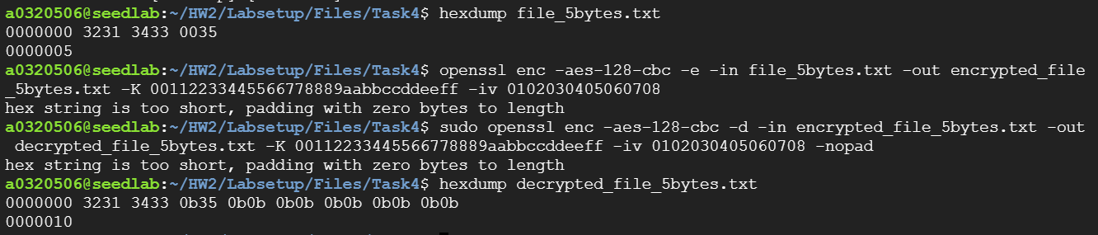

**aes-128-cbc**

**10 bytes**

hexdump file_10bytes.txt

openssl enc -aes-128-cbc -e -in file_10bytes.txt -out encrypted_file_10bytes.txt -K 00112233445566778889aabbccddeeff -iv 0102030405060708

sudo openssl enc -aes-128-cbc -d -in encrypted_file_10bytes.txt -out decrypted_file_10bytes.txt -K 00112233445566778889aabbccddeeff -iv 0102030405060708 -nopad

hexdump decrypted_file_10bytes.txt

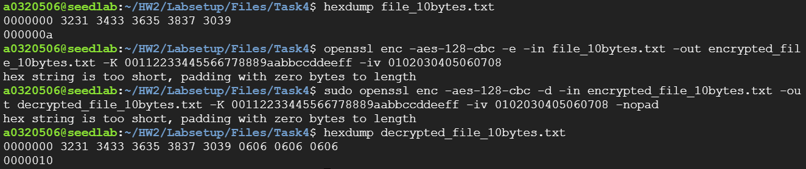

**aes-128-cbc**

**16 bytes**

hexdump file_16bytes.txt

openssl enc -aes-128-cbc -e -in file_16bytes.txt -out encrypted_file_16bytes.txt -K 00112233445566778889aabbccddeeff -iv 0102030405060708

sudo openssl enc -aes-128-cbc -d -in encrypted_file_16bytes.txt -out decrypted_file_16bytes.txt -K 00112233445566778889aabbccddeeff -iv 0102030405060708 -nopad

hexdump decrypted_file_16bytes.txt

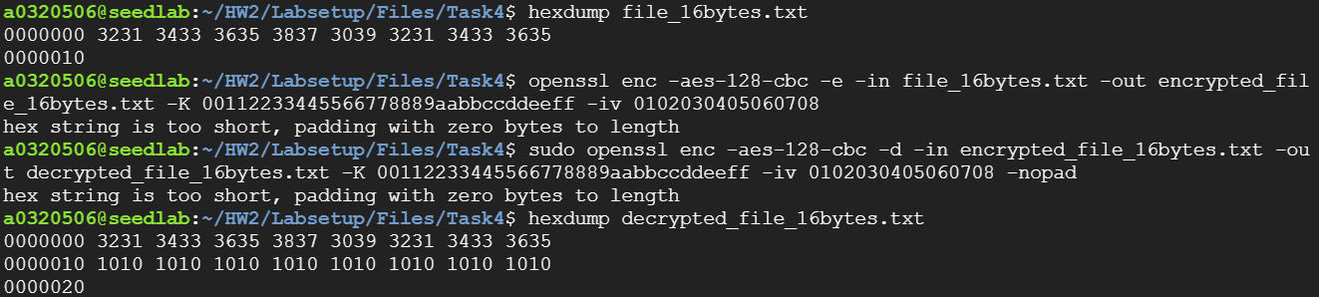

**aes-128-cbc 比較**

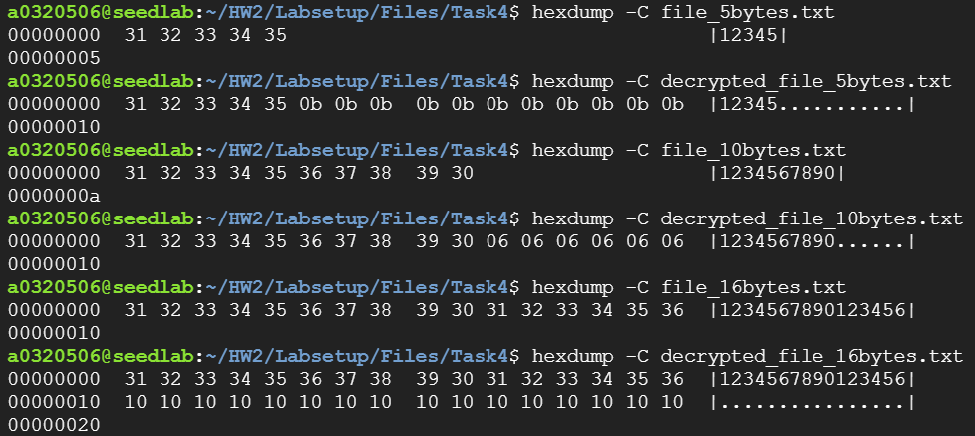

要填充

**aes-128-ecb**

**5 bytes**

hexdump file_5bytes.txt

openssl enc -aes-128-ecb -e -in file_5bytes.txt -out encrypted_file_5bytes.txt -K 00112233445566778889aabbccddeeff

sudo openssl enc -aes-128-ecb -d -in encrypted_file_5bytes.txt -out decrypted_file_5bytes.txt -K 00112233445566778889aabbccddeeff -nopad

hexdump decrypted_file_5bytes.txt

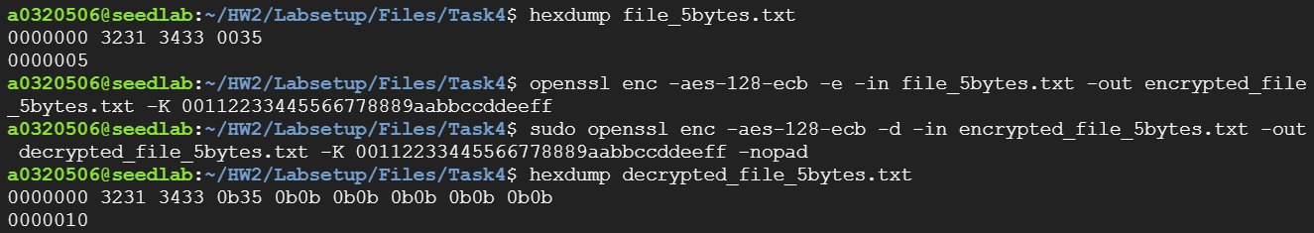

**aes-128-ecb**

**10 bytes**

hexdump file_10bytes.txt

openssl enc -aes-128-ecb -e -in file_10bytes.txt -out encrypted_file_10bytes.txt -K 00112233445566778889aabbccddeeff

sudo openssl enc -aes-128-ecb -d -in encrypted_file_10bytes.txt -out decrypted_file_10bytes.txt -K 00112233445566778889aabbccddeeff -nopad

hexdump decrypted_file_10bytes.txt

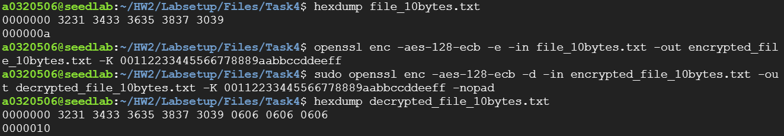

**aes-128-ecb**

**16 bytes**

hexdump file_16bytes.txt

openssl enc -aes-128-ecb -e -in file_16bytes.txt -out encrypted_file_16bytes.txt -K 00112233445566778889aabbccddeeff

sudo openssl enc -aes-128-ecb -d -in encrypted_file_16bytes.txt -out decrypted_file_16bytes.txt -K 00112233445566778889aabbccddeeff -nopad

hexdump decrypted_file_16bytes.txt

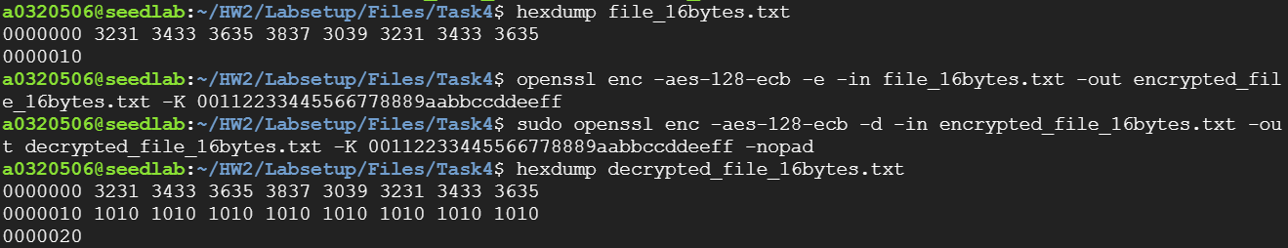

**aes-128-ecb 比較**

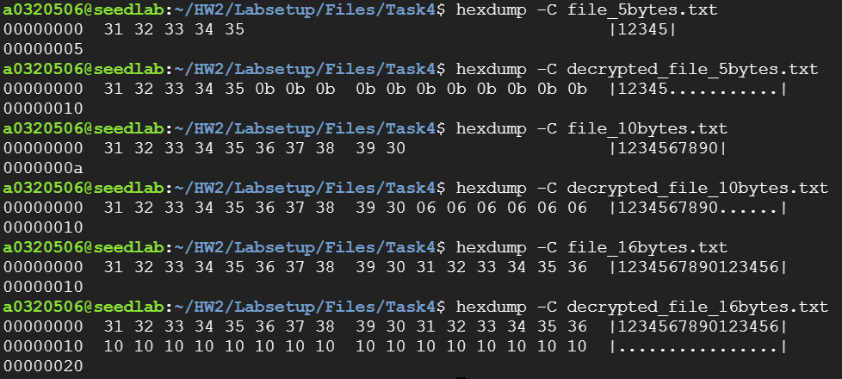

要填充

**aes-128-cfb**

**5 bytes**

hexdump file_5bytes.txt

openssl enc -aes-128-cfb -e -in file_5bytes.txt -out encrypted_file_5bytes.txt -K 00112233445566778889aabbccddeeff -iv 0102030405060708

sudo openssl enc -aes-128-cfb -d -in encrypted_file_5bytes.txt -out decrypted_file_5bytes.txt -K 00112233445566778889aabbccddeeff -iv 0102030405060708 -nopad

hexdump decrypted_file_5bytes.txt

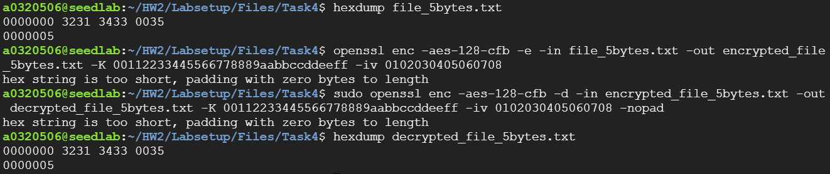

**aes-128-cfb**

**10 bytes**

hexdump file_10bytes.txt

openssl enc -aes-128-cfb -e -in file_10bytes.txt -out encrypted_file_10bytes.txt -K 00112233445566778889aabbccddeeff -iv 0102030405060708

sudo openssl enc -aes-128-cfb -d -in encrypted_file_10bytes.txt -out decrypted_file_10bytes.txt -K 00112233445566778889aabbccddeeff -iv 0102030405060708 -nopad

hexdump decrypted_file_10bytes.txt

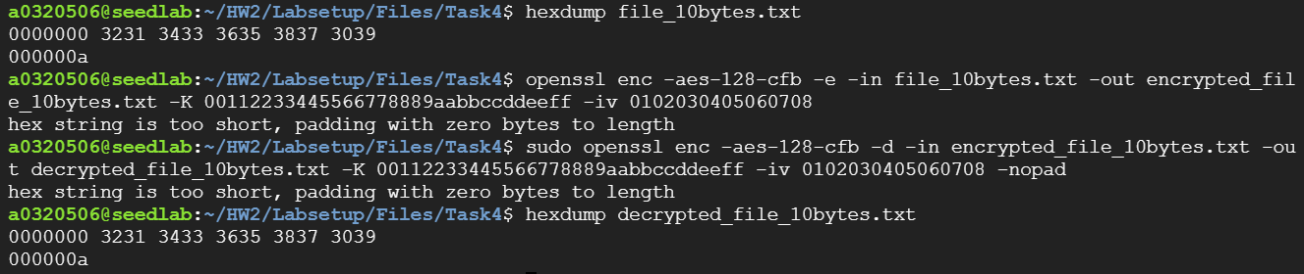

**aes-128-cfb**

**16 bytes**

hexdump file_16bytes.txt

openssl enc -aes-128-cfb -e -in file_16bytes.txt -out encrypted_file_16bytes.txt -K 00112233445566778889aabbccddeeff -iv 0102030405060708

sudo openssl enc -aes-128-cfb -d -in encrypted_file_16bytes.txt -out decrypted_file_16bytes.txt -K 00112233445566778889aabbccddeeff -iv 0102030405060708 -nopad

hexdump decrypted_file_16bytes.txt

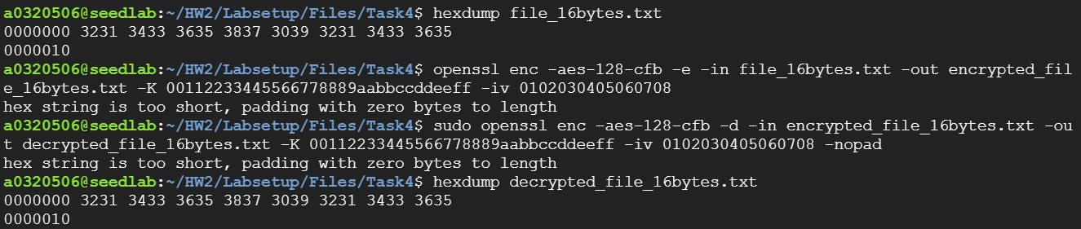

**aes-128-cfb 比較**

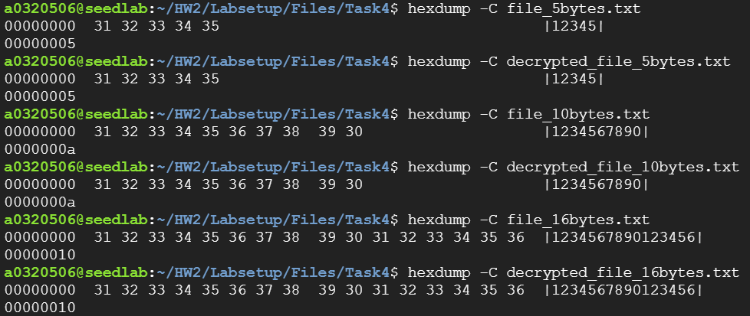

不填充

**aes-128-ofb**

**5 bytes**

hexdump file_5bytes.txt

openssl enc -aes-128-ofb -e -in file_5bytes.txt -out encrypted_file_5bytes.txt -K 00112233445566778889aabbccddeeff -iv 0102030405060708

sudo openssl enc -aes-128-ofb -d -in encrypted_file_5bytes.txt -out decrypted_file_5bytes.txt -K 00112233445566778889aabbccddeeff -iv 0102030405060708 -nopad

hexdump decrypted_file_5bytes.txt

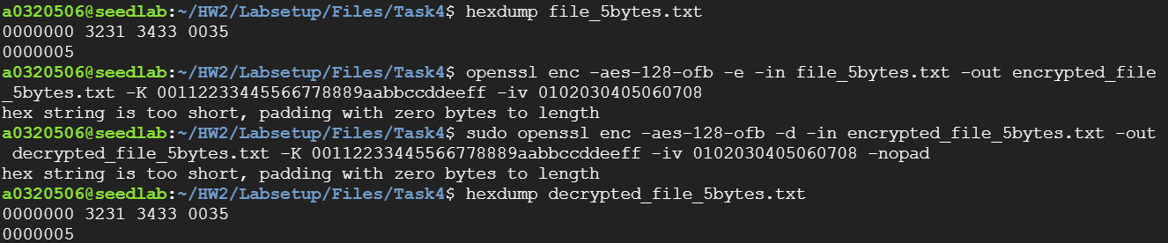

**aes-128-ofb**

**10 bytes**

hexdump file_10bytes.txt

openssl enc -aes-128-ofb -e -in file_10bytes.txt -out encrypted_file_10bytes.txt -K 00112233445566778889aabbccddeeff -iv 0102030405060708

sudo openssl enc -aes-128-ofb -d -in encrypted_file_10bytes.txt -out decrypted_file_10bytes.txt -K 00112233445566778889aabbccddeeff -iv 0102030405060708 -nopad

hexdump decrypted_file_10bytes.txt

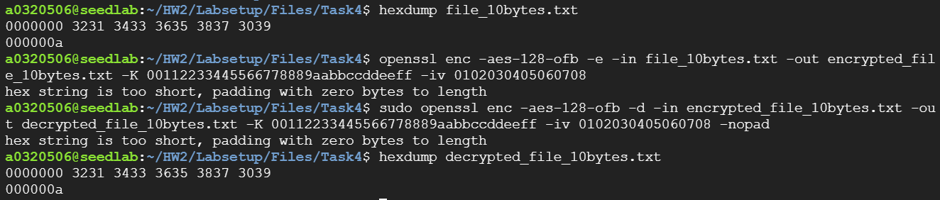

**aes-128-ofb**

**16 bytes**

hexdump file_16bytes.txt

openssl enc -aes-128-ofb -e -in file_16bytes.txt -out encrypted_file_16bytes.txt -K 00112233445566778889aabbccddeeff -iv 0102030405060708

sudo openssl enc -aes-128-ofb -d -in encrypted_file_16bytes.txt -out decrypted_file_16bytes.txt -K 00112233445566778889aabbccddeeff -iv 0102030405060708 -nopad

hexdump decrypted_file_16bytes.txt

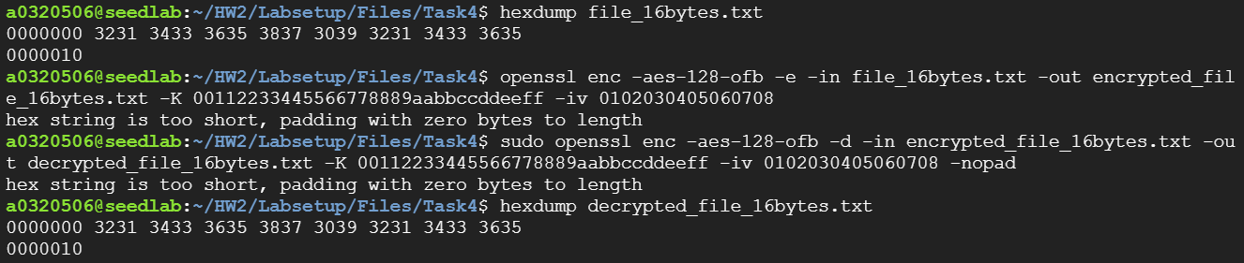

**aes-128-ofb 比較**

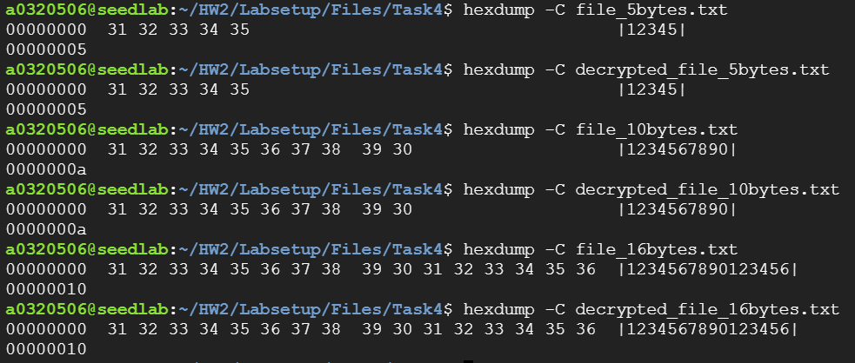

不填充

ECB、CBC要填充，因為在他們把明文分成固定大小的塊進行加密。如果明文的大小不是加密演算法要求的固定塊大小的倍數，就需要對明文進行填充，讓每塊的大小相同

CFB、OFB不填充，因為他們的加密是以byte為單位進行，所以即使明文的大小不是固定塊大小的倍數，也不需要填充



文本檔案在1000-bytes.txt

cd HW2/Labsetup/Files