Project type | Machine learning web application
Technology | Python, pandas, scikit-learn, joblib, Streamlit
Crop Yield Prediction System
Project Report and User Interface Output

1. Executive Summary
The Crop Yield Prediction System is a Streamlit application that estimates crop yield from agricultural inputs. It combines categorical crop and soil information with numerical measurements such as area, rainfall, temperature, humidity, fertilizer, pesticide, and year. A trained Random Forest Regressor provides the prediction directly in the browser.

2. Project Objectives
- Prepare agricultural data for machine learning by encoding categorical variables.
- Train and evaluate a regression model for crop-yield estimation.
- Persist the trained model and feature-column order for reliable inference.
- Provide an accessible UI that accepts user inputs and displays a prediction with an input summary.

3. Dataset and Processing
The source dataset contains 500 records and 10 columns. The target variable is Yield. Crop and Soil_Type are categorical fields; the feature-engineering step uses one-hot encoding and writes the resulting table to dataset/processed_crop_yield.csv.
Category | Columns | Purpose
Target | Yield | Value predicted by the model
Categorical | Crop, Soil_Type | Converted to indicator columns
Numerical | Area, Rainfall, Temperature, Humidity, Fertilizer, Pesticide, Year, Yield | Used as continuous model inputs

4. Model Development
The training script separates Yield from the encoded feature matrix, uses an 80/20 train-test split with random_state=42, and trains a RandomForestRegressor with 200 estimators. The fitted model is saved as model.pkl and the exact feature order is saved as feature_columns.pkl. The Streamlit app reconstructs a one-row input frame using that saved feature order before inference.
Metric | Reported value
R² score | 96.58%
RMSE | 0.3067

5. User Interface Design and Workflow
The Streamlit application follows an earthy farm theme with a warm cream background, deep forest-green accents, and the Nunito sans-serif typeface. The layout is wide (max-width 1200 px) and divided into a left sidebar and a centred main panel.

5.1 Sidebar Panel
The collapsible left sidebar displays a Farm Analytics header and two informational blocks. The About the Project block summarises the algorithm (Random Forest Regressor), dataset size (500 records), feature count (18), and target variable (Crop Yield). The Model Performance block shows two metric tiles side-by-side: R2 Score 96.58% and RMSE 0.3067. A footer caption reads Crop Yield Prediction v1.0 - Python - Scikit-learn - Streamlit.
- Select a crop and soil type from the available categorical options.
- Enter area, rainfall, temperature, humidity, fertilizer, pesticide, and year.

5.2 Main Header Banner
A full-width rounded banner with a forest-green gradient spans the top of the main content area. It displays the eyebrow text Machine Learning - Agricultural Insights, the main title Crop Yield Prediction System, and a subtitle: Estimate expected crop yield from soil, weather and farming input data.
- Select Predict Crop Yield to run the saved model.

5.3 Input Form Layout
Below the banner, a green-bordered section card labelled Enter Agricultural Details introduces a two-column input form. Column 1 hosts Crop and Field controls (crop selectbox and area number input) plus Weather Conditions inputs (rainfall mm, temperature deg C, humidity %). Column 2 hosts Soil and Inputs controls (soil type selectbox, fertilizer kg/acre, pesticide kg/acre) and a Season block (year). Input labels are bold forest-green.
- Review the predicted yield, selected crop/soil/year summary, and input-data table.

5.4 Predict Button
A full-width Predict Crop Yield button sits below the input grid. Clicking it constructs a one-row DataFrame from the saved feature_columns.pkl ordering, applies the one-hot encoding for the chosen crop and soil type, then calls model.predict() on the assembled frame.

6. UI Components and Output
The following capture shows the running Streamlit interface after the default input was submitted: Wheat, Red soil, area 10, rainfall 1000, temperature 25, humidity 60, fertilizer 100, pesticide 30, and year 2026. The resulting prediction shown by the UI is 3.11 Yield Units.

6.1 Prediction Result Card
After prediction, a centered yield card renders showing the label Predicted Crop Yield, the numeric value in large 54 px font (e.g. 3.11), the unit tonnes / unit area, and three green pill tags summarising the selected crop, soil type, and year. The card uses an ivory gradient background with a warm border and soft green box-shadow for visual hierarchy.
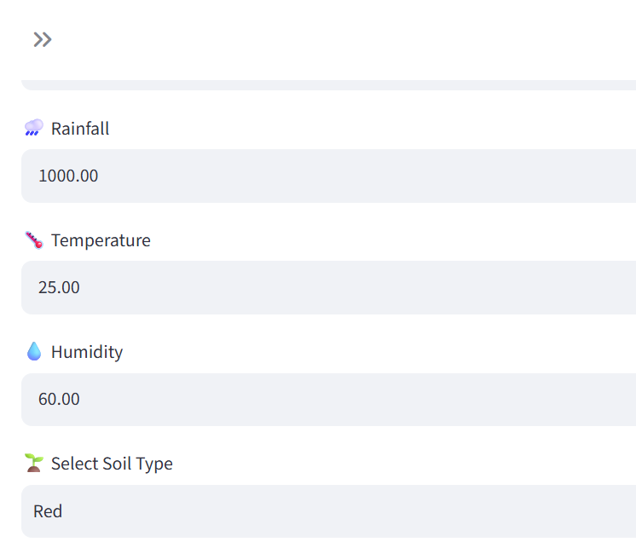
Figure 1. Streamlit prediction output captured from the running application.

6.2 Input Summary Metrics
Below the yield card, a four-column metric row displays Selected Crop, Soil Type, Area (acres), and Year using Streamlit's st.metric tiles. These tiles give the user a clean at-a-glance confirmation of the parameters submitted for the prediction.

6.3 Input Data Table
A full-width two-column dataframe (Parameter / Value) lists all nine input values: Crop, Area, Rainfall, Temperature, Humidity, Soil Type, Fertilizer, Pesticide, and Year. The table is rendered via st.dataframe with hide_index=True and a rounded warm border, giving the prediction session a complete audit trail.

6.4 UI Input Fields — Default Values
The screenshot in Figure 1 (above) is captured from the live application showing the input form default state: Rainfall 1000.00 mm, Temperature 25.00 deg C, Humidity 60.00 %, and Soil Type Red. These defaults reflect typical mid-range agricultural conditions and serve as sensible starting values for first-time users.

7. Conclusion
The project delivers an end-to-end crop-yield prediction workflow: dataset inspection, feature engineering, model training, model persistence, and interactive inference. The Streamlit interface makes the trained model usable without requiring users to interact with the training code directly.

