BA Capstone Project: Checkpoint 1

Retail & Sales Analytics
Sales Performance & Revenue Forecasting

Data Fundamentals & SQL Querying
Group Name: MANTA RAY
Course & Section: BED 106 - Business Analytics
Date: [SUBMISSION DATE]
Team Members & Roles:

- Sugar-Rey R. Garcia — Project Lead / Analyst
- Rudelyn Joy Abanador— Data Engineer
- Joel Madula — Statistician / Modeler

Task 1.1 — Business Problem Statement

Business Domain & Problem Investigation
This project belongs to the Retail & Sales Analytics domain. The business problem being investigated is Sales Performance & Revenue Forecasting — specifically, identifying which products and regions generate the most revenue, analyzing sales trends over time, and forecasting future revenue to support business decision-making. Using historical transactional data from a retail superstore, this project aims to uncover patterns in sales, profit, and discount behavior across different product categories and geographic regions.

Business Impact & Significance
Understanding sales performance is critical for any retail business. Without clear visibility into which products, regions, and time periods drive the most revenue, businesses risk over-investing in low-performing areas and missing growth opportunities. Accurate revenue forecasting enables management to plan inventory, allocate budgets, and set realistic sales targets. This project directly addresses the need for data-driven decision-making in retail operations, which can lead to improved profitability, reduced waste from overstocking, and more targeted marketing efforts toward high-value customer segments.

Key Business Questions
1. Which product categories and regions generate the highest total sales and profit?
2. Does offering higher discounts lead to lower profit margins?
3. What are the monthly and seasonal sales trends over time?
4. Which customer segments contribute the most to total revenue?
5. What will next quarter's sales look like based on historical trends?

Data Source Overview
The dataset planned for this project is the Sample Superstore Sales Dataset, a publicly available retail transaction dataset sourced from Kaggle (www.kaggle.com). It contains structured, tabular data consisting of 9,994 rows of order-level records with 21 columns covering customer information, geographic data, product categories, and financial metrics such as sales, profit, discount, and quantity. The data represents multiple years of retail transactions, making it suitable for time-series trend analysis and regression-based forecasting.

Task 1.2 — Dataset Documentation

Data Source Report
Attribute | Details
Dataset Name | Sample Superstore Sales Dataset
Source URL/File | https://www.kaggle.com/datasets/vivek468/superstore-dataset-final
Date Accessed | 19/07/2026
License Type | CC0: Public Domain (No restrictions on use)

Data Dictionary
Column Name | Data Type | Description
Order ID | VARCHAR(20) | Unique identifier for each order transaction
Order Date | DATE | The date when the order was placed
Ship Date | DATE | The date when the order was shipped
Ship Mode | VARCHAR(30) | Shipping method selected (e.g., First Class, Standard Class)
Customer ID | VARCHAR(20) | Unique identifier for each customer
Customer Name | VARCHAR(100) | Full name of the customer
Segment | VARCHAR(30) | Customer market segment (Consumer, Corporate, Home Office)
Country | VARCHAR(50) | Country where the order was delivered
City | VARCHAR(50) | City where the order was delivered
State | VARCHAR(50) | State where the order was delivered
Region | VARCHAR(20) | Geographic region (East, West, Central, South)
Product ID | VARCHAR(20) | Unique identifier for each product
Category | VARCHAR(30) | Main product category (Furniture, Office Supplies, Technology)
Sub-Category | VARCHAR(30) | Product sub-category (e.g., Chairs, Phones, Binders)
Product Name | VARCHAR(200) | Full descriptive name of the product
Sales | DECIMAL(10,2) | Total sales revenue for the order line item
Quantity | INT | Number of units ordered
Discount | DECIMAL(5,2) | Discount rate applied to the order (0.0 to 1.0)
Profit | DECIMAL(10,2) | Net profit earned from the order line item

Preliminary Data Quality Assessment

- Missing Values: The Sample Superstore dataset has no missing values across all 9,994 rows and 21 columns. All fields are fully populated with no null or empty entries detected.

- Duplicates: No exact duplicate rows were found. However, the same Order ID may appear multiple times when a single order contains multiple products, which is expected and normal behavior in order-line transactional datasets.

- Inconsistencies: Dates are stored in MM/DD/YYYY format requiring conversion to YYYY-MM-DD for MySQL. Postal Code contains numeric values stored as text which must be handled as VARCHAR. A number of records show negative Profit values indicating loss-making orders — these are valid data points and are retained for analysis.

- Cleaning Steps Applied: Date columns (Order Date, Ship Date) were reformatted to YYYY-MM-DD for MySQL compatibility. Postal Code was cast as VARCHAR. Column names were standardized by removing spaces and special characters. The flat dataset was split into three relational tables: customers, products, and orders, with primary keys and foreign keys assigned accordingly.

Raw Dataset Preview

The first 10–20 rows of the raw Superstore CSV file

Screenshot 1 – https://www.kaggle.com/datasets/vivek468/superstore-dataset-final

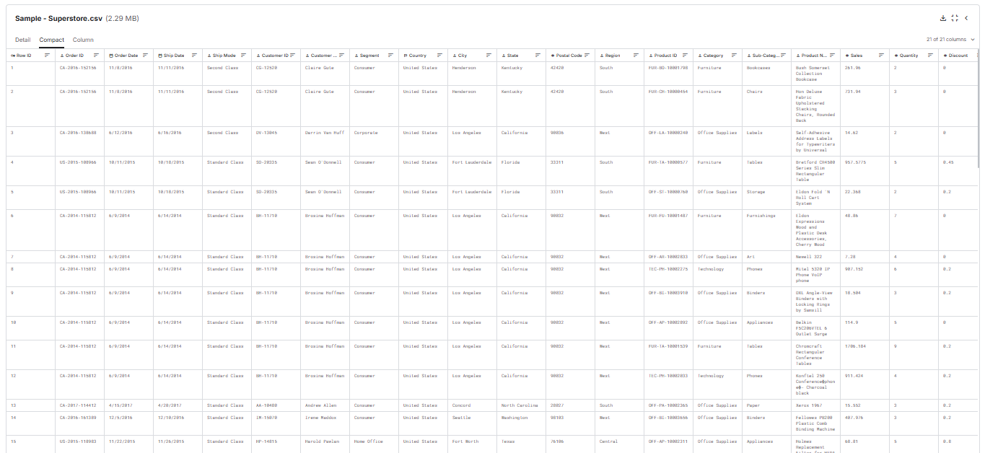

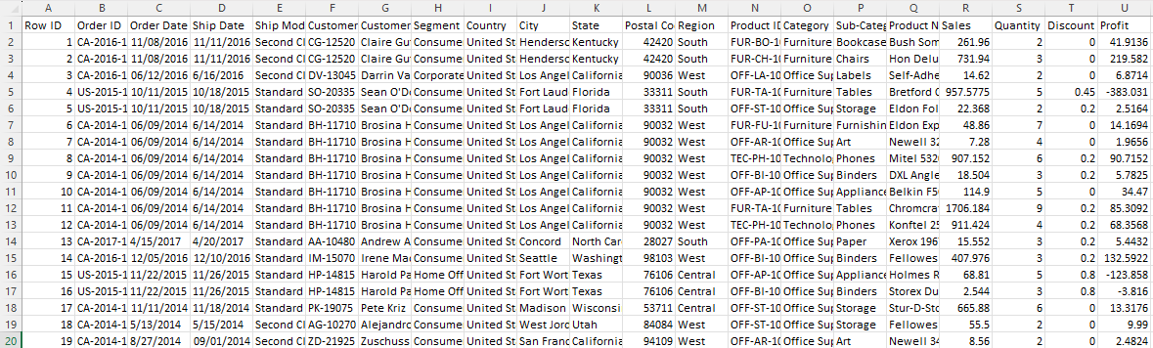
Screenshot 2 – Downloaded CSV file ( Sample – Superstore.csv)

Task 1.3 — Relational Database Design

Entity-Relationship Diagram (ERD)
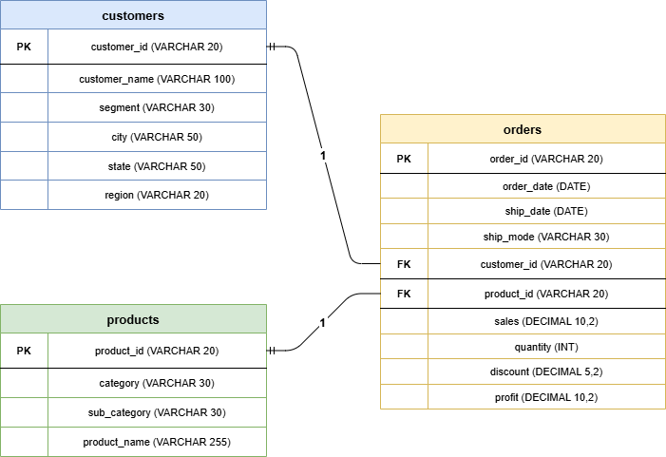

Database Schema & Population

Screenshot 1 — CREATE TABLE statements
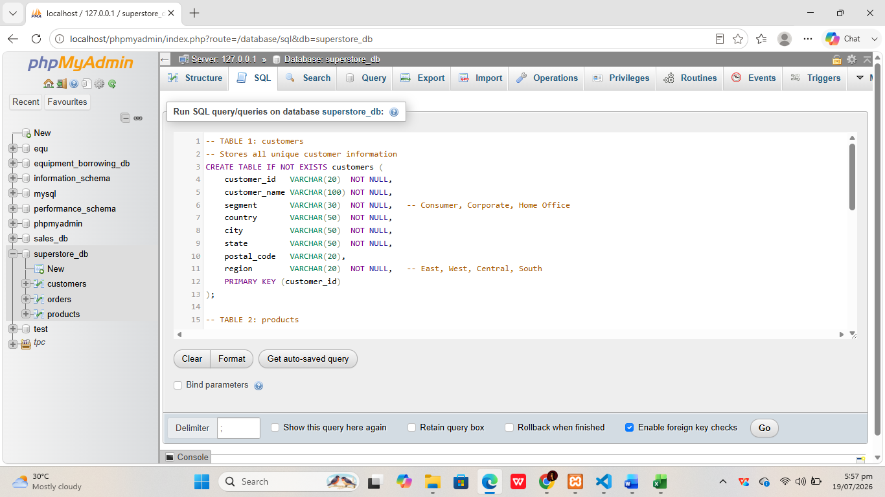

Screenshot 2 — Three tables in the schema
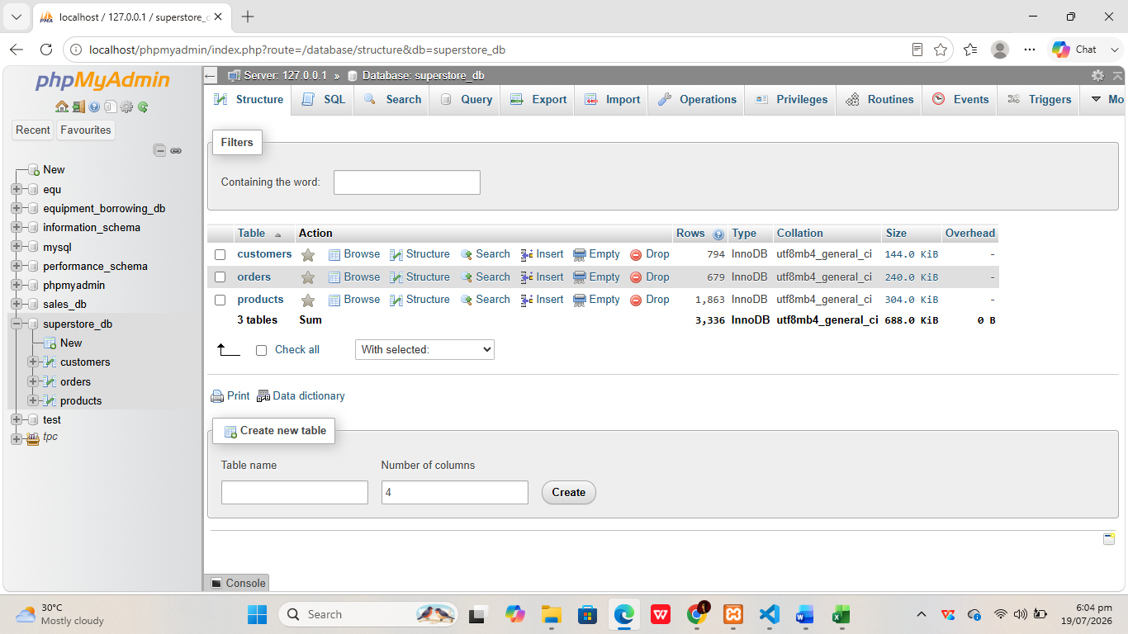

Screenshot 3 — Table previews

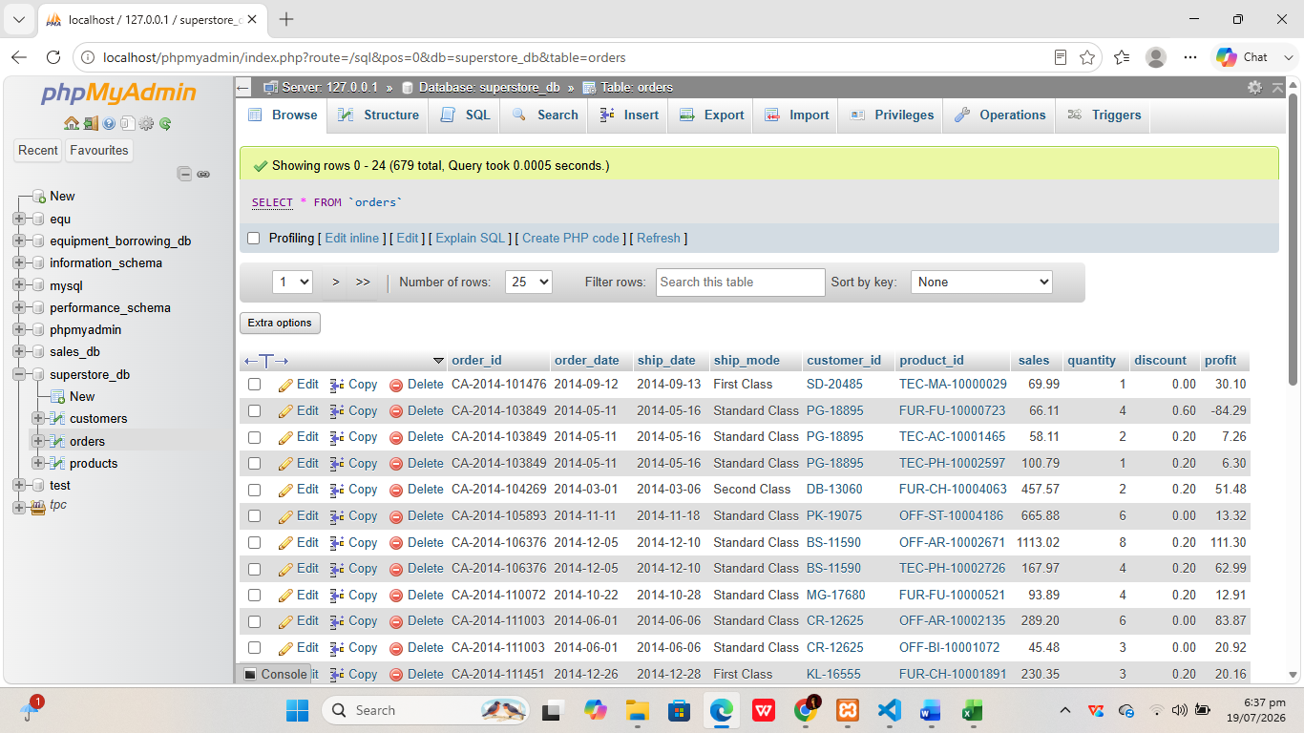
- Customers Table
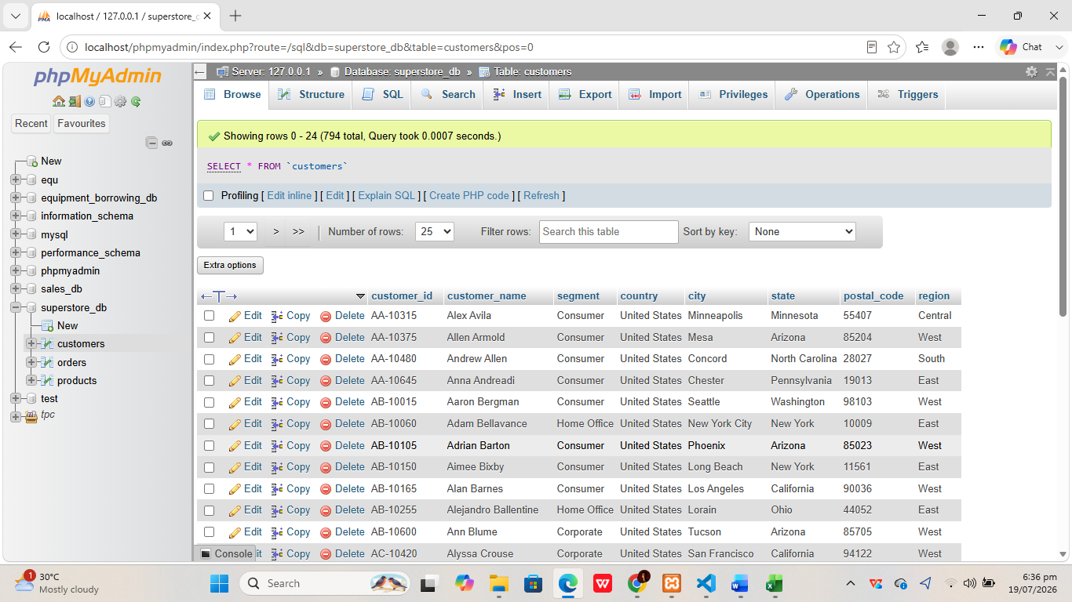

- Orders Table

- Products Table

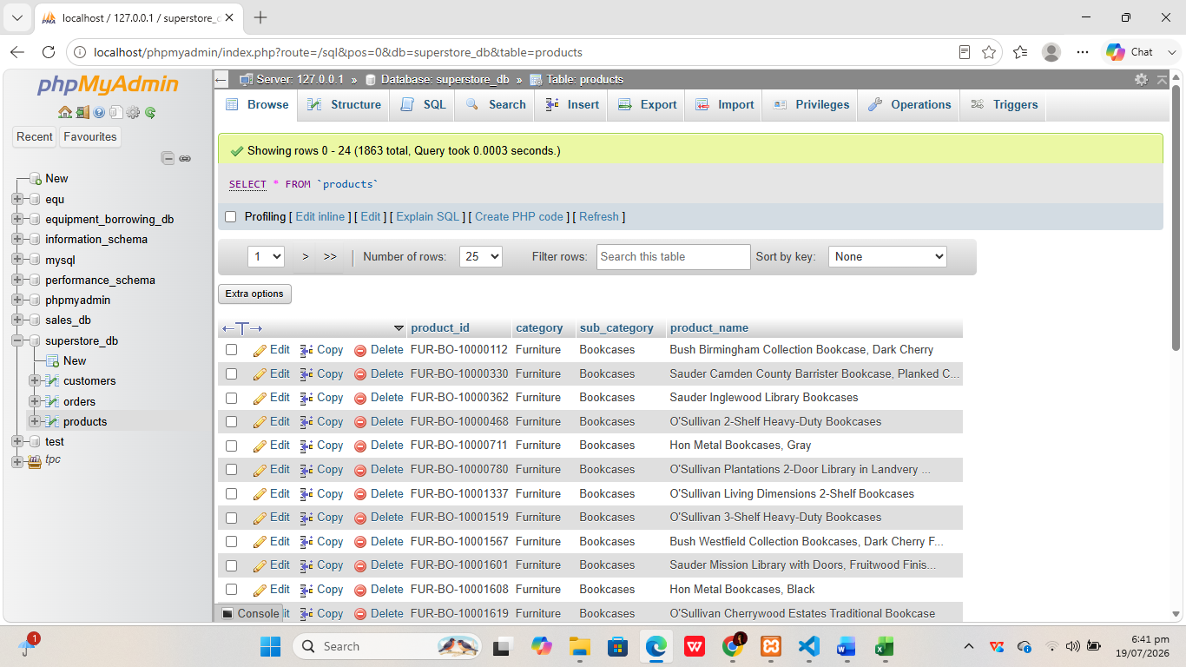

Task 1.4 — SQL Query Report

1. Basic Data Retrieval (2 Queries)
Must include SELECT, WHERE, and ORDER BY clauses.

QUERY 1B: SELECT + WHERE + ORDER BY
- -- Business Question: What orders were placed in 2017?
- Screenshot of SQL Code
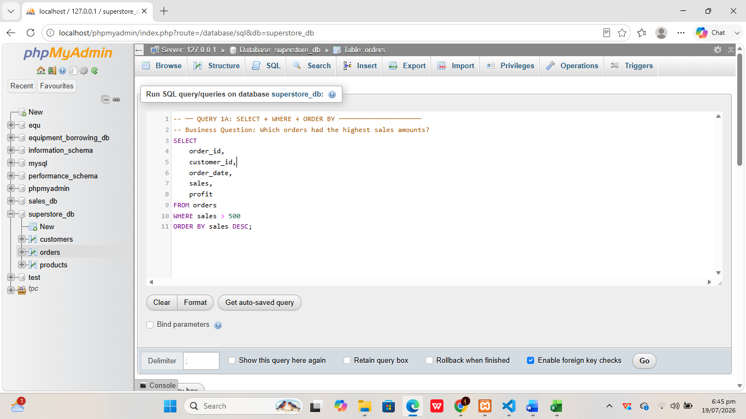

- Result Screenshot
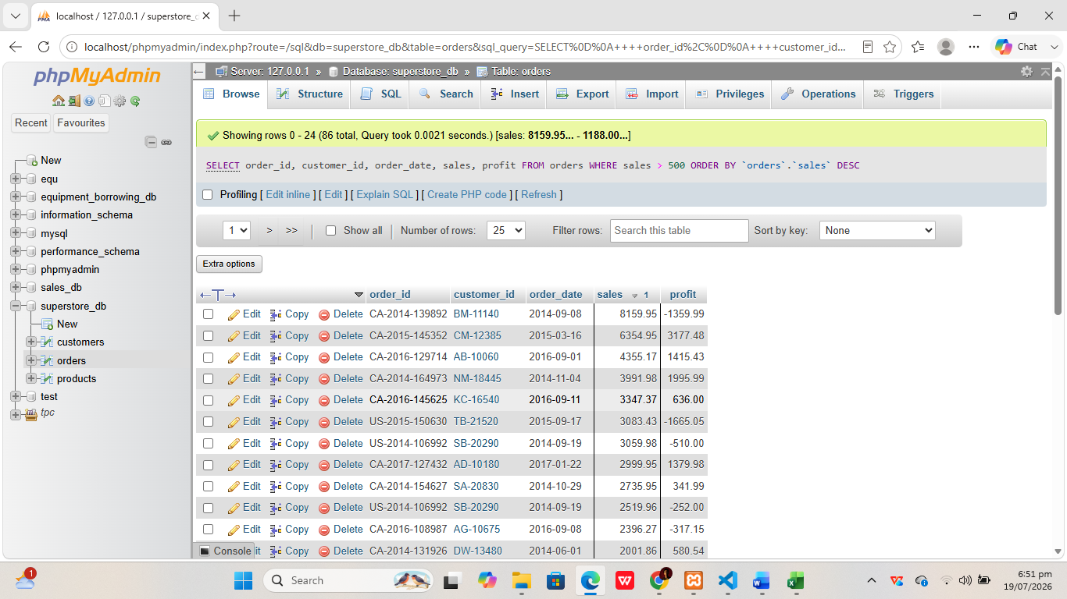

- Business Interpretation
Query 1A: Retrieves all orders where the sales amount exceeds 500, sorted from highest to lowest. This identifies high-value transactions that contribute most significantly to total revenue, helping management understand patterns among large purchases such as which products or regions tend to produce high-value orders.

QUERY 1B: SELECT + WHERE + ORDER BY
-- Business Question: What orders were placed in 2017?

- Screenshot of SQL Code
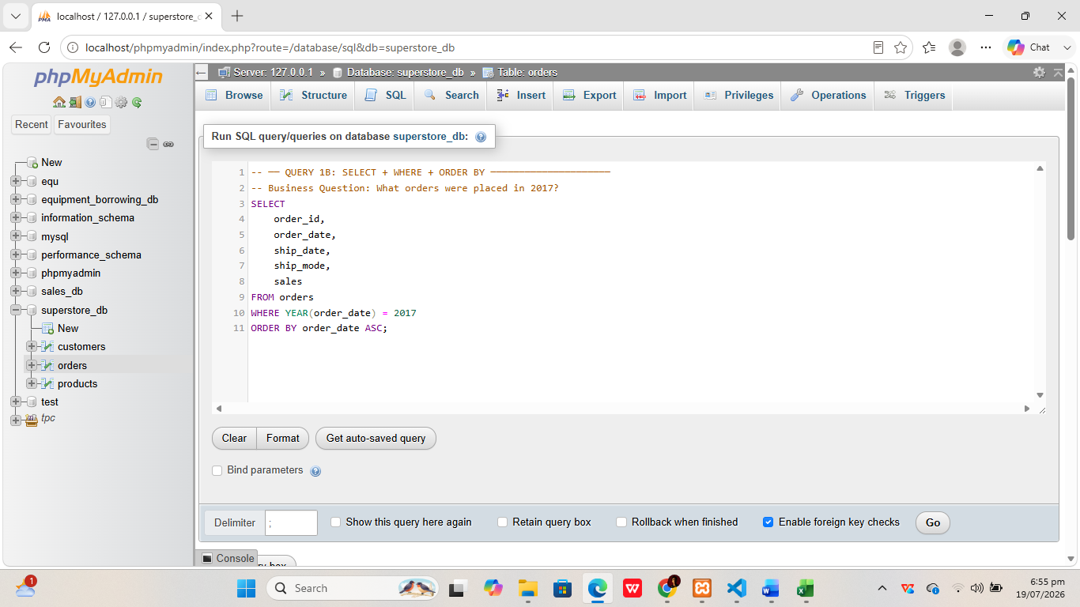

- Result Screenshot
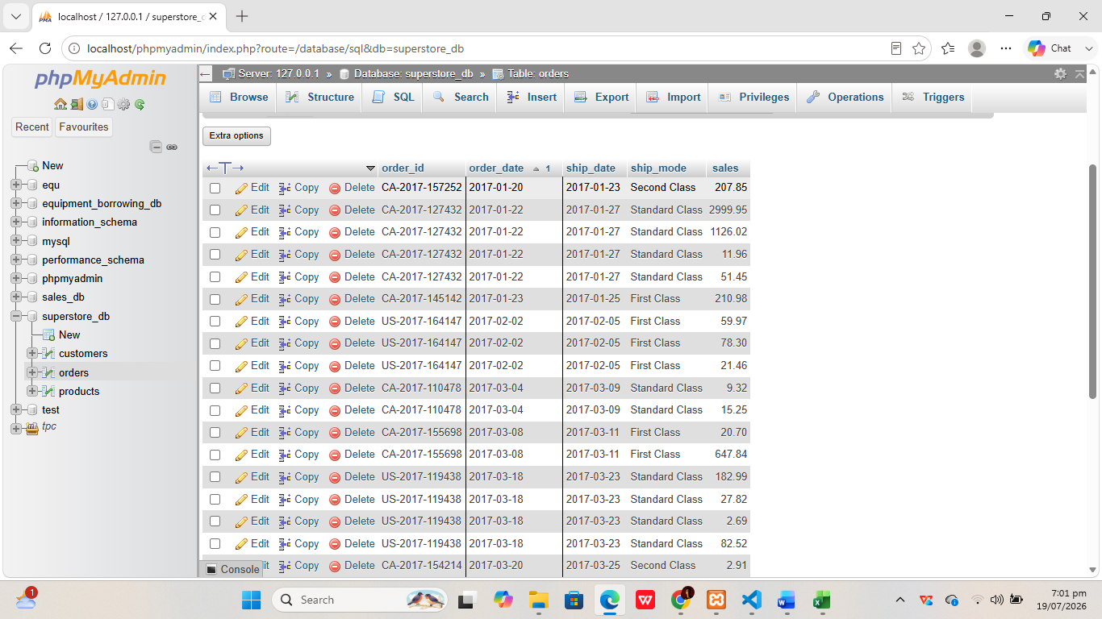

- Business Interpretation:
Query 1B: Filters all orders placed in 2017 in chronological order, allowing the business to review the full transaction history for a specific fiscal year and compare annual sales volumes to track business growth over time.

2. Aggregate Analysis (2 Queries)
Must include GROUP BY and Aggregate Functions (COUNT, SUM, AVG, etc.).

QUERY 2A: GROUP BY + AGGREGATE
-- Business Question: Which product category earns the most?

- Screenshot of SQL Code

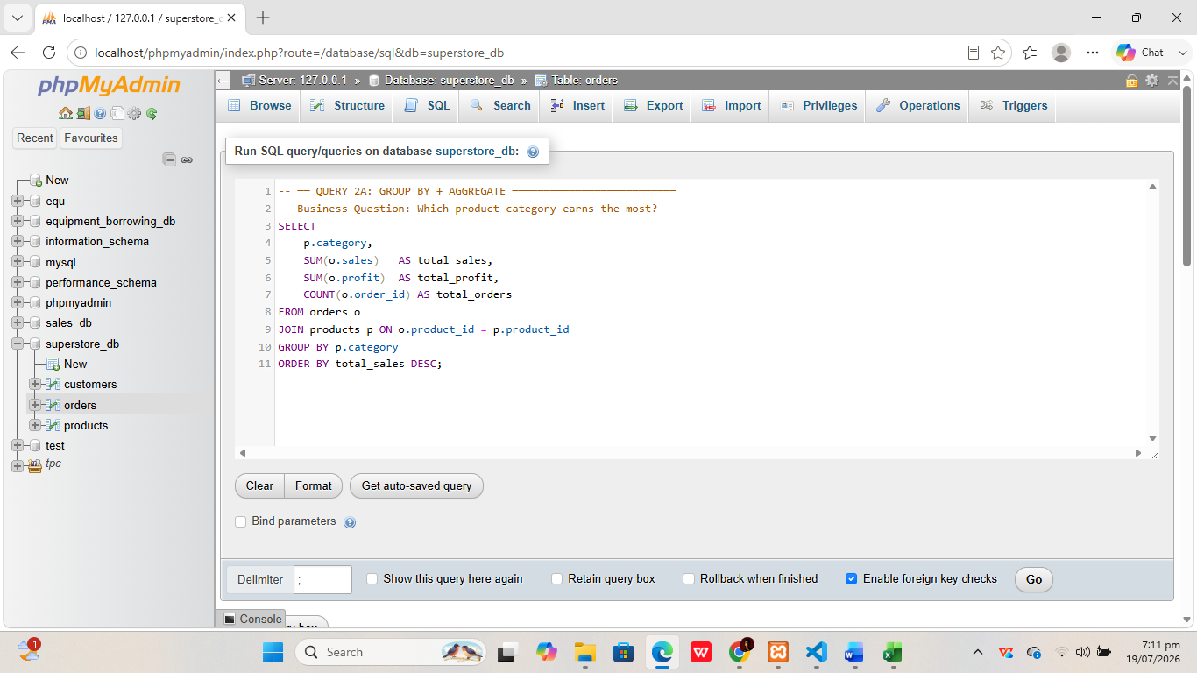

- Result Screenshot

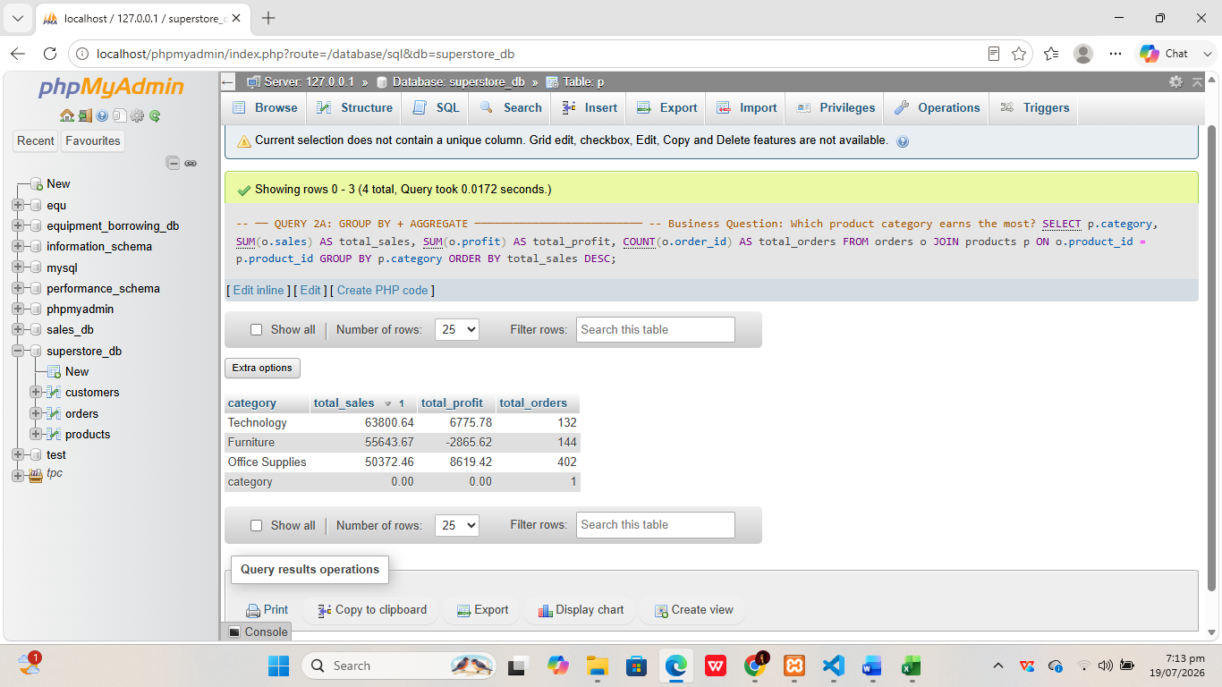

- Business Interpretation:
Query 2A: Calculates total sales revenue and total profit per product category. Results reveal which of the three main categories — Furniture, Office Supplies, or Technology — generates the most revenue and profit, informing product mix and resource allocation decisions.

QUERY 2B: GROUP BY + AGGREGATE
-- Business Question: Which region is the most profitable?

- Screenshot of SQL Code

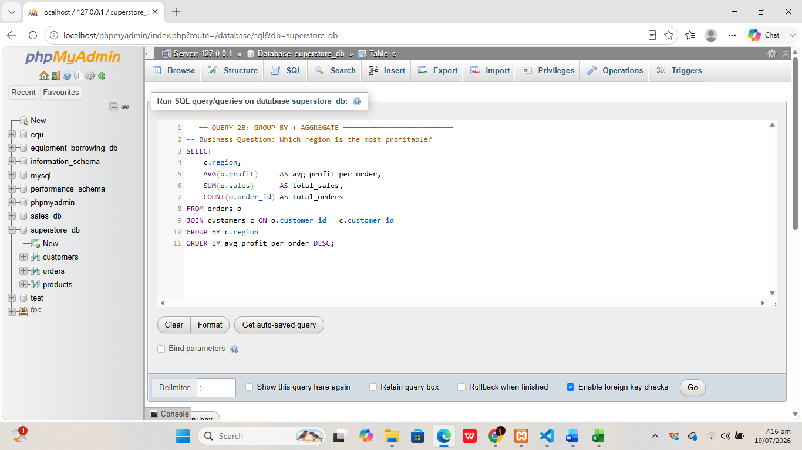

- Result Screenshot
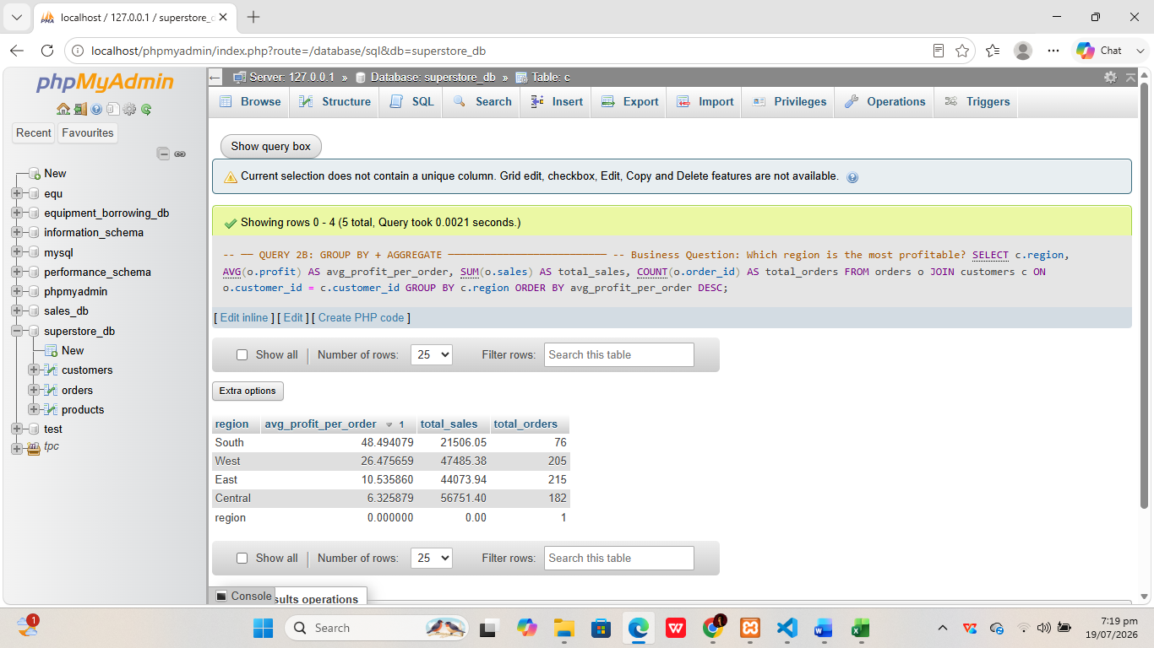

- Business Interpretation:
Query 2B: Computes average profit per order and total order count by geographic region. A region with many orders but low average profit may indicate heavy discounting or inefficiencies, while a high-profit region signals a target for increased investment.

3. Multi-Table Joins (2 Queries)
Must connect two or more tables.

QUERY 3A: JOIN (orders + customers)
--Business Question: Who are the top 10 highest-spending customers?

- Screenshot of SQL Code

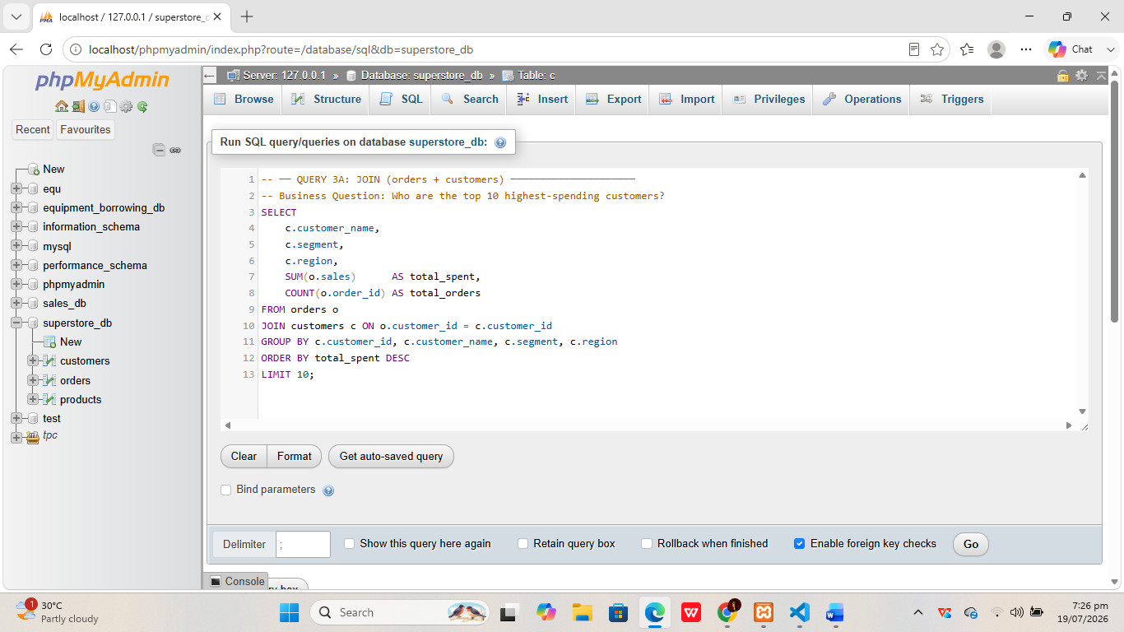

- Result Screenshot
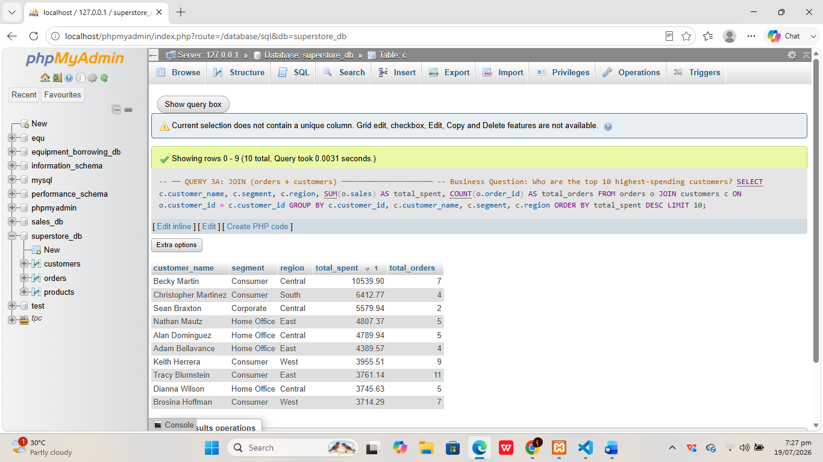

- Business Interpretation
Query 3A: Joins orders and customers tables to identify the top 10 customers by total spending. Knowing which customers generate the most revenue enables the business to prioritize relationship management with high-value clients and design targeted loyalty programs.

QUERY 3B: JOIN (orders + products)
-- Business Question: Which sub-categories sell the most?

- Screenshot of SQL Code

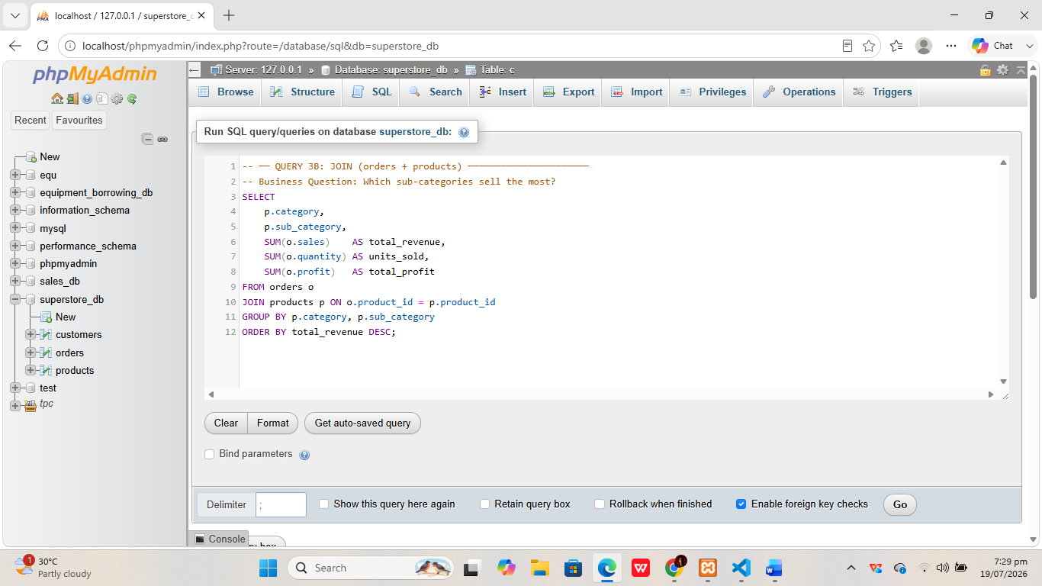

- Result Screenshot

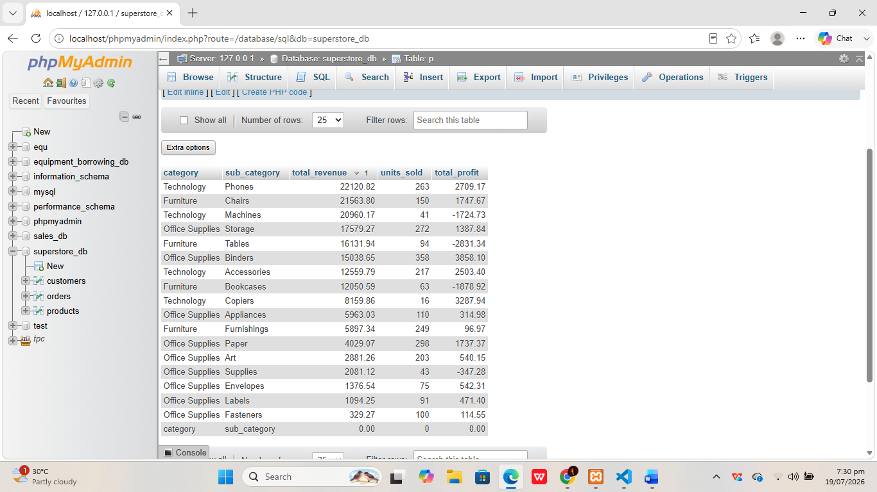

- Business Interpretation
Query 2B: Joins orders and products tables to rank all sub-categories by total revenue and units sold, providing granular insight into which specific sub-categories like Phones, Chairs, or Binders are the strongest performers.

4. Business-Relevant Insights (2 Queries)
Queries specifically designed to answer your key business questions listed in Task 1.1.

QUERY 4A: BUSINESS INSIGHT — Monthly Sales Trend (Question 3)
-- Business Question: What does the monthly sales trend look like over time?

- Screenshot of SQL Code

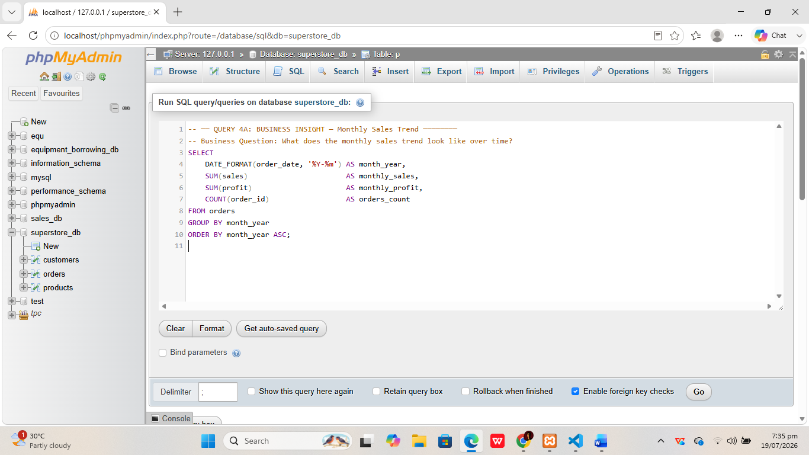

- Result Screenshot

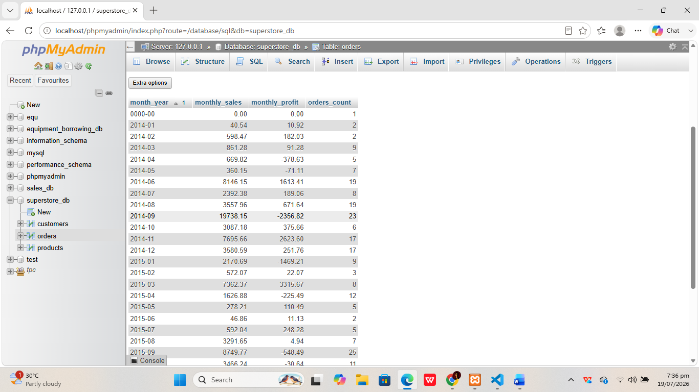

- Business Interpretation
Query 4A: Groups total sales and profit by month to reveal peak sales periods such as the November–December holiday season and slower months. This time-series output is essential for demand forecasting and inventory planning for upcoming quarters, directly answering the business question about seasonal trends.

QUERY 4B: BUSINESS INSIGHT — Discount vs Profit (Question 2)
-- Business Question: Do higher discounts lead to lower profits?

- Screenshot of SQL Code

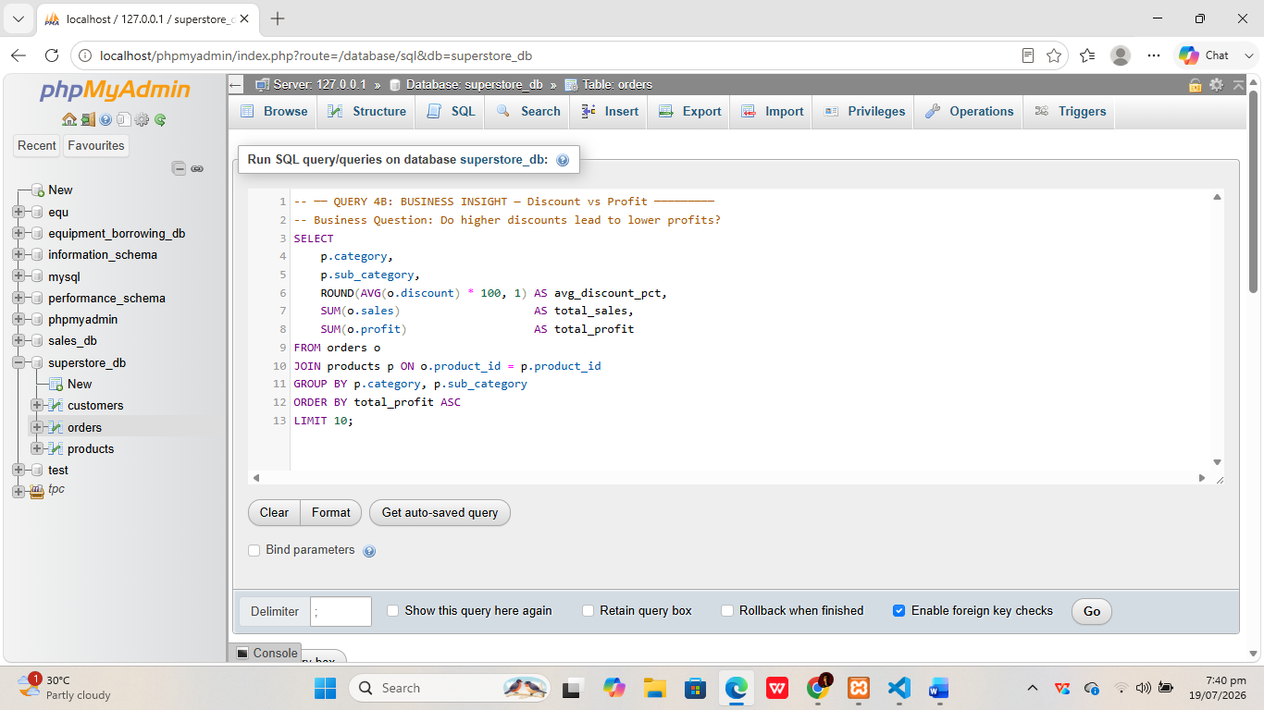

- Result Screenshot

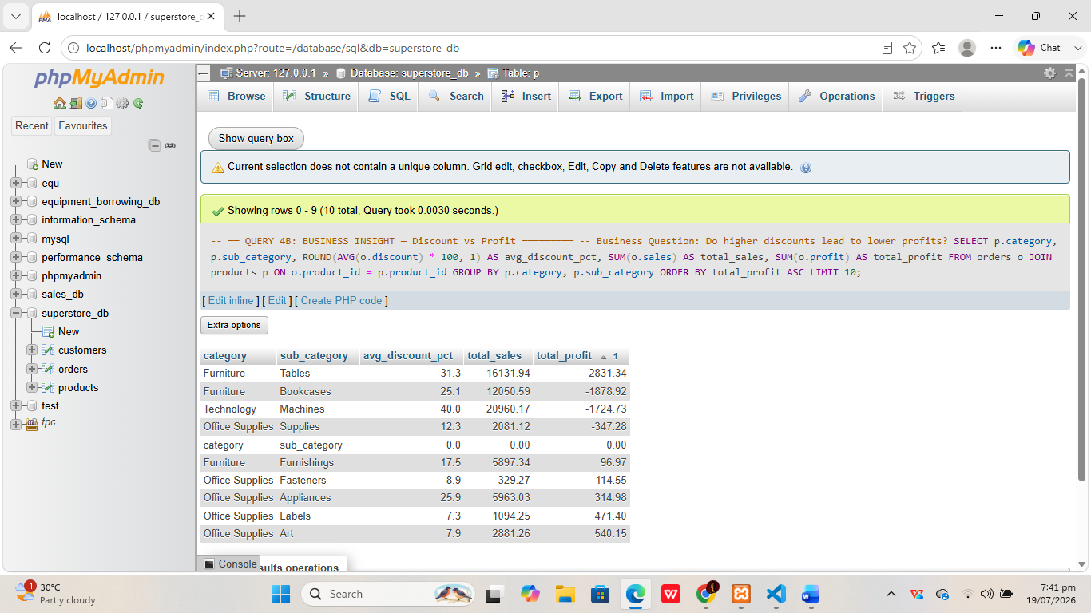

- Business Interpretation
Query 4B: Identifies the 10 least profitable sub-categories along with their average discount rates. Sub-categories with high average discounts and low or negative profit confirm that aggressive discounting is hurting margins, providing actionable data to revise the discounting strategy.

Time Finished – 19/07/2026, 7:43 pm

