BA Capstone Project: Checkpoint 2
Retail & Sales Analytics
Sales Performance & Revenue Forecasting
Spreadsheet & Statistical Analysis

Group Name: MANTA RAY
Course & Section: BED 106 - Business Analytics
Date: [SUBMISSION DATE]

Team Members & Roles:
Sugar-Rey R. Garcia — Project Lead / Analyst
Rudelyn Joy Abanador — Data Engineer
Joel Madula — Statistician / Modeler

Task 2.1 — Spreadsheet Analytics Report
The full analysis lives in the accompanying Excel workbook, Checkpoint2_Spreadsheet_Analysis.xlsx, organized into the sheets described below. The dataset is the same Sample Superstore Sales Dataset (9,994 order-line records) used in Checkpoint 1.
Sheet 1 — Cleaned Data
The finalized dataset (21 original columns plus two helper columns, Order Month and Order Year, used to power the monthly pivot and trend calculations) is imported as a formatted Excel Table for easy filtering and formula referencing.
Sheet 2 & 3 — Pivot Analysis & Pivot Charts
Three pivot-style summary tables were built with live SUMIF / AVERAGEIF / COUNTIF formulas referencing the Cleaned Data sheet, each paired with a chart:
- Pivot Table 1: Total Sales & Profit by Product Category, Order Count, and Average Discount.
- Pivot Table 2: Average Sales & Profit per Order, Total Sales, and Order Count by Region.
- Pivot Table 3: Order Count and Revenue Share (%) by Customer Segment.
Category | Total Sales | Total Profit | Order Count | Avg Discount
Furniture | $741,999.80 | $18,451.27 | 2121 | 17.4%
Office Supplies | $719,047.03 | $122,490.80 | 6026 | 15.7%
Technology | $836,154.03 | $145,454.95 | 1847 | 13.2%
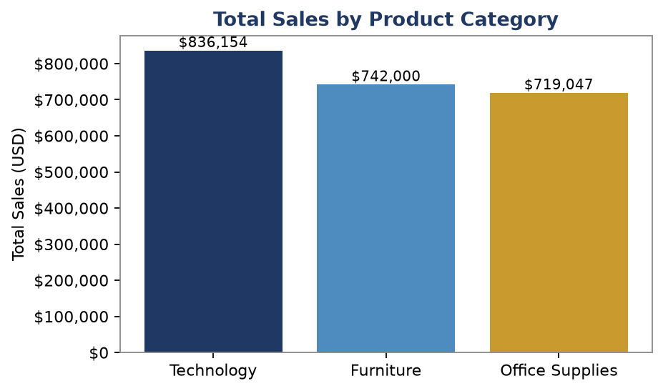
Figure 2.1 — Total Sales by Product Category
Region | Avg Sales/Order | Avg Profit/Order | Total Sales | Order Count
Central | $215.77 | $17.09 | $501,239.89 | 2323
East | $238.34 | $32.14 | $678,781.24 | 2848
South | $241.80 | $28.86 | $391,721.91 | 1620
West | $226.49 | $33.85 | $725,457.82 | 3203
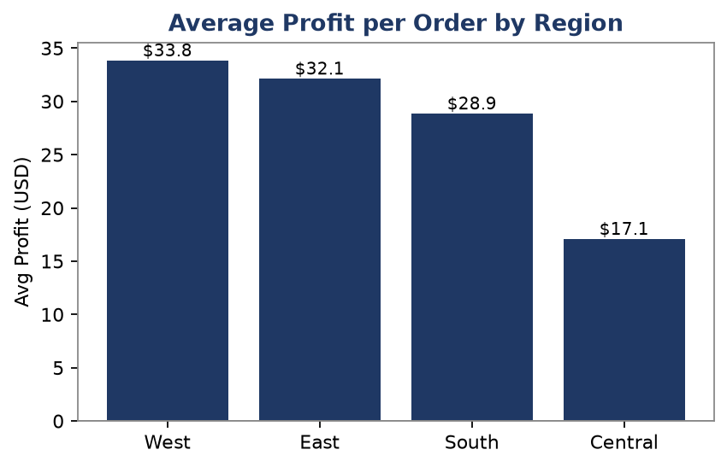
Figure 2.2 — Average Profit per Order by Region
Segment | Order Count | Total Sales | % of Total Sales
Consumer | 5191 | $1,161,401.34 | 50.6%
Corporate | 3020 | $706,146.37 | 30.7%
Home Office | 1783 | $429,653.15 | 18.7%
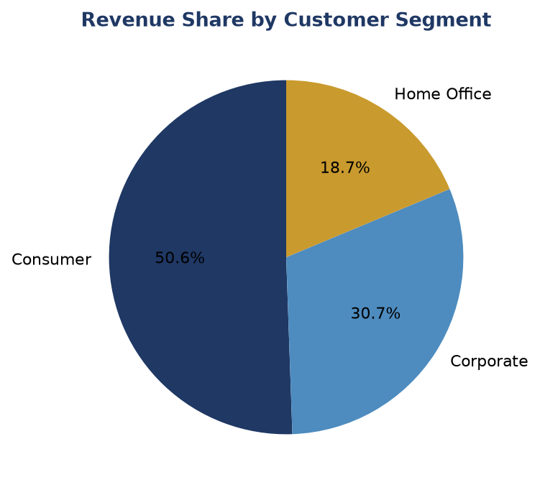
Figure 2.3 — Revenue Share by Customer Segment
Sheet 4 — Formulas Showcase
Six Excel functions relevant to the business context were demonstrated as live formulas against the Cleaned Data sheet:
- SUMIF — Total Sales generated by the Technology category.
- COUNTIF — Number of orders shipped to the West region.
- AVERAGEIF — Average profit earned from Corporate-segment orders.
- IF — Flags whether the company-wide average discount indicates a high-discount environment.
- XLOOKUP — Looks up the Sales value for a specific Order ID.
- TEXT — Formats the report-generation date for the workbook cover.
Task 2.2 — Descriptive Statistics Report
Variable | Mean | Median | Mode | Std Dev | Variance | Min | Max | Range
Sales | 229.8580 | 54.4900 | 12.9600 | 623.2451 | 388,434.4553 | 0.4440 | 22,638.4800 | 22,638.0360
Profit | 28.6569 | 8.6665 | 0.0000 | 234.2601 | 54,877.7981 | -6,599.9780 | 8,399.9760 | 14,999.9540
Discount | 0.1562 | 0.2000 | 0.0000 | 0.2065 | 0.0426 | 0.0000 | 0.8000 | 0.8000
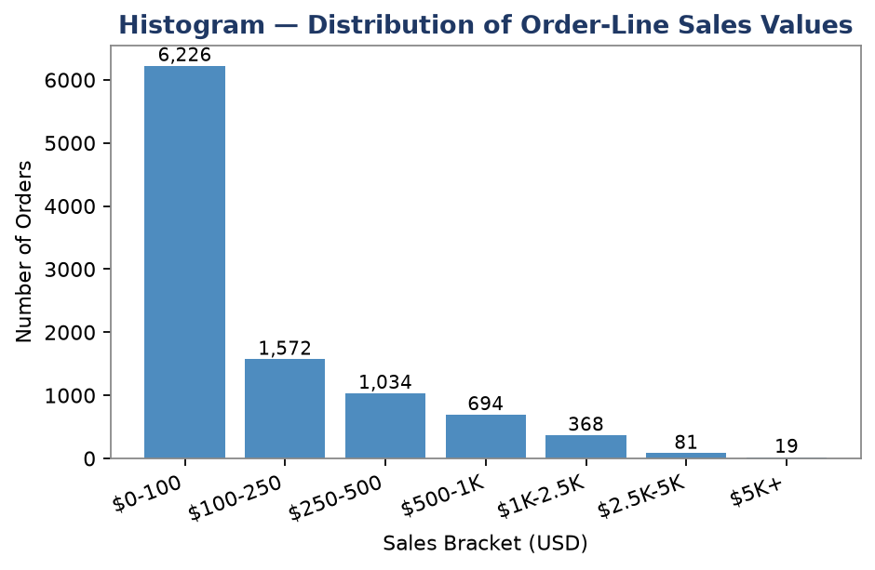
Figure 2.4 — Frequency Distribution of Order-Line Sales Values
Interpretation
Sales: The average order-line sale is $229.86, but the median of only $54.49 is far lower, showing the distribution is heavily right-skewed — most transactions are small, everyday purchases while a small number of large orders (up to $22,638) pull the average upward. The high standard deviation (≈$623) confirms wide variability in order size, meaning revenue planning should not rely on the 'average sale' alone; the frequency distribution above gives a more realistic picture of typical transactions.
Profit: Average profit per order line is $28.66 with a median of only $8.67, and a minimum value of $-6,599.98 shows that a meaningful share of transactions are sold at a loss. The gap between mean and median, combined with a mode of $0.00, indicates that profit outcomes are inconsistent across orders — some product/discount combinations are actively eroding margin. This directly motivates the discount-and-profitability analysis in Tasks 2.3 and 2.4.
Discount: The average discount applied is 15.6%, with a median of 20% and a mode of 0% (no discount), meaning a large share of orders are sold at full price while a separate cluster of orders receive deep discounts up to 80%. This pattern suggests discounting is applied inconsistently — likely tied to specific categories or clearance activity rather than a uniform pricing policy.

Task 2.3 — Correlation Analysis
Pair 1: Sales vs. Profit
Pearson Correlation Coefficient: r = 0.4791
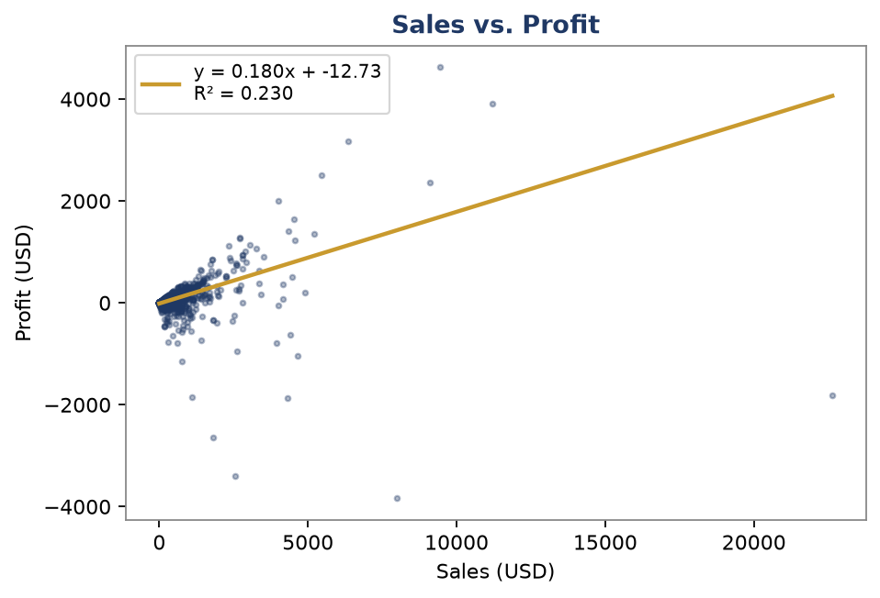
Figure 2.5 — Sales vs. Profit Scatter Plot with Trendline
Direction & Strength: The correlation is positive and moderate (r = 0.479). Larger sales transactions tend to generate higher absolute profit, which is expected, but the relationship is far from perfect — meaning sales volume alone does not guarantee profitability.
Business Implication: Sales growth strategies must be paired with margin discipline; a high-sales order can still post a loss if discounting is aggressive (see Pair 2 below).
Pair 2: Discount vs. Profit
Pearson Correlation Coefficient: r = -0.2195
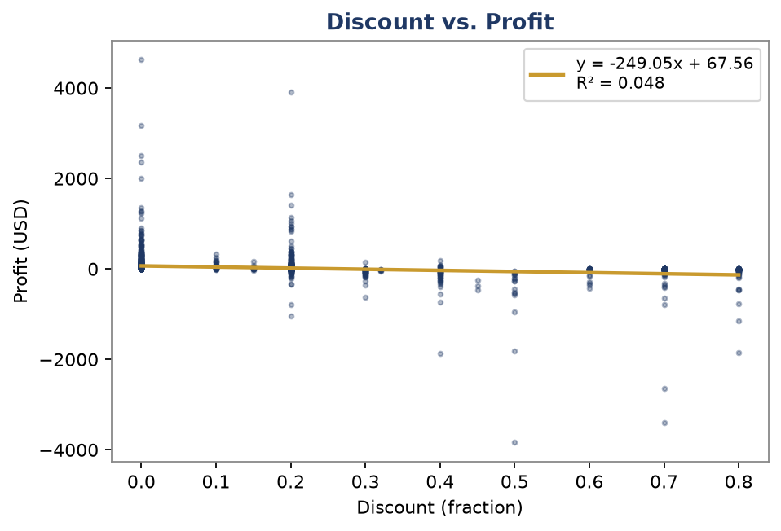
Figure 2.6 — Discount vs. Profit Scatter Plot with Trendline
Direction & Strength: The correlation is negative and weak-to-moderate (r = -0.219). As discount rate increases, profit tends to decrease, confirming the concern raised in Business Question 2 (Checkpoint 1).
Business Implication: The relationship is not strongly negative, implying discount is one contributing factor among several (category, shipping cost, product margin) rather than the sole driver of unprofitable orders — explored further with regression in Task 2.4.

Task 2.4 — Simple Linear Regression
Dependent variable (Y): Profit | Predictor variable (X): Sales

Figure 2.7 — Regression Fit: Profit vs. Sales
Regression Equation
Profit = -12.7329 + (0.1801 × Sales)
Statistic | Value
Slope (b) | 0.180067
Intercept (a) | -12.732867
R-squared (R²) | 0.2295
Standard Error of Slope | 0.003301
p-value | < 0.0001 (statistically significant)
Interpretation
R² ≈ 0.230, meaning Sales explains roughly 23% of the variation in Profit across order line items. The remaining variation is driven by factors not in this simple model, primarily discount rate and product-category margin. The slope is statistically significant (p < 0.001), confirming Sales is a genuine, non-random predictor of Profit at this sample size.
Business Forecast
Using the regression equation, predicted profit at several hypothetical sales levels:
Hypothetical Sales | Predicted Profit
$500 | $77.30
$1,000 | $167.33
$2,500 | $437.43
$5,000 | $887.60
$10,000 | $1,787.93
Limitations & Conditions for Use
This is a single-variable linear approximation of a relationship that is likely non-linear and interacts with discount and category; it should not be used to predict profit for individual orders with high confidence, only for directional, portfolio-level estimates. It also assumes the historical relationship between sales and profit holds going forward, and does not account for outlier loss-making orders driven by heavy discounting. A multiple regression incorporating Discount and Category (planned for Checkpoint 4) is expected to improve predictive accuracy substantially.

Task 2.5 — Trend / Seasonality Analysis
The dataset contains time-series order data spanning 48 months (January 2014 – December 2017), making trend and forecast analysis directly applicable to Business Question 5 (Checkpoint 1): 'What will next quarter's sales look like based on historical trends?'
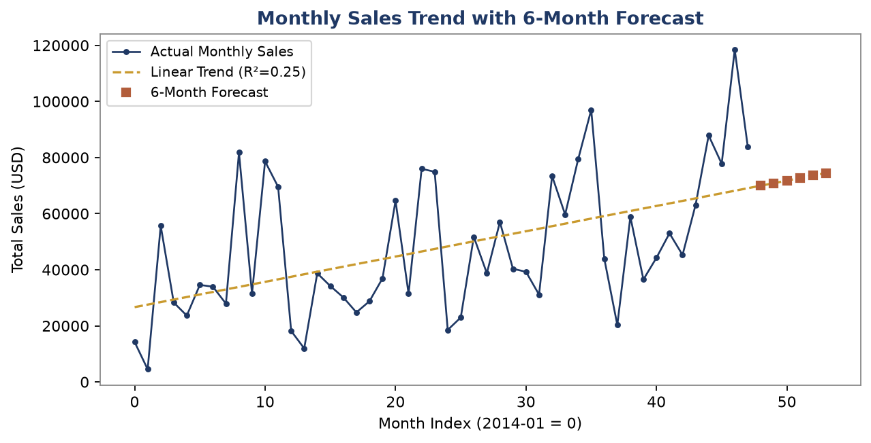
Figure 2.8 — Monthly Sales Trend with 6-Month Forecast
Trend Summary
Linear trend slope: ≈ $902 additional sales per month | R² ≈ 0.25
Projected Month | Forecasted Sales
2018-01 | $69,957.54
2018-02 | $70,859.54
2018-03 | $71,761.55
2018-04 | $72,663.56
2018-05 | $73,565.57
2018-06 | $74,467.57
Reliability & Assumptions
The linear trend across 48 months of historical data shows a positive slope of approximately $902 in additional monthly sales per period, with R² ≈ 0.25. This R² is moderate, not high, because monthly sales are strongly seasonal — visible spikes occur around Q4 (September and November–December) each year that a simple straight-line trend cannot fully capture. The 6-month forecast should therefore be read as a general growth trajectory, not a precise month-by-month prediction; a seasonal model (e.g., moving average or multiplicative seasonal decomposition) would likely outperform this linear projection for operational inventory planning. The forecast also assumes no major structural changes (new store openings, macroeconomic shocks, promotional calendar changes) going forward.

