Block chain (BITS F452)

Final Project



BITS-Pilani, Hyderabad Campus December, 2021

**Group No – 51**

**Members –**

MANAN AGRAWAL – 2019A3PS0400H  
JUHIL DESAI - 2019A7PS0153H  
TOSHIT CHEELI - 2019A3PS0462H

**Introduction –**

For a long time, online bidding has been a part of the digital world. The bidding house's centralised data processing and storage might enhance the level of distrust amongst participants in the auction process. Decentralized Applications can aid in the resolution of these issues.

A computer programme that operates on a distributed computing system is known as a decentralised application (dApp). DApps also provide developers with simple tools to undertake user identification checks and allow financial transactions in a transparent way, as the great majority of DLTs support native cryptocurrencies, smart contracts, and wallets.

We built an auction house on the Ethereum test network where users may put bids on things, based on the flaws with the present online auction system and the benefits that DApps provide. Because of its popularity and extensive set of development tools, we decided to build on the Ethereum network (Solidity, Truffle, Ganache, etc.). We were also able to ensure user privacy by using Ethereum-based wallets for identity verification, which do not store any personal information. Finally, the Ether cryptocurrency, as well as the gas fees and transaction confirmation time, assisted us in inhibiting unfair behaviours such as price gouging.

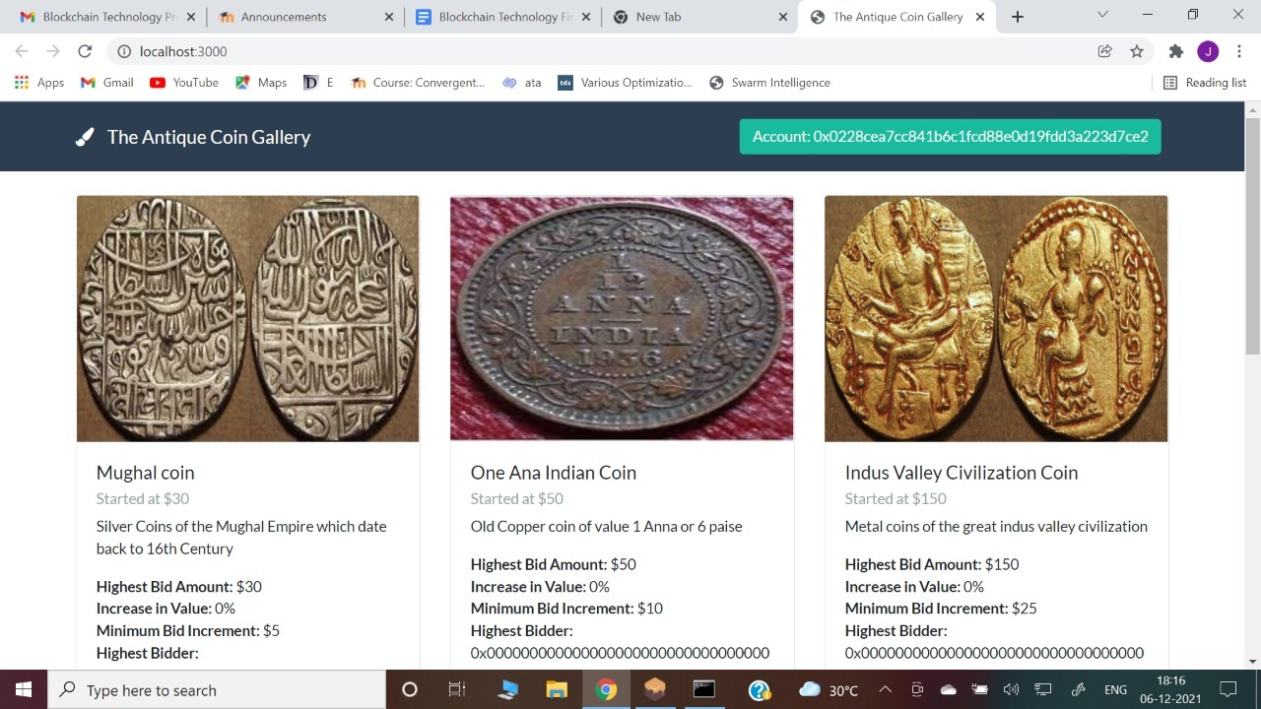

Smart contracts are used in the "Antique Coin Gallery" Auction DApp to allow users with an Ethereum wallet to bid on items supplied by the auction house. A list of objects, their descriptions, and auction information are all available through the online interface. Users can put the highest offer on any item as long as the proposed bid follows the contract's restrictions. The blockchain stores the transactions and information connected to the top bids and bidders.

Due to time restrictions, the breadth of our project was constrained, and our DApp shows a simplified version of a sophisticated bidding procedure. Currently, the app is mostly a data management system that records auctions and only charges customers the gas price related with bid contract fulfilment. When users put bids, the app does not take the real bid amount out of the bidder's wallet as a deposit. Furthermore, for each item, the app only keeps track of the top bidder and the highest bid amount. Furthermore, customers are unable to build their own auctions using the app. Furthermore, because auctions have no time restriction, bids can be submitted indefinitely. Finally, all of the data is published to the blockchain, which can be very consuming, especially if the programme grows in popularity.

**Ganache**

We have used Ganache to create a Ethereum Blockchain.

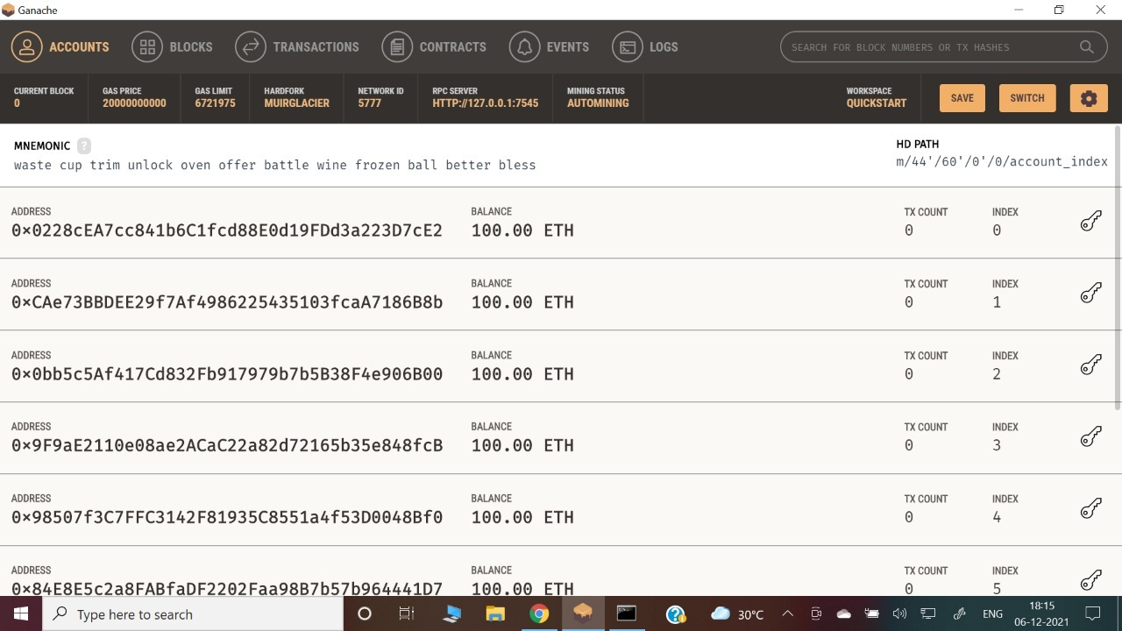

**How to Run the dApp:**

Once we have all the required tools installed, we can run the Coin bidding system dApp as follows:

1. Run Ganache and connect an account to the Metamask
2. Open command prompt
3. Go to the folder where the file is present
4. Execute truffle Compile
5. Next truffle Migrate
6. Next npm run dev
7. The dapp opens.
8. The user sees the metamask pop up. press confirm to connect the user account
9. The user can then give input to use the bidding system.

# Results & Plots –

# Connecting Metamask to Ganache

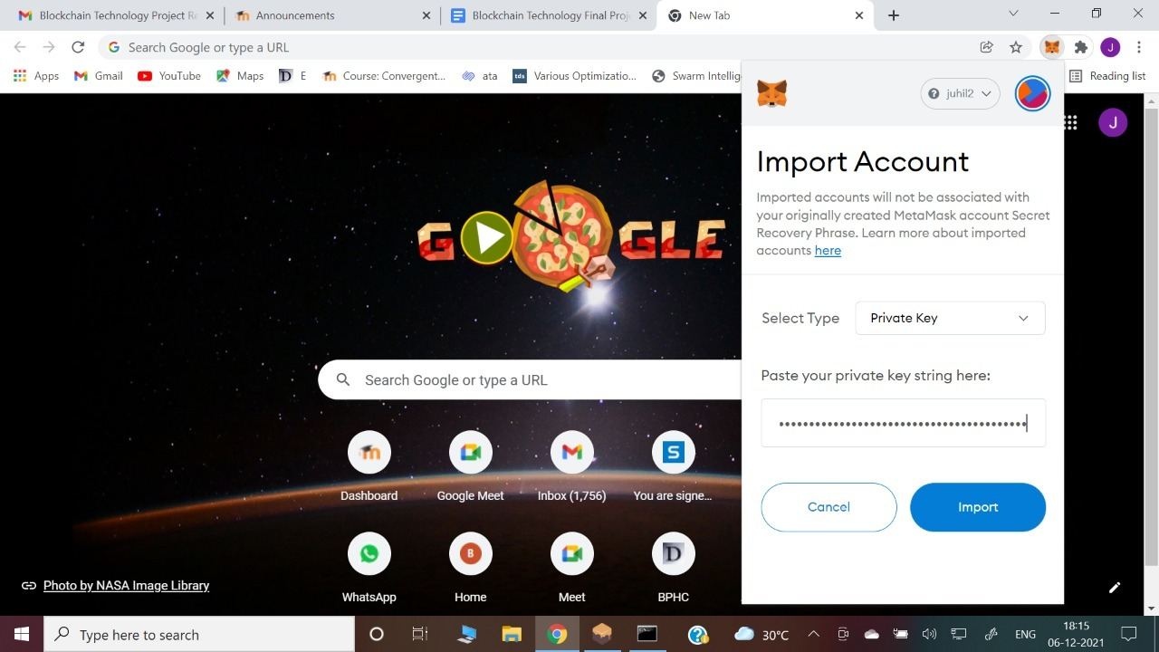

**Connecting Ganache Account to dApp**

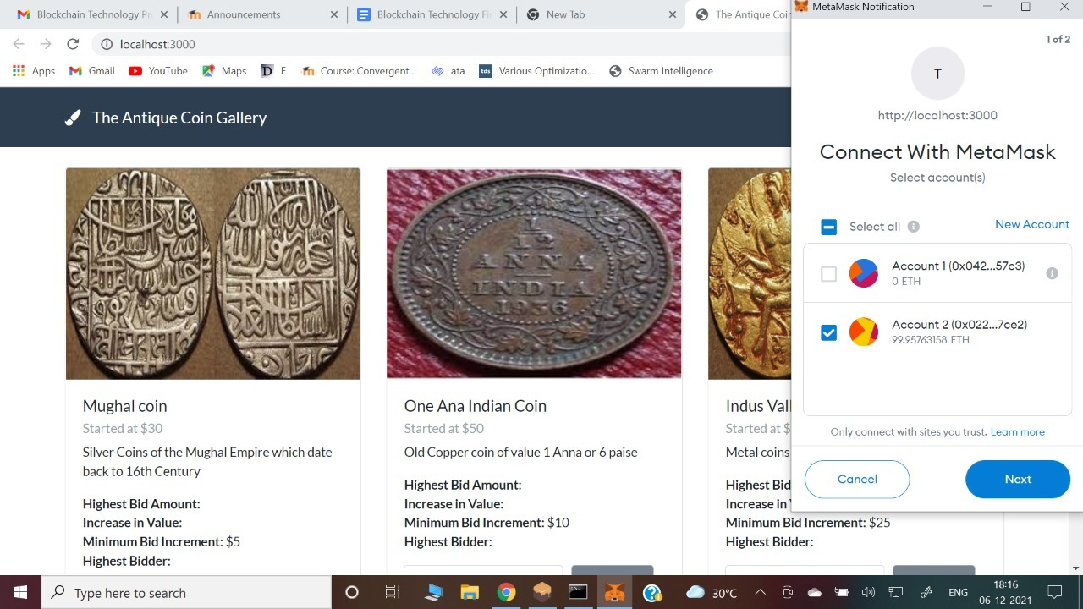

**The bidding System, With input options**

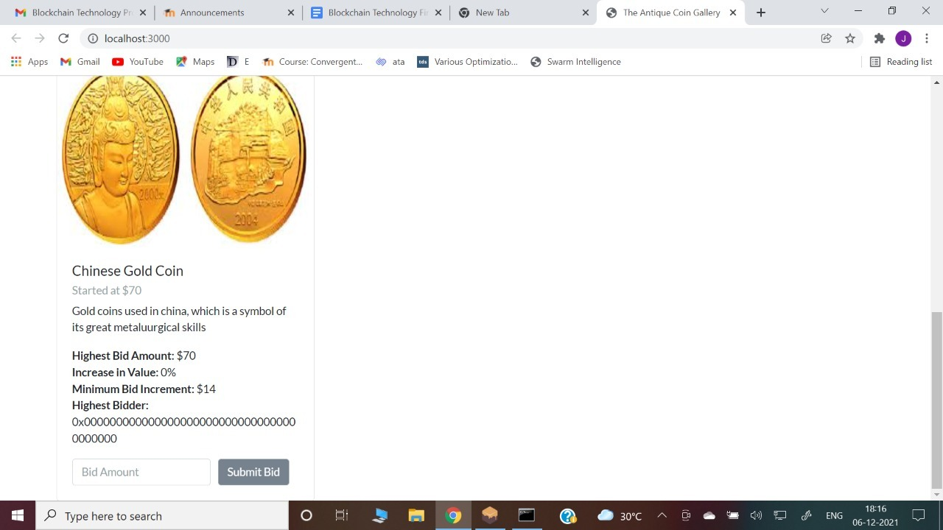

**Problems and challenges faced:**

1. Creating the UI
2. Implementation of smart contract and solidity.
3. Setting up the conditions for the validity of a bid

**Link to video:**

https://drive.google.com/file/d/1EML97XvzIUp9kSZc9tIFxOqc1oPbTocu/view?usp=sharing