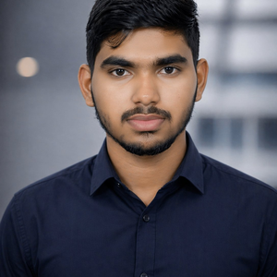 | TOSHIT SAI GALAM  Computer Science Student • Web Developer • Hyderabad, India  GitHub: github.com/toshitsai | LinkedIn: linkedin.com/in/toshitsai  Open to Internships & Entry-Level Roles

PROFILE
Motivated Computer Science student with a strong interest in web development and emerging technologies. Passionate about building real-world projects to enhance problem-solving and technical skills. Actively seeking internship or entry-level opportunities to grow and contribute to impactful software solutions.

EDUCATION
Bachelor of Technology (B.Tech) – Computer Science 2025 – 2029
NxtWave Institute of Advanced Technologies (NIAT), Chaitanya Deemed University
Intermediate (12th Grade) – MPC Stream 2023 – 2025
Bhavishya Junior College

SKILLS
Web Technologies: HTML, CSS, JavaScript, React (Basics), Node.js (Basics)
Frameworks & Libraries: Bootstrap, Tailwind CSS
Tools & Platforms: Git, GitHub, VS Code, Webflow
Soft Skills: Problem-solving, Teamwork, Communication, Time Management

PROJECTS
Personal Portfolio Website HTML · CSS · JavaScript
- Designed and developed a fully responsive portfolio website to showcase skills and projects.
- Focused on clean UI design principles and mobile-first responsiveness.
- Handled end-to-end delivery — from design to development and deployment.

ADDITIONAL INFORMATION
- Strong interest in modern web technologies and UI/UX best practices.
- Continuously learning through self-directed projects and online resources.
- Open to internships and entry-level roles to contribute and grow professionally.

